Phishing Simulation
In this exercise, I learned how phishing attacks work and how attackers can create fake login pages to capture user credentials.
I created a simple HTML login form and explored the Social Engineering Toolkit (SEToolkit) in Kali Linux.
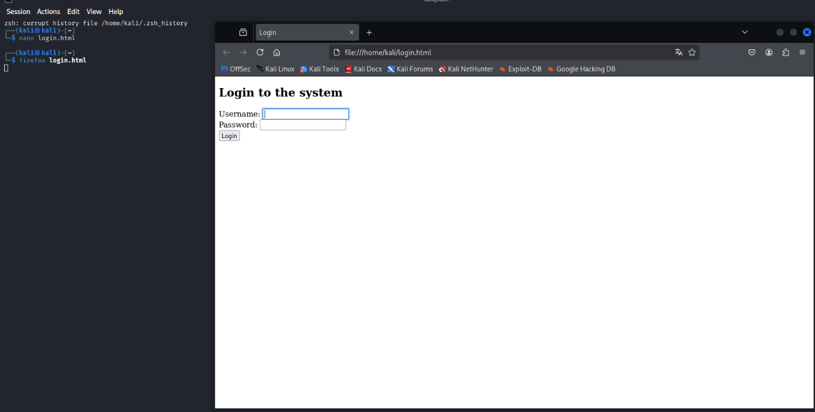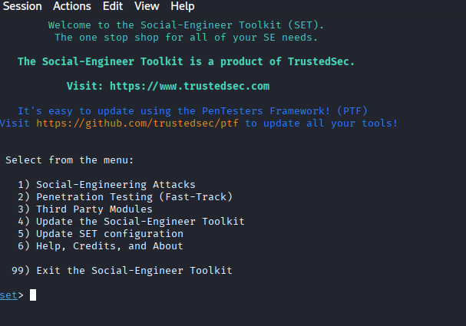

Reflection
Characteristics of phishing pages
- suspicious or incorrect URLs
- fake login forms
- requests for sensitive information
- missing HTTPS certificate
Protection against phishing attacks
- checking URLs carefully
- avoiding suspicious links
- using two-factor authentication
- verifying website authenticity
Why are modern sites more secure?
Modern websites use HTTPS encryption, MFA, browser security protections, and anti-phishing systems that make attacks more difficult.

