Nmap Scan
I used Nmap to scan the target system and identify open ports and services.
The scan detected:
- Port 2222 open
- SSH service running

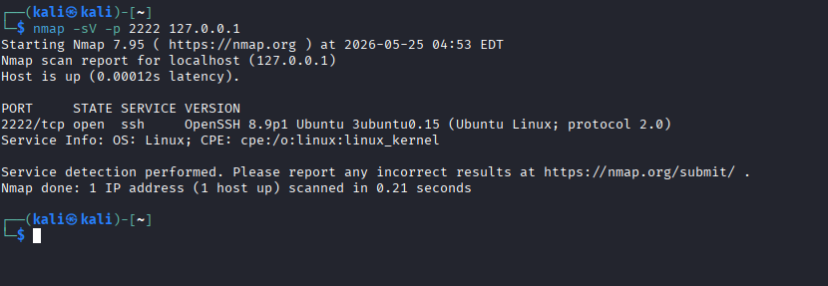

Hydra Brute Force Test
I used Hydra with a small password list to test SSH login security.
Hydra successfully discovered the password:
- Username: testuser
- Password: test123
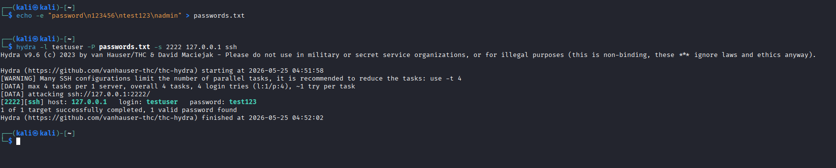

Reflection
Weak passwords are dangerous because attackers can easily brute-force them. Unused ports should be closed to reduce security risks.
To improve SSH security:
- use strong passwords
- use SSH keys
- limit login attempts
- use a firewall
- disable unused services
Strong passwords make brute-force attacks significantly more difficult.

