GPG Encryption and Signing
Key Generation
I generated a new GPG key pair using RSA 4096 encryption.
gpg --full-generate-key
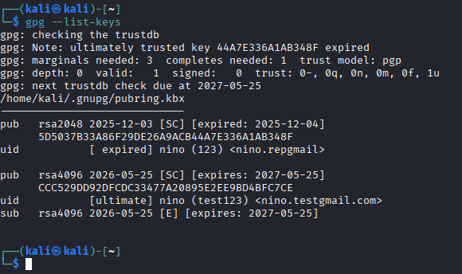

Encryption and Signing
I created a text file and encrypted/signed it using GPG.
gpg --encrypt --sign --armor –nino.testgmail.com message.txt
The encrypted file was successfully generated.

Decryption and Verification
I decrypted the encrypted message and verified the digital signature.
gpg --decrypt message.txt.asc
The terminal displayed a valid signature confirmation.
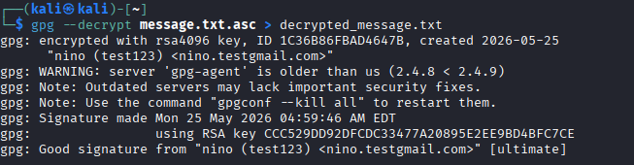

Reflection

Difference between encryption and signing
Encryption protects confidentiality, while digital signing confirms authenticity and integrity.

Role of public and private key
The public key is used for encryption, while the private key is used for decryption and signing.

What happens if the encrypted file is modified?
If the encrypted or signed file is modified, the signature verification will fail and integrity cannot be confirmed.

