PG MITM Attack Simulation
Key Generation
Three GPG keys were created for:
- Alice
- Bob
- Mallory
gpg --full-generate-key
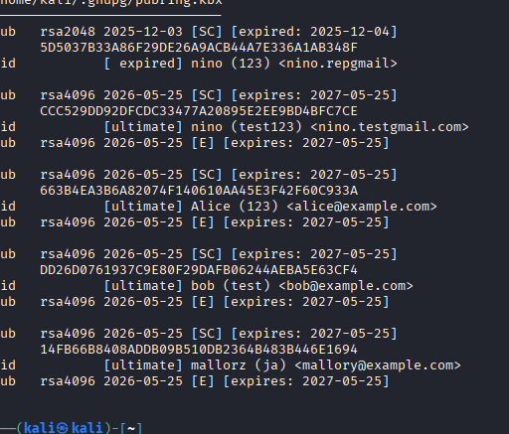

Fingerprint Verification
Fingerprints for all keys were displayed using:
gpg --fingerprint
Fingerprints are important because they uniquely identify a public key.

MITM Attack Simulation
Mallory exported her public key and renamed it as Bob’s public key.
Alice imported the fake key and encrypted a message intended for Bob.
However, the message was encrypted using Mallory’s key, allowing Mallory to decrypt the message successfully.
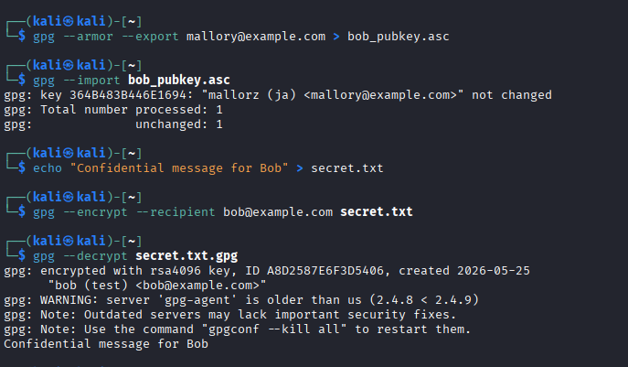

Reflection

Why doesn’t GPG detect MITM attacks automatically?
GPG cannot automatically verify whether a public key truly belongs to the claimed person.

What is a fingerprint and why is it important?
A fingerprint is a unique identifier of a public key. It helps verify the authenticity of the key.

Why is email not secure for exchanging keys?
An attacker can intercept or replace public keys during transmission.

How does the Web of Trust reduce MITM risks?
The Web of Trust allows users to verify and trust keys through trusted signatures and fingerprint verification.

