Secrets Management using GPG
Preparing Secrets
A file containing API keys and passwords was created.
cat secrets.env
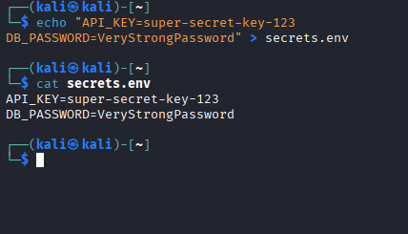

Encrypting Secrets
The secrets file was encrypted using GPG symmetric encryption.
gpg -c secrets.env
The original file was removed after encryption.

Decrypting Secrets
The encrypted secrets file was successfully decrypted using GPG.
gpg -d secrets.env.gpg
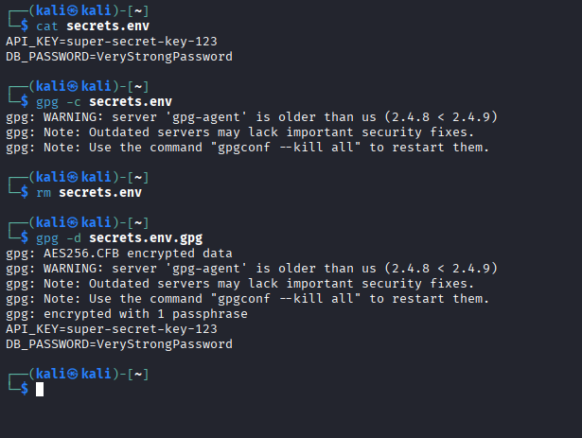

Reflection
Why don’t secrets belong in source code?
Secrets in source code can be leaked through repositories or accidental exposure.

Difference between symmetric and asymmetric encryption
Symmetric encryption uses one shared password, while asymmetric encryption uses a public/private key pair.

What happens if we lose the private key?
Encrypted data can no longer be decrypted.

How would this be handled in a larger enterprise?
Large companies use centralized secrets management systems, access controls, encryption, and secure key storage.

