This post was published to Azure Office Companion at 18:23:34 10/02/2019

Aziverso Billing Params

Account Azure Office Companion

Billing Params

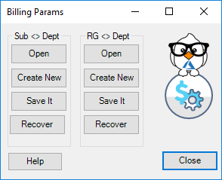

# Introduction

Azure Subscription and Resource Groups can be organised by Department, the billing parameters are necessary to calculate the costs by Departments.

# Functionalities

Subs <> Dept (Subscription by Department)

* Open: Open an existing Sheet Configuration
* Create New: Create a new Sheet.
  + The tool downloads all the subscription in the Azure account, set the column department to organize the subscriptions
* Save It: Save the Sheet (the sheet name must be **ParametersSD**)
* Recover: Recover the last copy of the sheet from the local HD.

RG <> Dept (Resource Groups by Department)

* Open: Open an existing Sheet Configuration
* Create New: Create a new Sheet.
  + The tool downloads all the RG from all the subscriptions selected in the Azure account, set the column department to organize the RG
* Save It: Save the Sheet (the sheet name must be **ParametersRD**)
* Recover: Recover the last copy of the sheet from the local HD.