Aziverso Enlist

Account Azure Office Companion

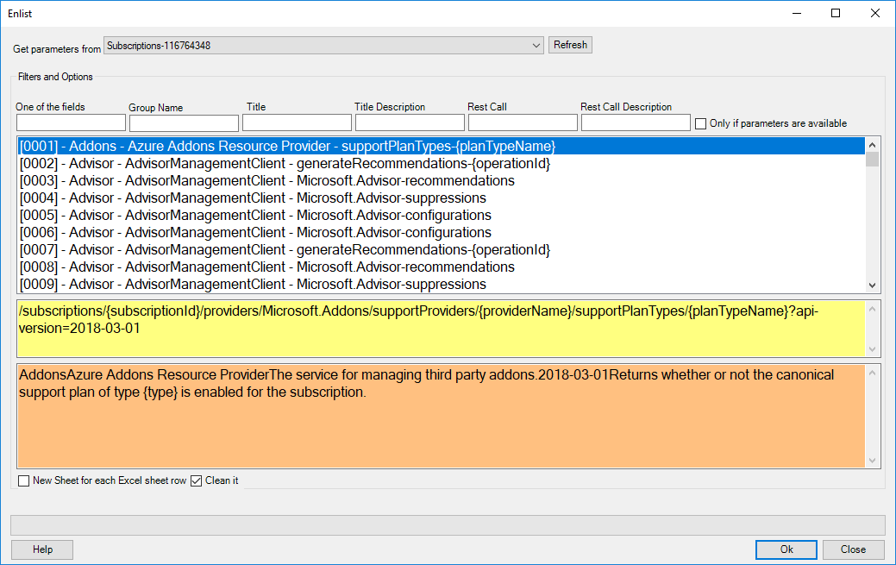

# Introduction

With Enlist form we have different ways and options to enlist Azure resources.  
Aziverso provides the possibility to call **1533** API calls and we can search the API call using many search options.

# Functionalities

**Get parameters from**  
The API call can get the value of the parameters from any active Excel Sheet, using this combo we can select which one we want to use to retrieve these parameters.  
Aziverso will execute one API call for each row and it will use the parameters present in the row.

For example:

Let say that we’d like to call some Azure APIs and passing the subscription id to them.  
Click on Subs to retrieve all our subscriptions

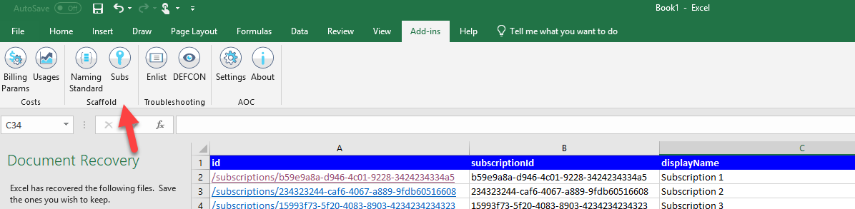

Click on Enlist and open the Enlist Form

Select the Excel sheet to retrieve our data for the API Call.  
Search for virtualmachine in any of the fields, we can also specify for specific fields.  
Check **Only if parameters are available** checkbox to retrieve only the API calls that we will be able to execute using this Excel Sheet, this filters all the API calls and makes our search very easy.

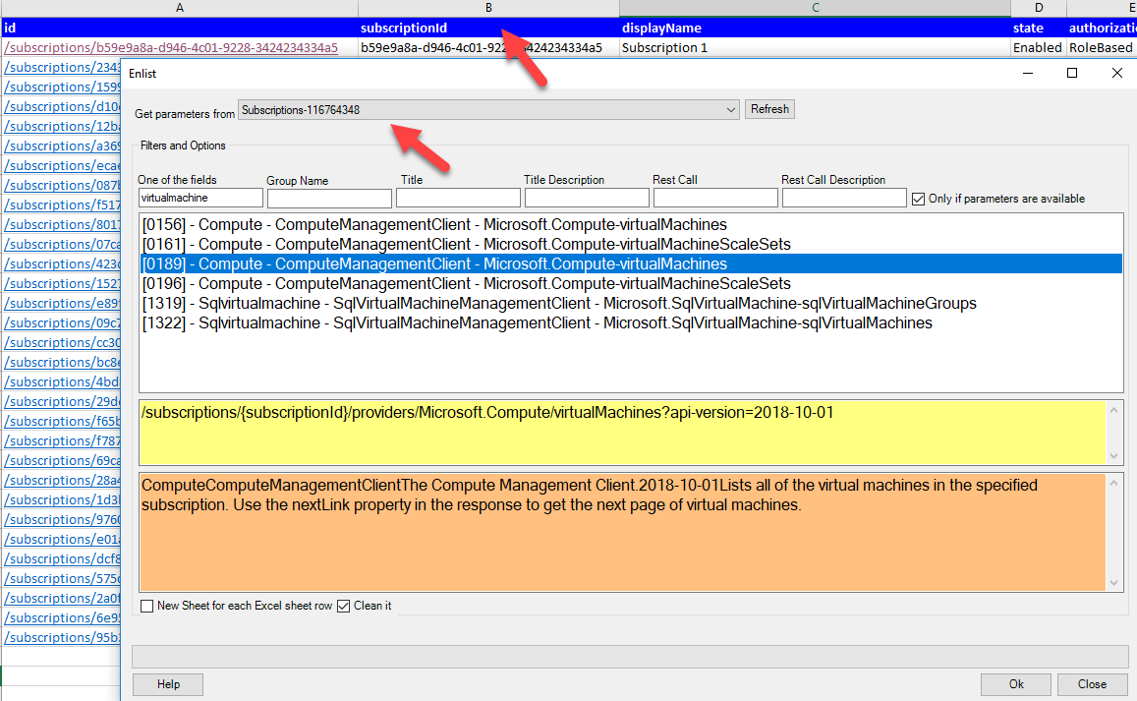

Select the API call 0189 and click Ok.

retrieve all virtual machines and all in our subscriptions.  
we can use multiple parameters from other Excel Sheets.

**Filters and Options**

* Writing in each textbox we can search for a word in one of the specific fields, the textbox [One of the fields] searches in OR, the other are filtering in each field by AND.
* New Sheet for each subscription: creates a new Excel sheet for each subscription selected
* Clean it: perform an intelligent cleaning of all the data (some API return a lot redundant data, it is recommended to keep this option checked)

|  |  |
| --- | --- |
|  | The column id is always present, and it is the direct link of the resource to the Azure Portal. Click on the link to directly access to the specific resource |

After we can use the DEFCON feature to execute more complex searches and troubleshooting.