Aziverso Heuristic

Account Azure Office Companion

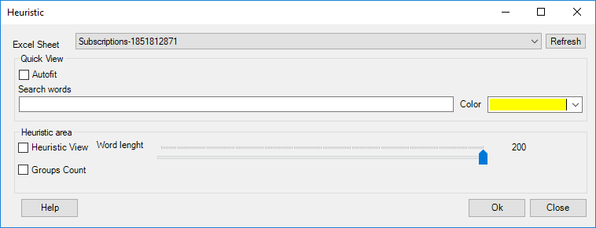

# Introduction

Aziverso offer many ways to perform advanced troubleshooting using heuristic views, group counts and searches.  
Select the Excel sheet you want to apply the rules and execute your rules.

|  |  |
| --- | --- |
|  | **The feature can be used in any Excel Sheet selected, even created by the Azure Portal.** |

# Functionalities

**Quick View**

The Autofit will fit all Excel columns, you can do the same in Excel or directly from here.

Write a word in the search box to highlight all fields containing that word and using the colour you selected.  
Aziverso will also add a new column that you can use to filter all rows, this is extremely useful to limit our working area.  
We can use multiple colours in multiple columns, below you can see an example using two simple searches using the words D4s in yellow and A3 in Red.

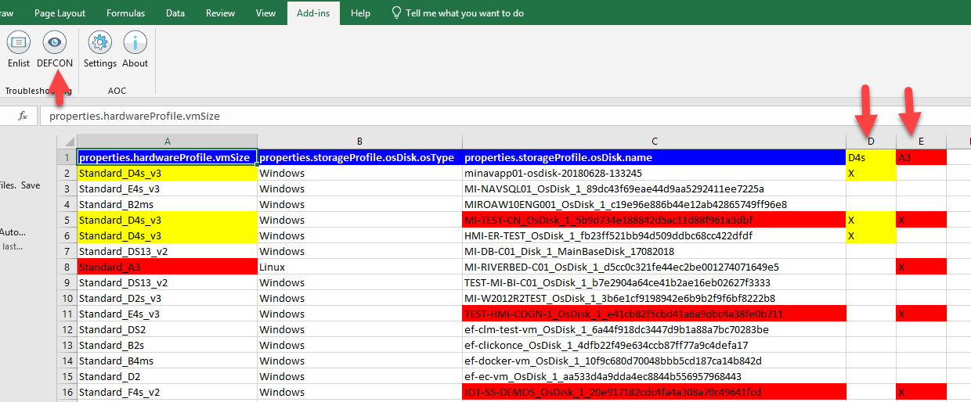

We can also use the Excel filter option to limit our working area, see below the filter applied for the D4s

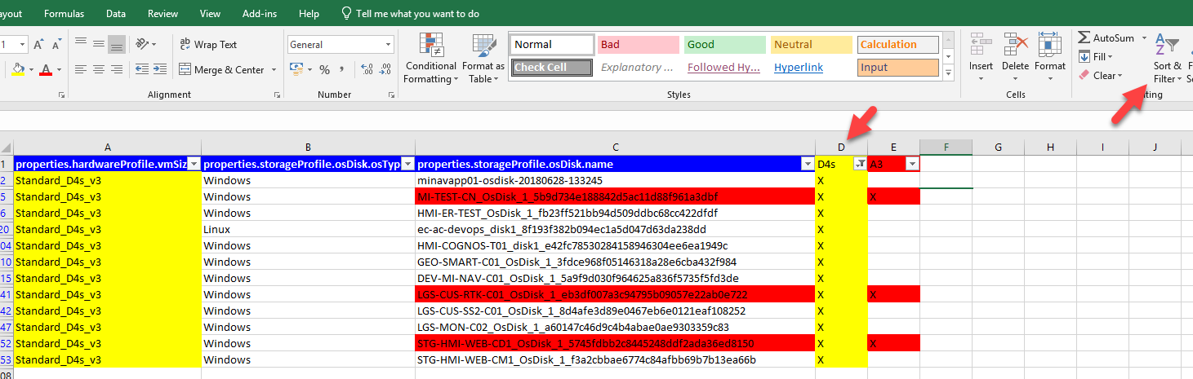

**Heuristic area**

Check Heuristic View to enable this powerful feature.

The Heuristic View performs an intelligent scanning to highlight different cases, more detail below in the section [Heuristic View].

Groups Count: create a new sheet with all data counted and by different groups, more detail below in the section [Groups Count]

|  |  |
| --- | --- |
|  | The column id is always present, and it is the direct link of the resource to the Azure Portal. Click on the link to directly access to the specific resource |

# Heuristic View

The heuristic view provides an intelligent view about the results, it is very useful in many cases, especially during troubleshooting, a simple example below.

The picture below is a result of the list of the recommendations in a subscription, thanks to the heuristic view we can immediately see the similar and the most critical.  
This feature is very useful in case of a many recommendation and multiple subscriptions.

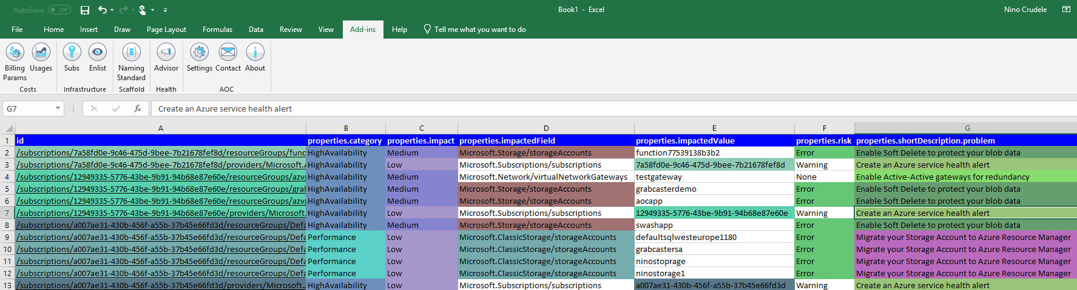

|  |  |
| --- | --- |
|  | The column id is always present, and it is the direct link of the resource to the Azure Portal. Click on the link to directly access to the specific resource |

The picture below is a result of the list of the virtual networks in a subscription, thank to the heuristic view you can immediately see that two virtual networks are using the same IP schema.

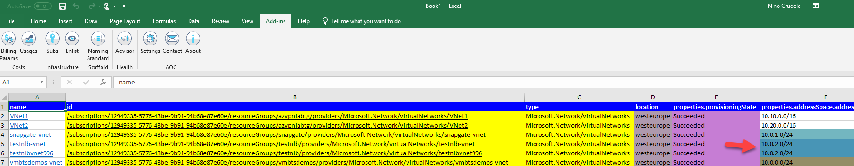

This is tremendously useful also in case of multiple subscription and check any overlapping before peering.

Another example is the list of the setting of the Network security group, thank you the heuristic view below, you can immediately see and filter who is using the same setting or port number, even if they use different rule name.

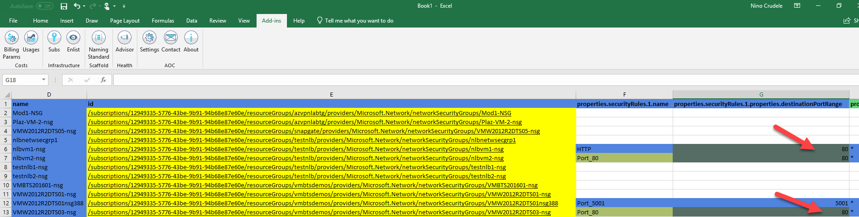

This feature can be used for a lot of different scopes.

# Groups Count

The Group Count provides a very useful view related to the amount of resources.

The example below provides me many important information about the subscription very quickly like, the number of same category and same impact.

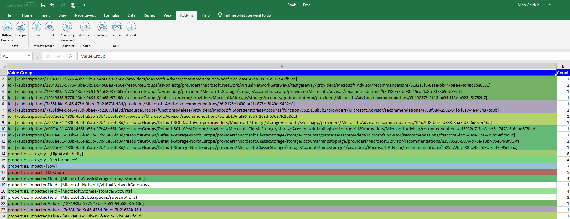

The example below provides me many important information about the subscription very quickly like, the number of subnets, the number of VNet with same IP schema, number of resources by region.

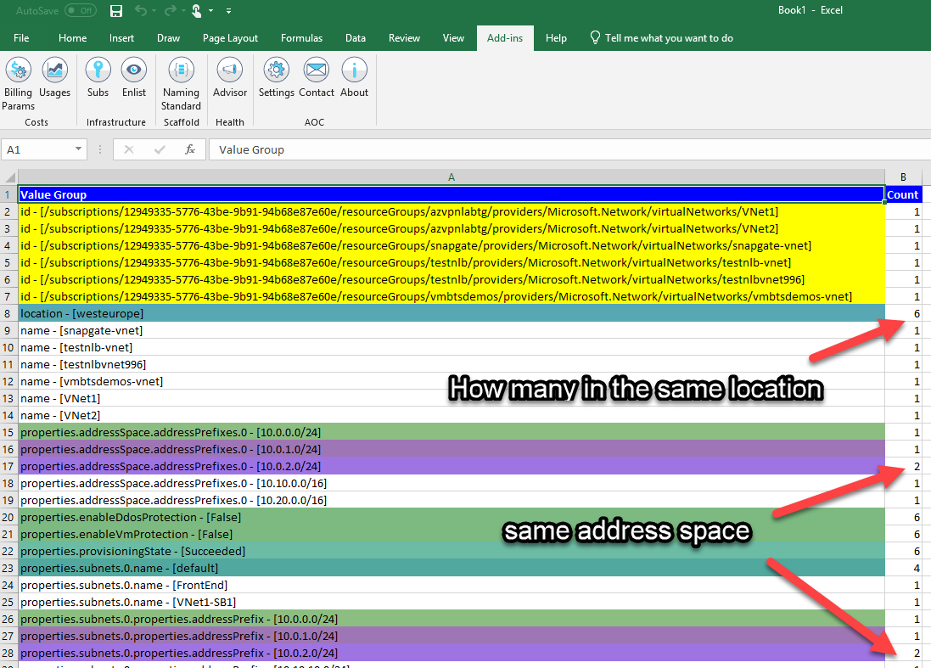

The same concept can be used for many other useful scopes, below you can see the result by Virtual Machine.  
I can immediately see how many VM of a specific tier I have in the subscription, how many are Windows 2012 R2, and more.

