Aziverso Naming Standard

Account Azure Office Companion

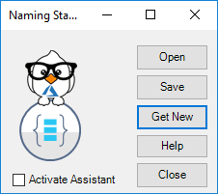

# Introduction

Naming Standard form provides or generate a new naming standard sheet.

# Functionalities

Filters and Options

* Open: open an existing naming standard.
* Save: save the naming standard.
* Get New: Download the last update of the naming standard sheet template, after downloaded it is possible to change and save our own naming standard.  
  The local ns.xlsx is in the Aziverso application folder.
* Activate Assistant: activate the naming assistant.

|  |  |
| --- | --- |
|  | The naming standard template is constantly update by the author, feel free to collaborate on extending it. |

# About naming standard and the matrix

The naming standard is a pillar of the Azure scaffold, the using of a good naming standard enable the team of improving the productivity, identify resources faster in the portal, on a bill and in within the scripts.

Governance is a crucial area of Azure and the implementation of a correct enterprise scaffold depend by a consolidate naming convention and by a correct relationship between all the components.

The pillars of the Azure Scaffold are below:

* Account/Enterprise Agreement
* Azure Policy & Audit
* **Naming Standards (Current Guide)**
* Subscriptions
* Roles Based Access Controls
* Azure Security Center
* Resource Groups
* Azure Automation
* **Resource Tags (Current Guide)**
* Resource Locks

The adoption of a naming standard from the starting it is important because it is very difficult change the name of a resource or component later.

**Note**

The Team is already partially adopting a naming standard and resources and components has been created, the guide will keep these standard where possible to avoid any renaming.

It is important to understand that the Azure scaffold is the highest representation level of Azure, the scaffold hierarchy is the highest level and can be represented as below.

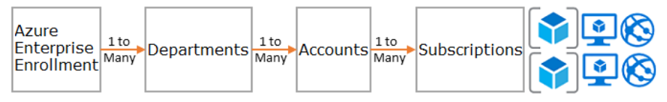

The hierarchy can be organized using three different patterns,

* **Functional** pattern
  + Enterprise
    - Enterprise Agreement
      * Department
        + Finance

Accounts

Owner

Subscriptions

Project 1

Project 2

* + - * + IT

Accounts

Owner

Subscriptions

Project 3

* **Business unit** pattern
  + Enterprise
    - Enterprise Agreement
      * Department
        + Auto

Accounts

Owner

Subscriptions

Application 1

Application 2

* + - * + Aerospace

Accounts

Owner

Subscriptions

Application 3

* **Geographic** pattern
  + Enterprise
    - Enterprise Agreement
      * Department
        + America

Accounts

Owner

Subscriptions

Project 1

Project 2

* + - * + Europe

Accounts

Owner

Subscriptions

Project 3

A mixed or a specific pattern can be used in relation with the business, functional or geographic requirement.

The using of a single pattern in any type of scenario is not recommended.

# The matrix

To use the Naming Standard click on Add-ins and Naming Standard

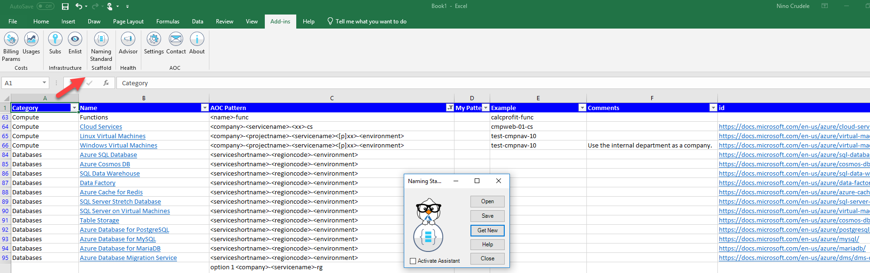

The Naming Standard Matrix is the Excel spreadsheet used to navigate across the naming patterns.

The Spreadsheet is organized by columns, below the description.

* Category
  + Contains the main Azure categories, like Subscription, Resource Group, Compute, Storage and more.
* Name
* The name of the specific Azure component related in the Category, for example Virtual Machine, Function App, Subnet and more.
* Aziverso Pattern
  + Naming pattern proposed by Aziverso.
* My Pattern
  + Our alternative pattern.
* Example
  + An example of using
* Comments
  + Comments related to the specific pattern
* Id
  + Link to the documentation, the same link is also used by the column name.

## How to use it

Aziverso provides two ways, one is using the Excel sheet manually and the second is using the Naming Assistant.

Using the Naming Assistant

This is the fastest and recommended way.

|  |  |
| --- | --- |
|  | Know issues:  First search is a bit slower because first connection to the Azure Storage. If the Assistant doesn’t appear try copy something different and do it again. |

Check the Naming assistant in the window.

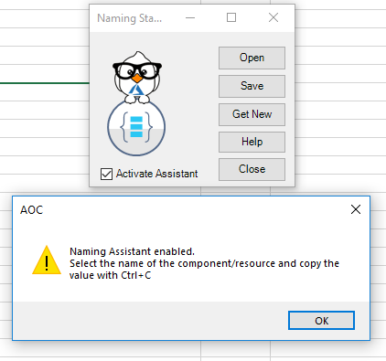

Now the assistant is enabled, and as an example we assume we want to create a Virtual Machine, below how it works.

Go in your Azure Portal and search for Virtual Machine  
Now select a relevant word like virtual machine and click Ctrl+C

The Assistant will show up with all best patterns to use, we select the most appropriate, in this case Virtual Machine.

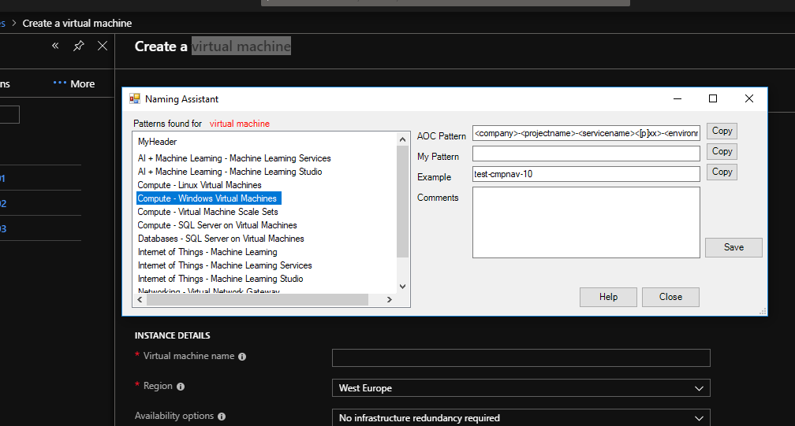

Click copy to put the pattern in the clipboard.

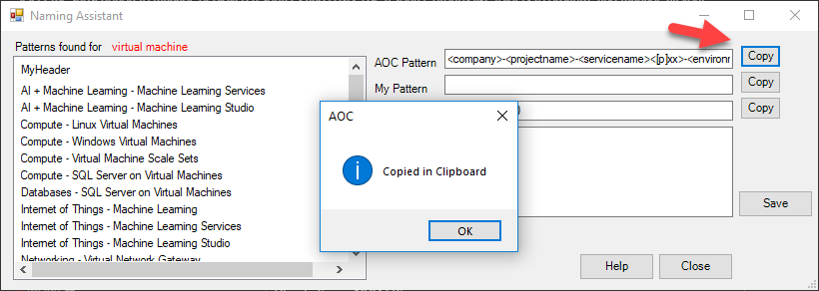

Change the pattern valuese with our values.

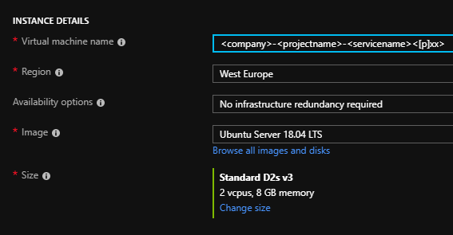

**Update from the Assistant Window**

We can update the values in the Naming Standard directly from the Assistant Window or from the Excel Sheet.

To update the values from the Assistant Window, select the naming pattern and add your a comment or add your pattern and click save, below an example.

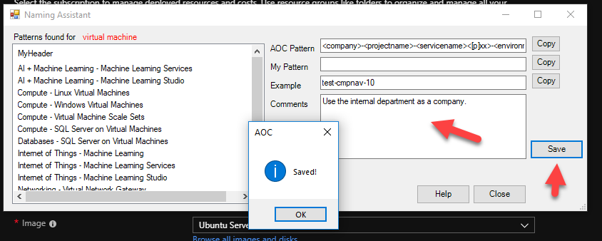

Now the information as been updated and all is aligned, see below.

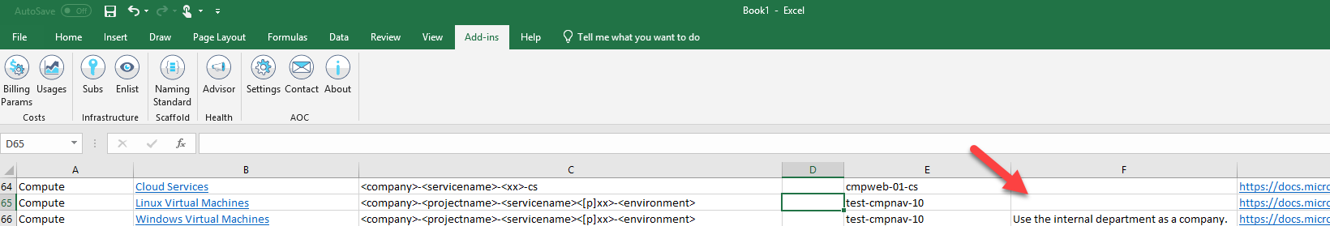

**Update from the Excel Sheet**

We can add and update the values in the Naming Standard directly from the from the Excel Sheet.

Open the Naming Standard Sheet.

To update the values from the Excel Sheet, select the naming pattern and add your comment or add your pattern.

Now to save, click on Naming Standards and click save, below an example.

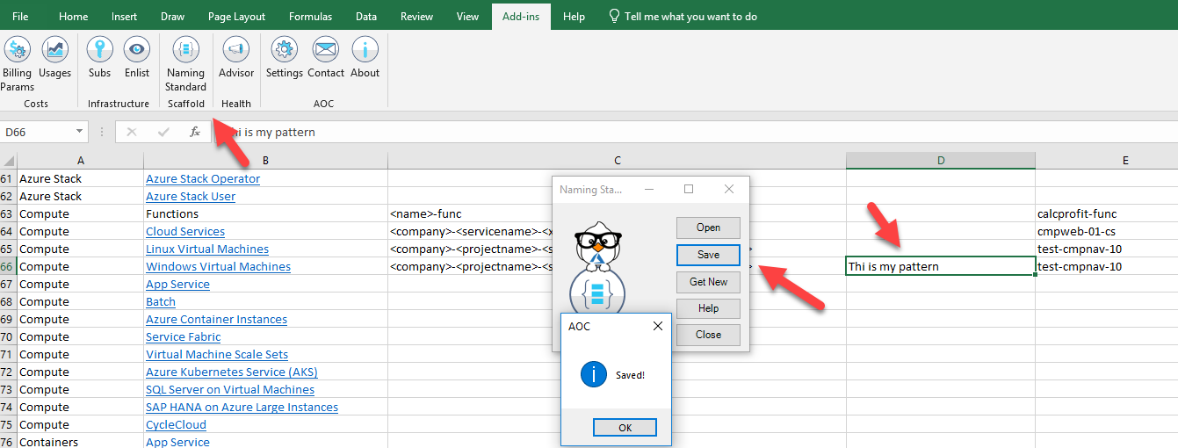

Manually using the Excel Sheet

To find a naming standard select a filter option or use the search option, below an example to work with Virtual Machine.

Select the Compute category.

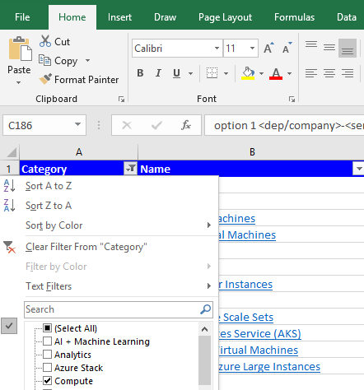

You can scroll the Compute components or directly select Virtual Machines

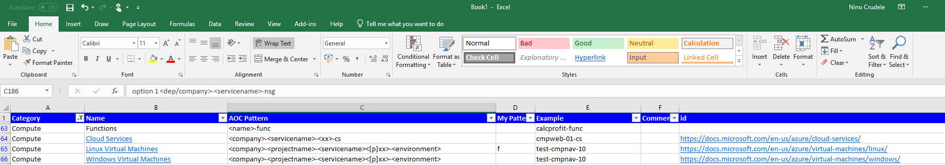

When available you can also click on the name to open your browser to the specific MSDN topic.