Aziverso Settings

Account Azure Office Companion

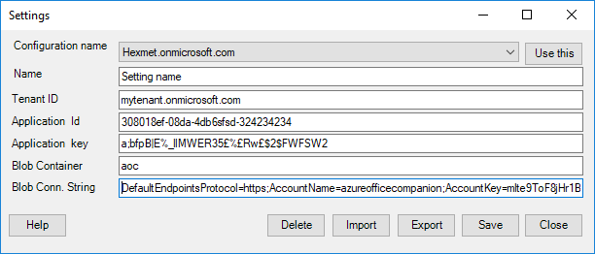

# Introduction

Settings form provides all application settings.  
At the first start Aziverso will require to create the first setting, to create the new setting refer to the [How To section](http://azureofficecompanion.com/how-to-setup-azure-office-companion-2-0) in the web site or the link below.

<http://azureofficecompanion.com/how-to-setup-azure-office-companion-2-0>

# Functionalities

* Use this button, select the configuration you want to use and click the button to apply it, Aziverso will use this setting from now.
* Name: this is the name of the configuration, you can change the name and click save to directly create a new configuration clone and setting.
* Tenant ID: Your azure tenant ID
* Application Id: the application id used by the Aziverso in AD.
* Application key: the application key used by Aziverso in AD.
* Blob Container: the blob container used by Aziverso
* Blob Conn. String: the blob connection string used by Aziverso

|  |  |
| --- | --- |
|  | The full video explaining how to retrieve these parameters is available at <https://www.youtube.com/watch?v=xBan-wADO7g> |
|  | **Aziverso requires read access only.** |