Aziverso Costs Usage

Account Azure Office Companion

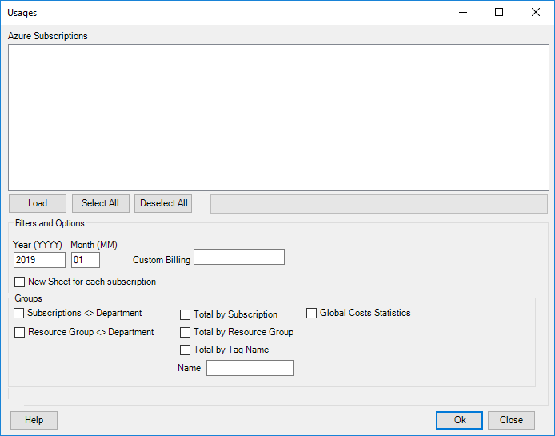

# Introduction

Usages form provides different ways and option to calculate costs and statistics, a single or multiple subscription can be selected.

|  |  |
| --- | --- |
|  | All options work selecting a single or multiple subscription. |

# Functionalities

Filters and Options

* Years: insert the year using the format YYYY
* Month: insert the month using the format MM
* Custom Billing: in some cases, a subscription can provide just some specific billing periods like 201811 or 201811-1, in that case we can override the pattern writing the value directly in this textbox.
* New Sheet for each subscription: creates a new Excel Sheet for each subscription.

Groups

* Subscriptions <> Department: return the costs group by subscriptions and departments plus the cost detail for all subscriptions selected
* Resource Group <> Department: return the costs group by resource groups and departments plus the cost detail for all subscriptions selected
* Total by Subscription: return the total costs for each subscription selected
* Total by Resource Group: return the total costs group by resource group for all subscriptions selected
* Total by Tag Name: return the total costs group by tag for all subscriptions selected
  + Name: the tag name to use
* Global Costs Statistics: provide different views and useful statistics for all subscriptions selected:
  + Group Product: the total cost by product type
  + Group Sku-Prod. : the total cost by SKU, critical information we need to provide to Microsoft about spending and discount.
  + Group Service: the total cost by service
  + Group Region: the total cost by region
  + Group Location: the total cost by location
  + Group Dtg.: the cost detail group by product