**SYSTEMS THINKING**

**Course Content:**

1. Introduction to Systems Thinking
2. Natural Systems: Global Warming
3. Health Systems: Obesity Epidemic
4. Economic Systems: Great Depression
5. Security Systems: International Terrorism
6. Social Systems: Poverty
7. Political Systems: Corruption I
8. Human Systems: Overpopulation
9. Labor Systems: Unemployment
10. Marketing Systems: Fake Advertising
11. Financial Systems: Bankruptcy
12. Operations Systems: product Recall
13. Human Resource Systems: Layoff
14. Project: Class Presentation
15. **Introduction to Systems Thinking**

Making Decision In Such a Complex Web Of Interaction

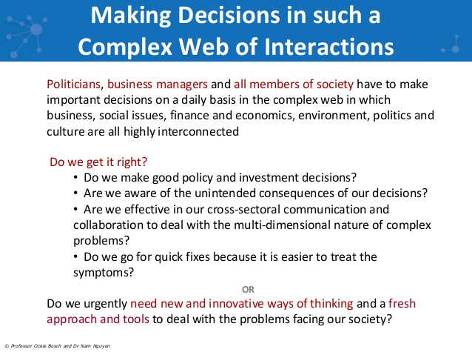

Systems Thinking has grown into wide spread use because it offers people a way to approach complex and persistent problems more effectively. By contrast the sense of urgency in organizations to fix problems quickly has led people to take short-sighted actions that result in unintended, adverse, and sometimes devastating effects. It is not unusual for people to acknowledge that they seem to be solving and re-solving the same problems over and over again.

* Systems thinking is a holistic approach to analysis that focuses on the way that a system's constituent parts interrelate and how systems work over time and within the context of larger systems. The systems thinking approach contrasts with traditional analysis, which studies systems by breaking them down into their separate elements. Systems thinking can be used in any area of research and has been applied to the study of medical, environmental, political, economic, human resources, and educational systems, among many others
* Systems thinking is your ability to see things as a whole (or holistically) including the many different types of relationships between the many elements in a complex system.
* Systems thinking is easy for some and difficult for others. Some people intuitively think in systems terms and have done so their entire lives. However, most people today think in linear, reductionistic, and mechanistic terms.
* Systems thinking is a language and set of tools meant to illuminate our thinking about how the systems we are all part of actually operate. Built into this language are important core principles about how systems function:

**System Defined**

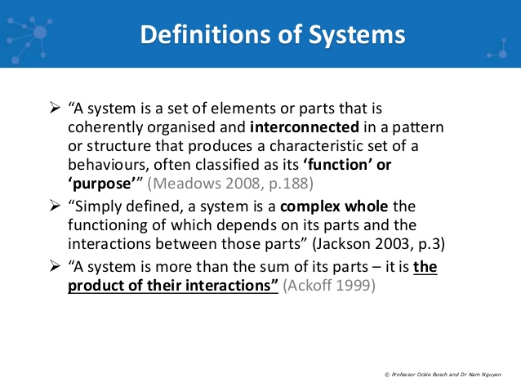

A system must consist of

* Elements or parts
* Interconnection Interaction
* Function and purpose

Examples

Business, disgestive system, city, corporation

**Systems Thinking Defined**

* System Thinking is a way of looking at, learning about, and understanding a complex situation
* Systems Thinking is a way of seeing and talking about reality that helps us better understand and work with systems to influence the quality of our lives
* A new way of thinking to understand and manage complex problems

**Why Systems Thinking**

* It can bolster your ability to think holistically about what’s happening—and to seek structural, not event-level, solutions in the face of your toughest challenges.
* It can help you uncover your assumptions—both the ones that have made you successful and the ones that have worked counter to your goals—and understand how strategies work and why.
* It can show you how to identify and avoid unintended consequences.
* It can strengthen your ability to capitalize on learning opportunities, which increase during times of change.
* It can increase your capability to look at a situation from multiple points of view, enabling you to determine the highest leverage actions and opportunities.
* It can sensitize you to the crucial role that productive conversations and high- quality interactions play in the processes of team-building and continuous learning.
* It can offer you a practice field to test various strategies against alternative future scenarios.
* It can prepare you for the next upswing, by giving you the opportunity to evaluate your current business to make sure you’re doing all you can to protect yourself now and uncover counterproductive strategies that were masked by the growing economy.

1. broadening our thinking and in new and different ways.
2. minimize its severity or even use it to our own advantage.
3. Systems thinking therefore allows us to make informed choices.
4. The tools TOOLS identifying, describing, and communicating your understanding of systems, particularly in groups.

Why Systems Thinking

* Technological Developments
* Increasing Conflicts
* Global Information Exchange
* Social and Political Developments
* Differentiation of Customer Needs
* Disruption at the Value Chain
* Social Responsibility
* Climate and Environmental Changes

Current Issues

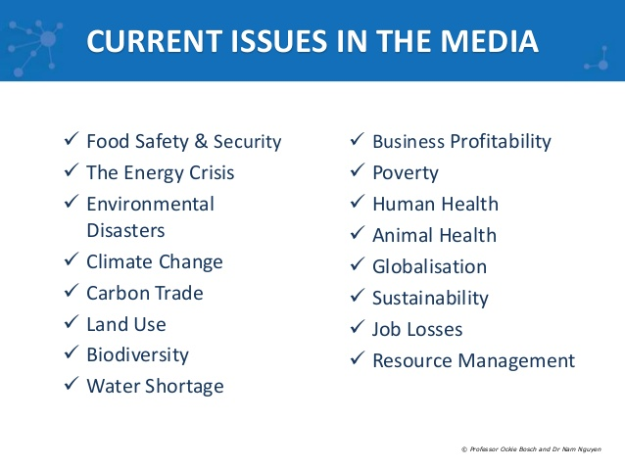

**Interconnectedness**

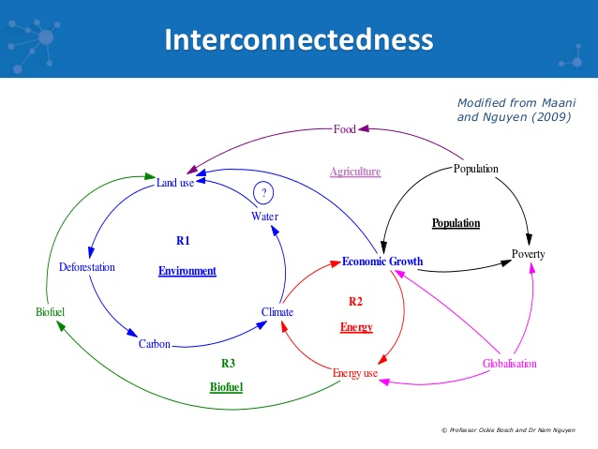

Application of Systems Thinking

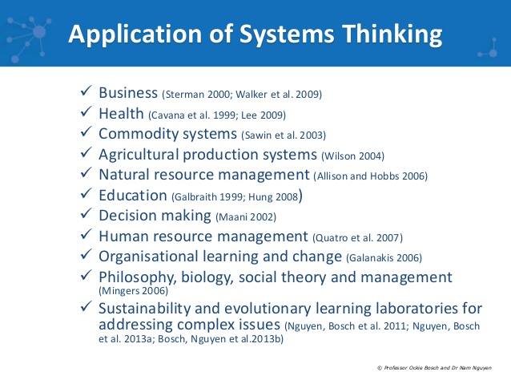

Symptom or Problem?

At first when people start thinking in systems, they can find things to be a bit chaotic. They become overwhelmed by the number of variables and think, “How can I do anything if I don’t know what effect my intervention will have?” This kind of thinking is normal and usually gives way to a sense of deeper insight as an individual begins to learn various principles of systems behavior. We hope the ideas in this article offer a first step toward that kind of understanding.

Adopting a systems approach takes persistence and curiosity. Being the sole systems thinker in a linear thinking organization can be a lonely place. People will not understand you. You’ll feel like you’re walking around with two heads… whenever you talk, people will stare at you, confused.

One way to start to shift from linear to systems thinking is to practice identifying whether something is the problem or merely a symptom of something deeper. Linear thinking tends to focus on addressing surface-level behaviors – or symptoms. Unfortunately, making a symptom go away won’t solve the problem. In fact, it may make things worse and cause effects in other parts of the organization. A manager taking a systems thinking approach will work to understand the underlying problem before addressing any of the symptoms. Usually, if the true problem is solved, the symptoms will be eliminated as well.

Below are eight clues that what you are experiencing is an indicator of a larger problem rather than the problem itself:

* **The Size of the Problem Isn’t Commensurate with the Discussion Around It.**

Is the problem too small in comparison to the time and energy it is taking? If people are spending all their time, for example, complaining about the color of the carpet or the shape of their offices, you can assume that their reaction is a symptom of another problem.

* **People Don’t Solve a Solvable Problem.**Is it within the power of the people in your organization to solve the problem, but they don’t? For example, people complain there is no decaffeinated coffee, but no one does anything about it. Why don’t they feel empowered to change the status quo?
* **The Problem Won’t Go Away.**What has the history of the problem been? Is it something that won’t go away? Have you tried to solve it and have been unsuccessful? Does it keep coming back, like a monster in a horror movie? Does the problem morph into a related issue once you “solve” the original issue? Generally speaking, if you “solve it” and it comes back, then you haven’t addressed the underlying problem.
* The Problem Involves Emotional Barriers.

They were unwilling to do it because it hadn’t been done before. Sailors never even considered it a possibility. As such, it was an emotional barrier, a product of stunted imagination.

* **The Problem Has a Pattern.**Does the problem have an annual cycle? Is it predictable? If so, it may be a symptom of something deeper.
* **The Organization Has Kept the Problem Around, like a Pet.**In a healthy organization, if a problem arises, people solve it once and for all. Unhealthy organizations need problems because they give people something to focus on and fuss about.
* **Other Stresses and Anxieties Are Present in the Organization.**The more anxiety in an organization, the more likely it is that real problems are hidden, manifested only in symptoms.
* **As One Problem Is “Solved,” Another Crops Up.**In an organization that relies on reactive, quick-fix, cause-and-effect management, once one problem is solved, another tends to crop up. Most linear thinkers won’t realize that the two issues are related.

## Ten Enemies of Systems Thinking

The ten statements below are usually evidence of linear thinking and, thus, enemies of systems thinking. Hearing them is not always a sure-fire guarantee that linear thinking is coming, but they should set off warning bells.

1. **We’ve got to fix it quick!**This is the proverbial “quick-fix” mentality. We see a problem, and we react to fix it before we really understand it. Short-term quick fixes almost always harm long-term sustainability.
2. **“Oh, let’s just put a bandage on it.”**The bandage solution is often a half-hearted attempt to fix a problem. The danger is that it can cover up the worst of the symptoms while allowing the problem to continue to fester.
3. **“We must make the budget by the end of the fiscal year!”**Budgets are notoriously linear. They force us to make decisions based on money rather than on whether the idea is good.
4. **“We need to respond immediately!”**Knee-jerk reactions and panic attacks, borne out of anxiety and learned helplessness, create linear solutions. A calm, reasoned strategy offers a more systemic way to address a situation. This does not mean acting slowly; it means taking a moment to consider the different variables that contribute to a situation.
5. **“Who cares?”**An apathetic approach, or a plain lack of curiosity, is a barrier to effective problem solving. Curiosity, play, imagination, and adventure are the antidotes to stuck organizations.
6. **“We need more information.”**There is nothing wrong with seeking more information, unless we believe it will solve the problem for us. Additional data is good when we know its place. We – not information -have the power to act. And we – not information – must have the courage to do so.
7. **“Oh, you’re just thinking too much.”**Shallow and superficial thinking is everywhere – just watch the nightly news. All of the complex problems of the world are boiled down to a few sound bytes. The accusation of “thinking too much” usually means “Stop thinking differently from me.” The reality is that systems thinking is a new kind of thinking, and not everyone likes to stretch in new ways.
8. **“To hell with the rest of the organization; we must get our own needs met.”**Many people in organizations hold this kind of fortress mentality. In our companies and schools, we live in bunkers, protecting our own needs and the resources of our unit. Consequently, we end up thinking of win-lose strategies and strategizing about how to get more for ourselves. This approach is classic linear thinking.
9. **“We can’t have any conflict.”**Some of us will do anything to keep the peace in our organizations. Edwin Friedman calls this “peace-mongering.” Peace-mongers will avoid, suppress, and mask conflict, at the expense of discussing and addressing real issues.
10. **“You will do it this way, and you will enjoy it!”**Authoritarian managers who force their will on the workforce are prime examples of linear thinkers. Wisdom is collaborative, and domineering interventions undermine innovation, collective problem solving, and creativity.

**When Should We Use Systems Thinking?**

Problems that are ideal for a systems thinking intervention have the following characteristics:

1. The issue is important.
2. The problem is chronic, not a one-time event.
3. The problem is familiar and has a known history.
4. People have unsuccessfully tried to solve the problem before.

**Where Should We Start?**

avoid assigning blame

Instead, focus on items and try to arouse the group’s curiosity about the problem.

iceberg three angles: events, patterns, and structure

get different perspectives in order to make sure that all viewpoints are represented and that solutions are accepted by the people who need to implement them.

**How Do We Use Systems Thinking Tools?**

Causal Loop Diagrams.

First, remember that less is better. Start small and simple; add more elements to the story as necessary. Show the story in parts. The number of elements in a loop should be determined by the needs of the story and of the people using the diagram. A simple description might be enough to stimulate dialogue and provide a new way to see a problem. In other situations, you may need more loops to clarify the causal relationships you are surfacing.

Also keep in mind that people often think that a diagram has to incorporate all possible variables from a story; this is not necessarily true. In some cases, there are

* external elements that don’t change,
* change very slowly, o
* r whose changes are irrelevant to the problem at hand.

You can unnecessarily complicate things by including such details, especially those over which you have little or no control.

Some of the most effective loops reveal connections or relationships between parts of the organization or system that the group may not have noticed before.

And last, don’t worry about whether a loop is “right”; instead, ask yourself whether the loop accurately reflects the story your group is trying to depict. Loops are shorthand descriptions of what we perceive as current reality; if they reflect that perspective, they are “right” enough.

11 Key Principles Of Systems Thinking.

1. **Everything is interconnected:** We live on a closed ecosystem called planet Earth where everything is connected to everything else. Otherwise, it ceases to survive and thrive.
2. **The easy way out often leads back in:** If the solution were easy then it should have already been found.
3. **Today’s problems are yesterday's solutions:** We need to make sure we don't accidentally create tomorrow problems through today's solutions.
4. **There is no blame in complex systems:** Everything is interconnected. Thus, it's impossible to ever find one culprit for a problem. Systems have both the issue and the solution embedded within.
5. **Parts are elements of a complex whole:** Everything is part of something else; there are no isolated elements in a complex system.
6. **There are no simple solutions to complex problems:** We need to embrace complexity in order to truly address complex issues. Otherwise, we just deflect the problem to somewhere else in the system.
7. **Small, well-placed interventions can have big impacts:** A well-designed, small intervention can result in significant and enduring systems change if it is in the right place – this is called a leverage point.
8. **Humans make linear systems – nature makes circular ones:** We can learn to create regenerative products and services through understanding nature's design principles.
9. **Time changes complexity:** Over time, things naturally get more complex. Simplicity and efficiency are very different things, yet we always think we can oversimplify complexity or reduce it down to the sum of its parts.
10. **‘Failure’ is discovery in disguise:** If there is no blame, then there is always an opportunity to discover through failure.
11. **Cause and effect are not related in time nor space:** There is a mismatch and often a delay in the relationship between the cause of a problem in complex systems and the result (or symptom) appearing obvious.

**What Is 'Systems Thinking' in Business?**

The term "systems thinking" refers to a management and operations approach where single business decisions are analyzed based on the systematic consequences they have. If a company invests in a new computer software program, for instance, systems thinking leads to an analysis of the additional infrastructure, employee hiring and training and business delay costs that would result.

**Pros and Cons**

Thorough analysis of all of the potential costs and benefits of a business decision or activity can help you avoid wasted expenditures. Fast Company article noted that it hasn't really been a successful business process. Promising in theory, a systems perspective can impede a company's creativity, originality and design capabilities. It creates an environment where all decisions require thorough theoretical analysis and risk-taking is less prevalent.

**Theory and Model**

System thinking is a major departure from the old way of business decision-making in which you would break the system into parts and analyze the parts separately. Supporters of system thinking believe that the old way is inadequate for our dynamic world, where there are numerous interactions between the parts of a system, creating the reality of a situation.

According to system thinking, if we examine the interactions of the parts in a system, we will see larger patterns emerge. By seeing the patterns, we can begin to understand how the system works. If the pattern is good for the organization, we can make decisions that reinforce it; but if the pattern is bad for the organization, we can make decisions that change the pattern.

**Building Solutions**

Organizations employing a systems approach to sustainability and organizational change gain a more evolved understanding of how things are interconnected.

This helps develop creative, divergent, and effective ways to rapidly build solutions that have positive impacts.

Here are seven exciting outcomes that you gain from applying systems thinking to personal and professional activities:

**Optimization:**With a deeper understanding of the dynamics within a system, optimization is an emergent outcome of systems thinking. It allows organizations and individuals to take full advantage of any element within their system.

**Problem Loving:** Rather than avoiding complexity, systems thinking helps individuals **discover the exciting opportunities that problems offer for innovation and creative development.** Employees become problem lovers, not problem avoiders.

**3-Dimensional Perspective:**A systems approach looks at the whole organism or ecosystem, not the individual parts. This means moving beyond the siloed ‘departments’ and developing a trans-disciplinary understanding of the macro and micro in an interconnected, dynamic way. The world is not flat – developing a holistic systems view unlocks the power of creativity.

**From Linear to Circular:** Human-produced systems are largely linear. We take things from nature, manufacture them into usable goods, and then dispose of them back into holes from where resources were extracted. This approach is reductive and inefficient. A systems approach allows for the circularizing of all products and services so that we design out waste and inefficiencies, plus create more value.

**Failure is Fun:** Since there is no blame in a system and everything is interconnected, systems thinkers get excited about discovery. This is especially true when it's learned through ‘failure,’ as it helps gain new perspectives that build our creative capacity.

**Interconnectivity:** Everything in nature is dynamically interconnected and interdependent, just as humans need each other for success. Creativity and productivity depend on interconnectivity, and systems thinking provides the tools to integrate this into everyday practices.

**Creativity:** The more you develop a dynamic understanding of the world, the more creativity your brain starts to develop. Conformity kills creativity; to overcome this crisis, systems thinking activates new neurological development and enables dynamic, divergent thinking.

**Organizations Are Open Systems**

Today, organizations exist in competitive global environments where there is strong competition for resources, markets, skilled employees, and innovations. At the same time, many organizations confront environments that are unpredictable and complex. Organizational environments are multifaceted and can be categorized in the following way:

* **The Competition:** The competitive tactics between firms in an industry or business.
* **Customers:** Includes direct sales or companies that acquire another firm's customers through outputs for resale.
* **The Technological Sector:** The development of new production techniques and methods, innovation in materials and products, and general trends in research and science relevant to the organization
* **The Regulatory Sector:** Federal and state legislation and regulations, city or community policies, and political developments at all levels of government
* **The Economic Sector:** Factors such as stock markets, rate of inflation, foreign trade balance, federal and state budgets, interest rates, unemployment and economic growth rate
* **The Sociocultural Sector:** The social values of the general population, the work ethic, and demographic trends. (Daft, Sormunen, and Parks 1988)
* First, as open systems, organizations are highly engaged with their environments. Successful organizations develop characteristics and perform processes that allow them to adapt to constraints, threats, and opportunities. They import capability from the environment.
* This capability can be achieved by acquiring another organization through a joint venture; or by improving their human and physical capital; or by obtaining the information needed to transform that capability into desired outputs such as physical goods, services, or a focused set of monetary or operational actions.
* Next, organizations' transformation processes are cyclical in nature, that is to say they are a predictable, ordered set of processes that might be determined by a budget cycle, a sales cycle, or a growing season.
* These well-ordered processes create negative entropy, the resistance to disorganization. Negative entropy maintains the reliability of transformation processes in spite of changes in environmental conditions.
* Open systems also have environmental scanning processes that might exist in the recruiting directorate, the market
* research department, or the complaint department to provide information about the systems performance and to adjust processes within the system.
* Another feature of open systems is that they operate under conditions of dynamic homeostasis, the process of preserving the character of the system through its growth.
* Open systems use internal processes of review to modify their environmental scanning, input, .

TIPS FOR BEGINNERS

.

* Practice frequently, using newspaper articles and the day’s headlines.
* Study the archetypes Use systems thinking both at work and at home.
* Use systems thinking to gain insight into how others may see a system differently.
* Accept the limitations of being in-experienced; it may take you a while to become skilled at using the tools. The more practice, the quicker the process!
* Recognize that systems thinking is a lifelong practice

1. “systems thinking” can mean different things to different people. systems thinking is just a collection of tools and methods
2. there are consequences to our actions that we are oblivious to.  
   Systems thinking is also a diagnostic tool
3. examining problems more completely and accurately before acting.
4. In general, a systems thinking perspective requires curiosity, clarity, compassion, choice, and courage.

* At the same time, the principles of systems thinking make us aware that there are no perfect solutions;
* the choices we make will have an impact on other parts of the system

|  |  |  |
| --- | --- | --- |
| **System Defined**  A system is an entity which maintains its existence and functioning as a whole for some purpose through the mutual interaction of its parts.  **Systems Thinking Defined**  Systems thinking is your ability to see things as a whole (or holistically) including the many different types of relationships between the many elements in a complex system.  [**→**](http://kotelnikov.biz/coach/creativity_strategic_3b.html)[**3Bs*of*Strategic Creativity**](http://www.1000ventures.com/info/creativity_strategic_3b_brief.html)  *"Systems thinking is a discipline for seeing wholes. It is a framework for seeing interrelationships rather than things, for seeing patterns of change rather than static snapshots... Systems thinking is a sensibility – for the subtle interconnectedness that gives living systems their unique character." ~ Peter Senge*  **The Goal of Systems Thinking**  The goal of systems thinking is to manage the rapidly growing complexity of the worlds of business and technology. The task of a [**business architect**](http://www.1000ventures.com/info/business_architect_brief.html) and a[process manager](http://www.1000ventures.com/business_guide/ebpm.html) is to create systems, within a sensibly structured business, that [**empowers employees**](http://www.1000ventures.com/info/employee_empowerment_tao_brief.html) and enables people to achieve higher productivity and greater [**competitive advantage**](http://www.1000ventures.com/info/sca_brief.html)... [*More*](http://www.1000ventures.com/business_guide/opportunities_search.html#Balance)  **The Focus of Systems Thinking**  Systems thinking "focuses on the whole, not the parts, of a complex system. It concentrates on the interfaces and boundaries of components, on their connections and arrangement, on the potential for holistic systems to achieve [results that are greater than the sum of the parts](http://www.1000ventures.com/business_guide/crosscuttings/synergy.html). Mastering systems thinking means overcoming the major obstacles to building the [process-managed enterprise](http://www.1000ventures.com/business_guide/process_enterprise.html) – for every business process is a whole system."2  [**→**](http://www.1000ventures.com/business_guide/innovation_systemic.html)[**Systemic Innovation**](http://www.1000ventures.com/info/innovation_systemic_brief.html)**: 7 Areas [IMG_256](http://www.1000ventures.com/products/bec_mc_innovation_systemic.html)** | |  | | --- | |  | |

*"I shall proceed from the simple to the complex. But in*[***war***](http://www.1000ventures.com/business_guide/crosscuttings/cultures_sun_tzu_the_art_of_war.html)*more than in any other subject we must begin by looking at the nature of the whole; for here more than elsewhere the part and the whole must always be thought of together." ~ Carl Von Clausewitz*

**System Approach to Change**

Systems thinking and system [**→**](http://www.1000ventures.com/business_guide/crosscuttings/change_management.html)[**change**](http://www.1000ventures.com/info/change_mgmt_tao_brief.html) are essential to support individual and organizational development. The success of a [**→**](http://www.1000ventures.com/business_guide/crosscuttings/project_bizsys_main.html)[**project**](http://www.1000ventures.com/info/project_business_synergies_brief.html) or an [**→**](http://www.1000ventures.com/business_guide/org_balanced_5elements.html)[**organization**](http://www.1000ventures.com/info/org_balanced_5be_brief.html) is influenced by a magnitude of factors... [*More*](http://www.1000ventures.com/business_guide/crosscuttings/change_system_approach.html)

|  |  |  |
| --- | --- | --- |
| **Growing Demand for Systems Thinking**  "[End-to-end business processes](http://www.1000ventures.com/business_guide/ebpm.html) are dynamic systems, but today's business professionals are generally not trained in general systems thinking. Too often constrained to a perspective limited by ingrained business practices, rigid scripts and structured input-output work, few professionals have a wide-angle view of, or experience dealing with, end-to-end business processes."2  **Balancing the Five Basic Elements of Nature**  [**→**](http://www.1000ventures.com/business_guide/org_balanced_5elements.html)[**Balanced Organization**](http://www.1000ventures.com/info/org_balanced_5be_brief.html)***: 5 Basic Elements*[IMG_257](http://www.1000ventures.com/products/bec_mc_organization_synergistic.html)**  The Five Basic Elements are Fire, Earth, Water, Metal, and Wood. According to the ancient Chinese belief, those are the basic elements of the universe and everything in our word is a compound of the five elements. These elements are understood as different types of energy in a state of constant interaction and flux with one another.  The most important of all is the [**balance**](http://www.1000ventures.com/info/balance_brief.html) of all five elements... [*More*](http://www.1000ventures.com/business_guide/crosscuttings/cultures_5_basic_elements.html)  **Systems Thinking***and***Modern Management**  [**→**](http://www.1000ventures.com/business_guide/mbs.html)[**Master*of*Business Synergies**](http://www.1000ventures.com/info/mbs_brief.html)**[IMG_258](http://www.1000ventures.com/products/sl_smart_executive.html)**  [The system approach to management](http://www.1000ventures.com/business_guide/mgmt_system_approach.html) is based on general [system theory](http://www.1000ventures.com/business_guide/crosscuttings/system_analysis.html) – the theory that says that to understand fully the operation of an entity, the entity must be viewed as a system. This requires understanding the interdependence of its parts... [*More*](http://www.1000ventures.com/business_guide/mgmt_systems_thinking.html)  **The Power of Your Cross-Functional Excellence**  If you build broad cross-functional expertise, no idea will be wasted! Your [mind](http://www.1000ventures.com/business_guide/crosscuttings/mind_how-it-works.html) can accept only those ideas that have a frame of reference with your existing knowledge. It rejects everything else.  If your knowledge is functionally focused, you'll be open to new ideas related to your functional expertise only and will miss all other learning and innovation opportunities. | |  | | --- | |  | |

If you develop a broad cross-functional expertise, no new idea will be wasted. It will immediately connect with the existing knowledge and will inspire  you, energize you, and encourage your [**entrepreneurial creativity**](http://www.1000ventures.com/info/creativity_entrepreneurial_tao_brief.html). The broader your net, the more fish you catch... [*More*](http://www.1000ventures.com/business_guide/crosscuttings/cross-functional_expertise.html)

**Systems Thinking and Cross-functional Management (CFM)**

Cross-functional management (CFM) [manages business processes](http://www.1000ventures.com/business_guide/ebpm.html) across the traditional boundaries of the functional areas. In [Total Quality Management](http://www.1000ventures.com/business_guide/im_tqm_main.html)(TQM) and [Kaizen](http://www.1000ventures.com/business_guide/mgmt_kaizen_main.html), the cross-functional goals of QCD (Quality, Cost, Delivery) are clearly defined as superior to such line functions as planning, design, production and sales. The positioning of cross-functional goal as superordinate ones necessitates a new [systems approach to management](http://www.1000ventures.com/business_guide/mgmt_system_approach.html),[**→**](http://www.1000ventures.com/business_guide/crosscuttings/thinking.html)[**thinking**](http://www.1000ventures.com/info/thinker_brief.html)**[IMG_259](http://www.1000ventures.com/products/bec_mc_thinker360.html)** and [**→**](http://www.1000ventures.com/business_guide/crosscuttings/decision_making_main.html) [**decision making**](http://www.1000ventures.com/info/decision_maker_brief.html)... [*More*](http://www.1000ventures.com/business_guide/mgmt_cross-functional.html)

Systems thinking is a**language** and set of tools meant to illuminate our thinking about how the systems we are all part of actually operate. Built into this language are important **core principles about how systems f**

**unction**:

1. **Feedback:** performance of our organizations and systems is largely determined by a web of interconnected circular (not linear) relationship -

|  |
| --- |
| IMG_256 [Reading Systems Thinking Diagrams](https://www.appliedsystemsthinking.com/reading_diagrams.html) provides a primer on  how to read any systems thinking diagram on this site. |

1. **Delay:** actions we take have both immediate and delayed consequences that we don't always anticipate;
2. **Unintended Consequences:** today's problems were most likely yesterday's solutions - 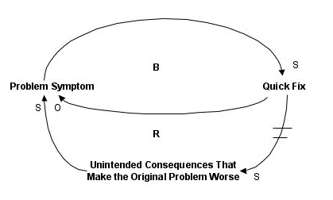
3. **Power of Awareness:** when we see and understand the system as it really operates, we are no longer controlled by it;
4. **Leverage:** systems improve as the result of a few key coordinated changes sustained over time.

