Business Template

Hotel Booking System

Contents
1 Business Description 3
1.1 Business background 3
1.2 Problems. Current Situation 3
1.3 The benefits of implementing a database. Project Vision 3
2 Model description 3
2.1 Definitions & Acronyms 3
2.2 Logical Scheme 3
2.3 Objects 3

Business Description

Business background
A hotel booking system facilitates the reservation process where customers book hotel rooms for specific dates and durations. The system manages hotels, rooms, bookings, customers, employees, payments, invoices, and reviews.
Traditionally, many small and medium hotels manage reservations manually or through disconnected tools such as spreadsheets or paper records. This approach often leads to inefficiencies in reservation management, double bookings, and difficulty tracking customer and payment information.
A centralized database system allows hotels to manage reservations, room availability, employees, and customer information efficiently.

Problems. Current Situation
• Lack of centralized data management Room availability, reservations, payments, and customer data may be stored across multiple disconnected systems.
• Inefficient reservation management Manual processes for checking room availability and confirming bookings can lead to delays and errors.
• Limited operational visibility Hotel managers cannot easily track booking trends, employee activity, or payment status in real time.
• Difficulty tracking customer experience Customer reviews and booking history are often not stored systematically.

the Benefits of implementing a database. Project Vision
A database-driven hotel booking system provides structured storage and efficient management of hotel operations.
Key benefits include:
• Centralized reservation management All bookings, rooms, customers, and employees are stored in one system.
• Automated booking and availability tracking The system can automatically manage room allocation and reservation dates.
• Improved financial management Payments and invoices can be tracked automatically.
• Enhanced customer experience Customer booking history and reviews can be stored and analyzed.
• Better decision-making Managers can generate reports on occupancy, payments, and customer feedback.

Model description

Definitions & Acronyms

Booking A reservation made by a customer for a hotel room for a specific period.
Customer A guest who books or stays in a hotel room.
Room An accommodation unit available for booking in a hotel.
Hotel An establishment offering lodging services with multiple rooms available for booking.
Employee A staff member responsible for managing reservations, customer service, and hotel operations.
Payment A financial transaction made by a customer for a booking.
Invoice A billing document generated for a completed payment.
Review Feedback provided by a customer after their stay.
PK (Primary Key) A unique identifier for records in a table.
FK (Foreign Key) A field used to link two tables together

Logical Scheme
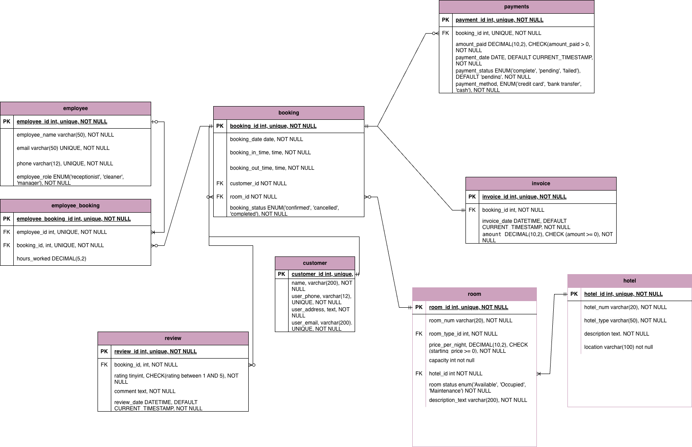

Relationships Between the Tables
1. Employee <> Booking (M:M)
An employee can be associated with multiple bookings, while one booking might involve multiple employees.
The employee_booking table acts as a bridge, linking employees to bookings.

2. Customer <> Booking (1:M)
One customer might make several bookings, but one specific booking is made only by one customer.

3. Hotel <> Room (1:M)
One hotel can contain multiple rooms, while each room belongs to exactly one hotel.

4. Room <> Booking (1:M)
One room can appear in many bookings across different dates, while each booking refers to one specific room.

5. Room <> Room_description_table (1:1)
Each room has one corresponding description entry that stores additional information about the room.

6. Booking <> Payments (1:M)
One booking can be associated with multiple payments, while each payment belongs to only one booking.

7. Payments <> Invoice (1:1)
Each payment generates one invoice, and each invoice refers to exactly one payment.

8. Booking <> Review (1:M)
One booking may have several reviews written by customers, while each review refers to only one booking.

9. Customer <> Review (1:M)
One customer can write multiple reviews for different stays, while each review belongs to one specific customer.

10. Employee <> Employee_booking (1:M)
One employee can appear in multiple records in the employee_booking table, while each employee_booking record refers to one employee.

11. Booking <> Employee_booking (1:M)
One booking can have multiple employee assignments recorded in the employee_booking table, while each employee_booking entry refers to one booking.

Objects

- Booking table
Description:
The booking table stores information about reservations made by customers for hotel rooms. It includes details such as the customer who made the reservation, the room being booked, check-in and check-out dates, and the booking status.
Each booking represents a reservation of a specific room by a specific customer for a defined period of time
Table Name | Field name | Field Description | Data Type
booking | booking_id | Item identifier PK | Int
 | booking_date | Booking_date, NOT NULL | date,
 | Booking_in_time | Date when the guest checks in, NOT NULL | date
 | Booking_out_time | Date when the guest checks out, NOT NULL | date
 | customer_id | Unique customer identifier, FK, UNIQUE, NOT NULL | int
 | room_id | Unique room identifier, int, UNIQUE, NOT NULL | int
 | Booking_status | ENUM('receptionist', 'cleaner', 'manager'), NOT NULL | ENUM

Relationships with Other Tables:

booking <> customer (M:1) (Mandatory to Optional)
Each booking is associated with one customer. A customer can make multiple bookings.

booking <> room (M:1) (Mandatory to Mandatory)
Each booking refers to one room. A room may be booked multiple times across different dates.

booking <> employee_booking (1:M) (Optional to Mandatory)
A booking may involve multiple employees responsible for managing the reservation. The employee_booking table acts as a bridge linking bookings with employees.

booking <> payments (1:M) (Mandatory to Optional)
One booking can be associated with one or multiple payments. Each payment refers to a specific booking.

booking <> review (1:M) (Optional to Optional)
A booking may receive one or more reviews from the customer after their stay.
Item Table Example:
booking_id | customer_id | room_id | Booking_in_time | Booking_out_Time | Booking_date | Booking_status
008198 | 448198 | 988198 | 2025-06-10 | 2025-06-15 | 2025-05-10 | cancelled
008199 | 768198 | 678198 | 2025-06-15 | 2025-06-19 | 2025-05-10 | confirmed

- Payment Table
Description:
The payments table records transactions related to completed bookings. It includes details such as the amount paid, payment date, payment method, and payment status. Each payment is associated with a specific booking and a customer.

Table Name | Field name | Field Description | Data Type
payment | payment_id | Unique payment identifier PK | Int
 | booking_id | Unique sale identifier FK, UNIQUE, NOT NULL | int
 | Amount_paid | The amount which was paid, CHECK(amount_paid > 0, NOT NULL | Decimal(10,2)
 | Payment_date | The date on which payment was made, DEFAULT CURRENT_TIMESTAMP, NOT NULL | date
 | Payment_status | A payment status: ‘pending’, ‘failed’, ‘complete’, NOT NULL | ENUM
 | Payment_method | Payment method: ‘credit card’, ‘bank transfer’, ‘cash’, CHECK (payment_method IN ('credit card', 'bank transfer', 'cash')) | Varchar(50)

Relationships with Other Tables
payments <> invoice (1:1) mandatory to mandatory
Each payment is linked to an invoice.
payment <> customer (1:M) (mandatory to optional)
A payment is associated with a customer, while one user might be associated with multiple payments . It is mandatory for a payment to be associated with a user but user might not be associated with any payment.
payment <> booking (1:M) (mandatory to optional)
A payment is associated with one booking, while one booking might be associated with multiple payments . It is mandatory for a payment to be associated with a booking but a booking might not be associated with any payment (cancelled, not confirmed ones)

Payment Table example:

payment_id | booking_id | Amount_paid | Payment_date | Payment_status | Payment_method
112 | 008198 | 40.00 | 2025-03-25 | complete | Cedit card
123 | 008199 | 500.00 | 2025-03-26 | pending | Bank transfer

- Invoice Table
Description:
The invoice table stores billing details related to sales transactions. It includes information such as the booking it corresponds to, invoice date, and total amount.

Table Name | Field name | Field Description | Data Type
invoice | invoice_id | Unique invoice identifier PK | Int
 | booking_id | Unique sale identifier FK, NOT NULL | int(60)
 | Invoice_date | The date invoice was made, DEFAULT CURRENT_TIMESTAMP, NOT NULL | Datetime
 | amount | The amount paid in USD, CHECK (amount >= 0), NOT NULL | Decimal(10,2)

Relationships with other tables:
Invoice <> booking (1:many) (Mandatory to optional)
Each invoice needs to be linked to a booking transaction. While a booking might have several or no related invoices

Invoice Table Example:

invoice_id | booking_id | Invoice_date | amount
20001 | 008198 | 2025-03-25 | 40.00
20011 | 008198 | 2025-03-26 | 500.00

- Customer Table
Description:
The customer table stores details about customer. It records customers who log in the reservation system, Each customer might or might not have associated bookings, payments and reviews.

Table Name | Field name | Field Description | Data Type
customer | customer_id | Unique sale identifier PK | Int
 | name | Customer name, NOT NULL | Varchar(60)
 | User_phone | Phone number, unique, NOT NULL | Varchar(12)
 | User_address | Address, NOT NULL | text
 | User_email | Email of the customer NOT NULL, unique | Varchar(200)

Relationships with Other Tables:
customer <> review (1:M) Mandatory to optional
each review should have an associated customer, however a customer might not have any reviews

customer <> booking (1:M) mandatory to optional)
a customer might have many bookings or might not have even one, however if booking is made it should have an associated customer

customer <> payments (1:M) mandatory to optional
a customer might have many payments or might not have even one, however if a payment is made it should have an associated customer

Customer Table Exmaple:
customer_id | name | User_phone | User_address | User_email
448198 | Ana McClean | 599584841 | Tbilisi, Tsereteli #1 | Ana.McClean@gmail.com
448199 | Eduard Shevardnadze | 599584842 | Tbilisi, Tsereteli #1 | shevardnadze@gmail.com

- Room Table
Description:
The room table stores information about rooms: its unique number, type price, hotel_id it is located as well as its availability

Table Name | Field name | Field Description | Data Type
room | room_id | Unique room identifier PK | Int
 | Hotel_id | Unique hotel_id identifier, FK, int, NOT NULL | int
 | Room_type_id | Unique room_type identifier, FK, int, NOT NULL | int
 | Price_per_night | Price per night, check(price_per_night >0) NOT NULL | Decimal(10,2)
 | Room_num | Number of the room NOT NULL | Varchar(20)
 | Room_status | Enum(‘Available’, ‘Occupied’, ‘Maintenance’) NOT NULL | ENUM
 | description | Description of the room | text

Relationships with Other Tables:
Room <> hotel (M:1) (Mandatory to Mandatory)
One hotel should have many rooms, one room should be located in just one hotel
room <> room_description_table (1:M) mandatory to optional
a room might have several associated descriptions in the room description table while each description should have one associated room from the room table.

Room.Example
room_id | Hotel_id | Room_type_id | Price_per_night | Room_num | Room_status | Description
988198 | 2345 | 12345678012 | 99.9 | 107 | Available | Double deluxe room, with a view on the sea
988194 | 2333 | 98765431098 | 101.8 | 101 | Occupied | Triplet room with a view on the yard

- Hotel Table
Description:
The hotel table stores information about hotels: its unique number, type, description, location

Table Name | Field name | Field Description | Data Type
hotel | hotel_id | Unique room identifier PK | Int
 | Hotel_num | Unique int, NOT NULL | int
 | description | Text not null | text
 | location | location | Varchar(60)

Relationships with Other Tables:
Room <> hotel (M:1) (Mandatory to Mandatory)
One hotel should have many rooms, one room should be located in just one hotel
hotel.Example
Hotel_id | Hotel_num | description | location
2345 | 23 | Luxury hotel | Chavchavadze #31
2333 | 24 | Cheap hotel | Varketili Metro

- Employee Table
Description:
The employee table stores information about employees involved in managing booking. It includes their name, email, and phone number.
Table Name | Field name | Field Description | Data Type
employee | employee_id | Employee identifier PK | Int
 | employee_name, NOT NULL | employee full name | Varchcar(50)
 | email, UNIQUE, NOT NULL | employee email | Varchar(50)
 | phone, UNIQUE, NOT NULL | The phone number of the employee | Varchar(12)
 | Employe_role | Enum(‘receptionist’, ‘manager’, ‘cleaner’), NOT NULL | enum

Relationships with Other Tables:
employee <> employee_booking (1:M) mandatory to optional
An employee might or might not be associated with an booking but each booking should have employees.

Employee Table Example:
employee_id | employee_name | User_email | Employ_role | User_phone
3456 | Margo Mcclean | margo@gmail.com | cleaner | 123456789014
3678 | Dato Sosiashvili | Anastasiadf@gmail.com | receptionist | 123456789512

- Employee_booking Table
Description: The employee_booking is a bridge table which tracks which employees are assigned to which bookings and their roles in managing them.
Table Name | Field name | Field Description | Data Type
Employee_booking | Employee_booking_id | Unique Employee_booking identifier PK | Int
 | Employee_id | Unique Employee identifier FK, UNIQUE, NOT NULL | int
 | booking_id | Unique booking identifier FK, UNIQUE, NOT NULL | int
 | Hours_worked | The hours the employee work on an booking, NOT NULL | Decimal(3,2)

Relationships with Other Tables:

employee_booking <> employee (M:1)
Each employee can be assigned to multiple bookings.

employee_booking <> booking (M:1)
Each booking can have multiple employees assigned.

Employee_booking Table example:
employee_booking_id | employee_id | booking_id | Hours_worked
34565 | 3456 | 008198 | 8
36785 | 3678 | 008199 | 5

- review Table
Description:
The review table stores details about reviews, associated bookings anf customers.

Table Name | Field name | Field Description | Data Type
review_id | review_id | Unique review identifier PK | Int
 | booking_id | booking identifier FK NOT NULL | int
 | rating | Tinyint CHECK(rating between 1 and 5) NOT NULL | Tinyint
 | comment | NOT NULL | text
 | Review_date | Default current timestamp not null | datetime

Relationships with Other Tables:
review <> booking (1:M) Mandatory: Optional
each review should have at least one assoicated booking, while one booking might have more than one reviews as well as don’t have any reviews at all

revuiew <> customer (M:1) optional to Mandatory
each review should have at least one customer reviewr, while one customer might review more than one bookings as well as don’t review any at all

Review Table Example:
review_id | Booking_id | Rating | Comment | Review_date
1699 | 008198 | 3 | Nice | 10/10/2023
1700 | 008199 | 4 | Great | 10/10/2023

