Response

To

US General Services Administration

Federal Acquisition Service, Integrated Technology Service

National IT Commodity Program

401 W. Peachtree Street Suite 820

Atlanta, GA 30308

FOR

Solicitation Number: 4QTFHS150004

GSA eBuy - RFQ993471

Multiple Award Blanket Purchase Agreements (BPAs)

for

**Agile Delivery Services (ADS I)**

**Agile Process Approach**

Submitted By



[**www.e-sci.net**](http://www.e-sci.net)

**Submission Date: July 7, 2015 1:00pm**

|  |  |  |
| --- | --- | --- |
| **Submitted To:** | **Submitted By: e-Sci Corporation** | |
| **Corporate Address** | **Point of Contact** |
| |  |  |  | | --- | --- | --- | | Hassan Harris  Senior Contracting Officer   |  | | --- | | National IT Commodity Program | | 401 W. Peachtree Street Suite 820  Atlanta, GA 30308 | | | 404-215-8705 / hassan.harris@gsa.gov | | e-Sci_Final_Full_Logo  5406 Roosevelt Street  Bethesda, MD 20817 | Sushma Kulkarni  Email: [srk@e-sci.net](mailto:srk@e-sci.net)  Tel: 301-257-0426 |

**Table of Contents**

[1. Agile Approach to Prototype Design and Development 3](#_Toc424033166)

[2. Project and Team Chartering for Agile Delivery Services 3](#_Toc424033167)

[3. Project Kick-off and Chartering 6](#_Toc424033168)

[4. Release Planning 8](#_Toc424033169)

[5. Sprint Planning and Backlog Story Grooming. 11](#_Toc424033170)

1. Agile Approach to Prototype Design and Development

The General Services Administration is seeking a proposal along with a prototype to establish a blanket purchase agreement for Agile Delivery Services. e-Sci Corporation is pleased to submit a prototype and a description of its agile approach to the prototype design and development. As a small business, e-Sci made a decision to submit proposal and prototype for only **Pool Two – Development**. However, the reviewers of this proposal will notice that we have presented a holistic approach of agile development methodology starting from user stories, analysis, design, development and deployment.

1. Project and Team Chartering for Agile Delivery Services

The goal of this project is to establish agile methodology for adoption in future agency challenges. The vision is to gather business intelligence from the vast information collected by federal agencies in an efficient and cost effective manner, by utilizing the IaaS, PaaS and SaaS concepts

The current business case is to collect useful information from FDA datasets for drugs, devices and foods that serves the general public. FDA currently has public datasets made available via web service APIs.

The constraints are that only open-source technology products and platforms can be used.

For the design and development of the prototype FDA Drug, Device, and Food datasets, we used a compressed Agile Sprint approach. We put together an agile team for the roles of:

* Product Manager (Category 1)
* Interaction Designer/User Researcher/Usability Tester (Category 3)
* Frontend Web Developer (Category 6)
* Technical Architect (Category 2),
* Backend Web Developer (Category 7)
* DevOps Engineer (Category 8).

As with many agile projects, and given that this was a short, limited prototype design and development effort, several roles were handled by a single person. For instance, the Product Manager also took on the role of the Interaction Designer/User Researcher/Usability Tester. Our software engineer took on the roles of Frontend Web Developer, Backend Web Developer, and DevOps Engineer.

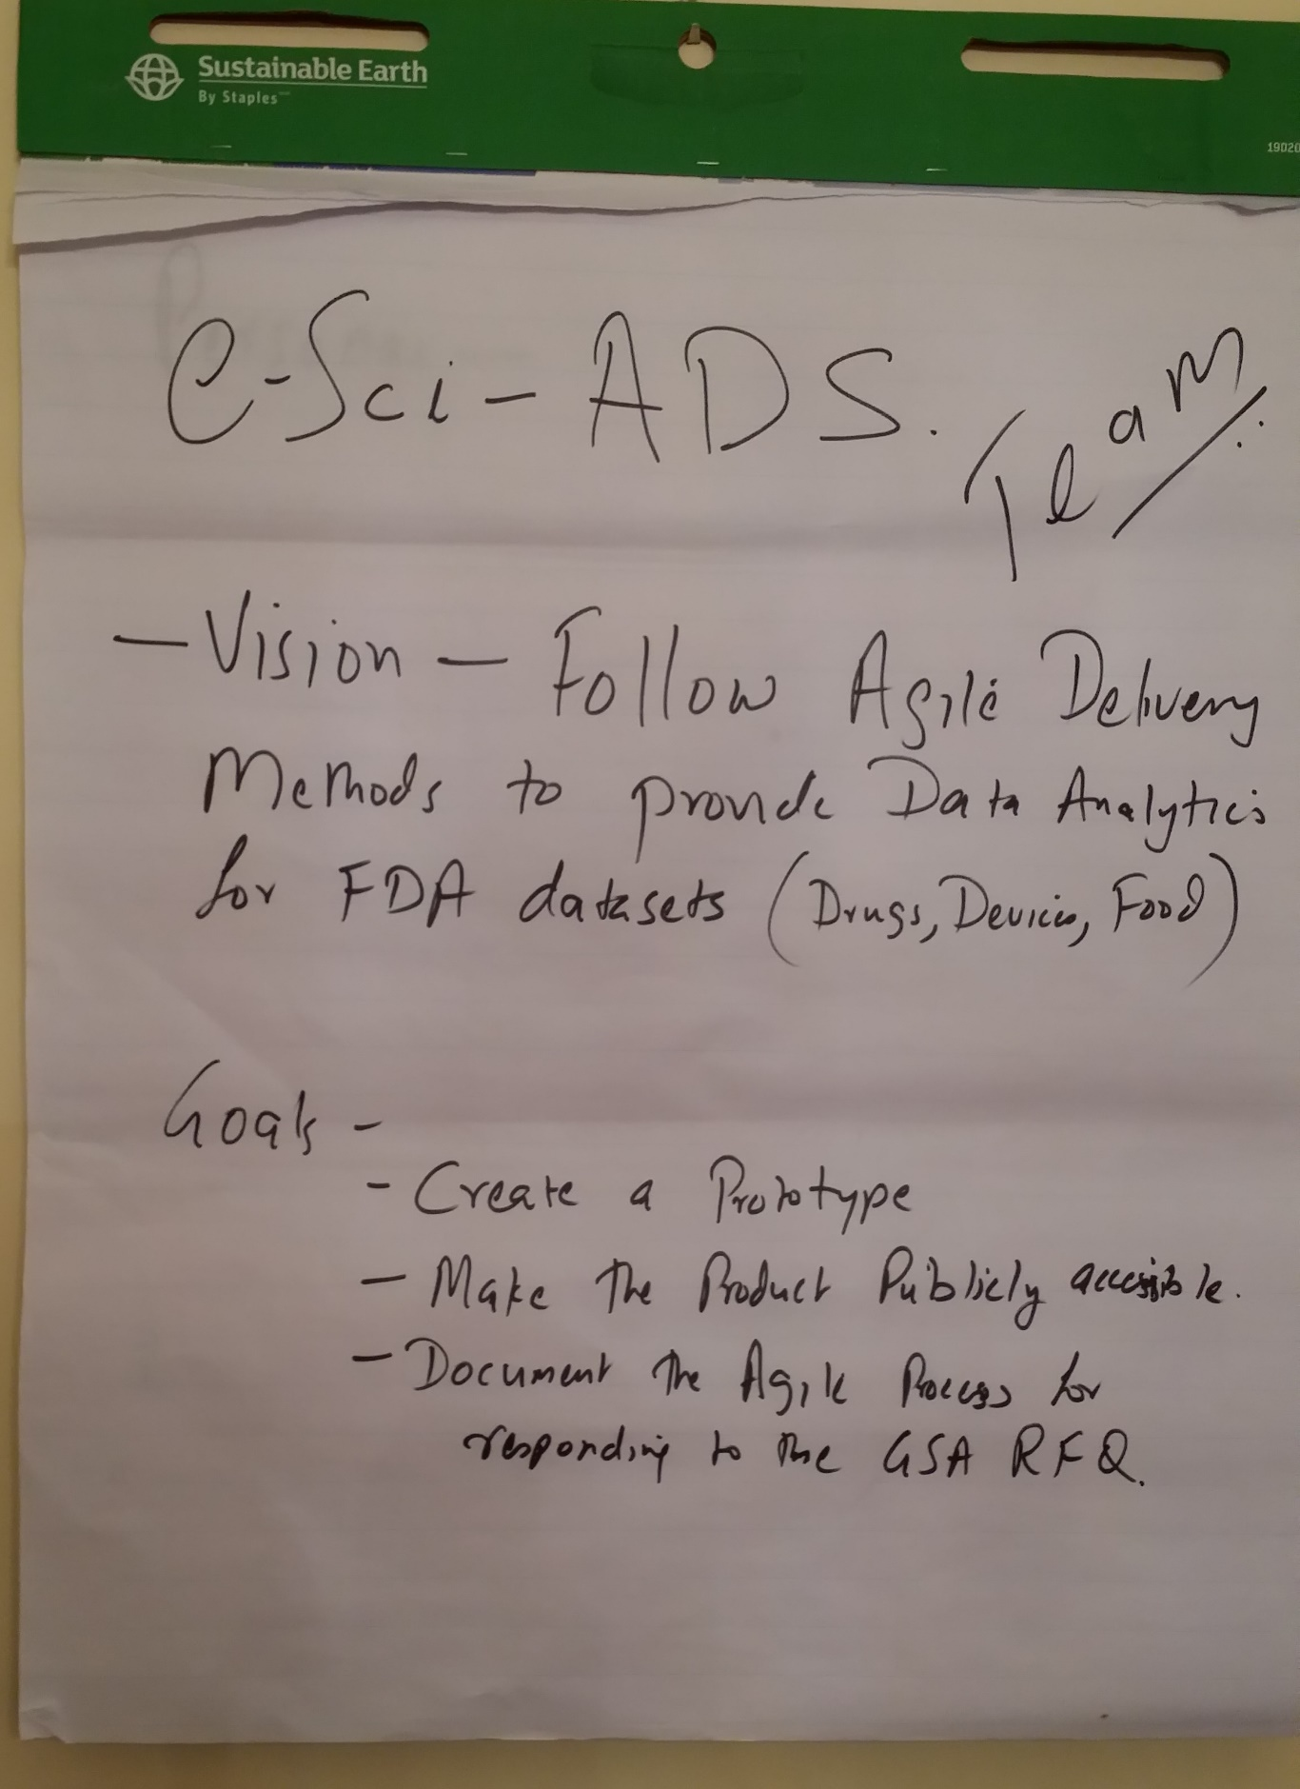

**Figure 1. Vision for the Agile Delivery Services**

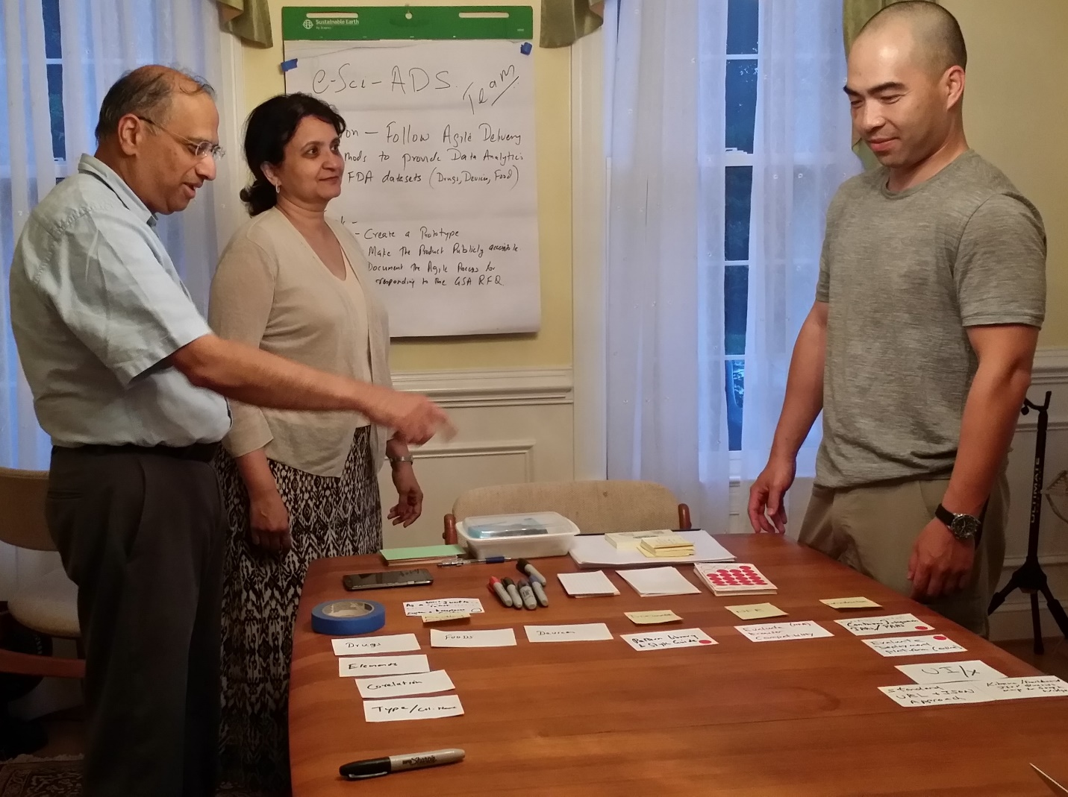

**Figure 2. The e-Sci Team**

1. Project Kick-off and Chartering

A short project kick-off/chartering meeting was convened to establish the vision and goals of the prototype design and development effort and to determine the agile approach to be used for the effort. The product manager led the entire team through the session. The vision and goals of the effort were expressed in terms of several User Epics.

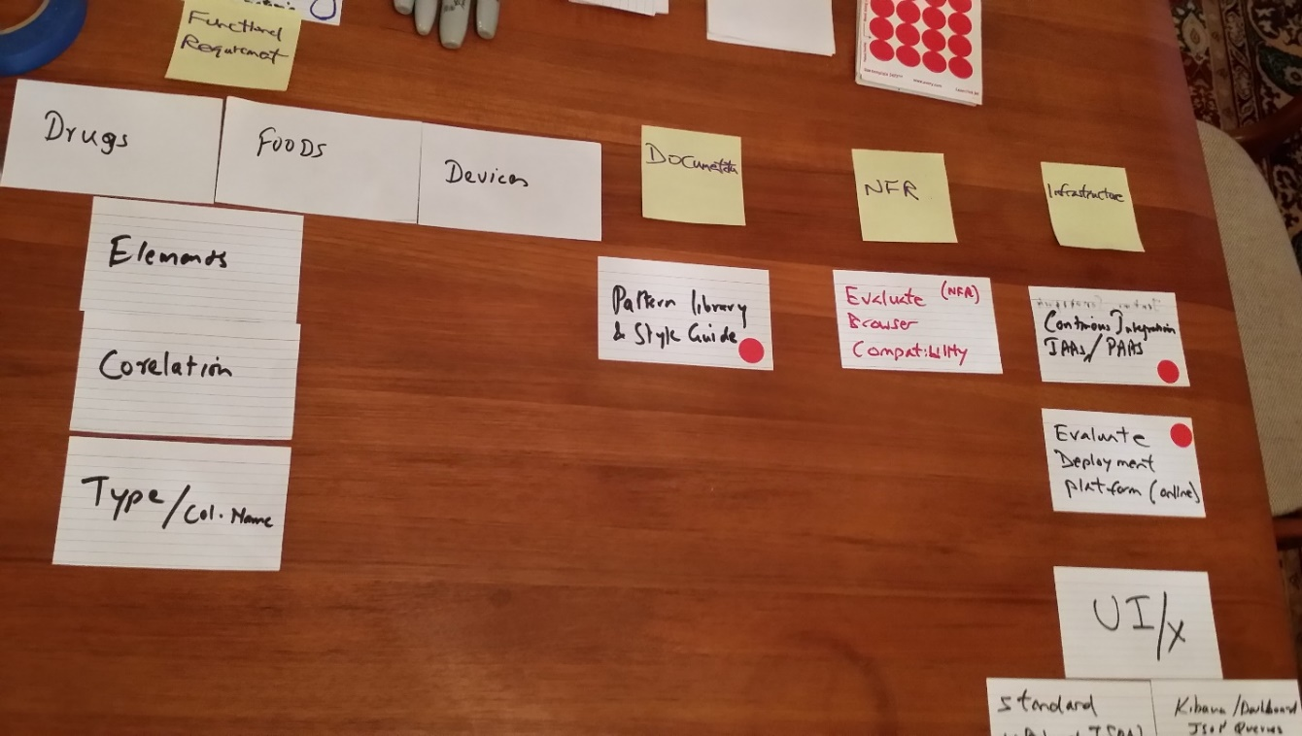

**Figure 3. Project Kick-off - 1**

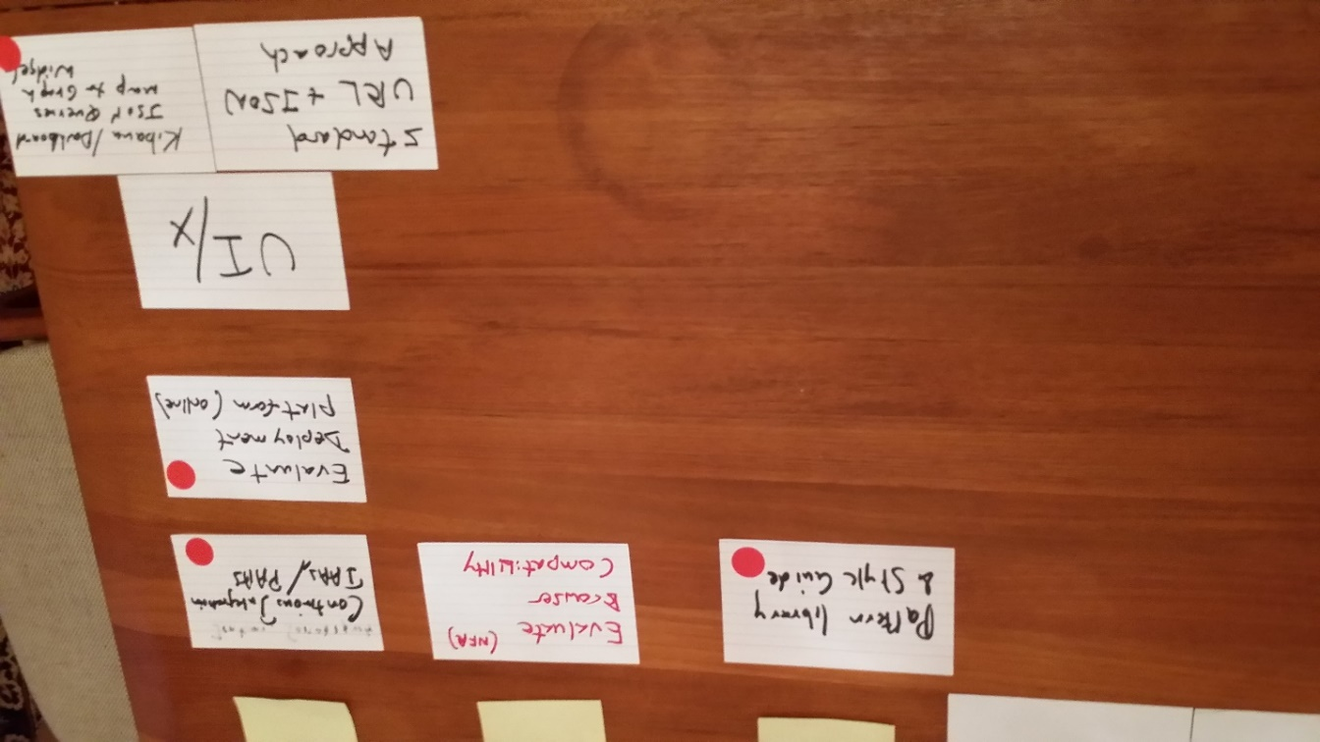

**Figure 4. Project Kick-off - 2**

It was also decided that a generic user “John” would be used to represent the public users of the prototype system. The team also agreed on a Definition of Ready for the Sprints (Table 1) and a Definition of Done for the individual stories and the Sprints (Tables 2 and 3 respectively). We have found it important to identify and agree upon a Definition of Ready at the Sprint level to make sure that the entire Agile Development Team, including the Product Owner and other member Stakeholders, know what is needed and expected in order to start a Sprint with User Stories that can be worked on in a short Sprint.

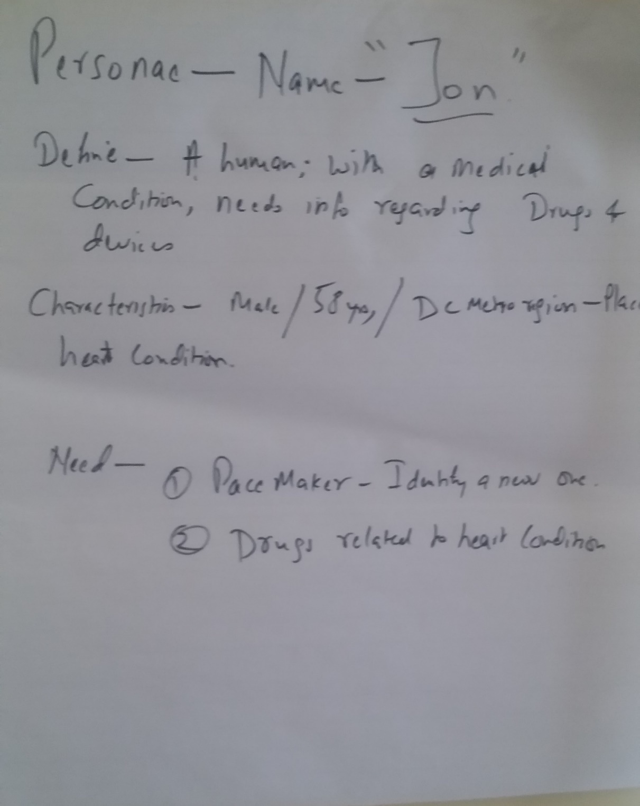

**Figure 5. User Stories**

Table 1. Sprint Definition of Ready

|  |
| --- |
| The sprint backlog is defined |
| The sprint backlog contains all user stories, and other work related to deployment |
| All aspects of project are addressed, including design, development and deployment |
| Team members are aware of their specific tasks |
| All user stories meet the definition of Ready |

Table 2. User Story Definition of Done

|  |
| --- |
| Analysis of card done along with business scenario |
| Team and the product owner are on the same page, and have addressed all the issues |
| No outstanding questions for the team preventing them from working on the story. |

Table 3. Sprint Definition of Done

|  |
| --- |
| All the code development is complete |
| All the unit tests are written and pass |
| Deployed to final environment and passed user acceptance tests |
| All the configuration and deployment changes have been communicated and implemented. |
| Relevant documentation for design, development, deployment is complete |

1. Release Planning

Following the kick-off/chartering meeting, a release planning meeting was conducted by the product manager. The epics were refined into smaller, discreet user stories. User stories are listed in Table 4. Note, that we used “John” to refer to a generic user that is a member of the general public that wishes to use the openFDA database. The team decided that the effort would be consist of 2 very short Sprints. It was also determined that several Technical Stories (also referred to as Technical Spikes) would be necessary to implement continuous integration with the GitHub and the openFDA libraries and database.

Table 4. Prototype Epics and User Stories

|  |  |
| --- | --- |
| Epic | User Story |
| Reports Over Time | John wants to get a count of all adverse reports related to medical devices from 2000 to 2015 |
|  | John wants to get a count of all adverse reported related to medical devices from 2000 – 2015 that were submitted by consumers. |
|  | John wants to get a count of all adverse reports related to medical devices from 2000 – 2015 for “PACEMAKERS”. |
| Devices | John wants to get a count of all adverse reports related to medical devices. |
|  | John wants to get a count of adverse reports related to medical devices where the incidents occurred at home. |
|  | John wants to get a count of adverse reports related to medical devices where incidents occurred in hospitals. |
| Types of Events | John wants to get a count of adverse reports related to medical devices based on the type of incidents. |
|  | John wants to get a count of adverse reports related to medical devices based on the type of incidents that occurred in a hospital. |
|  | John wants to get a count of adverse reports related to medical devices based on the type of incidents caused by a hospital bed. |
| Drugs | John wants to get a count of all adverse drug event reports for drugs prescribed for “HYPERTENSION”, between the years 2004-2015, that resulted in death, a life threatening condition, hospitalization, disability, congenital anomaly, or other serious condition. |
|  | John wants to get a count of all adverse drug event reports, submitted by drug manufacturers, for drugs prescribed for “HYPERTENSION”, between the years 2004-2015, that resulted in death, a life threatening condition, hospitalization, disability, congenital anomaly, or other serious condition. |
|  | John wants to get a count of all adverse drug event reports, submitted by drug consumers, for drugs prescribed for “HYPERTENSION”, between the years 2004-2015, that resulted in death, a life threatening condition, hospitalization, disability, congenital anomaly, or other serious condition. |

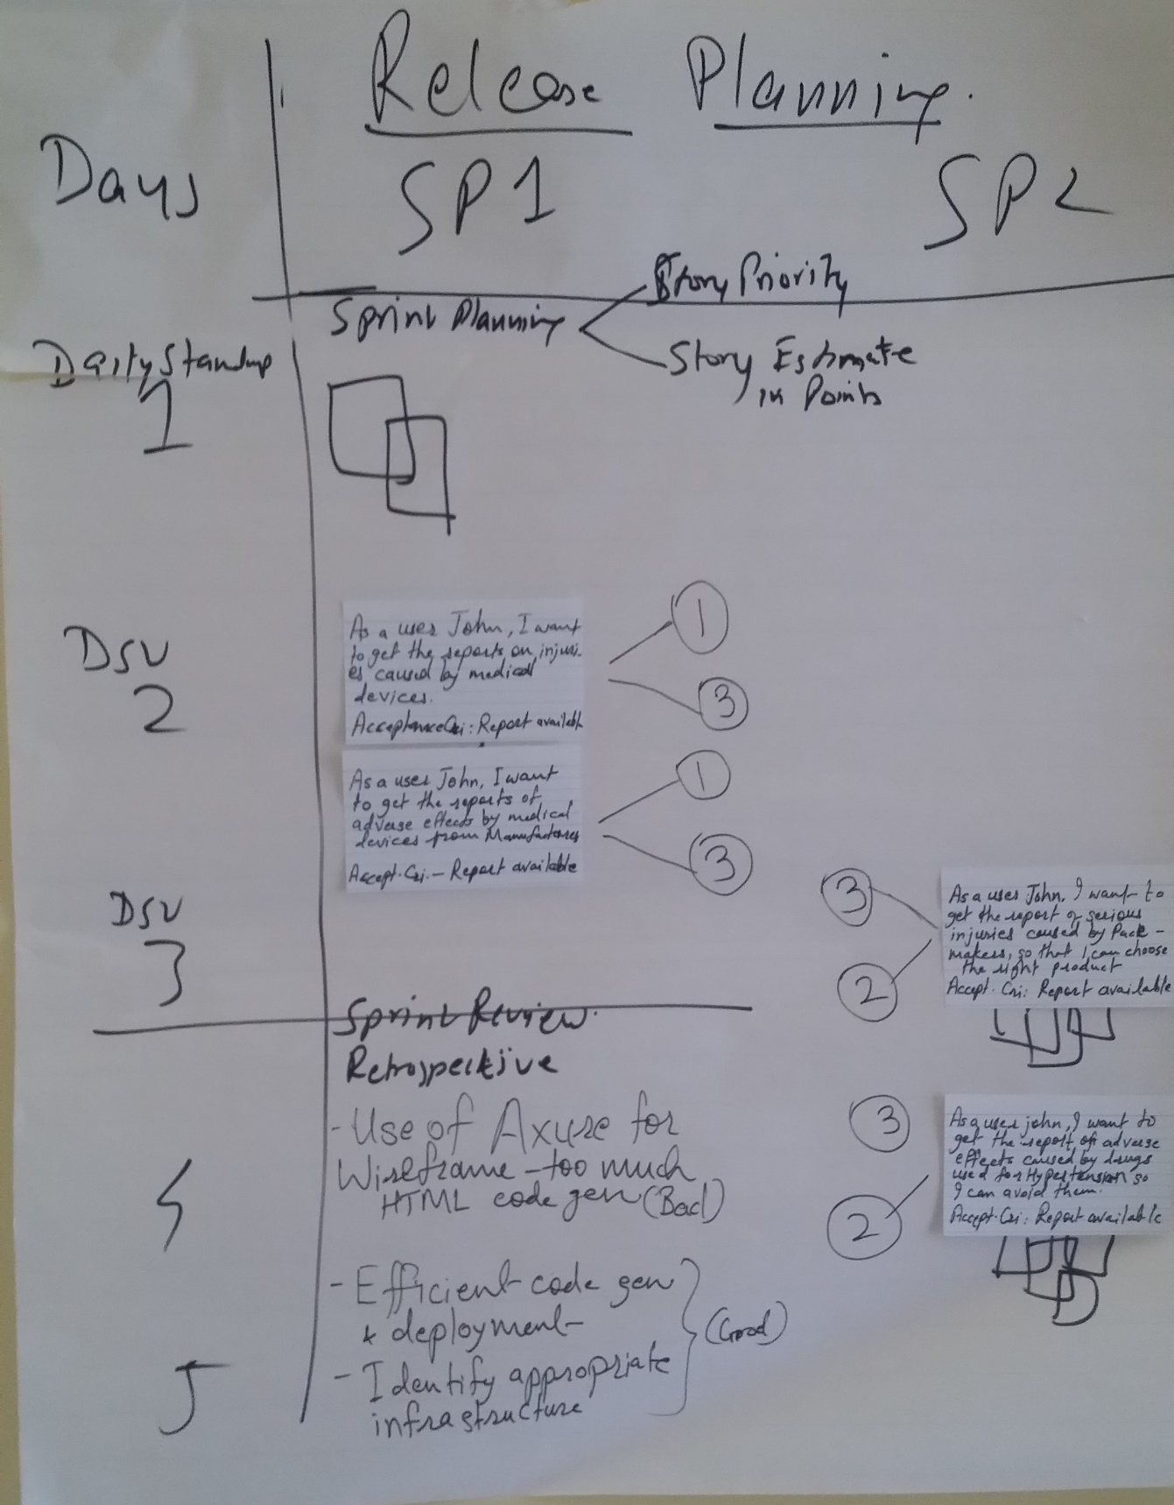

**Figure 6. Release Planning**

1. Sprint Planning and Backlog Story Grooming.

Following the Release Planning Session, the Agile Coach led the team through 2 combined Sprint Planning and Backlog Story Grooming sessions. The developers worked with our surrogate Product Owner on Backlog Grooming to ensure that each User Story was sufficiently defined and understood to allow the developers to begin work on them. As part of the Sprint Planning, points were assigned to each User Story and Technical Story to estimate the relative size and complexity of each story. The user stories were then allocated to the 2 Sprints by the consensus. The developers worked with our surrogate user/Product Owner to determine Acceptance Criteria for each User Story.

We used the free version of tool Axure and an open source HTML editor Brackets to do wireframes and user interface design.

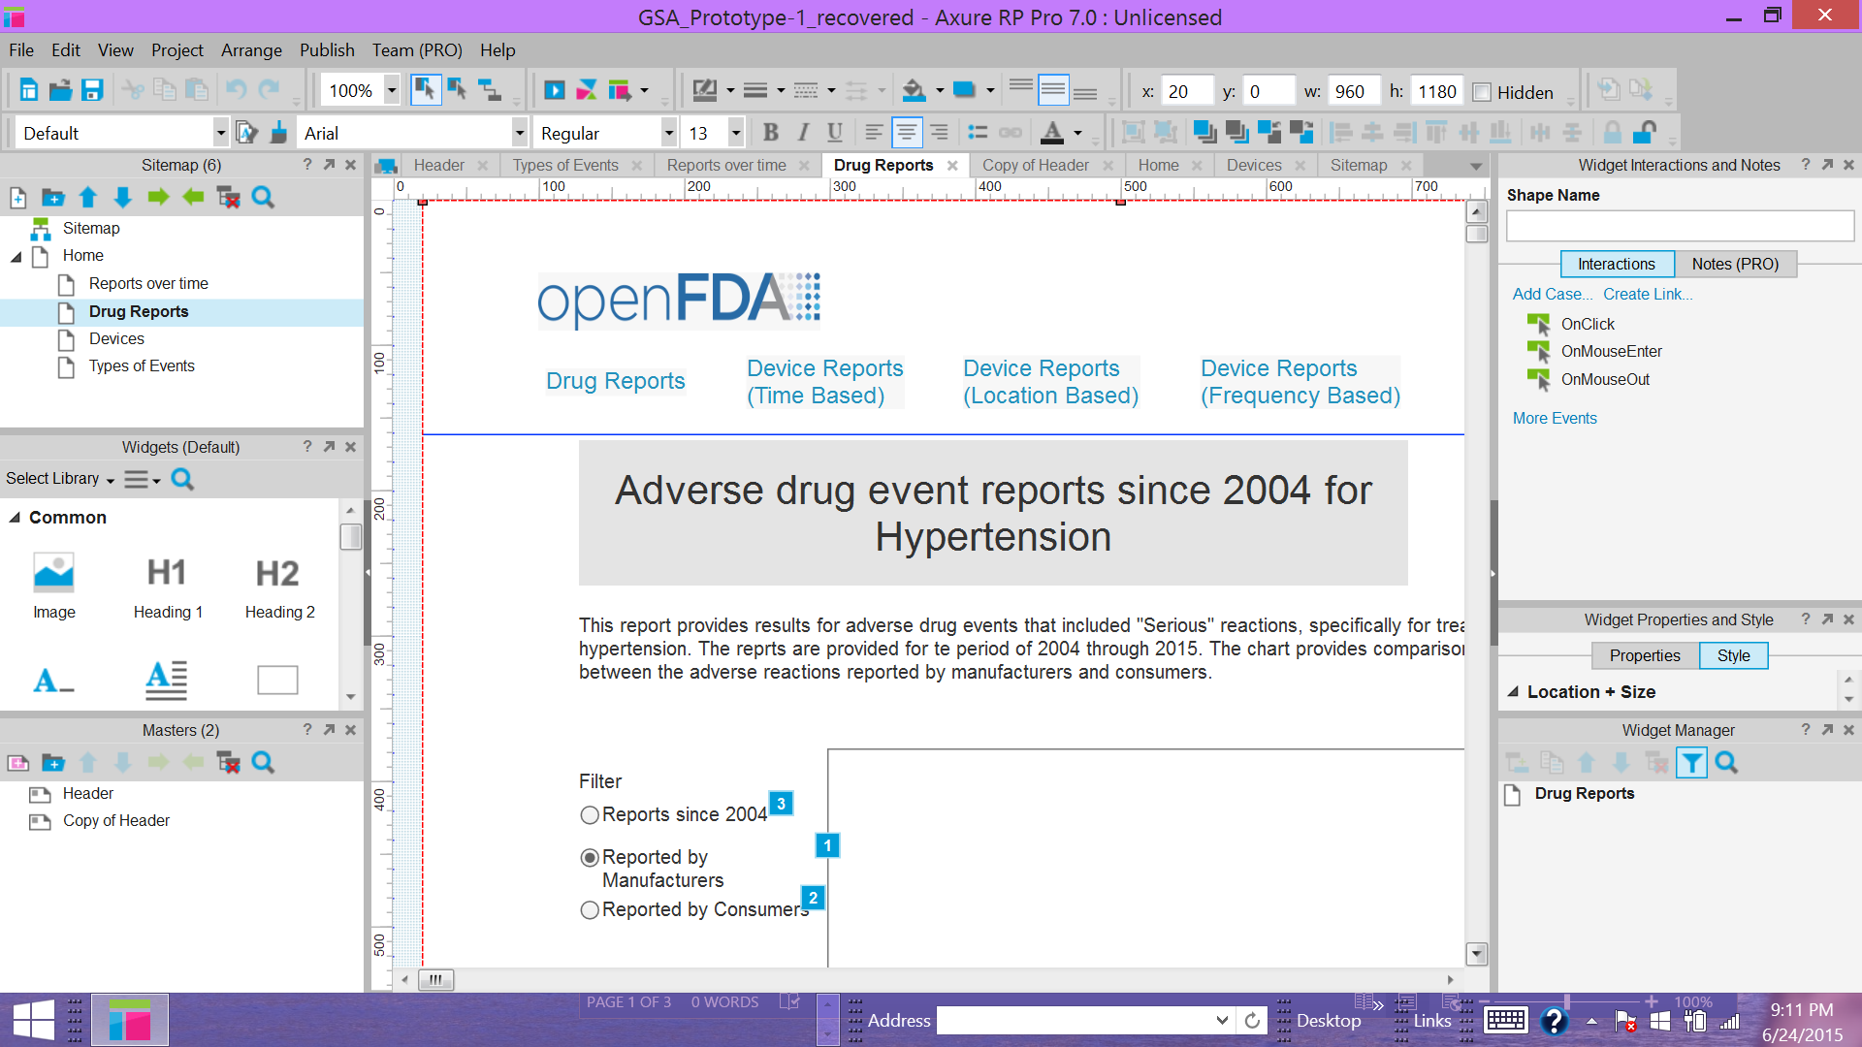

**Figure 7. Creating Wireframes**

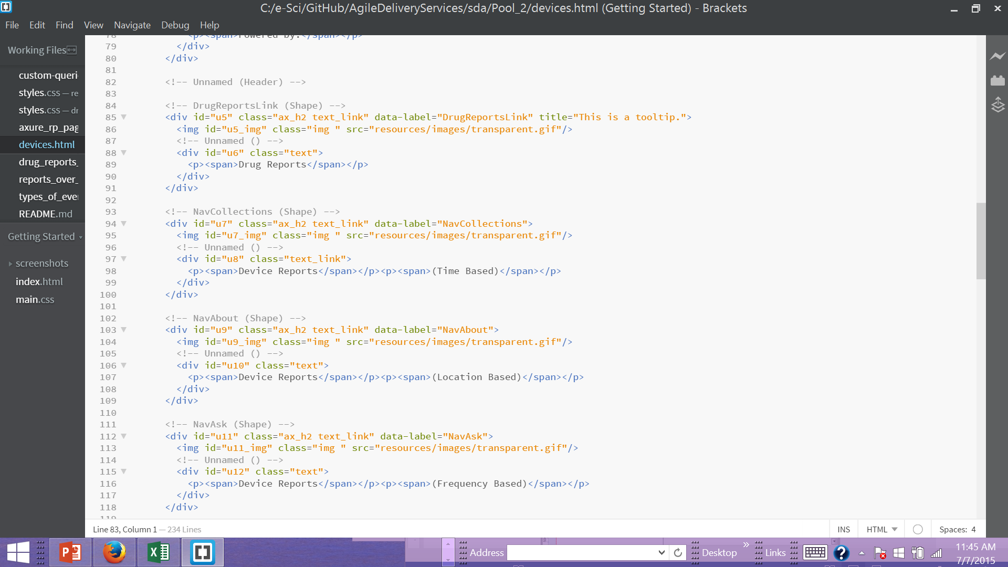

**Figure 8. Open-Source HTML Editor - Brackets**

**Sprinting.** Design and development was accomplished in 2 Sprints following the Sprint Planning and Backlog Grooming session. The team verified that the Sprint Readiness Criteria was satisfied before starting work on the Sprint, based on the user stories allocated to each Sprint. In Agile, design and development proceeded together, on a story basis. In keeping with Agile’s tenet of working software over comprehensive documentation, only those design artifacts needed by the developers and testers were developed. User stories were worked on individually. As developers completed coding on modules, they were integrated with the other software modules using continuous integration with GitHub. This allowed other members of the team to act as testers to perform User Functional Testing and Usability Testing.



**Figure 9. Sprint Planning**

As we were following a compressed Sprint approach for the short prototype effort, the Sprints ended when the User Stories were completed, in accordance with the User Story Definition of Done and our Sprint Definition of Done. Sprint 2 immediately followed Sprint 1. Upon completion of Sprint 2, some final integration testing was performed by the team to verify that the prototype had been properly integrated and built in the GitHub environment and integrated with the openFDA libraries.

During the Sprints, metrics were maintained on the progress of the work. The primary metrics were points completed versus points planned. A combined burn-down chart was maintained for both Sprints, shown below.

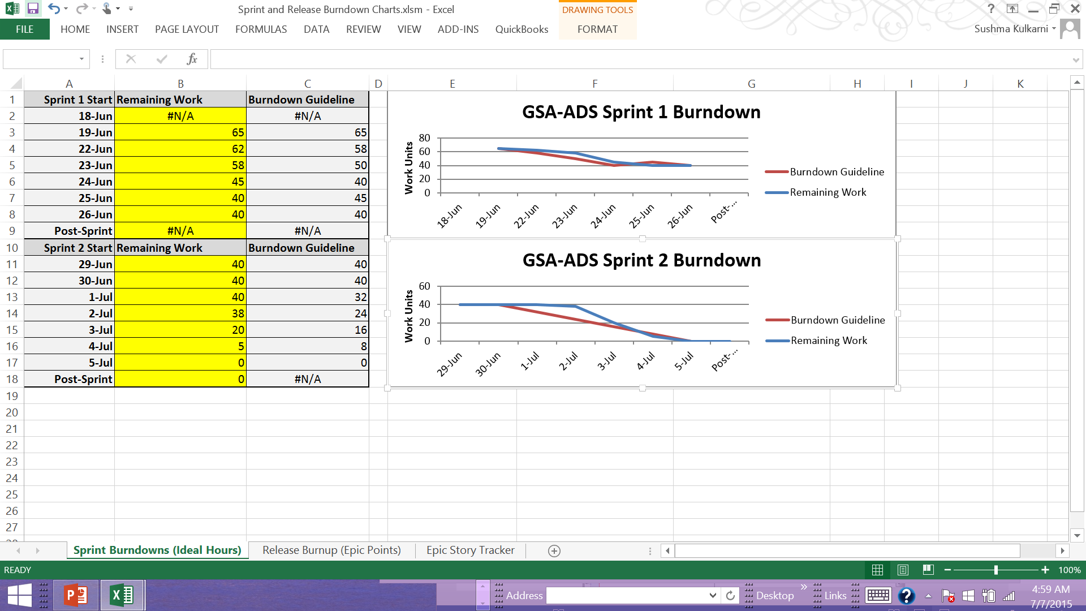

**Figure 10. GSA-ADS Prototype Burn-Down Chart**