Chris Swenson

CSC 130

3/14/16

Assignment 2 – Analysis Document

Java console output:

AVL Tree Insert Times (for 1000000 values) -

Ascending: 130.38ms, Descending: 139.08ms, Random: 506.97ms

Red-Black Tree Insert Times (for 1000000 values) -

Ascending: 354.22ms, Descending: 408.11ms, Random: 584.11ms

Analysis: The AVL Tree is faster in all operations, although both are slow to insert random numbers.

AVL Tree Graph: (40 intervals from 0 to 1,000,000 with 3 trials each interval)

(Y-Axis is time in milliseconds, X-Axis is # of insertions)

Red: Random, Blue: Incrementing, Red: Decrementing

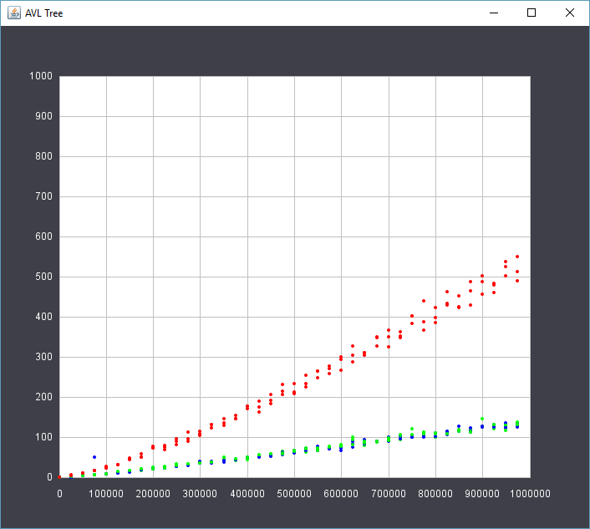

Red-Black Tree Graph: (40 intervals from 0 to 1,000,000 with 3 trials each interval)

(Y-Axis is time in milliseconds, X-Axis is # of insertions)

Red: Random, Blue: Incrementing, Red: Decrementing

