处理如下要查找的疑似孤块：



1. 登录Miner节点过滤当前日期的日志信息

root@f0428661-miner-172-25-5-44:~# grep -a -r '2023-05-17' /opt/raid0/lotusminer-winning/lotusminer/log* |grep 'mined new block' |grep took |grep height |awk -F"," '{print $3}'

"height": 2864999

"height": 2865497

"height": 2866036

"height": 2866477

1. 访问区块浏览器，查询该节点的区块列表，过滤当前日期的，对比区块高度是否一致



3.过滤不一致的区块高度的日志信息，对比区块浏览器的该区块高度的信息

root@f0428661-miner-172-25-5-44:~# grep -a -r '2023-05-17' /opt/raid0/lotusminer-winning/lotusminer/log* |grep 'mined new block' |grep took |grep height |awk -F"," '{print}' |grep 2864999

/opt/raid0/lotusminer-winning/lotusminer/logbak/miner_20230517103824.log:2023-05-17T00:59:27.255+0800 INFO miner miner/miner.go:743 mined new block {"sector-number": "59362", "cid": "bafy2bzacebypmrmeysknmxqmucwyxhjgqk7x35e63e6o643pqecj4xoxbnl6e", "height": 2864999, "miner": "f0428661", "parents": ["f0377277","f02090570","f01878693"], "parentTipset": "{bafy2bzacebd6jwdll3siah2i5rv2a64f3wmu6iohxrmokkvyrbm45vgmaodgm,bafy2bzacedx7hvvseotqf6d5cbpjyqb3jceij554xnlhayfar6mm42hkjydkk,bafy2bzaceb2me5sqqn6t5erh6zfcbvvm2fwvp64bog4h7rndrmq77g7yvibz6}", "tHardDealy ": 7.406048799, "tHardReplace ": 0.004653311, "took": 11.312142085}

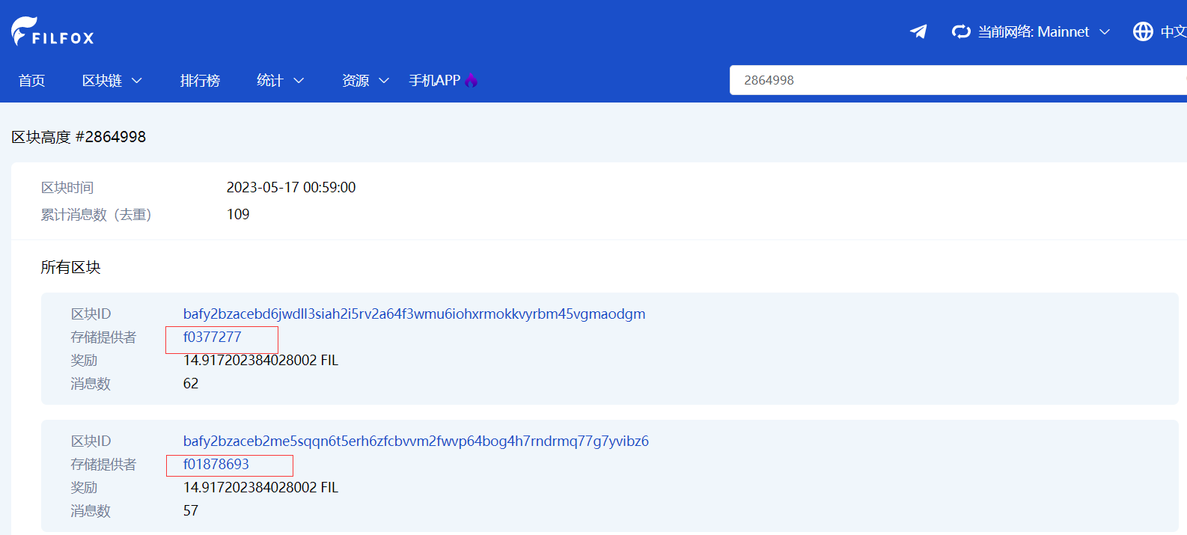

1. 对比发现缺少父区块的节点信息f02090570

同理的方法：

root@f0469055-172-25-3-26:/opt/raid0/lotusminer-window/lotusminer# grep -a -r '2023-05-17' /opt/raid0/lotusminer-winning/lotusminer/logs |grep 'mined new block' |grep took |grep height |awk -F"," '{print $3}'

"height": 2865019

"height": 2865068

"height": 2865111

"height": 2865731

"height": 2865779

"height": 2865863

"height": 2865869

"height": 2865891

"height": 2866108

"height": 2866115

"height": 2866471

"height": 2866605

"height": 2866632

"height": 2867105

"height": 2867374

"height": 2867417

"height": 2867436

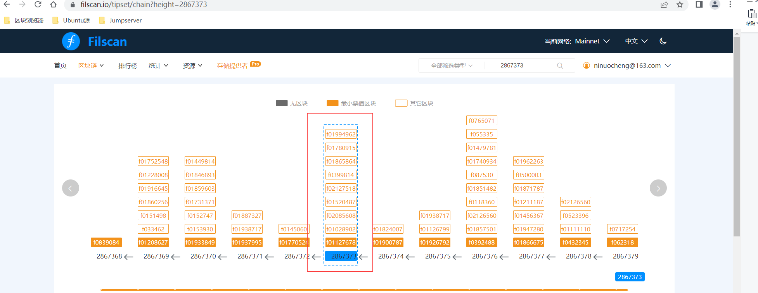

对比发现缺少父区块的节点信息f02085608