grep wdpost /opt/raid0/lotusminer-window/lotusminer/logs >/tmp/wdpost

排查/tmp/wdpost发现有faulty sectors的扇区ID:259805

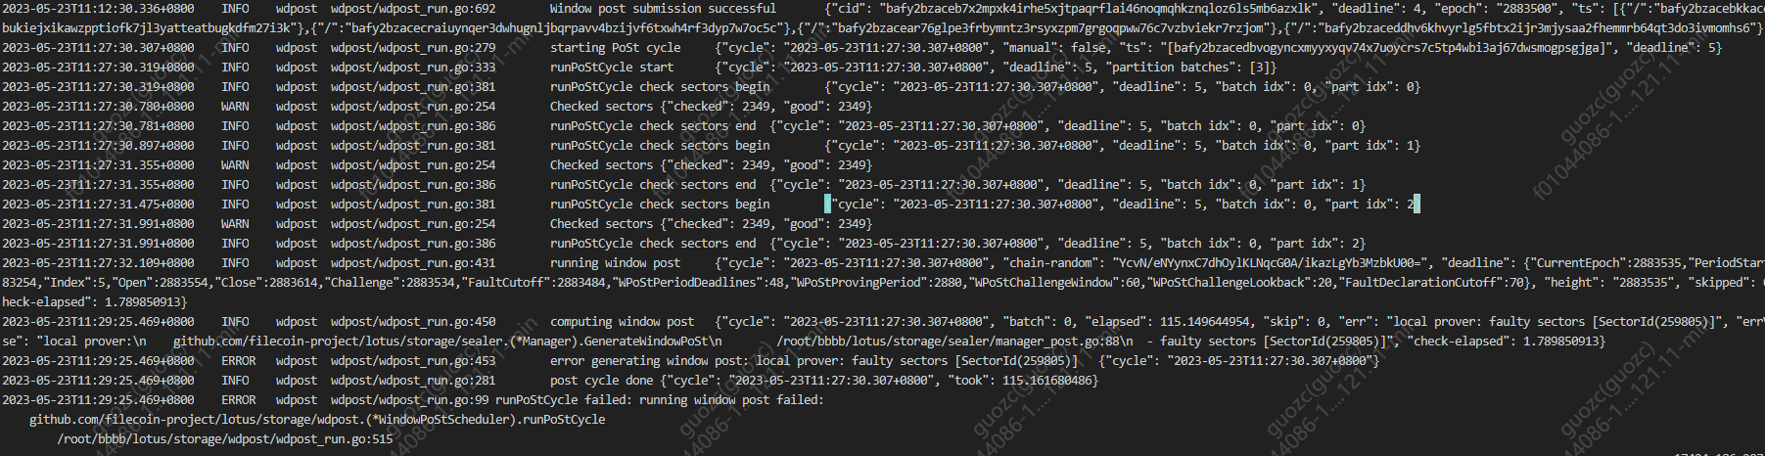

进一步查看扇区的状态及详细日志

lotus-miner sectors status 259805

lotus-miner sectors status --log 259805

查看扇区的存储位置

lotus-miner storage find 259805

删掉错误的扇区

lotus-miner sectors terminate --really-do-it 259805

查看有效的扇区信息，也就是可以续期的扇区

lotus-miner sectors check-expire --cutoff=2880000000

查看过期的扇区，执行该命令后会有删除过期的扇区命令

lotus-miner sectors expired --remove-expired

抽查日志提示runPoStCycle no sectors need to prove

排查原因是存储掉了

lotus-miner sectors list --states CommitWait

lotus-miner sealing jobs|grep 12500

lotus state sector f01530777 12500

lotus-miner sectors status 12500

lotus-miner storage find 12500