LINEKORA Data Flow Diagram

Visual Data Flow Map — Confirmed Production Architecture (Sept 14, 2026)
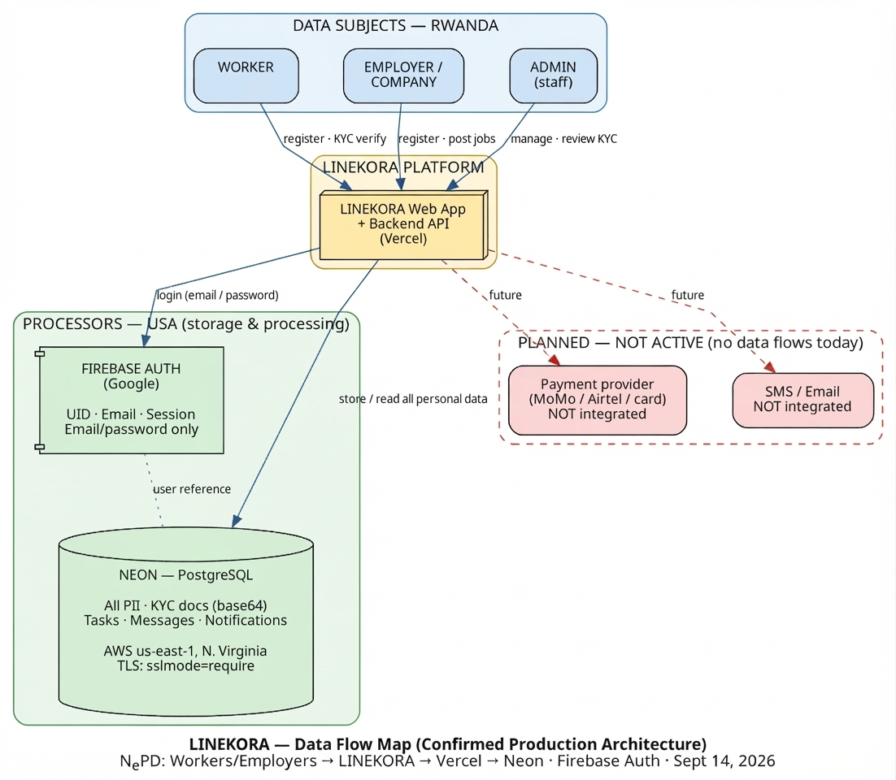
How to read this diagram: Data subjects (Workers, Employers, Admin) interact with the LINEKORA Web App hosted on Vercel. All personal data is stored in Neon (PostgreSQL, AWS us-east-1). Firebase handles authentication only. Payment and SMS/Email boxes are dashed = planned, NOT active — no data flows to them today.

International Data Flow (Confirmed)
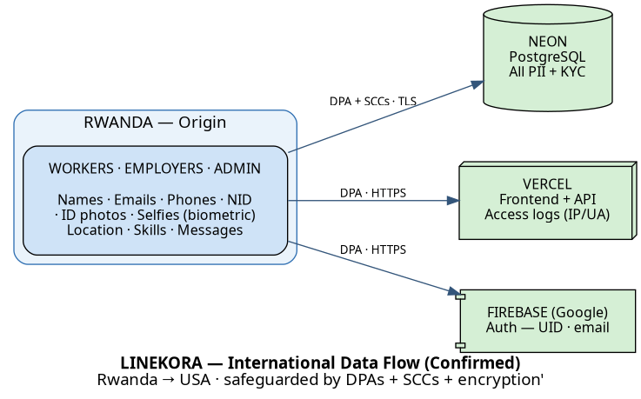
Origin: Rwanda → Storage & processing: USA (Neon AWS us-east-1, Vercel, Google/Firebase).

Legend
Symbol / Element | Meaning
Solid arrow | Active data flow (today)
Dashed arrow / red box | Planned only — NOT integrated
cylinder shape | Database
component shape | Service / external provider
box3d shape | Platform / hosting

Diagram source files (re-generate with dot -Tpng ...): diagrams/data_flow_map.dot, diagrams/international_data_flow.dot

Processors & Their Roles (ACTUAL)
Processor | Role | Data Handled | Confirmed Location
Vercel | Web hosting + serverless backend/API | App code, API traffic, access logs (IP, Browser/OS) | USA (global edge)
Neon | Primary PostgreSQL database | All PII, KYC docs (base64), tasks, messages, notifications | AWS us-east-1, N. Virginia, USA
Firebase (Google) | Authentication (email/password) | UID, email, auth token | USA

Stripe and Twilio are NOT processors today. Payments use an in-app/Wallet simulation stored in localStorage; there is no SMS or payment service. These are planned integrations only and must NOT appear in the DPO registration.

International Data Flows — Safeguards
Destination | Data | Lawful Basis | Safeguard
Neon (USA) | All PII, KYC docs, messages | Consent + Contract | Neon DPA + SCCs + TLS (sslmode=require)
Vercel (USA) | App traffic, access logs | Legitimate Interest | Vercel DPA + HTTPS
Firebase (USA) | Auth data | Contractual Necessity | Google Cloud DPA + HTTPS

Data Retention Policy (SUMMARY)
Data Category | Retention Period | Deletion Method
Worker/Employer PII | Active account + 2 years | Secure deletion
NID images + selfie (sensitive) | Active account + 2 years | Secure deletion
Messages & attachments | Account deletion + 2 years | Secure deletion
Job / application data | 7 years (legal) | Archive then delete
Transaction records | 7 years (legal) | Archive then delete
Vercel access logs | 1 year | Automatic purge
Firebase auth tokens | Session end | Automatic expiry

Full policy: `Data_Retention_and_Deletion_Policy.md`

Security Measures (CURRENT)
Measure | Status
Encryption in transit — Neon sslmode=require + Vercel HTTPS | Confirmed
Access controls — RBAC roles; KYC docs admin-only | In code
Encryption at rest (AES-256) | Confirm Neon/Google dashboard settings
Audit logging of data access | Not implemented — action required
Incident response / 72-hour breach notification | Policy drafted
Data Protection Agreements (official) on file | Pending — download

Compliance Status
Item | Status
Data Controller Registration | Obtained (RDB / NCSA)
Data Inventory — real architecture | Verified from production config (Sept 14, 2026)
Data Flow Diagram — real architecture | Verified (this document)
DPIA | Draft complete — DPO sign-off pending
DPAs (official) — Neon, Vercel, Google | Download & file
DPO/NCSA authorization — transfer outside Rwanda | Blocked until DPAs on file
DPO/NCSA authorization — storage outside Rwanda | Blocked until transfer authorization

CRITICAL: Do NOT submit Stripe or Twilio as processors — they are not in production.

Document prepared for LINEKORA Data Protection Compliance
Pursuant to Rwanda Data Protection Law No. 058/2021 of 13/10/2021 & PDPB No. 3/2021
Last Updated: September 14, 2026

