LINEKORA — Data Inventory & International Data Flow Map
UPDATED: September 14, 2026 — Corrected to reflect the confirmed production architecture (verified from production config files)

1. CONTROLLER INFORMATION
Field | Details
Data Controller Name (Legal Entity) | NDIVE LABS LTD
Platform (trading name) | LINEKORA
Registration Number (RDB) | [RDB CERTIFICATE NUMBER]
Date of Registration | [DATE]
DPO Name | [DPO Name]
DPO Contact | [DPO Email / Phone]
Legal Status | Private company registered in Rwanda

2. CONFIRMED PRODUCTION ARCHITECTURE (VERIFIED SEPT 14, 2026)
Component | Provider | Confirmed detail
Frontend (Web App) | Vercel | linekora/vercel.json, SPA on Vercel
Backend / API | Vercel | linekora-backend/vercel.json (@vercel/node); API at linekora-backend.vercel.app/api
Database (PostgreSQL) | Neon | Host ep-tiny-lab-at67jz3u.c-9.us-east-1.aws.neon.tech, database neondb — AWS us-east-1, N. Virginia, USA
Database connection security | Neon | sslmode=require (TLS in transit) confirmed
Authentication | Firebase / Google | Project linekora-7dd3e — email/password auth only
File/storage of uploads (ID images, selfies, CVs, photos, attachments) | Neon (PostgreSQL) | Stored as base64 strings inside PostgreSQL columns (verificationData, cvFile, avatarUrl, Message.attachments, Job.photos)
SMS / Email provider | None | No SMS or email service integrated. Notifications are in-app (Neon Notification table)
Payment provider | None | Wallet is a local simulation (localStorage); MTN MoMo / Airtel / card are planned, not integrated

Stripe and Twilio are NOT integrated. Do NOT list them as data processors. This document only lists services that actually process personal data today.

3. DATA SUBJECTS & PERSONAL DATA INVENTORY

3.1 Worker
Data Element | Data Category | Source | Purpose | Storage Location | Lawful Basis
Full Name | Identity | Direct (Worker) | Registration, Identification, KYC | Neon (AWS us-east-1) | Consent
Email | Identity | Direct (Worker) | Login, account | Firebase Auth + Neon | Consent
Phone Number | Identity | Direct (Worker) | Contact, notifications | Neon | Consent
Gender | Descriptive | Direct (Worker) | Demographics, service matching | Neon | Consent
District / Sector / Village | Address | Direct (Worker) | Task localization, service matching | Neon | Consent
National ID Number | ID Document | Direct (Worker) | KYC verification | Neon (sensitive) | Consent + Legal Obligation
National ID front image | ID Document | Direct (Worker) | KYC verification | Neon (base64) (sensitive) | Consent
National ID back image | ID Document | Direct (Worker) | KYC verification | Neon (base64) (sensitive) | Consent
Selfie (biometric) | Biometric | Direct (Worker) | KYC — matches identity | Neon (base64) (sensitive) | Consent
Profile photo | Visual | Direct (Worker) | Profile display | Neon (base64) | Consent
Skills / experience / education / CV / certificates | Occupational | Direct (Worker) | Task matching, recruitment | Neon | Consent

3.2 Employer / Company (Individual/Entity)
Data Element | Data Category | Source | Purpose | Storage Location | Lawful Basis
Full Name | Identity | Direct (Employer) | Registration, Identification | Neon | Consent
Email | Identity | Direct (Employer) | Login, account | Firebase Auth + Neon | Consent
Phone Number | Identity | Direct (Employer) | Contact | Neon | Consent
Company Name | Organizational | Direct (Employer) | Profile, invoicing | Neon | Consent
Company Location | Address | Direct (Employer) | Service delivery | Neon | Consent
TIN / Reg. Number | Official | Direct (Employer) | Verification (where collected) | Neon | Consent + Legal Obligation
Business registration documents | Official | Direct (Employer) | Company verification (where collected) | Neon (base64) | Consent
Payment details (planned) | Financial | — | Not yet collected (no payment integration) | — | —

3.3 Admin / Staff — Platform Administration
Data Element | Data Category | Source | Purpose | Storage Location | Lawful Basis
Name | Identity | Direct (Admin) | Platform administration | Neon | Contractual necessity
Email | Identity | Direct (Admin) | Admin authentication | Firebase Auth + Neon | Contractual necessity

3.4 User Activity Data (auto-collected)
Data Element | Data Category | Source | Purpose | Storage Location | Lawful Basis
IP Address | Technical | Auto-collected | Security, fraud prevention | Vercel access logs | Legitimate Interest
Browser/OS info | Technical | Auto-collected | Analytics | Vercel access logs | Legitimate Interest
Usage patterns | Behavioral | Auto-collected | Service improvement | Neon | Legitimate Interest
Auth tokens / session | Technical | Auto-generated | Session management | Firebase Auth | Contractual Necessity

3.5 Communications & Notifications (in-app only — no SMS)
Data Element | Data Category | Source | Purpose | Storage Location | Lawful Basis
Message content | Behavioral | Worker/Employer | In-app chat | Neon | Contractual Necessity
Message attachments (images/PDF, base64) | User content | Worker/Employer | In-app chat | Neon | Contractual Necessity
Notification records | Behavioral | LINEKORA | In-app alerts | Neon | Contractual Necessity

No SMS/email service is used. When an SMS or email provider is integrated, this inventory must be updated before it processes personal data.

3.6 Support Requests
Data Element | Data Category | Source | Purpose | Storage Location | Lawful Basis
Name | Identity | Direct (User) | Support resolution | LINEKORA Email / Neon | Consent
Phone Number | Identity | Direct (User) | Support contact | LINEKORA Email / Neon | Consent
Issue Description | Behavioral | Direct (User) | Support resolution | LINEKORA Email / Neon | Consent

4. PROCESSORS & ROLES (ACTUAL — NO OTHERS)
Processor | Confirmed Location | Role | Data Processed | Agreement
Neon (NeonDB Inc.) | AWS us-east-1, N. Virginia, USA | Primary PostgreSQL database — all PII, KYC documents, base64 uploads | All personal data, transaction records | Neon official DPA — [SAVE ON FILE]
Vercel Inc. | USA (global edge, data centers in US) | Frontend hosting + serverless backend/API | App code, API traffic, access logs (IP, browser info) | Vercel official DPA — [SAVE ON FILE]
Google LLC / Firebase | USA | Authentication (email/password) | UID, email, auth session data | Google Cloud DPA — [SAVE ON FILE]

Stripe and Twilio are NOT processors today. They must NOT be listed in the DPO registration form or the outside-Rwanda authorization. They are planned integrations only.

5. INTERNATIONAL DATA FLOW MAP (CONFIRMED)
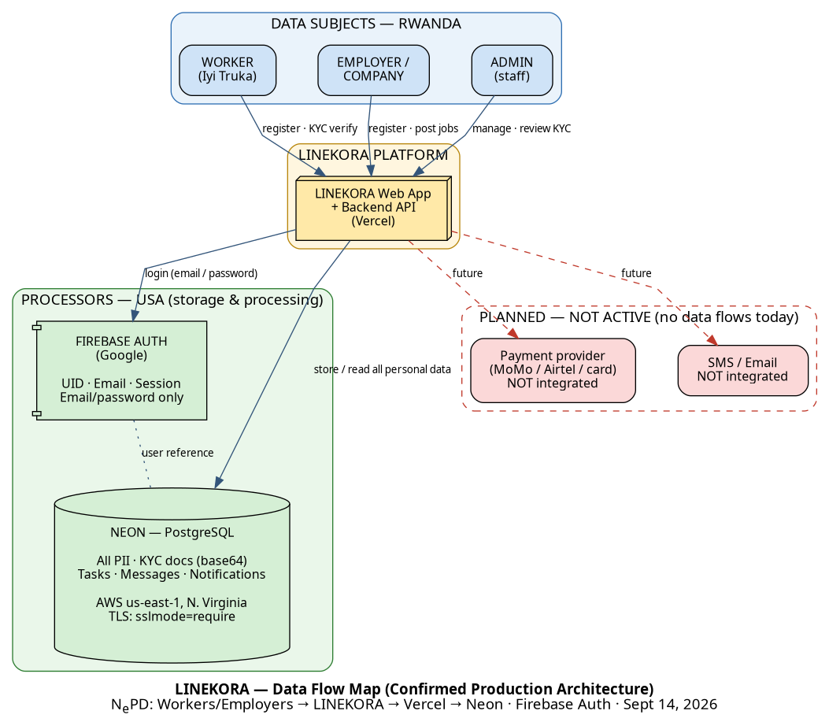
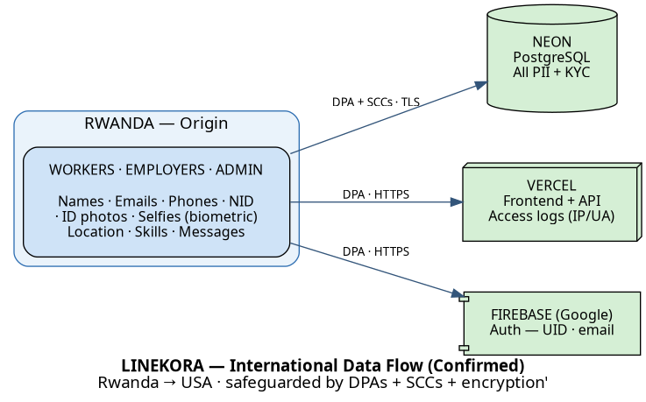
Origin: Rwanda → Storage/Processing: USA (AWS us-east-1 & Vercel/Google US).
Payment, SMS and Email services are planned only — NO data flows to them today.
Diagram sources (re-generate with dot -Tpng ...): diagrams/data_flow_map.dot, diagrams/international_data_flow.dot

International Transfer Justification
Destination | Data | Lawful Basis for Transfer | Safeguards
USA — Neon (AWS us-east-1) | All PII, KYC docs, messages | Consent + Contract | Neon DPA + Encryption (TLS sslmode=require)
USA — Vercel | App traffic, access logs | Legitimate Interest | Vercel DPA + Transmission encryption
USA — Google/Firebase | Auth data | Contractual Necessity | Google Cloud DPA

6. DATA SUBJECT RIGHTS
LINEKORA shall ensure data subjects (Workers, Employers, Admin staff) can exercise:
Right | Description | Implementation
Access | View collected data | Account dashboard + DPO request (Data_Subject_Rights_Policy.md)
Rectification | Correct inaccurate data | Profile editing
Erasure | Request deletion | Account deletion endpoint + DPO request
Restrict | Limit processing | DPO request
Portability | Export data | Data export (planned)
Object | Object to processing | DPO request
Not subject to automated decisions | Trust score does not produce legal effects | Policy + DPIA

7. DATA RETENTION SCHEDULE (SUMMARY)
Data Category | Retention Period | Deletion Method
Worker/Employer PII | Active account + 2 years | Secure deletion
National ID images + selfie (sensitive) | Active account + 2 years | Secure deletion (account deletion endpoint)
Messages & attachments | Account deletion + 2 years | Secure deletion
Job/application data | 7 years (legal) | Archive then delete
Transaction records | 7 years (legal) | Archive then delete
Support tickets | Resolution + 1 year | Secure deletion
Vercel access logs | 1 year | Automatic purge
Firebase sessions/auth tokens | Session end | Automatic expiry
Notifications | Account deletion + 2 years | Secure deletion

Full policy: `Data_Retention_and_Deletion_Policy.md`

8. SECURITY MEASURES (CURRENT STATUS)
Measure | Status
Encryption in transit (TLS) — DB confirmed (sslmode=require); Vercel HTTPS | Confirmed
Access controls — role checks (WORKER/COMPANY/EMPLOYER/ADMIN); verification docs admin-only | In code
Data Protection Agreements on file | Pending — download official DPAs (Neon, Vercel, Google)
Encryption at rest (AES-256) — confirm Neon/Google settings | To confirm in dashboards
Audit logging of data access | Not implemented — action required
Incident response / 72-hour breach notification | Policy drafted (Data_Breach_Response_Policy.md) — build contact list

9. COMPLIANCE STATUS — MILESTONE TRACKER
# | Milestone | Status | Target Date | Notes
1 | Data Controller Registration (RDB/NCSA) | Completed | — | Certificate obtained
2 | Data Inventory & Flow Map (real architecture) | Completed | — | Verified from production config (Sept 14, 2026)
3 | DPIA | Draft complete | — | DPIA_LINEKORA.md — needs DPO sign-off
4 | DPA — Neon (official, on file) | Pending | — | Download from Neon
5 | DPA — Vercel (official, on file) | Pending | — | Download from Vercel
6 | DPA — Google/Firebase (official, on file) | Pending | — | Download from Google Cloud
7 | DPO Authorization — transfer outside Rwanda | Blocked | — | Requires DPAs (#4-6) + current inventory
8 | DPO Authorization — storage outside Rwanda | Blocked | — | Requires DPO Authorization (#7)

10. STATUS LEGEND
Status | Meaning
Completed | Milestone finalized
In Progress | Actively being worked on
Pending | Prepared, waiting to be completed
Blocked | Cannot proceed until prerequisite met

Document prepared for LINEKORA Data Protection Compliance
Pursuant to Rwanda's Data Protection Law No. 058/2021 of 13/10/2021 & PDPB No. 3/2021
Last Updated: September 14, 2026
Verified against: `linekora-backend/.env` (Neon us-east-1), `linekora-backend/vercel.json` (Vercel backend), `linekora/firebase-applet-config.json` (Firebase), `linekora/vercel.json` (Vercel frontend)

