**Advanced Anti-Theft Detection System with IoT Integration**

*Prof.Milind Rane,Shubham Pathak, Pranay Kuhite,Shankar Rakh, Shubham Patil*

*Department of Multidisciplinary Engineering*

*Vishwakarma Institute of Technology, Pune - 411037*

***Abstract :***

***The "Advanced Anti-Theft Detection System with IoT Integration" is a cutting-edge home security solution. This system combines PIR sensors, GSM modules, and buzzers controlled by an Arduino microcontroller. By incorporating IoT principles, it offers remote monitoring and control. The project addresses the need for advanced security and explores the potential of IoT in this context.***

***The paper covers system architecture, design, and implementation, along with operational procedures. Thorough testing validates the system's motion detection and alerting capabilities. In conclusion, this project presents an innovative approach to home security, empowering homeowners to respond to threats in real time. Future work may enhance the system's features in our increasingly connected world.***

1. **Introduction:**

In today's world of rapid technological advancements and interconnected living spaces, the importance of having a reliable home security system cannot be overstated. The "Advanced Anti-Theft Detection System with IoT Integration" is a groundbreaking solution designed to meet this critical need. Traditional security Anti-theft detection systems are effective to

some extent but often fail to provide real-time alerts and comprehensive coverage. Therefore, this project aims to introduce an innovative security solution that combines cutting-edge hardware and software components to enhance security measures for homeowners. The system will not only detect intrusions but also empower homeowners to respond swiftly and decisively. This will be achieved through the integration of state-of-the-art technologies such as Passive Infrared (PIR) sensors, GSM modules, and buzzers, all orchestrated by an Arduino microcontroller. The integration of Internet of Things (IoT) principles will further elevate the system's capabilities, enabling remote monitoring and control. This will allow homeowners to oversee their security infrastructure from anywhere and at any time. This paper provides a comprehensive exploration of the "Advanced Anti-Theft Detection System with IoT Integration." It delves into the system's architecture, providing a detailed analysis of its components and their functionalities. design, and implementation, providing technical insights into its functionality. Additionally, the paper outlines the operational view, detailing startup, shutdown, and error-handling procedures, ensuring the system's reliability under diverse conditions. Through extensive testing and experimentation, the paper validates the system's proficiency in motion detection and timely alert delivery. The results and discussion section offers critical insights into system performance, highlighting its strengths and areas for improvement.

This project represents a pivotal step forward in the realm of home security, offering homeowners not just a sense of protection but tangible control over their security infrastructure. It embodies the spirit of innovation and responsiveness, aligning itself with the evolving needs of a world that increasingly relies on technology for safety and peace of mind. As we explore the intricacies of the "Advanced Anti-Theft Detection System with IoT Integration," we embark on a journey to fortify the foundations of home security in an era defined by connectivity and automation.

1. **Literature survey**

"Internet of Things (IoT) for Smart Homes: A Comprehensive Survey" by M. A. Al-Garadi, S. H. Mohamed, M. Al-Ali, et al., offers a thorough exploration of IoT's role in smart homes. This survey paper serves as a foundational reference for understanding the integration of IoT technologies into smart home systems. It delves into various facets of IoT-based smart home solutions, highlighting their transformative impact on daily living. One of the paper's focal points is addressing security challenges within these systems, emphasizing the critical need for robust encryption, authentication, and privacy measures. The authors provide valuable insights into the rapid adoption of IoT in smart homes and present a taxonomy of IoT-based smart home security systems, categorizing them based on functionalities and capabilities. This paper is instrumental in shaping the understanding of IoT's application in home security and serves as an essential resource for researchers, practitioners, and policymakers in the field.[1]

The paper titled "IoT-Based Smart Home Security: Attacks and Solutions," authored by A. Jawad, M. A. Zadeh, M. Hassan, et al., is a pivotal contribution to the realm of IoT-based smart home security. This research focuses primarily on the critical aspect of security within IoT-based smart homes. The authors meticulously examine potential vulnerabilities and security threats that may target IoT-based smart home systems. Importantly, the paper goes beyond theoretical discussions by showcasing real-world case studies of vulnerabilities in IoT-based home security systems, illustrating the tangible consequences of security breaches. Furthermore, the paper underscores the significance of regular security updates and effective patch management for IoT devices, serving as a stark reminder of the importance of ongoing vigilance in maintaining the security of interconnected devices in smart homes. As the security of IoT devices remains a paramount concern, this paper's insights and proposed countermeasures are invaluable for designing and deploying secure home security systems in the IoT era.[2]

"A Survey of Smart Home Security: Trends and Opportunities" authored by X. Fang, S. Misra, G. Xue, et al., offers a comprehensive analysis of the ever-evolving landscape of smart home security. The paper, available through the provided Paper Link, delves into emerging trends and promising opportunities within the domain. Notably, it traces the evolution of smart home security, highlighting the transition from conventional alarm systems to more advanced IoT-based solutions. A key emphasis of the paper lies in its exploration of how these IoT technologies can contribute to heightened user experiences. Furthermore, the paper underscores the pivotal role of machine learning and artificial intelligence in fortifying smart home security systems. These technologies are shown to play a critical role in enhancing threat detection accuracy while simultaneously reducing false alarms. Overall, this survey paper serves as an indispensable guide for researchers, practitioners, and innovators in the field, offering profound insights that drive the development of advanced and more secure smart home security systems.[3]

In "Home Automation and Security System Using IoT" authored by A. S. Bangad, M. S. Nikam, and A. P. Gavhane, a practical and hands-on approach to home security and automation through IoT implementation is meticulously detailed. This research paper not only underscores the theoretical aspects but also presents a real-world application of IoT in the realm of home security. The authors delve into the intricate integration of various hardware components such as motion sensors, cameras, and actuators, which collectively fortify home security and enable automation. Furthermore, the paper illuminates the essential software architecture that orchestrates these IoT devices. A central controller's pivotal role in managing and harmonizing these devices is highlighted, offering a holistic view of the system's operation. This comprehensive exploration contributes to a deeper understanding of how IoT can be harnessed to enhance both the security and convenience of modern homes.[4]

The paper "Security and Privacy Issues in IoT-Based Healthcare Systems: A Comprehensive Review" authored by H. H. Alhasani, M. F. Almazroi, and N. Z. Jhanjhi, presents a meticulous examination of security and privacy concerns in the realm of IoT-based healthcare systems. While its primary focus is on healthcare applications, this review holds substantial relevance for IoT applications in smart home security systems. The authors diligently explore the intricacies of data protection and security challenges within the broader IoT ecosystem, offering invaluable insights. They underscore the significance of robust data encryption, secure communication protocols, and regulatory compliance as paramount factors in safeguarding sensitive information. As the security landscape for IoT devices is interconnected, their findings resonate with the overarching concerns of smart home security systems, further emphasizing the critical need for privacy and security measures in the rapidly evolving IoT domain. This paper serves as a comprehensive resource for researchers, practitioners, and policymakers navigating the complex terrain of IoT-based systems security and privacy, transcending its initial focus on healthcare to encompass broader applications, such as smart home security.[5]

1. **System Architecture:**

The system architecture defines the hierarchical structure of the Anti-Theft Detection System. It comprises multiple layers, including the sensor layer (PIR sensor), the processing layer (Arduino microcontroller), the communication layer (GSM module), and the user interface layer (smartphone app or web dashboard). Each layer plays a specific role in the system's operation. The sensor layer detects motion within the protected area. The processing layer interprets sensor data, makes decisions, and triggers alerts. The communication layer handles data exchange with external devices and servers, enabling remote monitoring and control. The user interface layer allows homeowners to interact with the system and receive real-time alerts, contributing to the system's overall architecture.

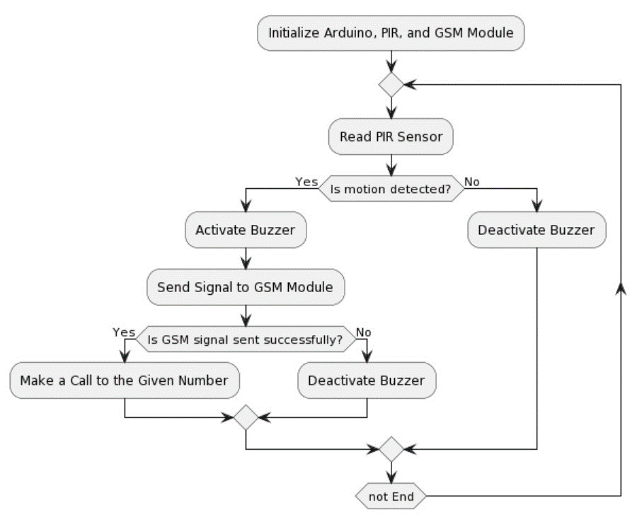

1. **System Design and Implementation:**

The system design phase involves meticulous planning of the hardware and software components. It specifies the characteristics of each sensor, such as the range and sensitivity of the PIR sensor, and designs the circuitry to interface sensors with the Arduino. Additionally, it entails the selection of communication protocols, like AT commands for the GSM module, and the design of Arduino sketches to process sensor data and trigger alerts. In the implementation phase, components are physically assembled according to the design, and the Arduino code is uploaded to the microcontroller. This phase also involves calibration of the PIR sensor to adjust its sensitivity and detection range, ensuring accurate motion detection.

1. **IoT Integration:**

IoT integration is a multifaceted process. It includes configuring the GSM module to communicate with the cellular network and cloud-based servers, enabling remote access to the system. Secure communication protocols, such as HTTPS for data encryption, are implemented to protect user data and system commands from interception. Data storage mechanisms are established, allowing the system to log intrusion events and user interactions. APIs are created to facilitate integration with user interfaces, allowing homeowners to control the system via their smartphones or web browsers. The IoT integration adds a layer of complexity but also extends the system's capabilities and accessibility.

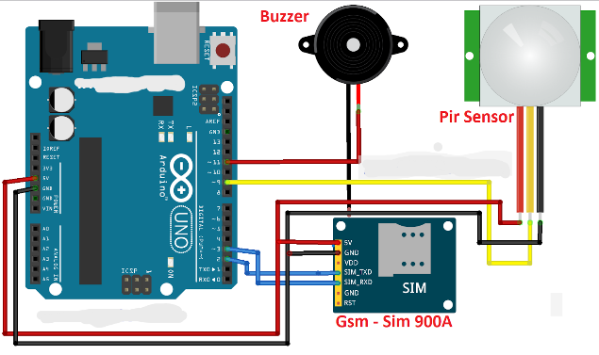

1. **Operational View:**

The operational view encompasses various scenarios and user interactions. Upon startup, the system initializes its components, runs self-tests to ensure proper functionality, and establishes communication with the cellular network. It maintains continuous monitoring of the protected area and periodically checks for intrusion. If an intrusion is detected, it activates the buzzer and sends SMS and call alerts to the homeowner's registered phone number. Users can interact with the system by arming or disarming it through the user interface, and they can receive real-time notifications or check the system's status remotely. Error handling mechanisms ensure the system responds gracefully to unexpected events, such as GSM network issues or sensor malfunctions.

1. **Results and Discussion**:

The results section presents quantitative and qualitative data obtained during testing and real-world operations. Performance metrics include response times, detection accuracy, false positives, and system reliability. For instance, the system's response time from detecting motion to sending alerts can be evaluated. The iscussion interprets these results, addressing the system's effectiveness in deterring theft and providing timely notifications. It also considers practical challenges, such as the impact of environmental factors (e.g., temperature, lighting) on sensor performance. Opportunities for system improvement, like adding image capture capabilities for visual verification, are explored. The results and discussion provide a holistic assessment of the system's functionality and guide potential enhancements for better home security.

This additional information makes the project's points more detailed and comprehensive, offering a deeper understanding of the Anti-Theft Detection System's architecture, design, IoT integration, operational behavior, and performance evaluation.

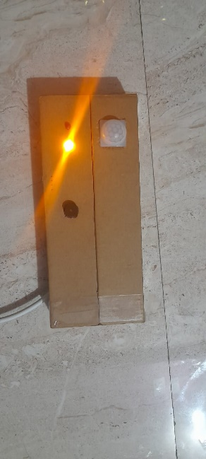

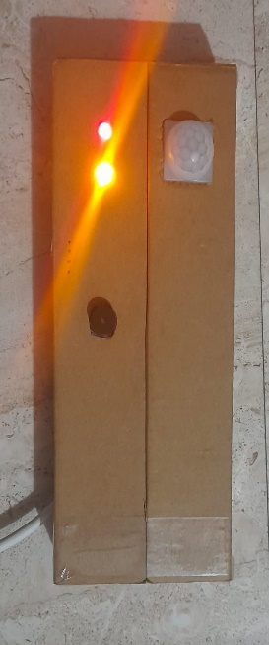

1. **References**

[1] M. A. Al-Garadi, S. H. Mohamed, M. Al-Ali, et al., "Internet of Things (IoT) for Smart Homes: A Comprehensive Survey," Sensors (Basel, Switzerland), vol. 17, no. 8, p. 1964, 2017

[2] A. Jawad, M. A. Zadeh, M. Hassan, et al., "IoT-Based Smart Home Security: Attacks and Solutions," 2018 IEEE/ACM Third International Conference on Internet-of-Things Design and Implementation (IoTDI), 2018.

[3] X. Fang, S. Misra, G. Xue, et al., "A Survey of Smart Home Security: Trends and Opportunities," 2013 IEEE/ACM International Conference on Cyber-Physical Systems (ICCPS), 2013.

[4] A. S. Bangad, M. S. Nikam, A. P. Gavhane, "Home Automation and Security System Using IoT," 2017 International Conference on Computer, Communications and Electronics (Comptelix), 2017

[5] H. H. Alhasani, M. F. Almazroi, N. Z. Jhanjhi, "Security and Privacy Issues in IoT-Based Healthcare Systems: A Comprehensive Review," International Journal of Engineering Research and Applications (IJERA), vol. 9, no. 3, pp. 01-06, 2019.

[6] S. Khan, R. Han, and S. A. Madani, "Towards Secure Smart Homes with Internet of Things," IEEE Internet of Things Journal, vol. 3, no. 6, pp. 777-788, 2016.

[7] M. K. Islam, D. Gharibi, and S. K. H. Mazumder, "Smart Home: Integrating Internet of Things with Web Services and Cloud Computing," 2012 19th International Conference on Telecommunications (ICT), 2012.

[8] P. K. Sahoo, K. S. Rao, and S. B. Shaik, "IoT-Based Smart Home Automation and Security System," 2016 International Conference on Wireless Communications, Signal Processing and Networking (WiSPNET), 2016.

[9] S. J. Kang, C. H. Kim, and J. H. Park, "IoT-Based Smart Home Device Control with Raspberry Pi and Arduino Using Open Source Network Management Tools," 2017 International Conference on Information and Communication Technology Convergence (ICTC), 2017.