Analog Ising chain simulation with transmons
G. Fedorov^{1,2}, E. Egorova^{1,2}, A. Dobronosova³, N. Orlikovskiy³ and A. Ustinov^{1,4}
¹Russian Quantum Center, Moscow, Russia
²Moscow Institute of Technology, Dolgoprudniy, Russia
² Bauman MSTU, Moscow, Russia
³Karlsruhe Institute of Technology, Karlsruhe, Germany
E-mail: gleb.fedorov@phystech.edu

Currently, the applications of medium-scale systems composed of superconducting qubits are mostly limited to testing basic principles of quantum computation, demonstrating those as proof-of-concept designs and developing scalable software and hardware interfaces to them. Although this is useful in terms of encouraging future developments in the domain, an alternative approach exists to exploit the built-in quantum properties of such devices to experiment with fundamental physical models. There already were [1], [2] some successful attempts to use small arrays of superconducting qubits to observe inherently quantum analog behaviour of these systems, and this work is aimed to continue those studies.
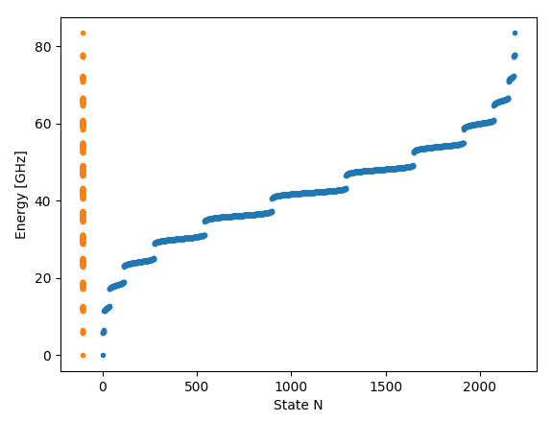
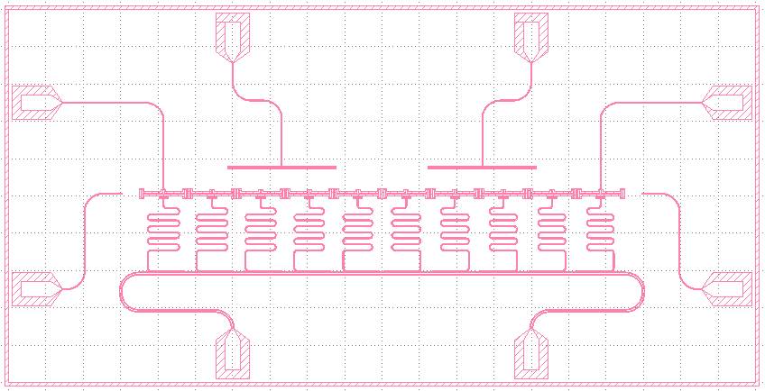

Fig. 1. The design concept (left). 10 transmon quibits are arranged into a chain with transverse coupling whose state can be read out at each site. Two area-of-effect microwave drives are present, as well as full XYZ controls at the chain edges. (Right) Computed spectrum of the system with a slight disorder. Clearly, the energy bands are emerging even for a small transmon number of 6.
We are developing a chip to experimentally simulate crystal structure, many-body localization (MBL) and heat transport properties with a chain of XX-coupled transmons. First results will be concerning spectroscopic properties of the system.

References
- Roushan, P., et al. Science 358.6367, 1175-1179 (2017)
- Macha, P., et al. Nature communications 5, 5146 (2014)

