NioGram
Grammar Analysis Tool

User Manual

Version 1.0.0

Copyright (c) by Nikolay Ognyanov, 2018

1. Introduction

NioGram is a tool for LL(k) syntax analysis of context free grammars. Such analysis can be benefitial in the process of language and grammar design and for the process of hand-coded parser implementation.
At present the only directly supported by NioGram grammar specification language is the language of ANTLR 4. The grammar model and analysis methods of NioGram though are not dependent on any specific grammar specification language. If an appropriate parser to NioGram AST is implemented then NioGram can process grammars specified in other languages such as e.g. JavaCC, YACC, Bison etc.
This manual assumes that the readers are familiar with the theory of grammar directed syntax analysis. Readers who need to refresh or acquire knowledge in the subject will need to first look into any of the available compiler design books. The one most favored by the NioGram author is [1].
Familiarity of the readers with the ANTLR 4 parser generator is also beneficial since NioGram can process grammars defined in the ANTLR 4 grammar specification language. A starting point for access to relevant information is the site at http://www.antlr.org/. As a matter of convenience further in this manual ANTLR 4 is referred to as simply “ANTLR”.

2. Product Overview

2.1. Use Cases

2.1.1. ANTLR IDEs

In ANTLR IDEs the data from NioGram analysis can be used to signal possible grammar inefficiencies and bugs. In the author's opinion this can be extremely helpful for ANTLR grammar developers.

2.1.2. Command Line Tool
NioGram provides a command line tool which servers the same purpose as the potential ANTLR IDE enhancements but in a less convenient way.

2.1.3. Code Generation
NioGram generates analysis data artefacts to be used in hand-coded parsers and simple recursive descend parsers.

2.2. ANTLR Grammar Syntax Analysis
ANTLR implements an extremely powerful parsing strategy. It can deal with almost any grammar which lacks indirect left recursion. For developers this power is both a blessing and a curse. During grammar development ANTLR provides no diagnostics of possible grammar inefficiencies and even outright bugs. NioGram mitigates this problem by providing tools for traditional LL(k) syntax analysis of ANTLR grammars. The information computed in the process of NioGram analysis is as follows:
- Nonterminal productivity
- Nonterminal reachability
- Nonterminal use
- Nonterminal nullability
- Grammar dependency graph
- Simple cycles in the grammar dependency graph
- Strongly connected components of the grammar depencency graph
- Left-recursive cycles in the grammar
- First/Follow sets
- FirstK/FollowK sets
- Linearized FirstK/FollowK sets
- Conflicts

Perhaps most important for ANTLR grammar development is the information about LL(k) conflicts. Even though ANTLR will typically deal with those automatically, the grammar author will be prompted to look into the corresponded rules for inefficiencies, ambiguities and bugs.

2.3. Hand Coded Parser Development
Despite the existence of excellent parser generator tools, hand-coded parsers are still being developed even for A-list languages such as Java. More often than not though the analysis data needed for hand coding is very difficult to collect by hand. Unfortunately there appear to be no publicly available tools for automatic computation of the needed data. NioGram fills this gap by providing the analysis information described above. Furthermore, since NioGram grammars are also ANTLR grammars, hand-coded parsers can be validated against parsers generated by ANTLR. NioGram also facilitates integration of generated parsers with ANTLR lexers.
In a bit more detail :
First order of business in grammar development is to clean up the grammar of (usually buggy) non-productive nonterminals and left recursion. Doing this by hand is usually feasible but with NioGram analysis the task is considerably easier to accomplish and verify. Then the typical situation will be :
- Most rules are LL(1)
- Some rules are LL(k) with small k > 1.
- A few rules may be not LL(k) for any k.
If the situation is worse than this then the language is either old, influential and bloated or poorly designed (or both). Apart from the subject of language implementation LL(k) properties of the grammar are highly important from the standpoint of ease of comprehension of the language by its "speakers".
Finding out which rules belong to which of the above categories is a crucially important task in parser development. Doing this by hand though is very far from trivial. Even very talented and experienced developers can easily make mistakes. NioGram on the other hand fully authomates the task and thus makes it cheap and error free.
Parsing of the LL(k) rules can be easily implemented by hand in a recursive descent parser if the FirstK/FollowK sets are known. This is more often than not a really big "IF" since the FirstK/FollowK sets for higher level nonterminals tend to be quite sizeable. Collecting the information by hand is very tedious and error prone. It is highly questionable whether the task is even feasible for "serious" language grammars. NioGram fully automates the process. Thus feasibility is always guaranteed and a lot of time for development and even more time for testing and debugging is saved.
The non-LL(k) rules (if any) have to be resolved by one or more of the following:
- Context dependency
- Temporary switch to a different parsing strategy
- Temporary switch to a different grammar
- Ad hoc tricks
NioGram strives to facilitate the above solutions with code generation support.

3. Code Overview

3.1. Project Structure
The NioGram project is Maven – based and has a fairly standard folder layout. All sources reside under the top level folder src. Documentation resides in the top level folder doc.
All Java packages are in the net.ognyanov.NioGram “domain”. And the packages are:
- analysis Tools for LL(k) analysis of grammars.
- ast The AST model.
- generator The code generator.
- parser The parser.
- tool The command line tool.
- util Various utility classes used by other packages.

3.2. Project Build
It is a standard Maven build:
mvn install
This generates in the target folder the following artefacts:

- NioGram-x.y.z-SNAPSHOT.jar – the compiled product without dependencies
- NioGram-x.y.z-SNAPSHOT-src.tar.bz2 – the product sources in bz2 package
- NioGram-x.y.z-SNAPSHOT-src.tar.gz – the product sources in tar.gz package
- NioGram-x.y.z-SNAPSHOT-src.zip - the product sources in zip package
- NioGram-complete-x.y.z-SNAPSHOT.jar – the compiled product with all dependencies
Where “x.y.z” stays for the current version.

The command line tool is invoked by :

java -jar NioGram-complete-x.y.z-SNAPSHOT.jar

The API documentation is built by

mvn javadoc:javadoc

3.3. Embedding in 3d Party Products
NioGram is meant to be published to Maven central for easy inclusion in third party projects. As of the time of this writing though the code is not mature enough for that. Information will be included here at later time.
Embedding of NioGram in ANTLR IDEs deserves some special attention. Normally an ANTLR IDE maintains its own internal object model of the grammar. Typically a parse tree or a model close to it. Startup IDEs can use the NioGram parse tree as (a starting point for) their grammar object model. Preexisting IDEs with already established grammar models will need to develop a translator from the IDE grammar object model to the NioGram AST grammar model. An example of such parser is the class net.ognyanov.NioGram.parser.GrammarParser. It translates an ANLTR – generated parse tree into NioGram AST tree. The source code of this class should be studied by eventual AST parser implementators. NioGram provides also a small facility meant to facilitate the interlinkig of the two object models – a publicly accessible (through a getter and a setter) field “sourceContext” which is not is available for use by third party AST parsers.

3.4. AST Model
The primary structure of interest for NioGram users is the AST (Abstract Syntax Tree) generated by the AST parser. It holds all substantial information about the grammar in a structured form. The model of the AST is described by the following grammar :
tokens {Nonterminal, Terminal, TerminalRule}

grammar : nonterminalRule* TerminalRule*;
nonterminalRule : alternative+;
alternative : term*;
term : Terminal | Nonterminal | block;
block : alternative*;
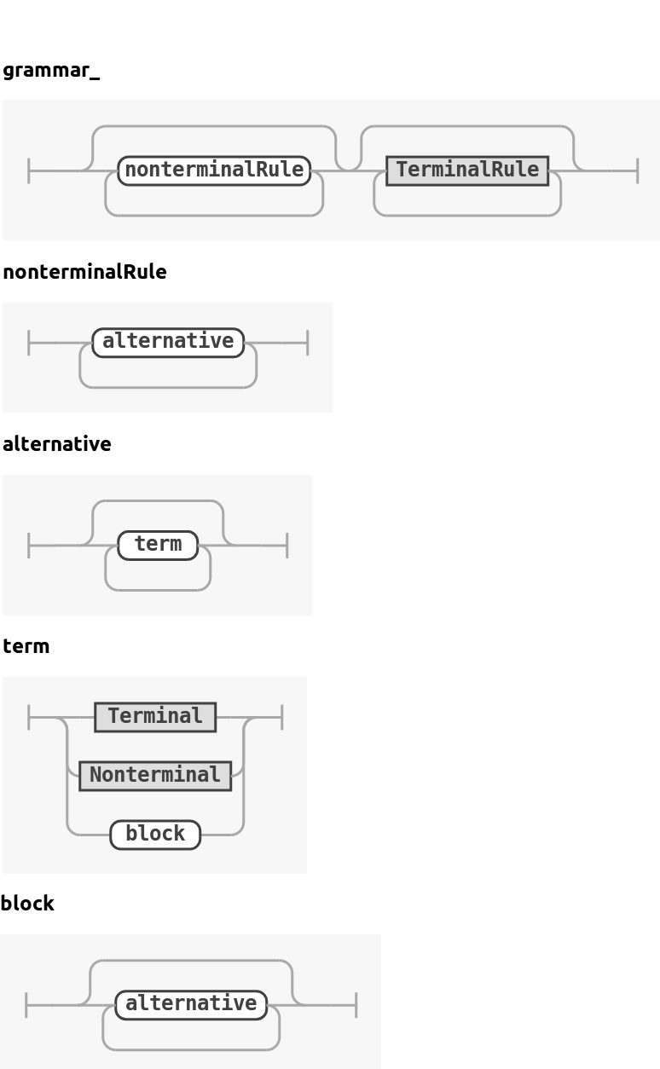

Here the names match up to first letter capitalization the names of the implementing Java classes. The type hierarchy of the implementing Java classes is as follows:

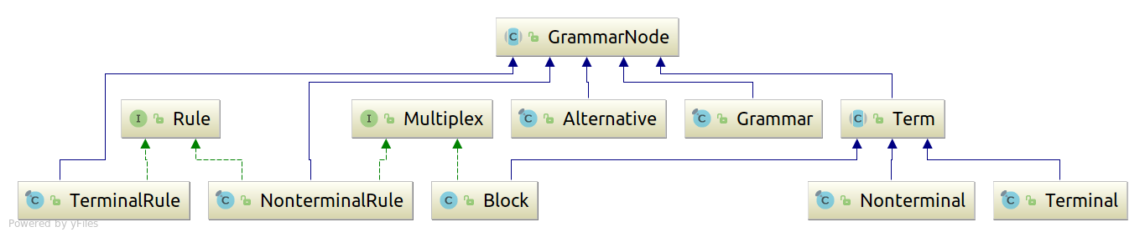

Grammar – related tools tend to have different conventions about the representation of the empty strings in grammar rules. Some use explicit epsilon symbol for that and others do not. NioGram adheres to the second convention and defines no explicit epsilon terminal in its AST model. Empty alternatives are literally empty rather than containing the epsilon terminal.
EBNF occurrence indicators have a representation in AST only for AST blocks. Therefore if other type of term (i.e. - terminal or nonterminal) has an EBNF occurrence indicator in the source text of the grammar then it (the term) is embedded in a dedicated AST block of its own. If an occurrence indicator in the source is one of ‘?’, ‘??’, ‘*’ or ‘*?’ then an empty alternative is inserted into the correspondent block.
For the sake of precision let us finally note that even though the AST is viewed mostly as a tree, technically it is a general directed graph. Rules contain references to all their instances on the right hand side of productions and instances contain references to their correspondent rule.

4. Grammar Specification Topics

4.1. Grammar Types
NioGram focuses primarily on pure parser grammars and provides code generation only for those. Combined grammars are supported for grammar analysis but not for code generation. Processing of pure lexer grammars technically doable but pointless.

4.2. Grammar Imports
ANTLR supports certain type of grammar import into other grammars. This facility is rarely used at all and even more rarely used to import parser rules. NioGram on the other hand is solely focused on parser rules and at this time does not support grammar imports.

4.3. Grammar Options
NioGram supports the token vocabulary grammar option and can import token vocabularies in ANTLR format. Other options are accepted and passed to the client but otherwise ignored. IDE developers may but do not have to choose to resurrect the “k” option from ANTLR 3.

4.4. Dot Expressions
ANRLR supports a feature called dot expressions which is not traditional to parser (as opposed to lexer) grammars. NioGram does not support this feature and converts all such sets to instances of the built-in terminal $DOT. Diagnostic information is provided whenever this happens. With such a substitution further grammar analysis will not be necessarily entirely correct but it may still provide useful suggestions about inefficient or/and incorrect rules.

4.5. Not Sets
ANRLR supports a feature called not sets which is not traditional to parser (as opposed to lexer) grammars. NioGram does not support this feature and converts all such sets to instances of the built-in terminal $NOT. Diagnostic information is provided whenever this happens. With such substitution further grammar analysis will not be necessarily entirely correct but it may still provide useful suggestions about inefficient or/and incorrect rules. Analysis in the presence of not sets could possibly yield somewhat better results if each individual not set was treated as an unique terminal but this enhancement does not appear to have a good enough price/performance ratio.

4.6. String Constants in Nonterminal Rules
The use of string literals in parser (as opposed to lexer) rules is a bad idea. It can be sort of convenience but can have unexpected interference with the lexer rules. ANTLR thow allows this feature, so NioGram has to address it. NioGram first sures that all occurrences of a literal are treated as instances of one single token. Then in combined grammars it tries to identify a declared lexer token which matches exactly the string. If such token is found then the literals are treated as its instances. If not then a new pseudo-token is created and the literals are treated as instances of that token. In the second case correctness of the grammar analysis can not be guaranteed since it is not really known how the lexer will treat these literals.

4.7. Non-greedy occurrence indicators
ANTLR allows for non-greedy occurrence indicators in parser grammars (??, *?, +?). NioGram on the other hand treats all occurrence indicators as greedy. The impact on grammar analysis is difficult to assess exhaustively but is definitely not positive. NioGram provides diagnostic information in such cases.

5. Grammar Analysis Topics

5.1. Start Rule
NioGram always treats the first parser rule as the start rule of the grammar.

5.2. Nonterminal Productivity
NioGram uses the standard definition of nonterminal productivity : a nonterminal is productive if a string consisting of terminals only can be derived from it. Nonproductive nonterminals are an error which has to be eliminated from the grammar before proceeding with further analysis and implementation.

5.3. Nonterminal Reachability
NioGram calculates reachability of nonterminal from the start rule in the dependency graph of the grammar. Normally all nonterminals with the possible exception of the start rule should be reachable. It may happen though that the developer wants to have multiple independent entry points to the parser. The presence of non-reachable nonterminals does not affect the LL(k) analysis.

5.4. Nonterminal Use
NioGram defines use of nonterminals as occurrence on the right side of a parser rule. Normally all nonterminals with the possible exception of the start one should be used this way. It may happen though as noted above that the developer wants to have multiple independent entry points to the parser and those are not otherwise used. The presence of unused nonterminals does not affect the LL(k) analysis.

5.5. Nonterminal Nullability
NioGram uses the standard definition of nullability : a string of terminal and nonterminal symbols is nullable if the empty string can be derived from it. Nullability of nonterminals is important for making parsing decisions. For nullable nonterminals the parser has to consider matches of the input with both the FirstX and the FollowX sets. By FirstX and FollowX here we refer to any type of first/follow set (see below).

5.6. Left-recursive Cycles
NioGram uses the following definition of left-recursive cycles : a sequence of nonterminals n₁,…, n_{k} such that n₁ = n_{k} and for each n_{i} n_{i}+1 is reachable from n_{i} in the grammar dependency graph through a nullable path and the same applies for n_{k} and n₁. The presence of left-recursive cycles inevitably leads to unresolvable LL(k) conflicts and prevents straightforward recursive descent implementation. It does not however invalidate the LL(k) analysis of the grammar.

5.7. First/Follow Sets
NioGram just uses the standard definition . We refer to [1] for that. A brief summary quote from [1] is :
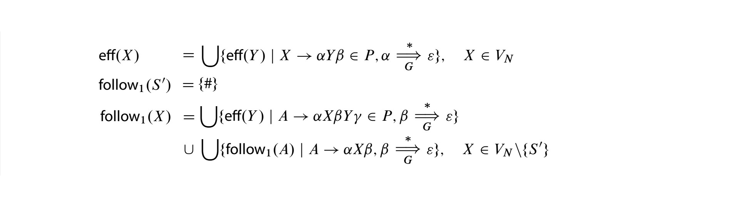
The definition is somewhat complicated by the use of EBNF occurrence indicators in ANTLR parser rules but this is easy to account for. AST blocks are equivalent to anonymous nonterminal rules with a single in-place reference.

5.8. FirstK/FollowK Sets
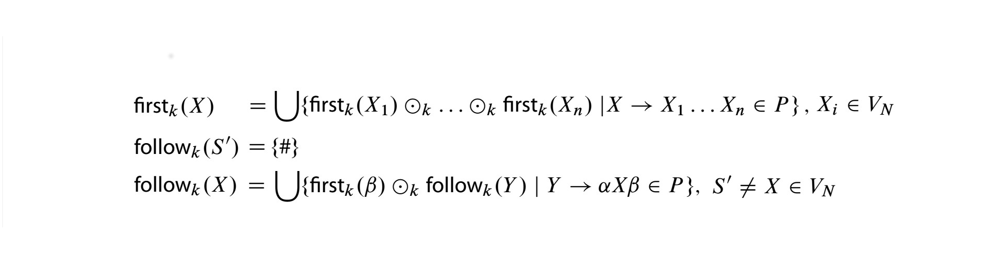
NioGram just uses the standard definition. We refer to [1] for that. A brief summary quote from [1] is :
The definition is somewhat complicated by the use of EBNF occurrence indicators in ANTLR parser rules but this is easy to account for. AST blocks are equivalent to anonymous nonterminal rules with a single in-place reference.

5.9. Linearized FirstK/FollowK “Sets”
Calculation of FirstK and FollowK sets is a computationally expensive procedure. It is usually more practical to use instead the so-called linearized “sets” which NioGram denotes as FirstKL and FollowKL. These “sets” are actually strings of length k of sets of terminal symbols. The set at position i contains all terminals which can occur at position i in a terminal-only string derived from the target string. The FirstKL/FollowKL “sets” have less prediction power than the FirstK/FollowK sets but are much cheaper to compute. Details about NioGram implementation and treatment of these “sets” can be found in the API documentation and the source code.

5.10. Conflicts
LL(k) conflicts occur when 2 or more nonterminal rule alternatives have intersecting FirstX sets and the parser is not able to choose between these alternatives based on lookahead into the input. Unless the conflicts stem from the presence of a left-recursive cycle, they can always be solved in a recursive descent parser by backtracking. Backtracking however is computationally expensive and often it is more appropriate to resolve the conflicts by choosing the first matching alternative or an alternative enforced by a semantic predicate. Both options however can mask ambiguities in the grammar which are generally speaking undesirable.
For nullable nonterminals there can also be FirstX/FollowX conflicts where the FirstX set of one or more alternatives intersects with the FollowX set of the nonterminal. Such conflicts are resolved similarly to the FirstX/FirstX conflicts.
NioGram calculates conflict information as part of the FirstX/FollowX calculation. Conflicts are calculated for each alternative in rules and blocks. In addition to this, NioGram calculates for blocks and nonterminal FirstX/FollowX conflicts. In case that a conflict of certain type does not exist, NioGram computes the minimum amount of lookahead for which the conflict still does not exits.

5.11. Terminal Occurrence Traces
When a terminal occurs in a conflict set it is good to know where the terminal “came from”. The answer to the question where do the terminals in FirstX/FollowX sets “come from” can be of interest in other cases too. Therefore NioGram supports computation of terminal occurrence traces. We will skip here the formal definition based on sequences of productions (which is rather straightforward) and will present instead an example. Let us consider the following grammar :

grammar traces;
tokens {A, B, C, D, E}
a : b | c | d;
b : B | A b;
c : E | C? d;
d : D | A d;

The terminal ‘A’ occurs at position 0 in the FirstX set of nonterminal ‘a’. It also participates in a conflict between all 3 alternatives for ‘a’. There are 3 paths through the AST which lead from the occurrence of ‘A’ in the FirstX set of ‘a’ to the possible sources of that occurrence. The endpoints of those paths are the occurrences of ‘A’ in the rules for ‘b’ and ‘c’. Two of the paths overlap to some extent since they both pass through the rule for ‘d’. Note also that one of the paths passes through the occurrence of ‘C’ in the rule for ‘c’. That ‘C’ does not contain ‘A’ in its FirstX set but is nullable and therefore – “transparent” for ‘A’. And the complete trace for ‘A’ at position 0 in the FirstX set of ‘a’ looks as follows:

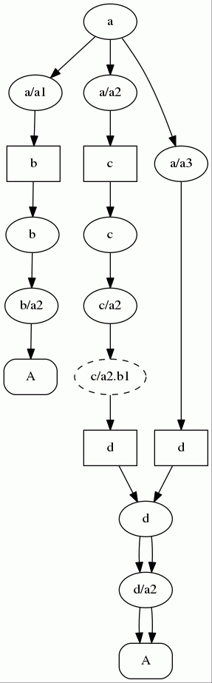

Generally a terminal occurrence trace is a directed acyclic graph which is a subgraph of the AST. Here we need to remind that in addition to the primary tree structure the AST also contains references from rules to their instances on the rhs of productions and from instances to their correspondent rules. Occurrence traces traverse the links from occurrences to their correspondent rules. All nodes in the trace either contain the specified terminal at the specified position in their FirstX/FollowX set or are nullable. Nullability is signaled in the image above by dashed edges of the correspondent node. NioGram supports computation of terminal occurrence traces for the following set types : First, FirstK, FirstKL, Follow, FollowK, FollowKL.
Note that whenever NioGram computes FirstX/FollowX sets, it computes those sets not only for the rules but also for the root Grammar node of the AST. Therefore it is possible to compute grammar-wide traces of terminal occurrence.

6. Hand-Coded Parser Support
NioGram does not yet generate code. Even so though the results of its analysis can be used in hand-coded parsers. The command line tool has an option to record a serialized version of the analyzed grammar. This serialized object can be later deserialized and used in a hand-coded parser. Deserialized grammar objects can also be used in tools which generate more convenient and efficient analysis data artefacts for use in hand-coded parsers.
The process of serialization/deserialization has two caveats as follows:
The “unique” IDs of grammar nodes are only unique within a single running Java virtual machine. This may cause problems if nodes from different JVMs are mixed e.g. in the same container because the equality and hashing of grammar nodes are based for the sake of efficiency on the “unique” IDs only. It is (so far) the belief of the NioGram author that resolving these issues by more rigorous equality/hashing or by truly globally unique IDs would be an overkill.
The content of the source context and payload fields of grammar nodes is not retained in the serialization/deserialization process. This is a design decision rather than a limitation of the technology.

7. Grammar Visualization
NioGram provides DOT format printouts of the grammar parse tree, the grammar AST, the railroad diagrams of all rules and the terminal occurrence traces. The parse tree and the AST can also be printed out in XML format.

8. Literature
[1] R.Wilhelm, H. Seidl, S.Hack : Compiler Design – Syntactic and Semantic Analysis, Springer 2013

