This is the test mechac has done, the highlighted example is for the student called Nelson Amani

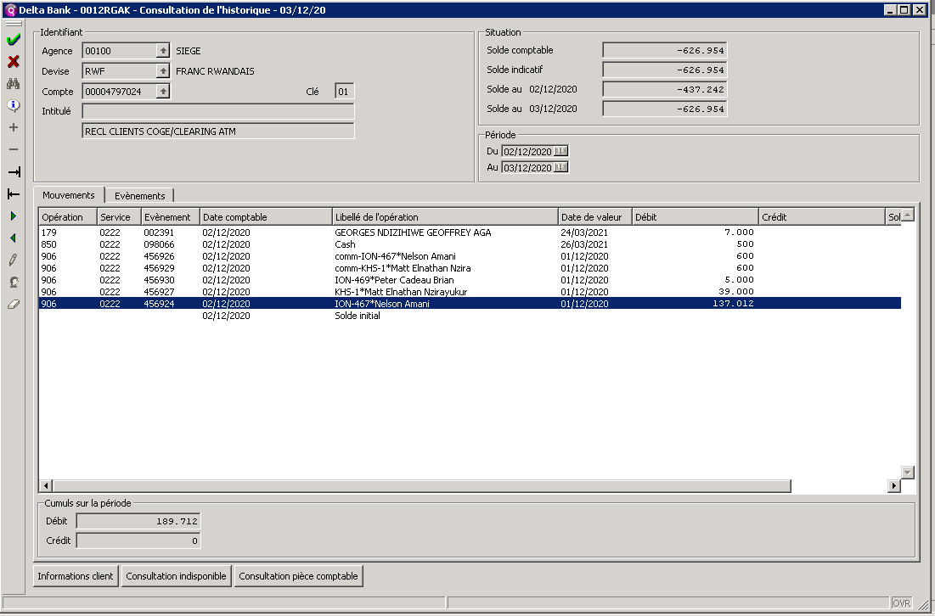

This is the counting(comptabilisation) of that example

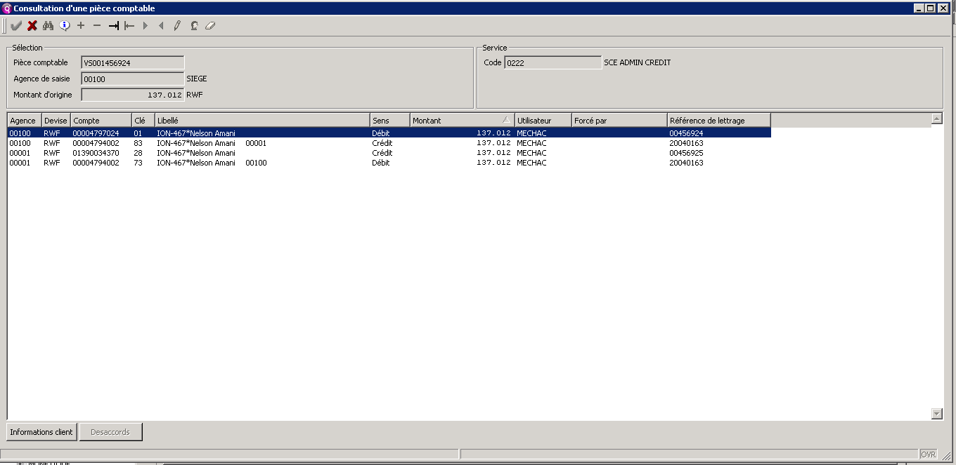

The third screen shows the commission paid!

