Grp arbete:

Vi hade från början ett nedbryttning av project.

Brött ner proj så detajerad så möjligt och skappade Jira "Epic" med reps "Task".

- Så till att allaförstod vad rep Epic/Task innehöll samt att de är lagom stora.

- Epic/Task - tilldelades ut till medlemarna i team.

- Ett gemensamt kod bas och struktur.

- Satte tidig namn definitionen på de mother som alla teamet har ett beroende till. (klass interface som definerar vilka metoder som hebövs i proj)

- Förmiddags avstämning (kort ang vem som gör vad och om det finns olkarhet) max tid 20-30min.

- Längre avstämning under eftermiddag av kod som är klar.

- Fritt parprogrammering vid behov.

- Avstämning i Jira vilka Epic/Task status

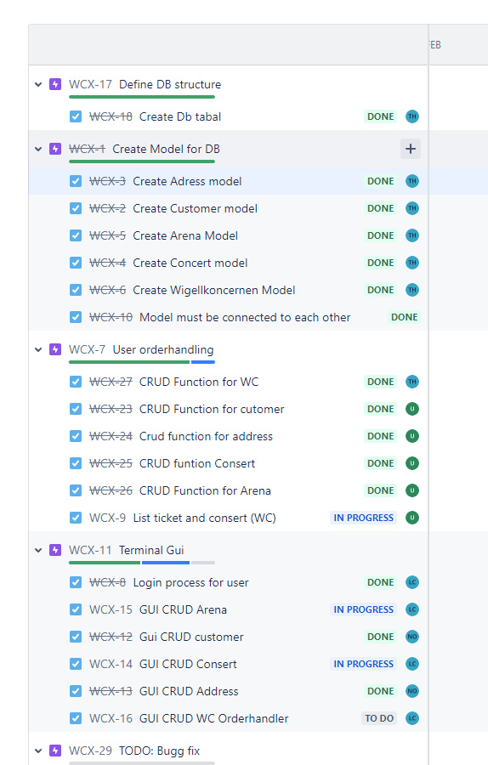

Git LOG: on project

commit 162343fb4146c84816f8e530c8345b5f6d430b6d (HEAD -> main, origin/main, origin/HEAD)

Author: Nils Ottosson <info@noidea.se>

Date: Sun Mar 17 21:44:50 2024 +0100

done bugg fix

commit d0ff8377faecd6a195e71f629e739f780043d8cd

Author: Nils Ottosson <info@noidea.se>

Date: Sun Mar 17 21:16:12 2024 +0100

more bygg fix

commit 1bca8918c29cd1053edbf6e96a6329a2b33935ff

Author: Nils Ottosson <info@noidea.se>

Date: Sun Mar 17 20:26:43 2024 +0100

fix cunstmer order

commit 8027b9b648cb64ff85f087d13fea544238a8e01b

Author: Nils Ottosson <info@noidea.se>

Date: Sun Mar 17 11:32:06 2024 +0100

new project-zip

commit 2261694e8b517e6efadf92915094bcfcf3e7f19d

Author: Nils Ottosson <info@noidea.se>

Date: Sun Mar 17 09:02:31 2024 +0100

fix selection on menu depend on users rolestype

commit 19ec5380bfece6a9681bea7a219c7102d69aa3ba

Author: Nils Ottosson <info@noidea.se>

Date: Sun Mar 17 08:45:36 2024 +0100

add attribut Role with default 1 to entity for cunstomer

commit 549223e754f199b081e1261dc881410129eb265e

Author: Nils Ottosson <info@noidea.se>

Date: Sun Mar 17 08:36:07 2024 +0100

new project-zip

commit fc0f06ed03743b2406f64ce337c3cc821ee56c15

Author: Nils Ottosson <info@noidea.se>

Date: Sun Mar 17 08:35:19 2024 +0100

Add @Tarek and @Urban WcDBHandling service

commit 44f3e11635d57c0eaac5f0cd9a8d9bd6cef53831

Author: Nils Ottosson <info@noidea.se>

Date: Sat Mar 16 17:44:53 2024 +0100

add new zip påroject and remove unuse file

commit 168af0bafd63674d4f9fd69d637d5cb04fa74cef

Author: Nils Ottosson <info@noidea.se>

Date: Sat Mar 16 17:40:42 2024 +0100

menu for customer, change customer profile

commit 395abb026e7c8963322a5a2e11f9d5edcb66ec8b

Author: Nils Ottosson <info@noidea.se>

Date: Sat Mar 16 12:16:23 2024 +0100

upload new project zip

commit 884f361043bae5cc0cd1993faccd327108ec5bda

Author: Nils Ottosson <info@noidea.se>

Date: Sat Mar 16 11:39:11 2024 +0100

export new project zip file

commit 8273d4e92d579ec445de1c83e19648fab310a536

Author: Nils Ottosson <info@noidea.se>

Date: Sat Mar 16 11:38:10 2024 +0100

Add @Tarek and @Urband databaseService and fix GUI intergration between thems

commit c422fd56f4ba69be48e517b5be898b643bd8174e

Author: Nils Ottosson <info@noidea.se>

Date: Fri Mar 15 14:39:59 2024 +0100

Update project zip file

commit b619bc35e3ad929b1198ad2712f724c1021f257d

Author: Nils Ottosson <info@noidea.se>

Date: Fri Mar 15 14:38:55 2024 +0100

Update/Delete is done

commit aa703aad5cbc048f594b8b3795f1c2ceaad5c914

Author: Nils Ottosson <info@noidea.se>

Date: Fri Mar 15 14:16:40 2024 +0100

done with update and upload new project zip

commit c6e380b1635d2c894ab7f7810212ab3ac6d099a7

Author: Nils Ottosson <info@noidea.se>

Date: Fri Mar 15 07:55:08 2024 +0100

submenu for customer handling

commit 5501838ce0c31292e7ed4f02d65decd9a5c3d314

Author: Nils Ottosson <info@noidea.se>

Date: Thu Mar 14 17:15:32 2024 +0100

export to zip

commit 492c579adceb7de5e1636b8c748f04e5c6086ff4

Author: Nils Ottosson <info@noidea.se>

Date: Thu Mar 14 16:46:24 2024 +0100

some chane

commit 658b87d1194d4e602888327a8385249dad4ec6c7

Author: Nils Ottosson <info@noidea.se>

Date: Thu Mar 14 16:06:02 2024 +0100

get address from customer

commit b38b428bd3d1da5d545e512346d4301aa7bbfeca

Author: Nils Ottosson <info@noidea.se>

Date: Thu Mar 14 13:57:26 2024 +0100

get address from customer

commit f77caae942ec95cc88b529735fb5ae45a8fd7d8c

Author: Nils Ottosson <info@noidea.se>

Date: Thu Mar 14 12:53:48 2024 +0100

create and modify view for customer and address, create interface for db handling

commit 36e516886416e6addb921cf6adf0bfcf26744716

Author: Nils Ottosson <info@noidea.se>

Date: Thu Mar 14 11:54:33 2024 +0100

Create admin controller and CRUD function fpr customer and address

commit 172b5b726b620f7710863043144478423ea5cf16

Author: Nils Ottosson <info@noidea.se>

Date: Thu Mar 14 08:39:18 2024 +0100

Onetomany cutomer and address

commit 7ade367d53e67e257fc7a6f00307012e4fbd61c4

Author: Nils Ottosson <info@noidea.se>

Date: Wed Mar 13 09:52:34 2024 +0100

add new entity arena and wc

commit ff7a4cef6156460b6498af7b2cb45f67620801fd

Author: Nils Ottosson <info@noidea.se>

Date: Wed Mar 13 09:44:34 2024 +0100

add new entity

commit 4c036993c06a3c70eda712981b3a1566eba3b3b2

Author: niot29 <50738105+niot29@users.noreply.github.com>

Date: Tue Mar 12 15:23:20 2024 +0100

new veiw

commit f41d08b476d49d2b4b202b358b335e64a6829df7

Author: niot29 <50738105+niot29@users.noreply.github.com>

Date: Tue Mar 12 15:22:03 2024 +0100

Update maven

update date pom with mysql dependecy

commit 95ea6ebd8166347ad6d5bad8c8d9d3394c1a90c0

Author: niot29 <50738105+niot29@users.noreply.github.com>

Date: Tue Mar 12 15:21:12 2024 +0100

Update cfg fil with nwe info

commit ef51f4cb20468ca73329dfdb012f12a79bc86482

Author: niot29 <50738105+niot29@users.noreply.github.com>

Date: Tue Mar 12 15:20:05 2024 +0100

New main

Mail with chouse on witsh user typs is loggin

commit ebda1b7280b71d20f9522794878bbf2ba16838fb

Author: Nils Ottosson <info@noidea.se>

Date: Thu Mar 7 14:38:56 2024 +0100

project structure

commit 1decc4dd71bf917af6839997bcc3becbc7672cd4

Author: Nils Ottosson <info@noidea.se>

Date: Thu Mar 7 14:38:33 2024 +0100

project structure

commit 84624ce001fae1421d98eece49caeb35cdcadc6b

Author: Nils Ottosson <info@noidea.se>

Date: Thu Mar 7 14:10:26 2024 +0100

new struckture

commit b18b85333aa40ace04291ea1068da98c33196ee0

Author: Nils Ottosson <info@noidea.se>

Date: Thu Mar 7 13:52:57 2024 +0100

create new proj

commit 7c3397366033d9e60a1179cac1c1527ab97606e2

Author: Nils Ottosson <info@noidea.se>

Date: Wed Feb 28 10:36:33 2024 +0100

change tabel creation

project structure

commit 84624ce001fae1421d98eece49caeb35cdcadc6b

Author: Nils Ottosson <info@noidea.se>

Date: Thu Mar 7 14:10:26 2024 +0100

new struckture

commit b18b85333aa40ace04291ea1068da98c33196ee0

Author: Nils Ottosson <info@noidea.se>

Date: Thu Mar 7 13:52:57 2024 +0100

create new proj