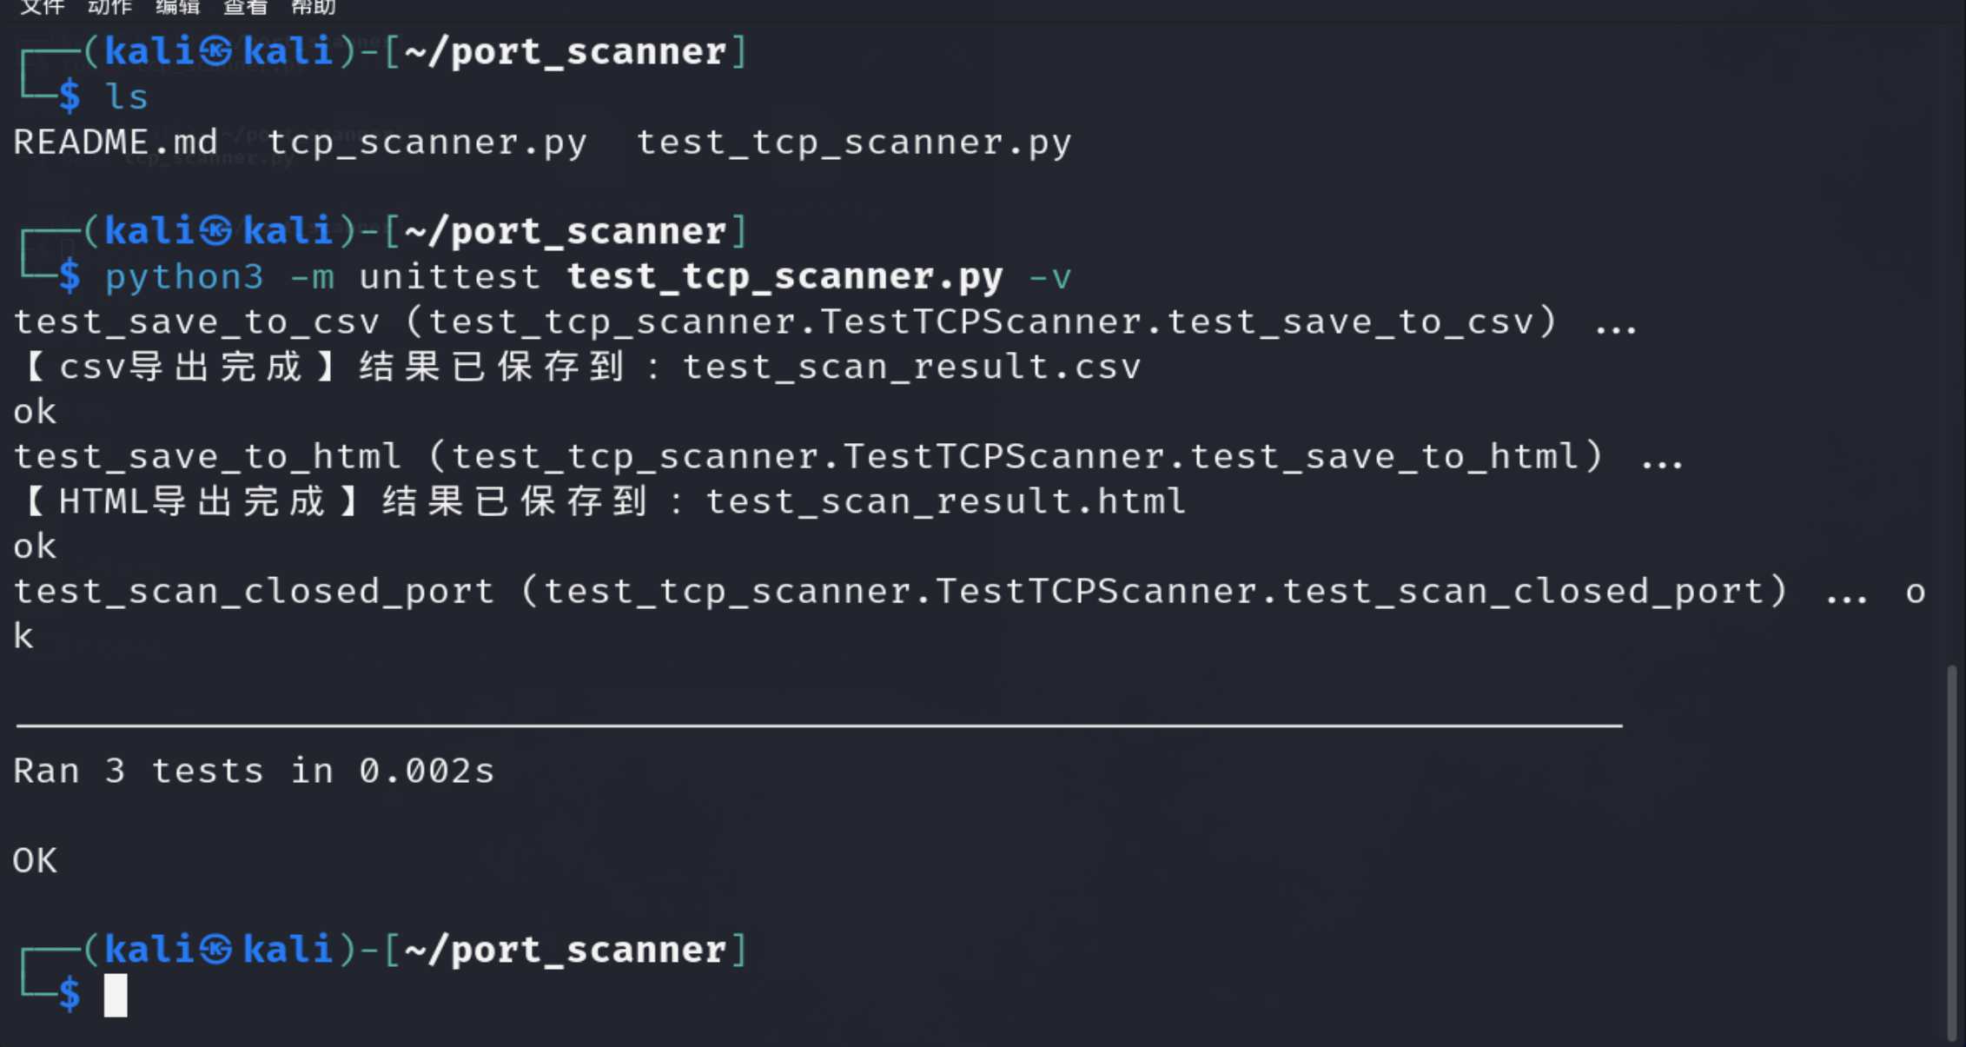
import unittest
import os
import csv
from scan1 import scan, save_to_csv, save_to_html
class TestTCPScanner(unittest.TestCase):
# 测试端口扫描函数
def test_scan_closed_port(self):
# 测试本地未开放端口
port, status = scan("127.0.0.1", 9999)
self.assertEqual(status, "关闭")
# 测试CSV导出功能
def test_save_to_csv(self):
target_host = "test_ip"
test_results = [(80, "开放"), (443, "关闭")]
test_filename = "test_scan_result.csv"
# 执行导出
save_to_csv(target_host, test_results, test_filename)
# 验证文件存在
self.assertTrue(os.path.exists(test_filename))
# 验证内容正确
with open(test_filename, "r", encoding="utf-8") as f:
reader = csv.reader(f)
header = next(reader)
self.assertEqual(header, ["目标主机", "端口", "状态"])
row1 = next(reader)
self.assertEqual(row1, ["test_ip", "80", "开放"])
# 清理测试文件
os.remove(test_filename)
# 测试HTML导出功能（仅验证文件生成）
def test_save_to_html(self):
target_host = "test_ip"
test_results = [(22, "开放")]
test_filename = "test_scan_result.html"
save_to_html(target_host, test_results, test_filename)
self.assertTrue(os.path.exists(test_filename))
# 清理测试文件
os.remove(test_filename)
if __name__ == "__main__":
unittest.main()
