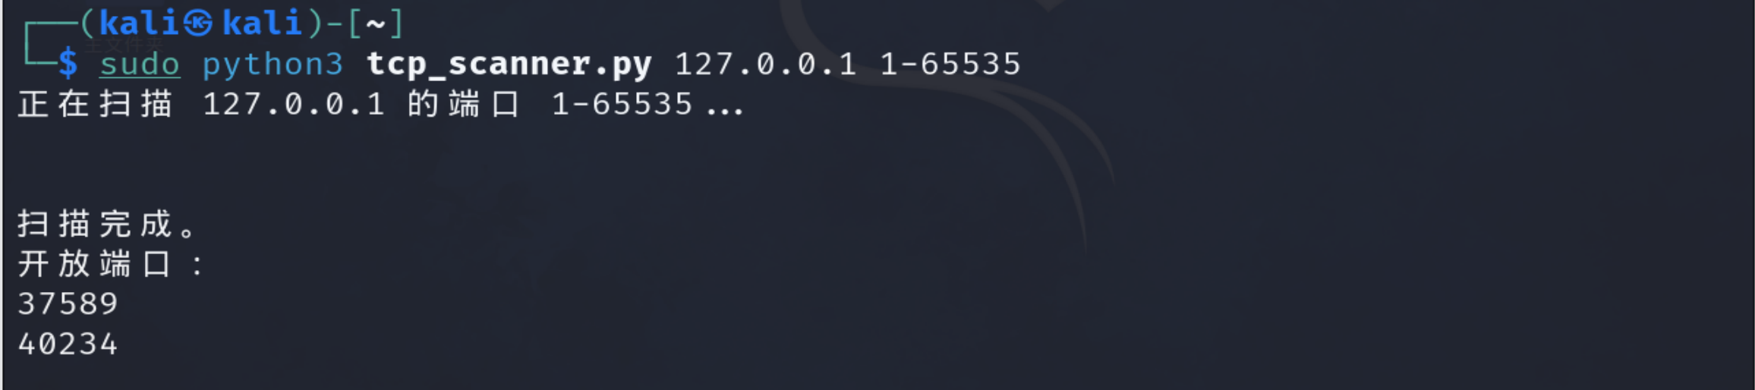

import socket
import sys
def scan(host, port):
s = socket.socket(socket.AF_INET, socket.SOCK_STREAM)
s.settimeout(3) # 超时 3 秒
try:
s.connect((host, port))
return True
except Exception:
return False
finally:
s.close()
if __name__ == "__main__":
if len(sys.argv) != 3:
print(f"用法: {sys.argv[0]} <目标主机> <端口范围(如:1-100)>")
sys.exit(1)
target_host = sys.argv[1]
start_port, end_port = map(int, sys.argv[2].split("-"))
print(f"正在扫描 {target_host} 的端口 {start_port}-{end_port}...\n")
open_ports = [] # 用来收集开放端口
for port in range(start_port, end_port + 1):
if scan(target_host, port):
open_ports.append(port)
else:
pass # 不打印未开放端口
# 扫描结束，统一输出开放端口信息
print("\n扫描完成。")
if open_ports:
print("开放端口：")
for p in open_ports:
print(p)
else:
print("未发现开放端口。")

