First I mapped each needed value into it's own RDD. Then I calculated the Pearson correlations of required values with the function of previous exercise:

Correlation between energy rate and cpu load: 0.00897893228638918
Correlation between energy rate and screen brightness: -2.550540607267431E-4
Correlation between energy rate and wifi link speed: 0.002433415320945404
Correlation between energy rate and wifi signal strength: -0.017981212297007488

This would indicate that the correlations between these values were really small. The most significant ones are the negative correlation of energy rate and wifi signal strength and the correlation between energy rate and cpu load.

I then used this tool https://www.meta-chart.com/scatter# to create the charts for 100 first values of each of these values. I think the charts are hard to look into since all different values are pretty widely scattered. Still the two previously mentioned relationships do pop out as energy rate chart differes clearly the most from wifi signal strength and some similarities can be seen between it and cpu load.

Energy rate:
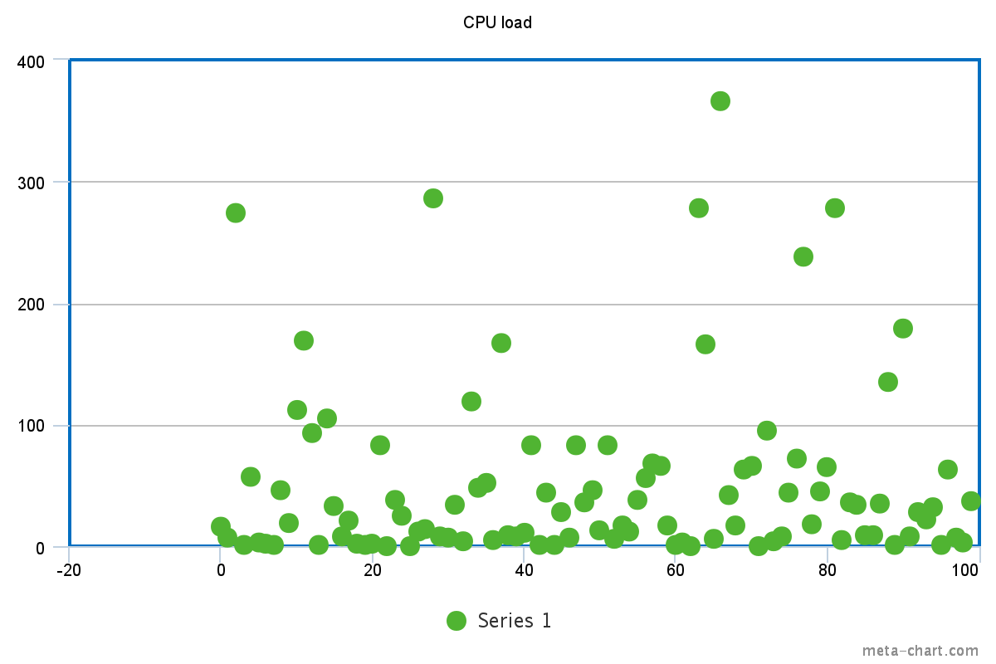

CPU load:

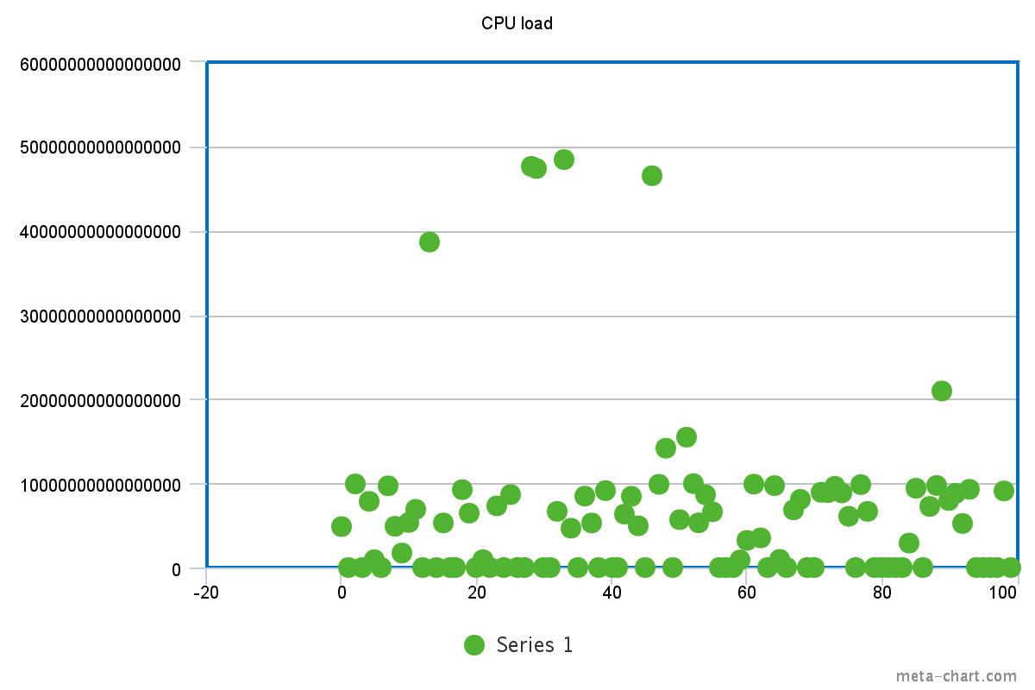
Screen brightness:
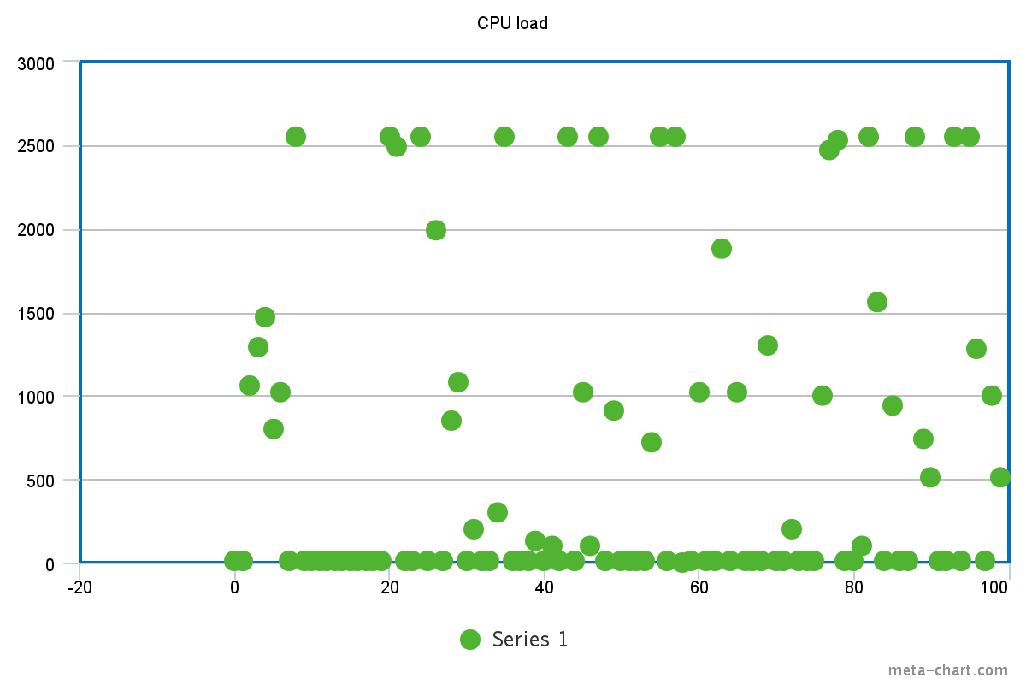

Wifi link speed:
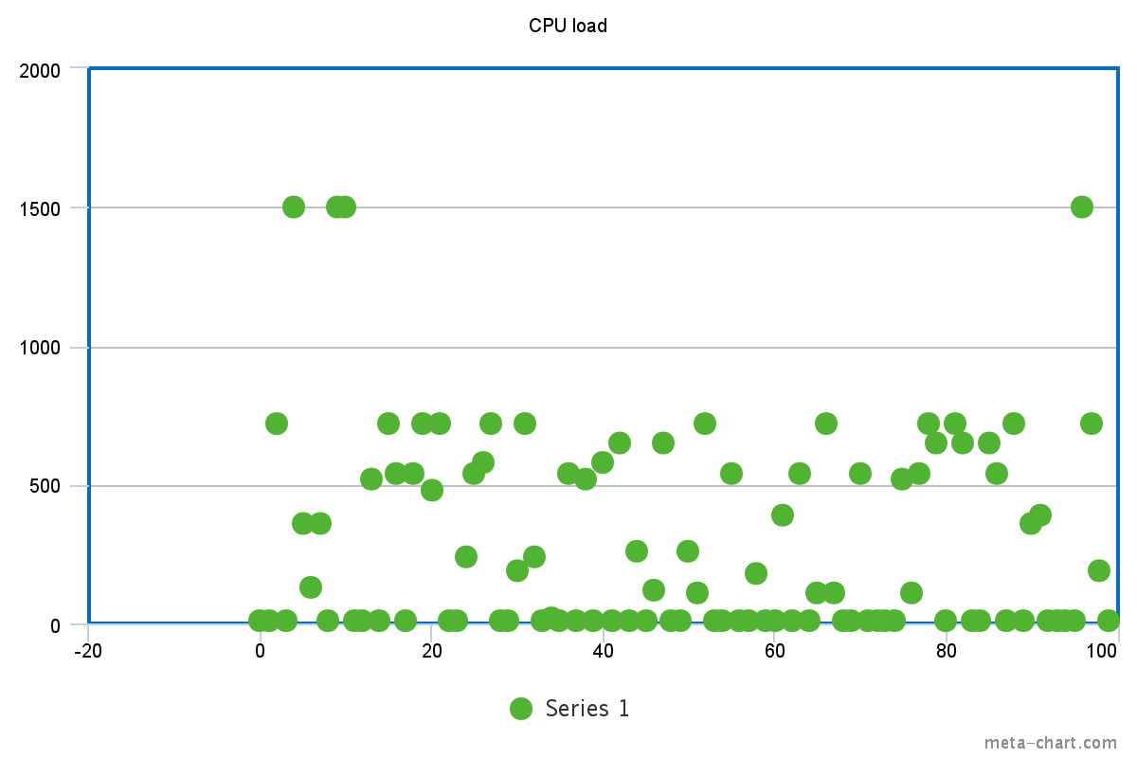
Wifi signal strength:
