# A:\CBHE-factori\aa-starter\Factori_soumis\communication\logo\Logo Factori 4.0.png

# From Automation and Control Training to the Overall Roll-Out of Industry 4.0 Across South-East Asian Nations

# (ASEAN FACTORI 4.0)

**PROJECT No. 609854-EPP-1-2019-1-FR-EPPKA2-CBHE-JP**

**MOU Ceremony Between Chulalongkorn University, Thailand and University of Ruse “Angel Kanchev.” Bulgaria on November 25, 2022**

In addition, to foster further collaboration and knowledge exchange, CU entered into a Memorandum of Understanding (MOU) with University of Ruse "Angel Kanchev." This MOU facilitates the exchange of knowledge and expertise between the two universities, creating opportunities for joint research projects, faculty exchanges, and other collaborative initiatives. This partnership strengthens the academic resources available to both institutions and promotes a fruitful exchange of ideas and experiences in the field of engineering.

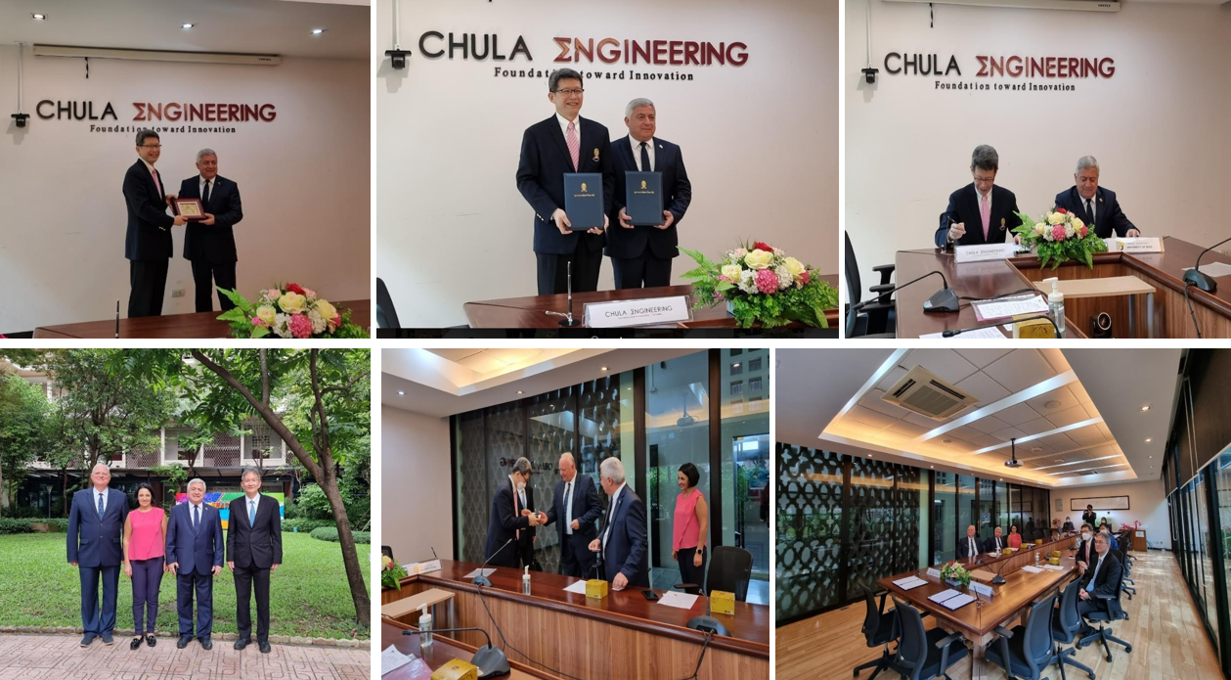

On November 25, 2022, a significant milestone was achieved as Prof. Supot Teachavorasinskun, D.Eng., the Dean of the Faculty of Engineering at Chulalongkorn University, and Prof. DTSc. Hristo Beloev, the Rector of the University of Ruse "Angel Kanchev" in Bulgaria, presided over the signing ceremony of a Memorandum of Understanding (MOU). This MOU marked the establishment of an academic collaboration between the Faculty of Engineering at Chulalongkorn University and the Department of Automation and Mechatronics at the University of Ruse "Angel Kanchev."

The primary objective of this bilateral cooperation is to facilitate an exchange program for both students and staff members between the two esteemed institutions. This collaborative initiative aims to foster a dynamic environment where knowledge and experiences are shared, enriching the educational and research opportunities for all involved.

The signing ceremony was graced by esteemed guests, including Prof. Plamen Daskalov, Ph.D., Vice Rector for Development Coordination and Continuing Education, and Assoc. Prof. Tsvetelina Dimitrova Georgieva, Ph.D., the Head of the Department of Automatics and Mechatronics from the University of Ruse "Angel Kanchev." Additionally, Prof. Paisan Kittisupakorn, Ph.D., the Associate Dean (Planning and Budget), Prof. David Banjerdpongchai, Ph.D., the Deputy Director of Innovation for Education and Research, and Lecturer Sirikanya Singcuna from Department of Chemical Engineering, were also present as distinguished witnesses of this momentous occasion. The collaboration opens possibilities for cultural exchange, collaborative research projects, and mutual learning opportunities for students and faculty members from both institutions. By leveraging each other's strengths and expertise, this partnership will contribute significantly to the advancement of engineering education and research in both Thailand and Bulgaria. We extend our heartfelt gratitude to all individuals involved in making this MOU signing ceremony a success. We are confident that this academic corporation will foster long-lasting relationships and propel our institutions towards greater achievements in the field of engineering.