Hello, My Name is ' Chris Dyck'  
My StudentID is '20033515'  
My Birthdate is ' 11/29/1971'  
  
Hello, My Name is ' Junseob Noh'  
My StudentID is '200423859'  
My Birthdate is ' 11/14/1977'  
  
Hello, My Name is ' Sathish Parthasarathi'  
My StudentID is '200425031'  
My Birthdate is ' 11/14/1990'  
  
Hello, My Name is ' Sukanya Chulliparambil Mohanan'  
My StudentID is '200425170'  
My Birthdate is ' 11/19/1991'  
  
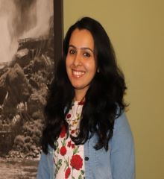Hello, My Name is ' MaryPravalika Jaddu'  
My StudentID is '200425198'  
My Birthdate is ' 7/20/1996'  
  
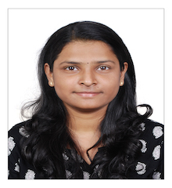Hello, My Name is ' Mostafizur Rahman'  
My StudentID is '200427977'  
My Birthdate is ' 7/11/1994'  
  
Hello, My Name is ' Ankita Singh'  
My StudentID is '200425898'  
My Birthdate is ' 7/10/1998'  
  
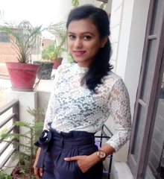Hello, My Name is ' Prakash Gurung'  
My StudentID is '200427531'  
My Birthdate is ' 1/1/0001'  
  
Hello, My Name is ' Mostafizur Rahman'  
My StudentID is '200427977'  
My Birthdate is ' 7/11/1994'  
  
Hello, My Name is ' Priyanka Garg'  
My StudentID is '200429013'  
My Birthdate is ' 12/9/1993'  
  
Hello, My Name is ' Pranav Sharma'  
My StudentID is '200429019'  
My Birthdate is ' 9/19/1997'  
  
Hello, My Name is ' Pranav Sharma'  
My StudentID is '200429019'  
My Birthdate is ' 9/19/1997'  
  
Hello, My Name is ' Kavya Arora'  
My StudentID is '200429439'  
My Birthdate is ' 9/8/1994'  
  
Hello, My Name is ' Aditya Pidikiti'  
My StudentID is '200429757'  
My Birthdate is ' 6/4/1997'  
  
Hello, My Name is ' Prajwal Acharya'  
My StudentID is '200430858'  
My Birthdate is ' 12/5/1994'  
  
Hello, My Name is ' Preet Shah'  
My StudentID is '200439773'  
My Birthdate is ' 10/4/1998'  
  
Hello, My Name is ' Bruno Simoes'  
My StudentID is '200439932'  
My Birthdate is ' 7/5/1976'  
  
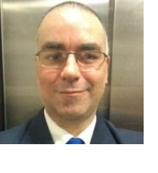Hello, My Name is ' Tugrul Goktas'  
My StudentID is '200443399'  
My Birthdate is ' 10/8/1995'  
  
Hello, My Name is ' Prajwal Katuwal'  
My StudentID is '200445913'  
My Birthdate is ' 7/16/1993'  
  
Hello, My Name is ' Pavel Sazonov'  
My StudentID is '200446535'  
My Birthdate is ' 3/20/1988'  
  
Hello, My Name is ' swarnim sharma'  
My StudentID is '2200447714'  
My Birthdate is ' 1/5/2020'  
  
Hello, My Name is ' Tugrul Goktas'  
My StudentID is '200443399'  
My Birthdate is ' 10/8/1995'  
  
Hello, My Name is ' Jay Kalal'  
My StudentID is '200447184'  
My Birthdate is ' 1/27/1998'  
  
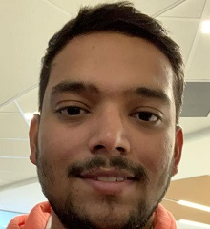Hello, My Name is ' HemaAbhinandu Kotha'  
My StudentID is '200447197'  
My Birthdate is ' 4/15/1997'  
  
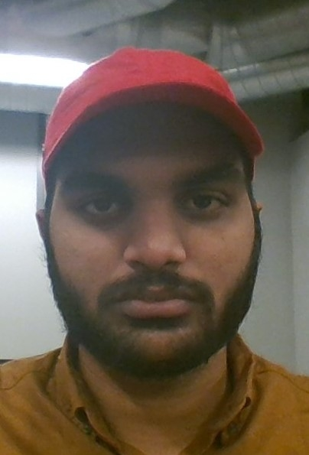Hello, My Name is ' AkhilDas PradeepKumar'  
My StudentID is '200447261'  
My Birthdate is ' 7/4/1993'  
  
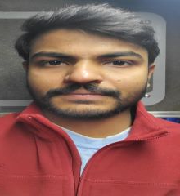Hello, My Name is ' Swathi Palavalli'  
My StudentID is '200447330'  
My Birthdate is ' 4/5/1992'  
  
Hello, My Name is ' KavirajSingh Jon'  
My StudentID is '200447599'  
My Birthdate is ' 9/22/1994'  
  
Hello, My Name is ' Althaf Edathara'  
My StudentID is '200447744'  
My Birthdate is ' 5/10/1993'  
  
Hello, My Name is ' Nipin Dasani'  
My StudentID is '200447887'  
My Birthdate is ' 1/29/1998'  
  
Hello, My Name is ' Avi Saini'  
My StudentID is '200448226'  
My Birthdate is ' 1/3/1997'  
  
Hello, My Name is ' Kashish Jhaveri'  
My StudentID is '200448232'  
My Birthdate is ' 12/26/1996'  
  
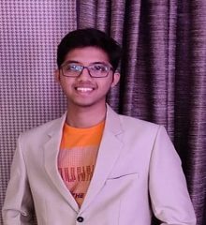Hello, My Name is ' Robert Routledge'  
My StudentID is '200449068'  
My Birthdate is ' 5/20/1980'  
  
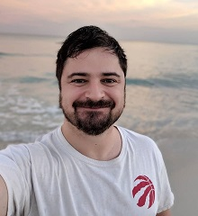Hello, My Name is ' Sahiba Sachdeva'  
My StudentID is '200449112'  
My Birthdate is ' 8/23/1994'  
  
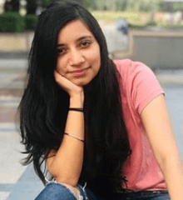Hello, My Name is ' Sofiya Raju'  
My StudentID is '200449872'  
My Birthdate is ' 9/22/1993'  
  
Hello, My Name is ' Sony Varghese'  
My StudentID is '200450261'  
My Birthdate is ' 4/15/1994'  
  
Hello, My Name is ' Krishnapriya Sarojam'  
My StudentID is '200450333'  
My Birthdate is ' 12/31/1992'  
  
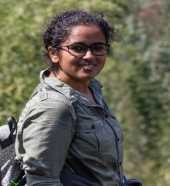Hello, My Name is ' SargunSingh Walia'  
My StudentID is '200450515'  
My Birthdate is ' 7/18/1994'  
  
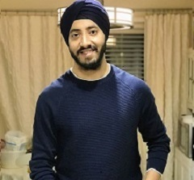Hello, My Name is ' Nikhil Patel'  
My StudentID is '200450550'  
My Birthdate is ' 11/30/1997'  
  
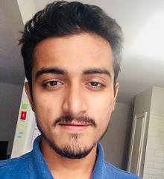Hello, My Name is ' Dayal Vijayan'  
My StudentID is '200450624'  
My Birthdate is ' 2/25/1998'  
  
Hello, My Name is ' Gurminder Singh'  
My StudentID is '200450635'  
My Birthdate is ' 2/9/1997'  
  
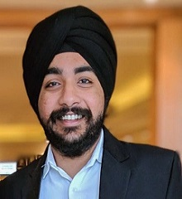Hello, My Name is ' Vrunda Patel'  
My StudentID is '200450730'  
My Birthdate is ' 5/26/1998'  
  
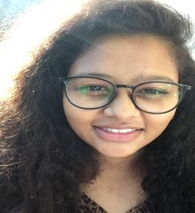Hello, My Name is ' Vrushabh Patel'  
My StudentID is '200451605'  
My Birthdate is ' 6/15/1996'  
  
