1. Using .net open site https://www.worldometers.info/coronavirus/

2. From the table on the screen bellow:

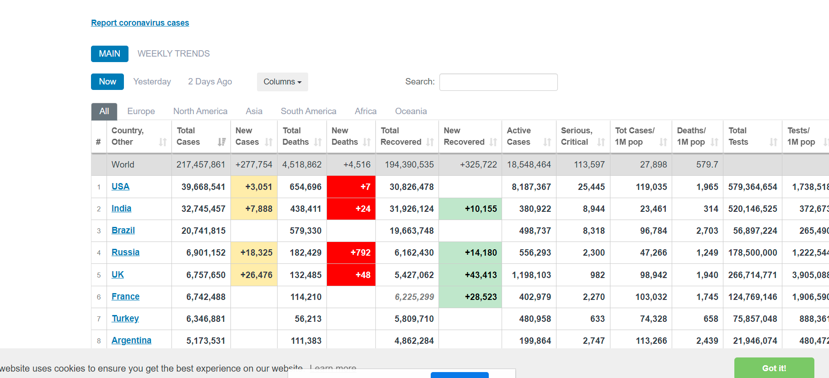

Parse and extract data from the following columns:

*Region (Europe, North America etc.),*

*Country,*

*Total cases,*

*Total Tests,*

*Active cases*

Data must be for current day.

3. Create SQL Lite local DB and store parsed data in it.

DB path should be local execution folder.

4. App should accept 0 or 1 parameter: region=xxxxxx (ex. region=Europe)

5. On execution with parameter region=xxxxx please print in console formatted table for requested region with all the columns and also create export_regionname_YY_MM_DD.csv containing this data.