**Scoping**

**Task:**

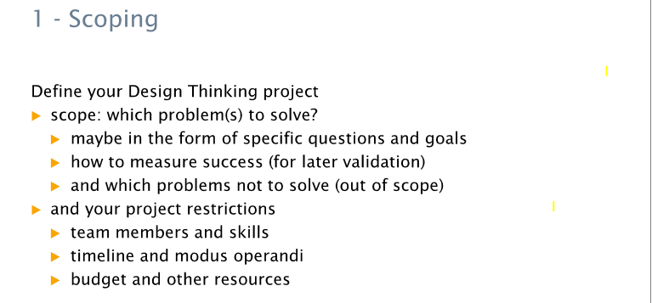

**Probleme:**

**Ziele:**

**Project restrictions:**