Objective Questions

Question 1:

Does any table have missing values or duplicates? If yes, how would you handle it?

Answer:

Approach
- To check for missing values, SQL queries were used with the ‘is null’ condition along with multiple column checks.
- Missing values were handled using NULL-handling functions such as COALESCE() to replace them with meaningful default values instead of removing records.

- Customer Table
- Inspected each column in the customer table using a query with multiple ‘is null’ checks.
- The output showed several rows have null values in columns.
- Instead of deleting these records, we replaced nulls with default text values using the coalesce() function.
- Output shows that column ‘company’, ‘address’, ’city’, ’state’, ’postal code’, ’phone’ and ‘fax’ contains null values.

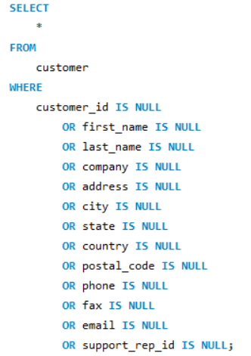
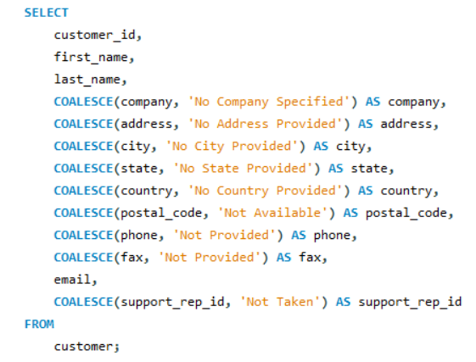

Output

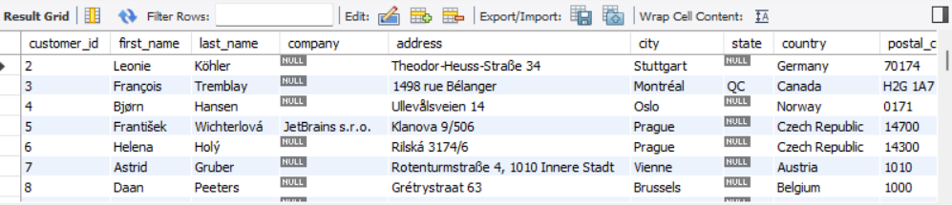

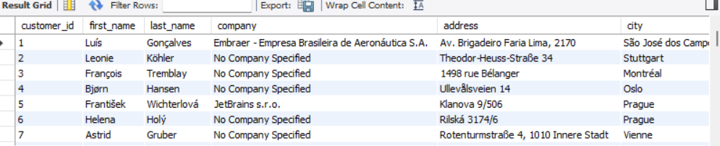

- Employee Table
- Checked for null values.
- Output showed only one row and in a one column ‘reports_to’ has a null value.
- Handled the missing or null value using coalesce() function and passed a default message ‘Not Available.’

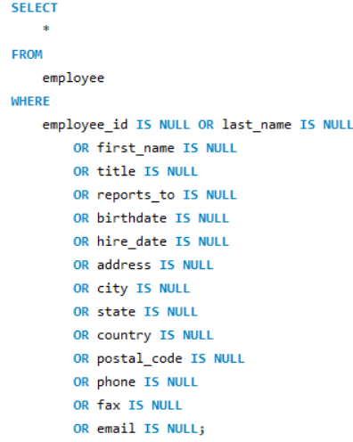
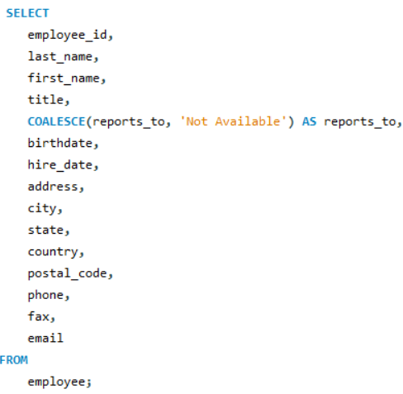

Output

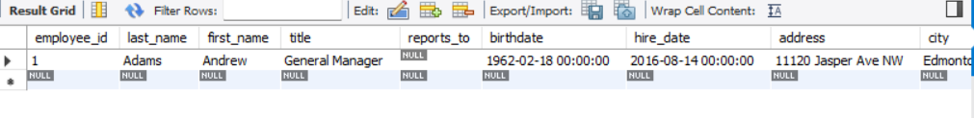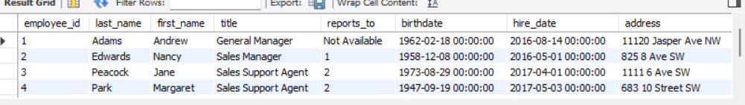

- Track
- Checked the null values or missing values from Track table.
- Inspected each column using is null.
- Using coalesce() function replaced the null values and passed a default message.

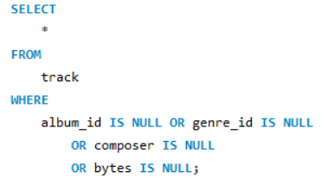
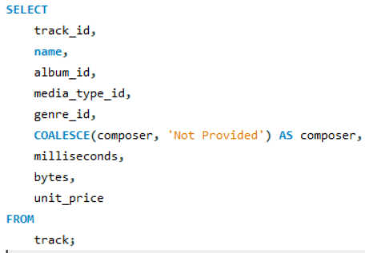
Output

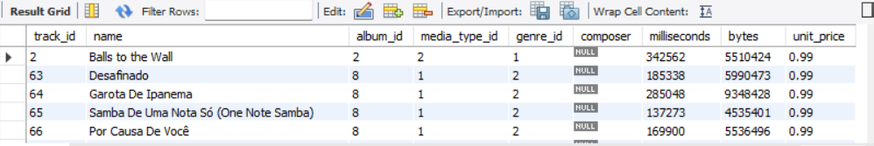

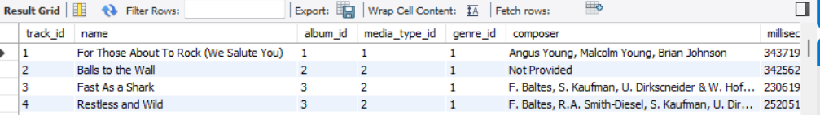

Question 2:

Find the top-selling tracks and top artist in the USA and identify their most famous genres.

Answer:

Approach

- Joined multiple tables (track, invoice_line, invoice, and customer) to connect track purchases with customer location.
- Filtered the data to include only customers from the USA using the WHERE clause.
- Identified top-selling tracks, aggregated the total quantity sold using SUM(quantity).
- Grouped by track ID and track name to calculate sales per track.
- The output is then sorted in descending order to highlight the highest-selling tracks at the top.
- The same approach is used for artist and genre using joins with album, artist and genre tables.

- Top-Selling Tracks
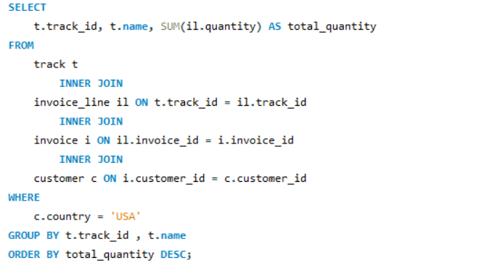

Output

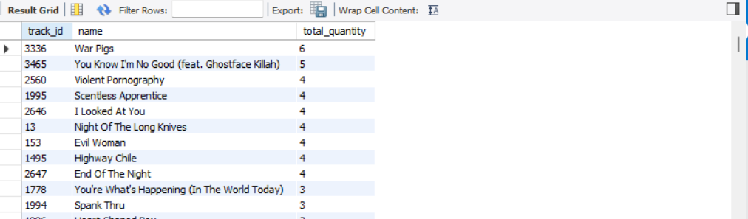

The output displays the top-selling tracks in the USA based on total quantity sold, displayed in descending order. The output table shows the track_id, name(track name), and total_quantity.

- Top Artist
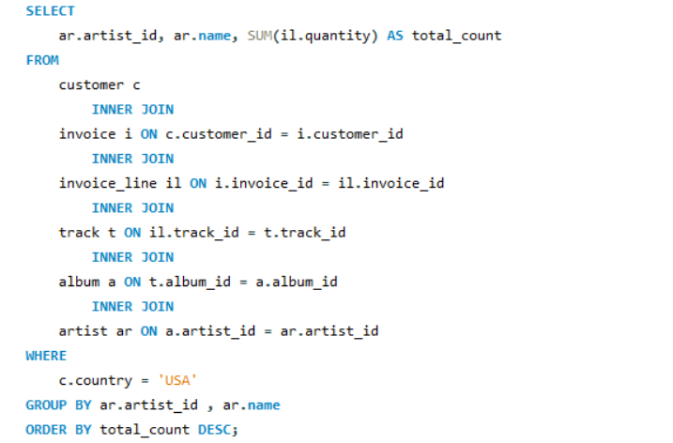

Output

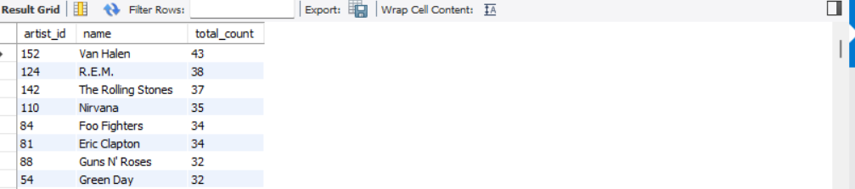

The output displays the top-selling tracks in the USA based on total count, displayed in descending order. The output table shows the artist_id, name(artist name), and total_quantity.

- Famous Genre
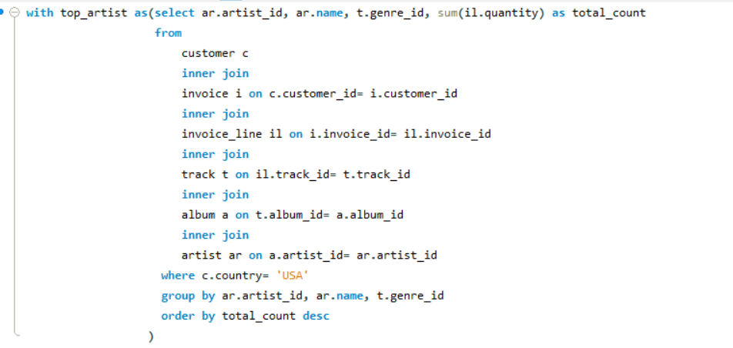
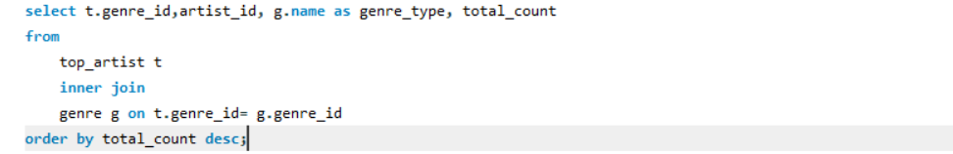

Output

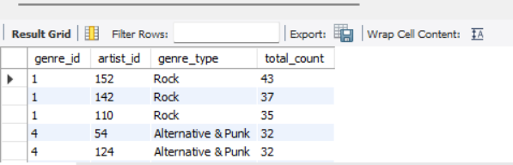

The output displays the top genre in the USA based on total quantity sold, and shows the genre_id, artist_id, genre_type, total_count ordered in descending order.

Question 3:
What is the customer demographic breakdown (age, gender, location) of Chinook's customer base?

Answer:

Approach

- Missing values in the state column were handled using coalesce() to avoid grouping issues.
- Used group by on country, state, and city fields to count how many customers are located in each region.
- The aggregation function, count() was applied to find the total number of customers in each city
- The results were ordered by customer count in descending order to highlight the most populated regions.

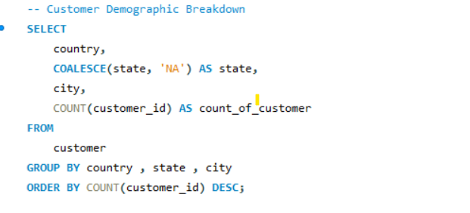

Output

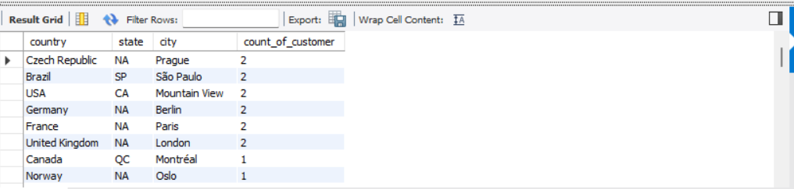

The output displays the regions with the highest customer concentrations. Since the dataset does not contain age or gender information, so the demographic breakdown is limited to location-based insights only.

Visualization

To visualize Customer Used an Excel filled map to visualize customer distribution by country, where colour intensity represents customer concentration, helping identify regions with the highest customer base.

Question 4:
Calculate the total revenue and number of invoices for each country, state, and city.

Answer:

Approach

- Performed an inner join between the customer and invoice tables to link customer location with their invoice data.
- Aggregated total revenue and invoice count per city using sum and count, while handling missing state values using coalesce().
- Grouped the results by country, state, and city, and ordered them to identify top-performing regions by revenue.

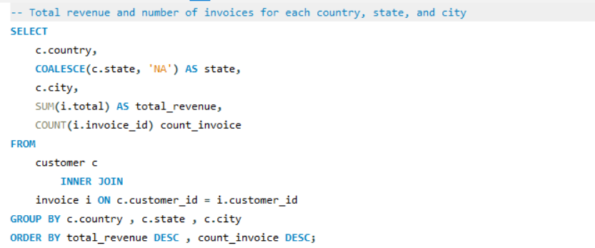

Output

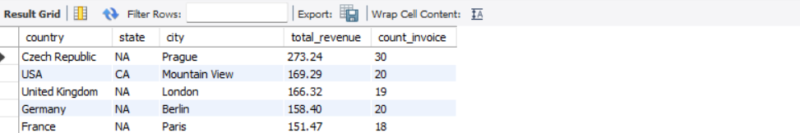

The output shows revenue and transaction volume by location, helping identify top-performing countries, states, and cities based on sales.

Visualization

Used the column chart to compare revenue across countries, where taller bars indicate higher sales, helping quickly identify top-performing regions.

Question 5:
Find the top 5 customers by total revenue in each country.

Answer:

Approach

- Performed an inner join between the customer and invoice tables to link each customer with their transactions.
- Used sum() to calculate total revenue generated by each customer.
- Applied the rank() window function to rank customers within each country based on their total revenue in descending order.
- Filtered the result to return only the top 5 customers per country and sorted the output by country and rank.

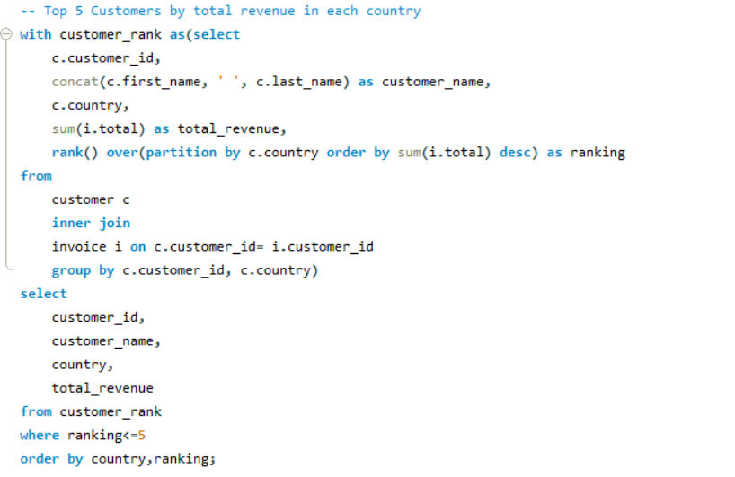

Output

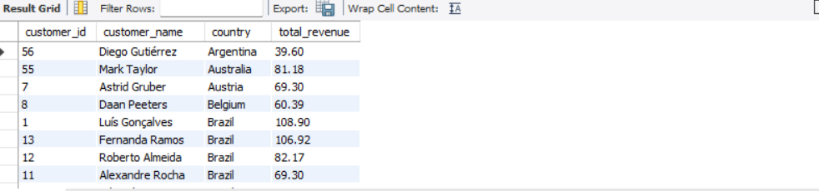

- The output includes customer details of top 5 customers by revenue in each country along with their total revenue contribution.
- Customers are ranked within each country based on revenue, which helps identify high-value customers across different regions for better business insights.

Visualization

This visualization helps in quickly identifying key customers across different regions.

Question 6:
Identify the top-selling track for each customer.

Answer:

Approach
- Data Integration: Join customer, invoice, and invoice_line tables to collect purchase data including quantities and prices.
- CTE Usage: Use a single CTE to aggregate total tracks and spend per customer by country.
- Result Analysis: Group by country, calculate averages, and sort by spend to highlight top regions.
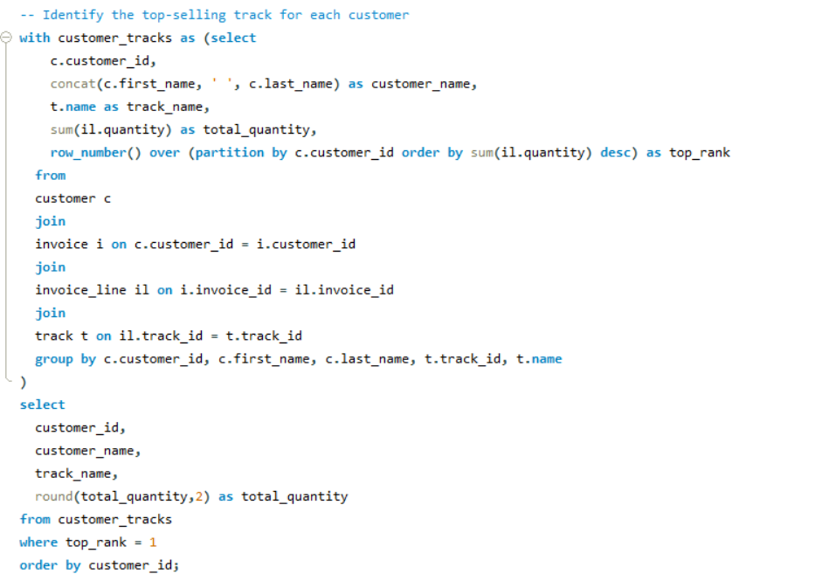

Output
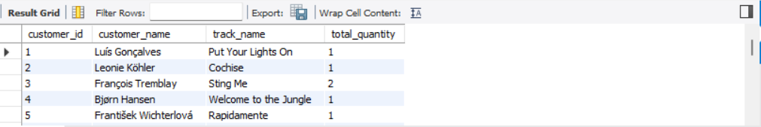

Question 7:
Are there any patterns or trends in customer purchasing behavior (e.g., frequency of purchases, preferred payment methods, average order value)?

Answer:

Approach

Analyse yearly customer purchase activity using SQL joins and grouping.
- Year wise purchase count:
Performed an inner join between the customer and invoice tables to extract customer_id, full name, and invoice year. Applied count(invoice_id) to compute total purchases per customer each year. Grouped by customer_id, customer_name, and year, and sorted results in ascending order.

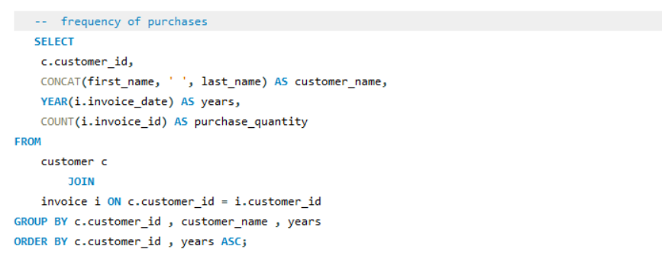

Output
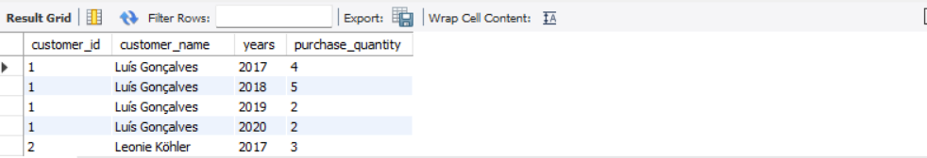

Visualization

The above chart displays that each customer has purchase records from 2017 to 2020 with varying yearly quantities, and overall purchase quantity shows a decreasing trend toward 2020 across all customers.

Top Customers by Average Invoice Value
- Joined the customer and invoice tables using the customer_id key.
- Concatenated first and last names to get the full customer_name.
- Calculated the average invoice amount (avg(i.total)) per customer.
- Grouped the results by customer and sort them in descending order of average invoice value.
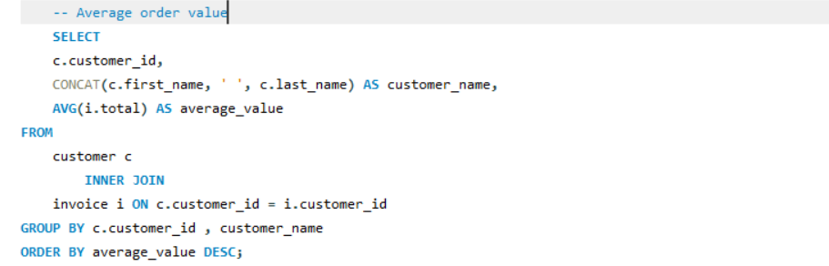

Output
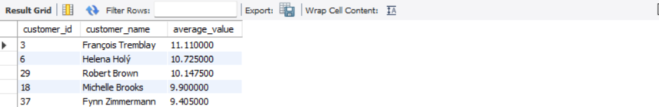

Visualization

The visualization highlights variation in customer spending patterns and helps identify premium customers for targeted business strategies.

Question 8:
What is the customer churn rate?

Answer:

Approach to Calculate Churn Rate (1-Year Interval)

- Identify purchase years per customer
Use the invoice table to extract the year of each transaction and group them by customer. This gives you a list of active years per customer.
- Find the latest consecutive years
Determine the most recent pair of back-to-back years where customer activity occurred. This focuses the churn analysis on the latest available period.
- Check customer activity across years
Create two customer groups one active in the earlier year and another in the following year. Then compare them to find out who did not return in the next year.
- Calculate churn rate
Divide the number of customers who left like who active in the first year but not the next by the total number of customers in the first year. Multiply by 100 to get the churn rate percentage.

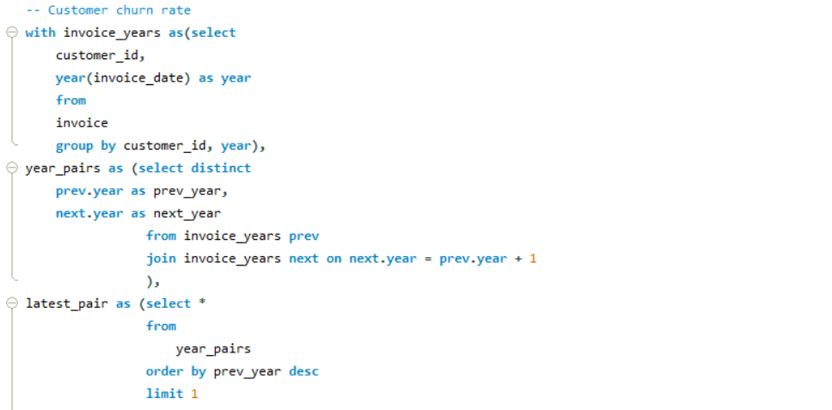
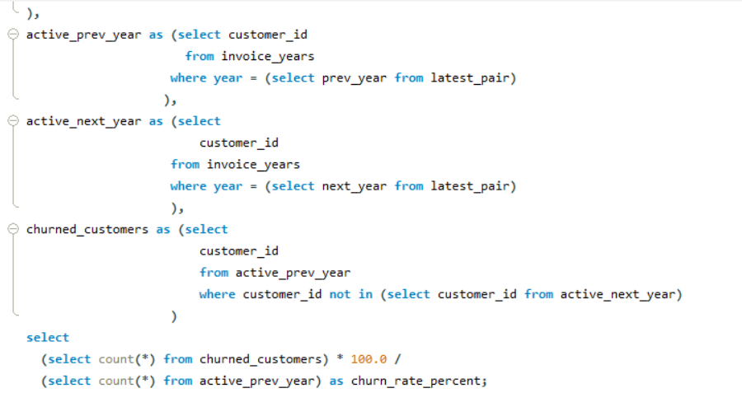

Output
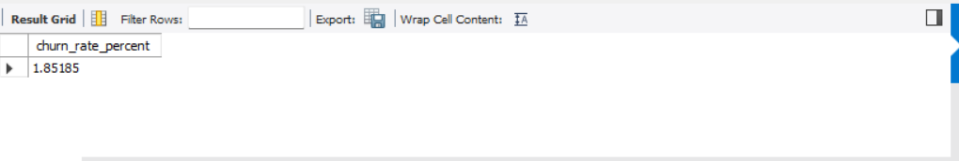

The churn rate of 1.85% indicates that the company losses 1.85% customer over a period (year or month). Generally, a lower churn rate is better, suggesting that a business is effectively retaining its customers.

Question 9:
Calculate the percentage of total sales contributed by each genre in the USA and identify the best-selling genres and artists.

Answer:

Approach
Genre-wise Sales Contribution and Top-Selling Artists Analysis in the USA

- Joined the genre, track, invoice_line, invoice, album, and artist tables to connect customer purchases with corresponding genres and artists.
- Filtered the data to include only USA-based transactions using the billing country condition.
- Calculated total sales for each artist within every genre using SUM(i.total) and grouped the results by genre and artist.
- Applied DENSE_RANK() to rank artists based on sales within each genre and identify the top-performing artists.
- Used a separate CTE to calculate total USA sales across all genres.
- Computed each genre’s percentage contribution to total sales using the formula: (genre_sales/total_sales)*100
- Sorted the final output in descending order of sales to highlight the best-selling genres and artists in the USA market.

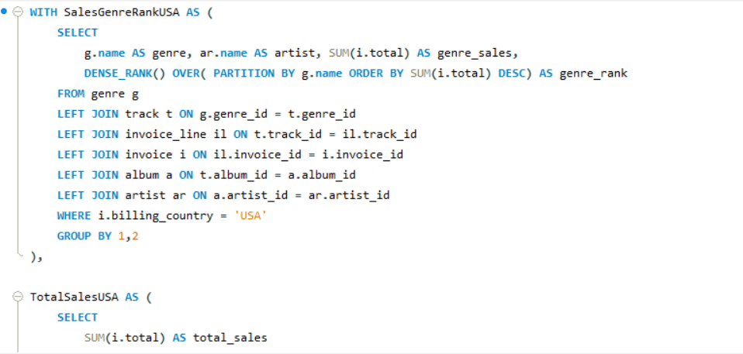
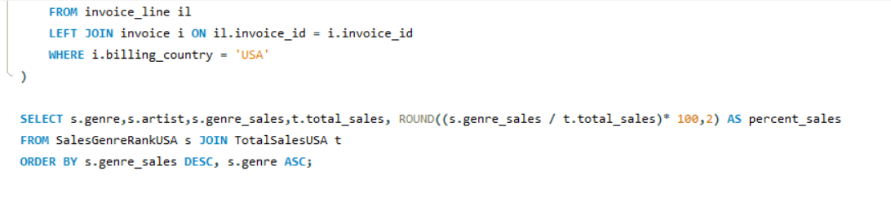

Output
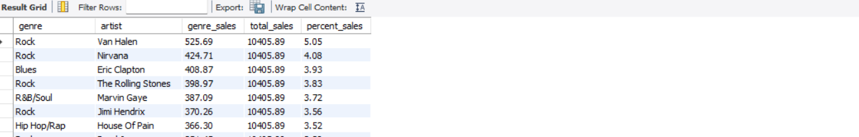

Visualization

The visualization provides a clear understanding of genre preferences and market demand distribution among USA customers.

The above visualization enables easy comparison of artist performance across genres and helps identify the most commercially successful artists.

Question 10:
Find customers who have purchased tracks from at least 3 different genres.

Answer:

Approach
Customer Genre Diversity Analysis
- Joined the customer, invoice, invoice_line, track, and genre tables to connect customer purchases with corresponding music tracks and genres.
- Concatenated the customer’s first and last names to generate a full customer name for better readability.
- Used Count(distinct g.genre_id) to calculate the number of unique genres purchased by each customer and Count(distinct t.track_id) to determine the total unique tracks purchased.
- Grouped the data by customer to analyse individual purchasing behavior across different music genres.
- Applied a Having clause to filter customers who purchased tracks from at least three different genres.
- Sorted the results in descending order of genre count to highlight customers with the most diverse music preferences.

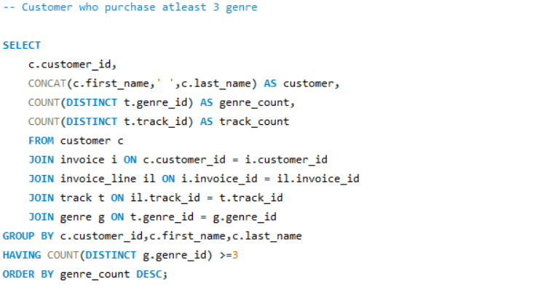

Output
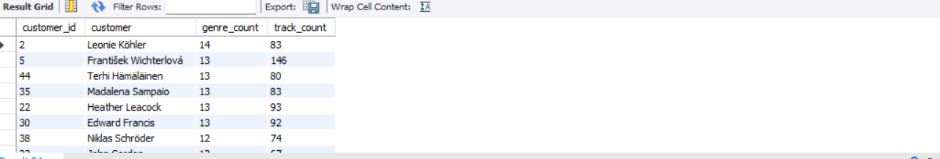

Visualization

A clustered horizontal bar chart was used to compare customers based on the number of unique genres purchased. The visualization helps identify customers with diverse purchasing behavior and broader music preferences

Question 11:
Rank genres based on their sales performance in the USA.

Answer:

Approach

Genre Sales Performance Ranking in the USA
- Joined the genre, track, invoice_line, and invoice tables to connect music genres with customer purchase transactions.
- Filtered the data to include only USA-based sales using the billing country condition.
- Calculated total sales for each genre using Sum(i.total) and grouped the results by genre name.
- Applied the Dense_Rank() window function to rank genres based on total sales in descending order, ensuring genres with equal sales receive the same rank.
- Organized the final output by genre rank to highlight the best-performing music genres in the USA market based on sales performance.

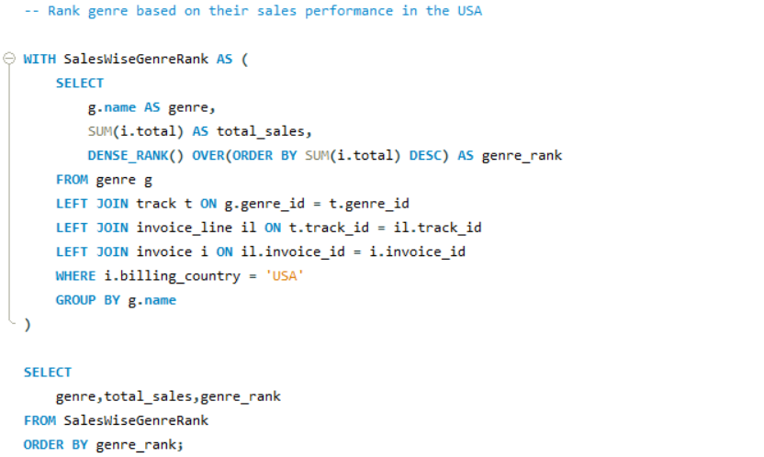

Output
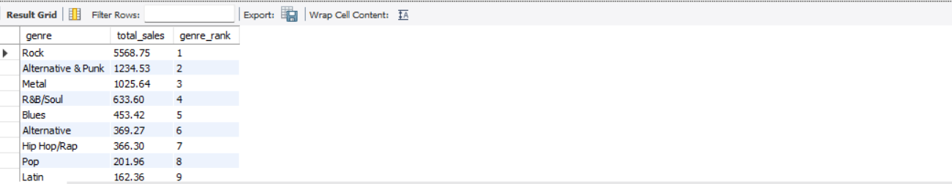

The analysis highlights Rock as the top-performing genre, followed by Alternative & Punk and Metal, while genres such as Classical and TV Shows generated comparatively lower sales, indicating lower customer demand.

Question 12:
Identify customers who have not made a purchase in the last 3 months.

Answer:

Approach
- Join Customer with Invoice Table
Used a left join to connect each customer with their purchase records, ensuring customers with no recent activity are still included.
- Group by Customer
Grouped the data by customer ID and full name to evaluate purchases at the individual level.
- Calculate Latest Purchase Date
Used max(invoice_date) to determine the most recent purchase date for each customer.
- Filter Inactive Customers
Applied a condition to return only those customers whose last purchase was more than 3 months ago from the current date.
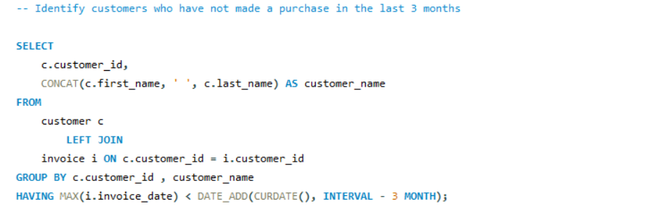
Output
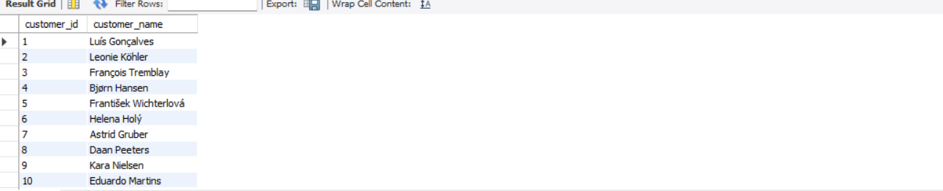A list of customers was identified who have not made any purchases in the last 3 months, indicating potential churn or inactivity.

Subjective Questions

Question 1:
Recommend the three albums from the new record label that should be prioritised for advertising and promotion in the USA based on genre sales analysis.

Answer:

Objectives
To identify the top 3 albums based on total sales in the USA, grouped by genre and album, to help the new record label prioritize which albums to promote.

Approach

- Data Source and Filtering
- Queried sales data by joining tables: customer, invoice, invoice_line, track, genre, and album.
- Applied a filter to only include customers from the USA (c.country = 'USA').
- Sales Aggregation and Ranking
- Calculated total sales per genre and album using sum(i.total).
- Ranked albums using dense_rank() based on total sales in descending order (highest sales ranked first).
- Selection of Top Albums:
- Grouped by genre_name and album_name, then selected the top 3 albums using LIMIT.
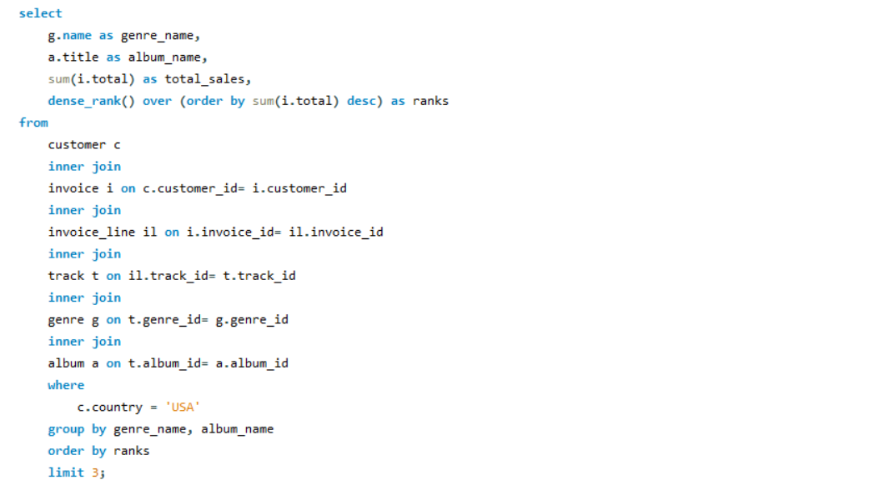
Output
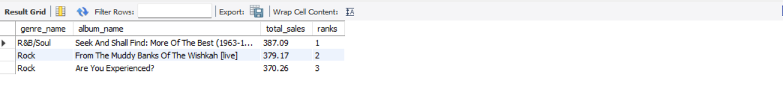
Insights
- The sales analysis of USA customer purchases shows that the R&B/Soul and Rock genres are performing exceptionally well.
- The album “Seek And Shall Find: More Of The Best” from the R&B/Soul genre recorded the highest sales among all albums.
- Rock albums such as “From The Muddy Banks Of The Wishkah [Live]” and “Are You Experienced?” also ranked among the top-performing albums.
- The results indicate a strong listener base and consistent customer demand for R&B/Soul and Rock music in the USA market.
Recommendations
- It is recommended to prioritize the promotion of the top-selling albums in the USA market to maximize customer engagement and sales growth.
- Marketing strategies should focus primarily on the R&B/Soul and Rock genres, as they have demonstrated strong sales performance and audience preference.
- Increasing the visibility and promotion of these high-performing albums can help the record label effectively target a receptive customer base and drive higher revenue.
Final Suggestion
The record label should prioritize advertising the top three best-selling albums, with a particular focus on the R&B/Soul and Rock genres, as they are currently the strongest-performing categories in the USA market based on sales analysis.

Question 2:
Determine the top-selling genres in countries other than the USA and identify any commonalities or differences.

Answer:

Objectives
The goal was to identify which music genres are most popular among customers outside the USA, using sales data. This helps in understanding regional preferences and planning targeted marketing or inventory strategies.

Approach

- Data Selection and Filtering:
Used data from multiple related tables—customer, invoice, invoice_line, track, genre, and album—by performing inner joins. The filter c.country <> 'USA' was applied to exclude U.S. customers, focusing only on international sales.
- Aggregation Logic:
The query grouped data by genre_name and summed up the quantity of tracks sold using SUM(il.quantity). This aggregation allowed us to calculate total sales per genre from international customers.
- Sorting for Top Performers:
The result was ordered in descending order of total quantity sold (order by quantity desc) to highlight the most popular genres among international audiences.
- Interpretation of Output:
The final output shows which genres are in high demand outside the US. This insight can be used for strategic decisions like recommending more Rock or Metal tracks to global users, or exploring why certain genres underperform in non-U.S. markets.

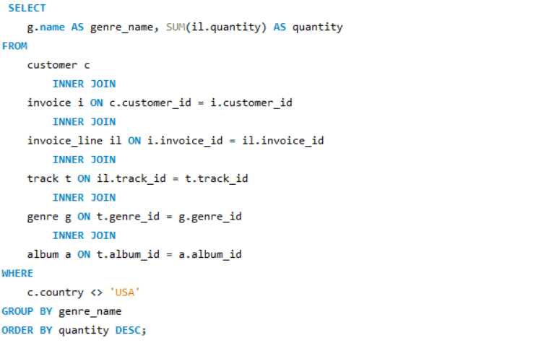

Output
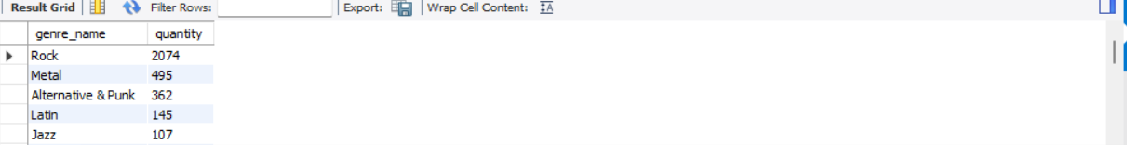

Insights

- Based on customer purchases from countries outside the USA, Rock emerged as the most purchased genre with 2,074 units sold.
- Metal (495 units) and Alternative & Punk (362 units) were the next highest-performing genres, indicating strong international preference for high-energy, guitar-based music.
- Genres such as Classical (43 units), Electronica/Dance (50 units), and Easy Listening (61 units) recorded comparatively lower sales, reflecting lower customer demand outside the USA market.
Recommendations
- Prioritize the promotion of Rock albums, as Rock is the strongest-performing genre across multiple international markets and has broad audience appeal.
- Along with Rock, include genres such as Pop, Latin, and Metal in promotional campaigns to target diverse listener preferences and expand audience reach.
- Utilize genre-level sales insights to optimize digital advertising strategies and deliver market-specific promotional content based on regional genre preferences.
- Align album release schedules and promotional activities with the most popular genres in each region to improve customer engagement and maximize return on investment.
Final Suggestion
- To maximize global reach and sales performance, the record label should focus its marketing efforts on genres that consistently perform well across different regions.
- Leveraging data-driven insights on genre popularity can help optimize promotional strategies, personalize audience targeting, and improve campaign effectiveness, ultimately leading to stronger market penetration and increased revenue.

Question 3:
Customer Purchasing Behaviour Analysis: How do the purchasing habits (frequency, basket size, spending amount) of long-term customers differ from those of new customers? What insights can these patterns provide about customer loyalty and retention strategies?
Answer:
Objectives
- Analyzed customer purchasing behavior by segmenting customers into two categories:
- Recent Customers: Customers with a purchase history of less than 1 year
- Long-Term Customers: Customers with a purchase history of 1 year or more
- Evaluated key customer metrics for each segment, including purchase frequency, basket size (total products purchased per customer), total spending amount, and average order value.
- Observed that long-term customers demonstrated higher purchase frequency and overall spending, indicating stronger customer engagement and loyalty.
- Identified that recent customers generally had slightly smaller basket sizes and lower spending levels compared to long-term customers.
- Utilized the analysis to identify loyal customer segments and support the development of targeted marketing and customer retention strategies.
Approach
- Joined Core Tables:
Joined the customer, invoice, and invoice_line tables to collect transactional data, linking customer_ids to purchases and product quantities.

- Calculated Key Metrics per Customer:
Aggregated data at the customer level to compute:
- Number of purchases (purchase_quantity)
- Total products bought (total_product_purchase)
- Total amount spent (total_spent)
- Average order value (avg_spent_per_order)
- Customer lifetime in days (customer_lifetime_days)

- Classified Customers:
Created a segment using a case statement:
- Customers with a lifetime under 365 days labelled as 'recent'
- Others labelled as 'long-term'

- Created Customer Segmentation Table:
Stored all metrics along with the customer category into a CTE named customer_segment for clean modular analysis.

- Aggregate by Customer Category:
Grouped the data by customer_category to analyse segment-level behaviour.
- Calculated Segment-Level Averages:
Computed:
  - Average purchase frequency
  - Average basket size
  - Average total spending
  - Average order value

- Formatted Output
Used the round() function to keep the result readable and suitable for reporting dashboards or business insights.
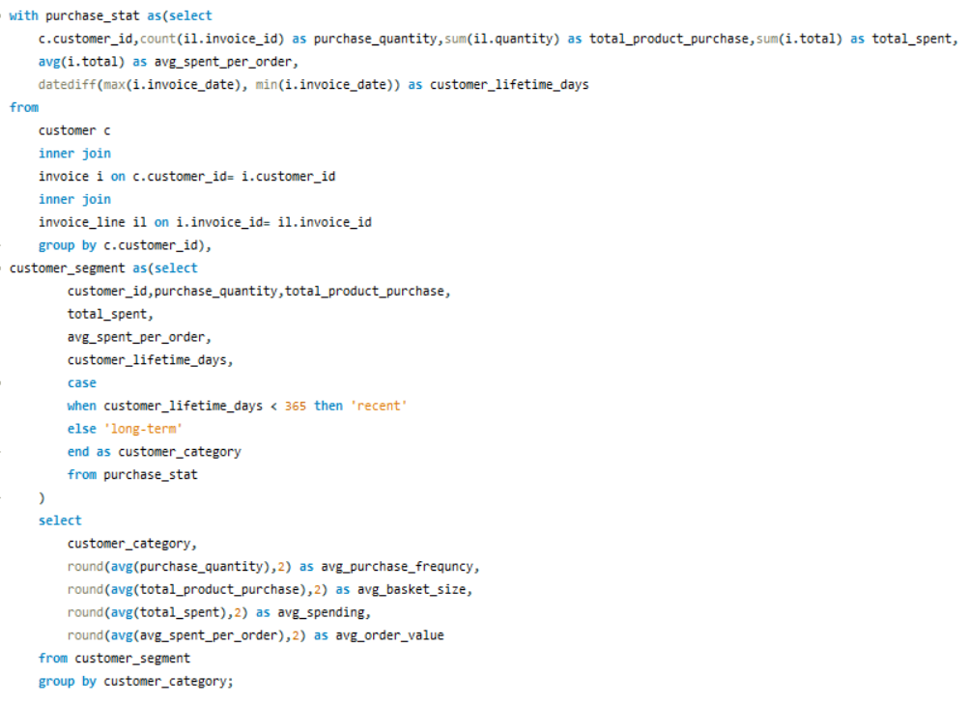

Output
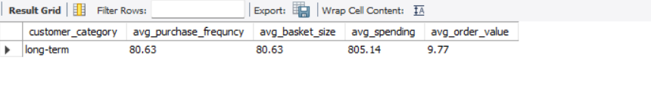

Ensuring Accurate Lifetime Days Calculation Based on Initial Purchase:

To accurately segment customers, check each customer's first purchase date using min(invoice_date) instead of relying solely on the full date range. This ensures the customer_lifetime_days reflects the time since their first purchase, not just the dataset range.

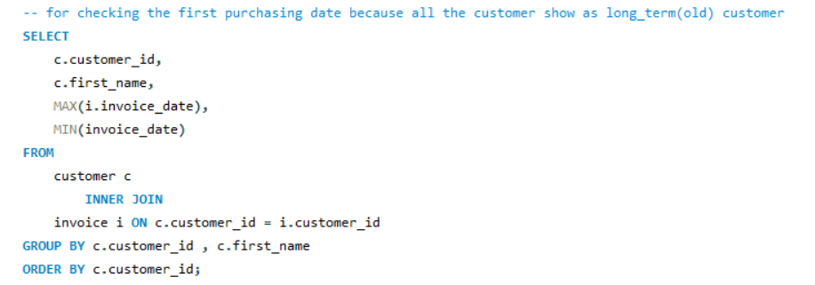

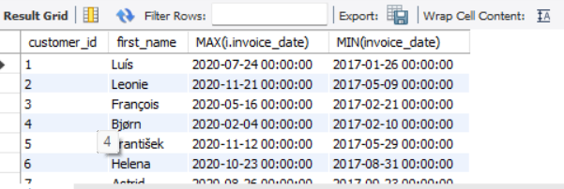

Insights

- Only Long-Term Customers Identified:
The dataset currently contains only long-term customers (with a lifetime over 1 year); no recent customers were found, indicating either missing new customer data or outdated segmentation logic.
- High Engagement from Long-Term Customers:
Long-term customers show high purchase frequency and strong basket sizes, suggesting consistent engagement and brand loyalty.
- Steady Revenue Contribution:
These customers also contribute significantly to total revenue, although their average order value remains modest, indicating frequent but smaller purchases.
- Implications for Loyalty Strategy:
The presence of only long-term customers reflects a loyal customer base, but also highlights a lack of new customer acquisition, which may pose long-term growth risks.
- Retention vs. Acquisition Balance:
The business should continue nurturing existing customers while focusing on strategies to attract and convert new users to maintain sustainable growth.
Result Summary-
- Customer Category: Long-Term
- Average Purchase Frequency: 80.63
- Average Basket Size: 80.63 products
- Average Total Spending per Customer: ₹805.14
- Average Order Value: ₹9.77

Recommendation

- No New Customers Identified:
The current dataset shows only long-term customers, indicating that no new (recent) customers have been recorded in the data within the last 12 months.

- Review Customer Segmentation Logic:
Recalculate customer_lifetime_days using each customer’s first purchase date min(invoice_date) and compare it with the dataset’s maximum invoice date to correctly identify recent customers.

- Check Data Recency:
Ensure the dataset includes recent transactions. If the data is outdated, update it to include more recent customer activity.

- Introduce Time-Based Filters:
Use a consistent reference date (e.g., max(invoice_date)) instead of datediff(max, min) across all customers to avoid skewed segmentation.

- Enable Comparative Analysis:
Once new customers are identified correctly, analyse and compare their purchasing behaviour with long-term customers for better business decisions.

- Investigate Acquisition Strategy:
If genuinely no new customers exist, the business should review its customer acquisition efforts and explore new channels or promotions.

Question 4:
Product Affinity Analysis: Which music genres, artists, or albums are frequently purchased together by customers? How can this information guide product recommendations and cross-selling initiatives?

Answer:

Objective
- Analyze purchasing patterns across tracks, albums, and genres to identify combinations that are frequently purchased together.
- Understand customer preferences and buying behavior based on music consumption patterns.
- Identify relationships and affinities between artists, albums, and genres through purchase trends.
- Generate insights that can support recommendation systems, targeted marketing, and promotional strategies.

Approach
- The SQL queries analyse affinity by combining data from invoice_line, track, album, and artist or genre tables using inner joins to identify pairs of tracks, albums, or genres purchased together.
- The results are grouped by the combined pairs, counted for frequency (time_of_purchase_together), and ordered by this count to highlight the most frequently co-purchased combination.

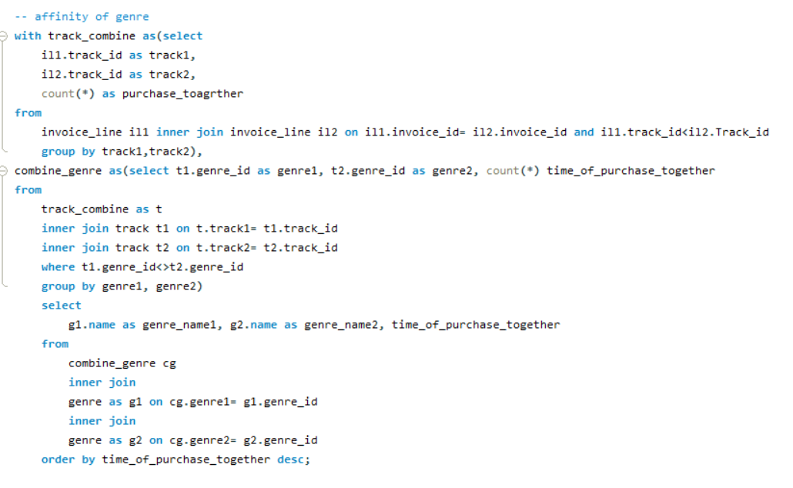
Output
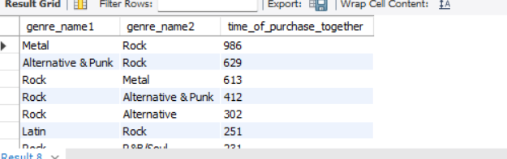

Insights
- The query identifies pairs of genres frequently purchased together, offering insights into customer music preferences and potential genre combinations for marketing or recommendations.
- The time_of_purchase_together count highlights the popularity of specific genre pairings, with higher counts indicating stronger affinities.
- The use of inner joins ensures only valid combinations from the same invoices are considered, providing accurate data on simultaneous purchases.
- Ordering by time_of_purchase_together descending allows businesses to prioritize the most common genre pairings for targeted promotions or playlist suggestions.
- The inclusion of genre names enhances the usability of the results, making it easier to interpret and act on the affinity data.
Result Summary-
- The highest affinity is between "Metal" and "Rock" with 986 co-purchases.
- "Alternative & Punk" and "Rock" follow with 629 co-purchases.
- Other notable combinations include "Rock" with "Metal" (613), "Alternative" (302), and "Alternative & Punk" (412).
- Lesser affinities are observed with "Rock" and "R&B/Soul" (231), "Blues" and "Rock" (180), and "Rock" and "Latin" (176).
- The data highlights "Rock" as a central genre with strong connections to multiple other genres.
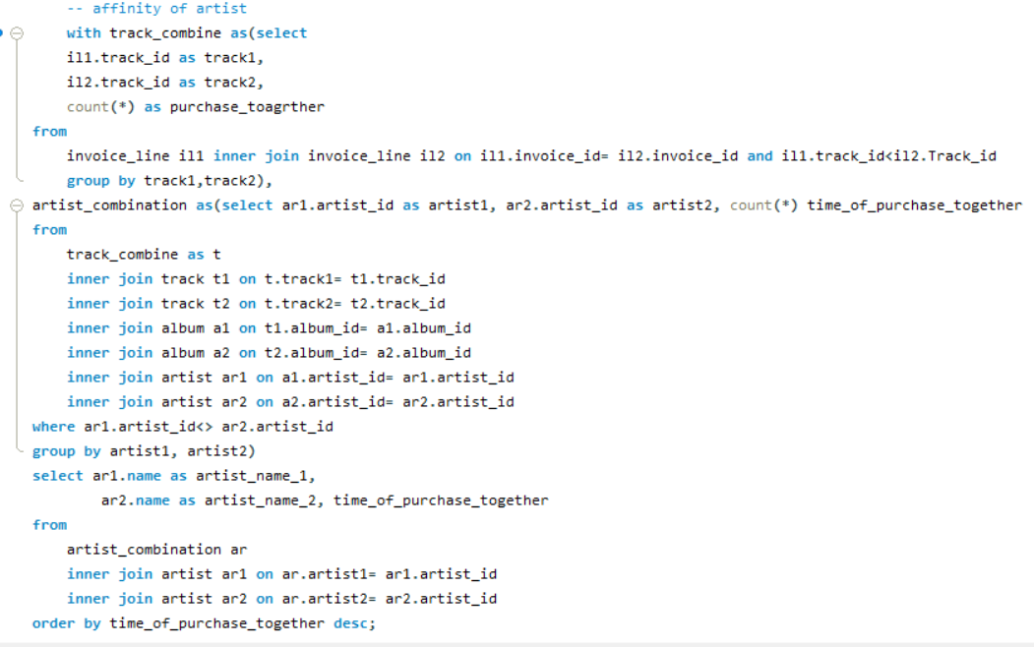

Output
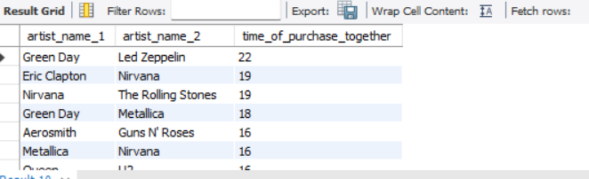

Insights
- The query identifies artist combinations frequently purchased together, revealing customer preferences for specific artist pairings.
- Inner joins with track, album, and artist tables ensure accurate linking of tracks to their respective artists, providing reliable affinity data.
- The time_of_purchase_together count measures the frequency of co-purchases, highlighting popular artist collaborations or preferences.
- Ordering by time_of_purchase_together descending prioritizes the most frequently bought artist pairs, aiding in targeted marketing or recommendation strategies.
- The inclusion of artist names enhances the interpretability of the results for practical business applications.
Result Summary-
- The result summary highlights the affinity between various artists based on their co-purchase frequencies.
- It identifies popular artist pairings, with some combinations showing stronger connections than others.
- The data is ordered to emphasize the most frequently purchased pairs, reflecting customer preferences.
- The inclusion of artist names improves the usability of the results for further analysis or marketing purposes.
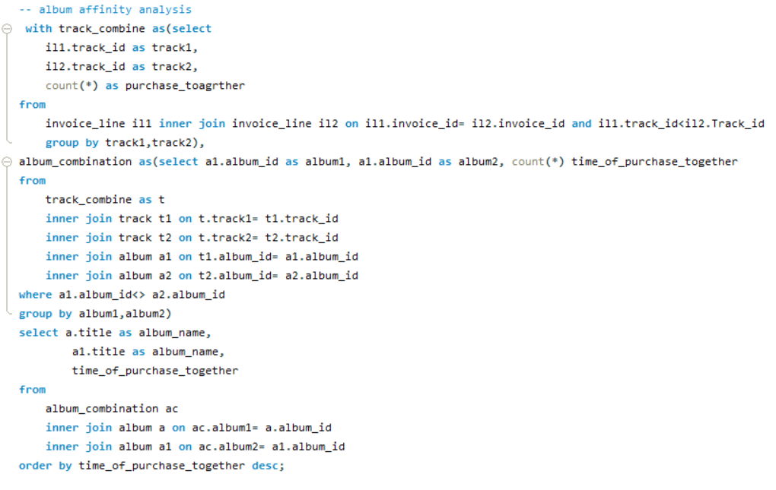

Output
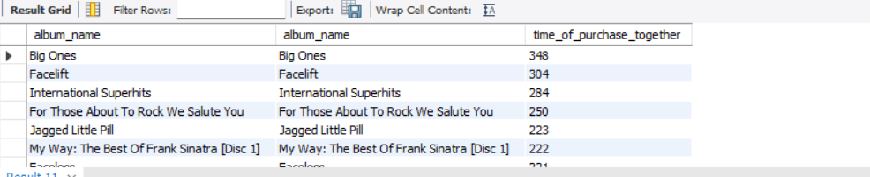

Insights

- The query analyzes album affinities by identifying pairs of albums frequently purchased together, offering insights into customer music preferences.
- Inner joins with track and album tables ensure accurate linking of tracks to their respective albums, providing reliable co-purchase data.
- The time_of_purchase_together count measures the frequency of album combinations, highlighting popular pairings.
- Ordering by time_of_purchase_together descending prioritizes the most commonly bought album pairs for targeted marketing or recommendation strategies.
- The inclusion of album titles enhances the interpretability of the results, making them actionable for business purposes.
Result Summary-
- The result summary showcases the affinity between various albums based on their co-purchase frequencies, with "Big Ones" paired with itself at 348 times, indicating strong individual album popularity.
- Other notable pairings include "Facelift" with itself at 304 times, "International Superhits" with itself at 284 times, and "For Those About To Rock We Salute You" with itself at 250 times.
- Additional combinations such as "Jagged Little Pill" with itself at 223 times, "My Way: The Best Of Frank Sinatra [Disc 1]" with itself at 222 times, and "Faceless" with itself at 221 times show consistent co-purchase trends.
- Lesser affinities are observed with "Are You Experienced?" paired with itself at 205 times and "I Am The New Rock" with itself at 201 times.
- The inclusion of album names enhances the usability of the results for further analysis or marketing strategies.

Recommendation
- Artist Affinity: Focus marketing campaigns on popular artist pairs like those with high co-purchase frequencies (e.g., Green Day and Led Zeppelin, Nirvana and The Rolling Stones). Create bundled offers or playlists featuring these artists to leverage their combined appeal.
- Album Affinity: Promote albums with strong self-pairing frequencies (e.g., "Big Ones" at 348, "Facelift" at 304) through targeted discounts or loyalty rewards. Suggest these albums as must-haves in customer recommendations to boost individual sales.
- Genre Affinity: Highlight genre combinations with high co-purchase counts (e.g., Rock with Metal, Alternative & Punk) in curated playlists or genre-specific promotions to enhance cross-genre engagement and increase overall sales.

Question 5:
Regional Market Analysis: Do customer purchasing behaviours and churn rates vary across different geographic regions or store locations? How might these correlate with local demographic or economic factors?

Answer:

Customer purchasing behaviour by region
Objective
- Analyze customer purchasing patterns across different regions, including country, state, and city levels.
- Evaluate key metrics such as total customers, purchase frequency, total spending, and average order value.
- Identify high-performing regions and gain insights into regional customer purchasing behavior.
Approach

- Created a CTE (customer_purchase) to calculate each customer's total purchases, total spending, and average order value.
- Grouped results by country, state, and city to compute:
- Total number of customers per region.
- Overall and average purchase metrics (spending, frequency, order value).
- Used aggregation functions to summarize regional trends.

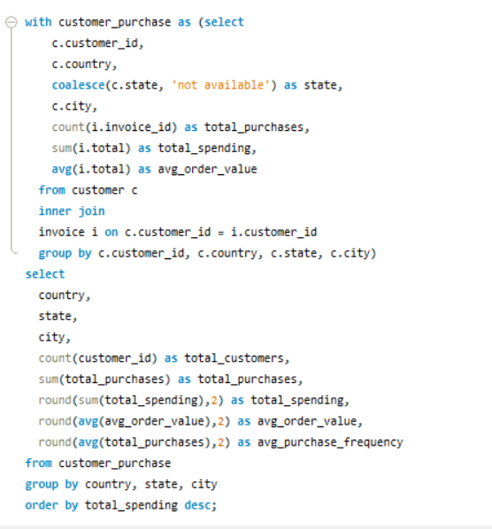

Output
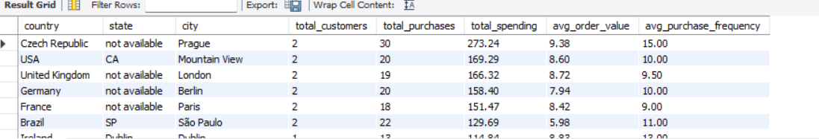

Visualization

Insights
- Prague (Czech Republic) has the highest total spending, suggesting highly active or high-value customers.
- Dublin (Ireland), despite having only 1 customer, shows high average spending and frequency—indicating strong engagement.
- Cities like São Paulo and Mountain View have consistent average order values but lower purchase frequency.
- Some states are listed as "not available", indicating incomplete or missing data in the customer address fields.
Result Summary-
The analysis highlights that cities like Prague and Mountain View have highly engaged customers with strong spending behavior. Other cities such as London and Berlin show steady performance. Some locations with fewer customers, like Dublin, still show high average engagement. Missing state data in many records limits deeper regional insights.

Recommendation
- Prioritize Prague for retention and upselling campaigns—high-value customers exist there.
- Investigate Dublin’s single high-engagement customer—may indicate niche opportunity.
- Clean up address data (e.g., missing states) for better segmentation.
- Use these insights to guide regional marketing strategies and personalized outreach based on average spending and frequency.
- Consider incentivizing cities with medium engagement (like Berlin and Paris) to increase frequency or order value.
Churn Rate by Region:

Objective
To identify the churn rate of customers across different regions by analysing their most recent purchase dates and determining where customer retention is weakest.

Approach
Used two CTEs:
- The first CTE (region_churn_rate) calculates the most recent purchase date for each customer by region.
- The second CTE (churn_customer) filters out customers who haven't purchased anything in over a year.
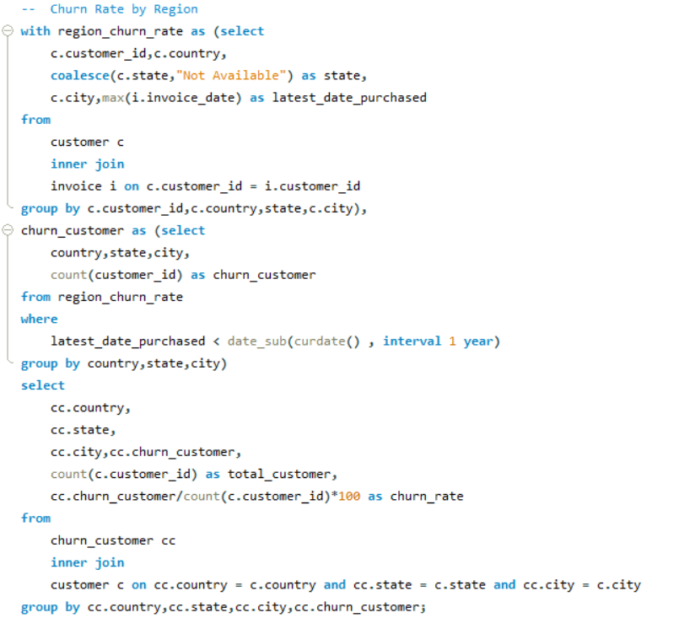
- Finally, we joined the churn data with customer data to compute the churn rate as a percentage of total customers per region.

Output
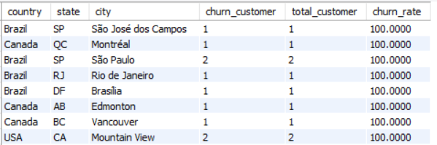

Insights
- Every city analysed in the dataset has a churn rate of 100%.
- This indicates that in all these regions, customers have not made any purchases in the last year.
- The churn is consistent across countries like Brazil, Canada, and the USA, which may point to broader customer engagement or product usage issue.

Result Summary-
The churn analysis reveals that customers from several cities across different countries have become inactive for over a year, resulting in a 100% churn rate in those locations.

Recommendation
- Investigate the reasons behind the complete churn in these cities—whether due to lack of marketing, poor service experience, or regional product fit.
- Re-engagement campaigns and customer feedback collection should be prioritized in these regions.
- Evaluate onboarding and retention strategies to prevent similar trends in other areas.

Question 6:
Customer Risk Profiling: Based on customer profiles (age, gender, location, purchase history), which customer segments are more likely to churn or pose a higher risk of reduced spending? What factors contribute to this risk?

Answer:

Objective
To identify and categorize customers based on their purchasing behaviour to assess their risk level of churn or reduced engagement. This allows for proactive strategies to retain valuable customers.

Approach
- Used two CTEs: one to capture the latest invoice date, and another to summarize customer purchases.
- Calculated key metrics such as total orders, total spent, average purchase amount, and average quantity.
- Classified customers into three risk levels (Risk, Medium Risk, Low Risk) based on: How long it has been since their last purchase and their total purchase.
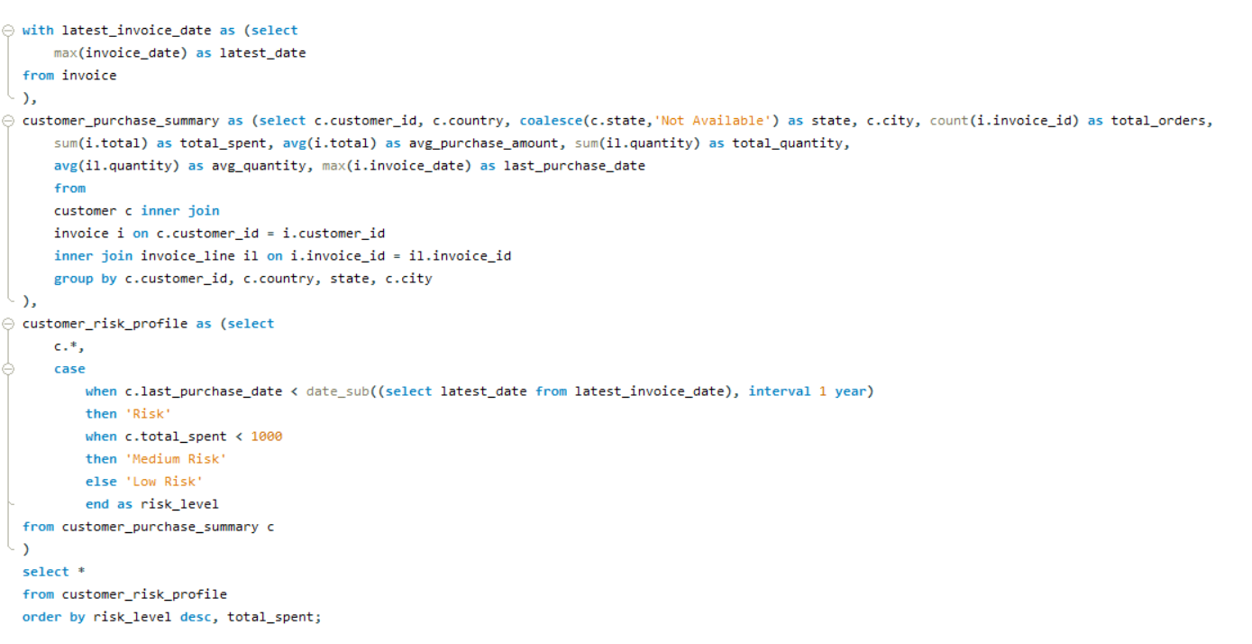

Output
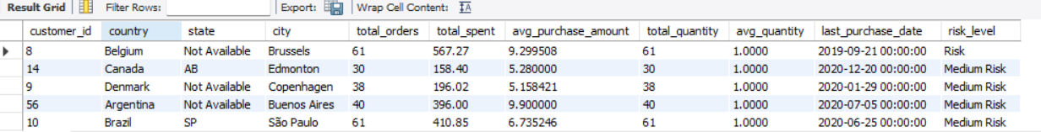

Visualization

Insights
- Customers label as Risk have not made a purchase in over a year, showing signs of potential churn.
- The Medium Risk group includes customers with moderate spending but recent activity. They may need engagement to maintain loyalty.
- Customers in the Low Risk category consistently engage and spend more, indicating high loyalty and satisfaction.
Result Summary-
- The analysis effectively segments customers based on recent behavior and purchase value.
- Those marked as high risk had no recent purchases and relatively lower spending patterns.
- Meanwhile, medium-risk customers have shown some engagement but with limited purchase activity.
- The majority of consistent spenders fall into the low-risk category.
Recommendations
- For Risk customers: Initiate re-engagement campaigns (e.g., discount offers, personalized emails).
- For Medium Risk customers: Offer loyalty programs or incentives to increase purchase frequency.
- For Low Risk customers: Maintain their satisfaction with exclusive benefits or early access to new products.

Question 7:
Customer Lifetime Value Modeling: How can you leverage customer data (tenure, purchase history, engagement) to predict the lifetime value of different customer segments? This could inform targeted marketing and loyalty program strategies. Can you observe any common characteristics or purchase patterns among customers who have stopped purchasing?

Answer:

Objective
The objective is to analyse customer purchase data to model Customer Lifetime Value by leveraging tenure, purchase history, and engagement metrics. This will enable the identification of customer segments, prediction of future value, and development of targeted marketing and loyalty program strategies to enhance retention and maximize revenue.

Approach

- Data Collection and Aggregation:
- Extract customer details (customer_id, customer_name, country, state, city) and invoice data (dates, totals) using an inner join between the customer and invoice tables.
- Compute key metrics: first_purchase min(invoice date), last_purchase max (invoice date), tenure (datediff of last and first purchase), purchase_count (count of invoices), total_spend (sum of invoice totals), and average_spend (rounded avg of totals).

- Segmentation:
  - Categorize status as 'churn' (if last purchase > 1 year ago) or 'active' using a case statement.
  - Segment spending_segment into 'high value' (>100), 'mid value' (50-100), or 'low value' (<50) based on total spend.
  - Classify frequency_segment as 'frequent' (>12 purchases and tenure > 90 days), 'occasional' (6-11 purchases), or 'rare' (<6 purchases) using case statements.

- CLV Calculation:
  - Calculate customer_lifetime_value as the product of average_spend, purchase_count, and tenure (in days) divided by 365, rounded to 2 decimal places.
  - Use this as a baseline for predictive modeling with advanced techniques (e.g., regression) to forecast future value.

- Analysis and Strategy Development:
- Identify patterns in churned customers (e.g., tenure, spending, frequency) to inform re-engagement tactics.
- Develop targeted marketing and loyalty programs based on segments (e.g., high value frequent customers receive exclusive offers, mid/low value occasional customers get re-engagement campaigns).
- Continuously update the model with new data and refine segments based on emerging trends.

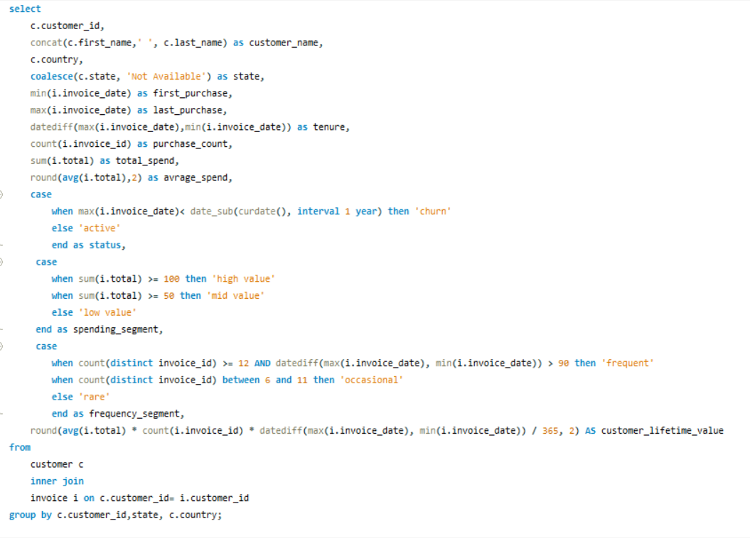
Output
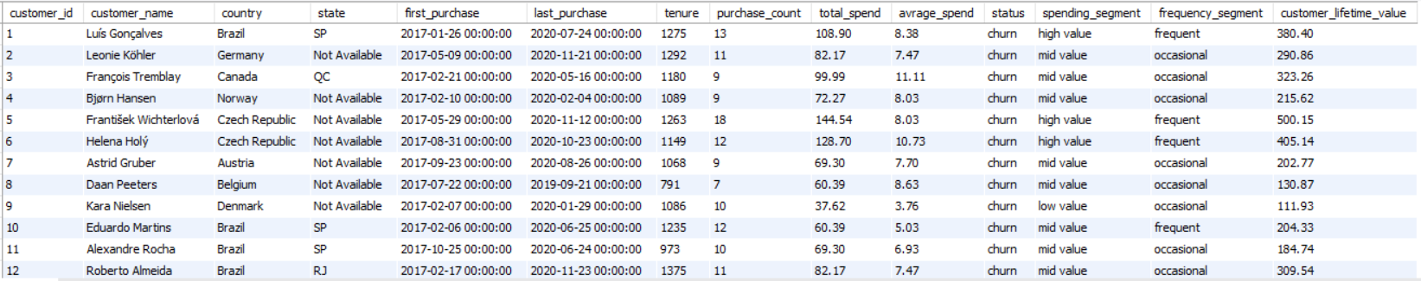

Visualization

Insights

- The analysis reveals a consistent pattern of inactivity among all customers, indicating a widespread churn issue that requires urgent attention.
- Customer engagement varies across different spending and purchase frequency levels, suggesting diverse reasons for disengagement that need segmented exploration.
- The calculated Customer Lifetime Value (CLV) highlights varying contributions, providing a basis for prioritizing retention efforts on higher-value customers.
- The lack of recent purchases across multiple regions, with some missing location details, points to potential data gaps or uniform market challenges affecting retention.
- Tenure and last purchase trends suggest that even long-term customers may lose interest over time, emphasizing the need for proactive re-engagement strategies.

Result Analysis-
- The analysis provides an overview of customer profiles across various regions, with some location details missing.
- Purchase metrics reveal a range of engagement durations, transaction frequencies, and spending levels among customers.
- Customers are segmented based on their spending habits and purchase frequency, identifying distinct behavioural groups.
- Customer Lifetime Value (CLV) is calculated to assess the overall value contributed by each customer over their engagement period.
- All customers are currently inactive, with no recent purchases, suggesting a uniform churn pattern that may indicate broader market or retention issues.

Informing Targeted Marketing and Loyalty Program Strategies:
The analysis of customer data, including tenure, purchase history, and engagement metrics, can inform targeted marketing and loyalty program strategies by:
- Segment-Specific Campaigns: Tailoring offers based on spending and frequency segments (e.g., high-value frequent customers receive premium rewards, while mid-value occasional customers get re-engagement incentives).
- Retention Focus: Using tenure and last purchase dates to identify at-risk customers for proactive outreach, such as personalized discounts or reminders.
- Loyalty Enhancements: Designing loyalty programs that reward consistent spending and frequent purchases, encouraging continued engagement from valuable segments.
- Customer lifetime value Optimization: Leveraging customer lifetime value insights to prioritize high-value customers for exclusive benefits, maximizing long-term revenue.

Common Characteristics or Purchase Patterns Among Customers Who Have Stopped Purchasing:
Observations of customers who have stopped purchasing (all classified as 'churn') include.
- Inactivity Period: A consistent lack of recent purchases, suggesting a significant time gap since their last transaction, which may indicate disengagement or external factors.
- Varied Engagement Levels: Customers exhibit a range of purchase frequencies and tenures, with no single pattern dominating, implying churn affects both frequent and occasional buyers.
- Diverse Spending: Churn occurs across different spending levels, indicating that high, mid, and low spenders are equally susceptible, pointing to factors beyond monetary contribution.
- Geographical Spread: Inactivity is observed across multiple regions, with some location details missing, suggesting churn may not be region-specific but could relate to data gaps or uniform market conditions.
- Potential Decline: Longer engagement periods with recent inactivity might suggest a gradual loss of interest or satisfaction, warranting further investigation into retention triggers.
Recommendation
- Targeted Marketing: Focus on re-engaging inactive customers with personalized campaigns, such as offering discounts on genres or artists they previously enjoyed, to recapture their interest.
- Loyalty Programs: Introduce tiered rewards for frequent spenders, encouraging continued purchases with exclusive content or early access to new releases.
- Retention Strategies: Identify at-risk customers early by monitoring purchase gaps and tenure, then offer tailored incentives like bundle deals to prevent churn.
- Segmented Offers: Prioritize high-value segments with premium loyalty benefits, while using low-cost promotions to boost engagement among lower-value customers.

Question 8:
If data on promotional campaigns (discounts, events, email marketing) is available, how could you measure their impact on customer acquisition, retention, and overall sales?

Answer:

Approach
To understand how promotional campaigns (such as discounts, events, or email outreach) influence customer growth, loyalty, and sales performance, a structured analysis can be followed:

Customer Acquisition
- Monitor how many new customers joined during promotional activities.
- Compare these numbers with periods without any promotions to measure how well the campaign attracted fresh customers.

Retention & Repeat Purchases
- Observe if customers continued buying after the campaign ended.
- Evaluate this against periods without promotions to see if the campaign influenced long-term customer engagement.

Sales Uplift
- Measure the increase in revenue by comparing sales during the campaign with usual sales from non-promotional times.
- Consider seasonal trends or external events that might have affected the results.

Segmented Response
- Analyse how various customer groups (such as based on location, age, or spending habits) reacted to the promotion.
- Find out which segments responded better so that future campaigns can be more focused and effective.
Each of these evaluations provides a thorough perspective on how well promotional activities shape customer actions and financial results.

Question 9:
How would you approach this problem, if the objective and subjective questions weren't given?

Answer:

- Data Cleanup: Start by checking and fixing the dataset, handling missing entries and removing duplicates for better accuracy.
- Key Metrics Check: Look at important numbers like how often customers buy, churn rates, and sales results to get a clear picture.
- Asking Questions: Come up with simple questions from the data, like which albums or tracks are most popular, top-selling genres, or buying differences by country.
1.Which albums or tracks are the most popular among customers?
2.What genres are leading in sales figures across the dataset?
3.How do buying patterns differ based on customers' countries?
- Customer Groups: Split customers into categories based on age, past purchases, and activity to understand their habits better.
- Churn Look: Find out why customers leave, focusing on at-risk groups and possible reasons for their exit.
- Country Differences: Compare what customers like, how they spend, and which music is popular in different countries.
- Sales Trends: Check which albums or tracks sell the most, looking at prices, promotions, and who’s buying them.

Question 10:
How can you alter the "Albums" table to add a new column named "ReleaseYear" of type INTEGER to store the release year of each album?

Answer:

Approach
- Table Modification: Use the alter table statement to add a new ReleaseYear column with an integer data type to the album table, enabling the storage of release year information.
- Data Update: Employ the update function to modify the ReleaseYear column, setting specific year values for selected records based on album_id conditions.
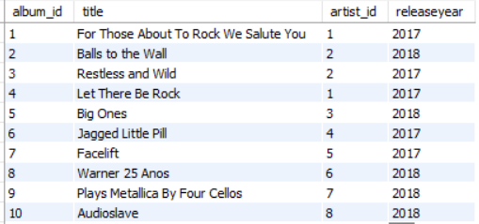
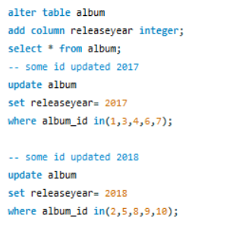

Result Summary-
- The alter table statement successfully added a new column named releaseyear with an integer data type to the album table, enabling the storage of release year information for each album.
- The initial select * from album query confirmed the addition of the ReleaseYear column, though it initially contained no values.
- The update statement for albums with album_id in (1, 3, 4, 6, 7) set their releaseyear to 2017, effectively assigning a release year to this group.
- The subsequent update statement for albums with album_id in (2, 5, 8, 9, 10) set their releaseyear to 2018, completing the year assignment for the remaining albums.
- The process ensured that all specified albums now have their releaseyear values updated based on their respective album_id groups.

Question 11:
Chinook is interested in understanding the purchasing behavior of customers based on their geographical location. They want to know the average total amount spent by customers from each country, along with the number of customers and the average number of tracks purchased per customer. Write an SQL query to provide this information.
Answer:
Approach
- Data Preparation: Start by joining customer, invoice, and invoice_line tables to gather purchase data, including customer_id, country, quantity, and unit_price, ensuring a solid foundation for analysis.
- CTE and Aggregation: Use a single CTE (purchase_summary) to calculate total_tracks and total_spent per customer, then aggregate by country to derive metrics like total tracks, average tracks per customer, and average spend.
- Result Organization: Sort the output by average_amount_spent_per_customer in descending order to prioritize high-spending regions, with results validated for accuracy.
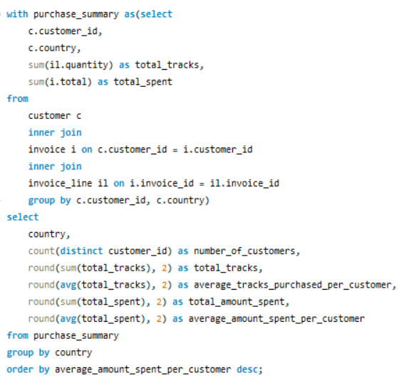

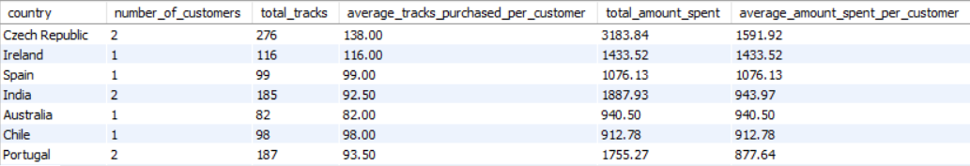
Output

Insights
- The analysis highlights differences in customer engagement and spending across various regions, pointing to opportunities for tailored marketing approaches.
- The single CTE approach streamlines purchase data aggregation, offering valuable insights into average customer behaviour that can inform resource and strategy decisions.
- Sorting by average spend per customer identifies leading regions, enabling a focused strategy to enhance revenue potential.
Result Summary-
The result summary showcases the aggregated purchasing behavior across different regions, reflecting variations in customer engagement and spending patterns. It highlights the number of customers and total tracks purchased per region, alongside average metrics for tracks and amount spent per customer. The results are organized to emphasize regions with the highest average spending, providing a clear basis for strategic decision-making.

