OBJECTIVE QUESTIONS

Question 1: What is the total no. of tables present in the data?

Solution:

Final Answer (if any):
The total number of tables present in the data is 2.

Approach (if any):
In Excel, each sheet with structured rows & columns is considered a table.
The dataset consists of two sheets, namely “Raw Data”, and “country description.”

Charts & Tables (if any):

Sheet Name | No. of Tables
Sheet 1: Raw Data | 1
Sheet 2: Country Description | 1
Total no. of Tables | 2

Question 2: What is the total no. of attributes present in the data?

Solution:

Final Answer (if any):
The raw data table contains 20 attributes, and the country lookup table contains 2 attributes. Therefore, considering both tables, the dataset has a total of 22 attributes.

Question 3: How many categorical columns are there in the data? [Search about categorical and continuous data, and try to answer this question]

Solution:

Final Answer (if any):
The dataset contains a total of 13 categorical columns.

Approach (if any):
Categorical data represents qualitative information. It represents labels, names, or categories - usually text or Yes/No values. In the raw data table, 13 columns are categorical, and the country lookup table contributes 2 additional categorical columns.

Charts & Tables (if any):
Classification of Columns

Categorical Columns | RestaurantID, RestaurantName, CountryCode, City, Address, Locality, LocalityVerbose, Cuisines, Currency, Has_Table_booking, Has_Online_delivery, Is_delivering_now, Switch_to_order_menu
Continuous Columns | Longitude, Latitude, Price_range, Votes, Average_Cost_for_two, Rating, Datekey_Opening

Question 4: The data consists of some inconsistent and missing values so ensure that the data used for further analysis is cleaned.

Solution:

Final Answer (if any):
Data Cleaning
- Filtered all the columns and checked for inconsistent or missing data
- All blank cuisine cells were replaced with ‘Unknown’
- City name changed (Sí£o Paulo to Sau Paulo, ÛÁstanbul - Istanbul, Brasilia to Brazil, Cedar Rapids/lowa City- Cedar Rapids, Chatham-Kent - Chatham) using find and replace
- New columns were created in the sheet ‘Cleaned Data’- namely Opening Year (Column V), cleaned_Average_cost_for_two (Column Z), Average_cost_in-INR (Column S), and in the sheet ‘Country Description’ - namely conversion multiple (Column D and E)
- Handled Data Types for each column
Pre-Processing
- Extracted the opening year from ‘Date_key_Opening’ using Left function
- Added the country for respective country code using vlookup function
- Identified conversion rate of countries into INR by using Google search engine, and added in the new column
- Used if function for handling invalid values in average cost for two column
- Changed the Average_cost_for Two into INR and then categorised them under range in new column

Approach (if any):
Steps required to clean the data are as follows:

Step 1: Handle Duplicates
Select all - Data - Data tools - Remove Duplicates

Step 2: Handle Null values
Using Filter to find Blank Cells

Step 3: Handle data types

Question 5: Using the LookUp functions, fill up the countries in the original data using the country code.

Solution:

Final Answer (if any):
The original data using the country code was successfully filled by mapping each country code to its corresponding country using the VLOOKUP function in Column W (Country Name (Objective Question 5).

Approach (if any):
The formula used here is:
=VLOOKUP(lookup_value, table_array, col_index_num, [range_lookup])

Charts & Tables (if any):
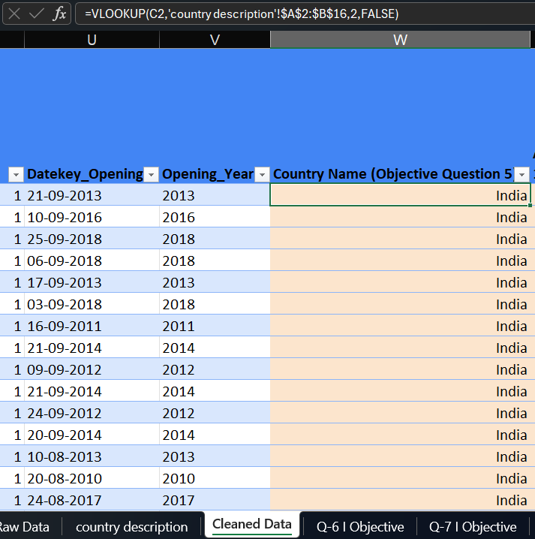
=VLOOKUP(C2,'country description'!$A$2:$B$16,2,FALSE)
(Where C2 contains the country code and the lookup table contains the mapping of country codes to country names,and an exact match lookup was used to ensure accurate mapping between country codes and country names.)

Question 6: Create a table to represent the number of restaurants opened in each country.

Solution:

Final Answer (if any):
The number of restaurants opened in each country is 9551.

Approach (if any):
- Created a pivot table with Country names in rows and Restaurant ID in values (count of restaurants)
- Aggregated data to analyze the number of restaurants in each country

Charts & Tables (if any):
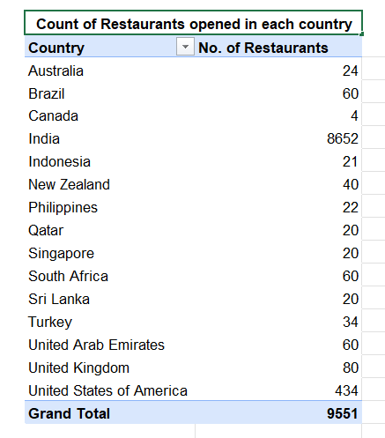
Key insights:
- Restaurant presence is highly concentrated in India,highlighting the strong domestic concentration.
- Other international markets (UK,UAE,Brazil, and South Africa) have moderate presence.
- Countries like Canada show minimal listings.

Recommendation:
- There is significant opportunity for expansion in underpenetrated international markets.

Question 7: Also, the management wants to look at the number of restaurants opened each year, so provide them with something here.

Solution:

Final Answer (if any):
Key insights:
- Restaurants opening remained stable over the years
- Peak observed in 2018, indicating recent growth momentum
- Lowest opening in 2012, suggesting a temporary slowdown
- Overall trend indicates a mature and consistent expansion strategy, rather than aggressive or volatile growth

Conclusion for Management:
- The business has maintained steady yearly expansion, with signs of renewed growth in recent years (post-2016)
- No major fluctuations suggest controlled scaling and stable market demand

Approach (if any):
- Created a pivot table with Opening Year in rows and Restaurant ID in values (count of restaurants)
- Aggregated data to analyze the number of restaurants opened each year
- Developed a line chart to visualize year-wise trends in restaurant openings
- Enabled clear identification of growth patterns and expansion phases over time

Charts & Tables (if any):
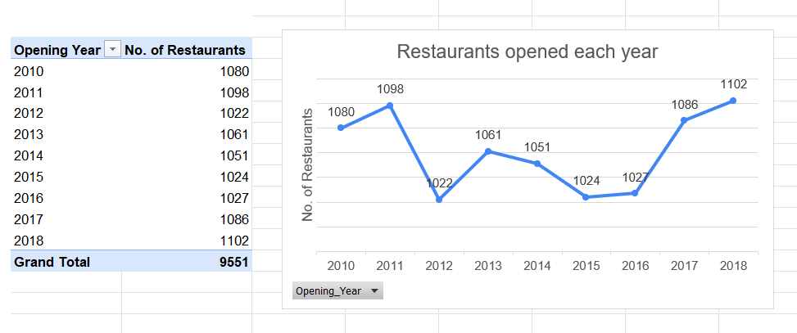

Question 8: What is the total number of restaurants in India in the price range of 4?

Solution:

Final Answer (if any):
The total number of restaurants in India in the price range of 4 is 388.

Approach (if any):
Formula used:
=COUNTIFS(criteria_range1,criteria1,.....)
(Where criteria_range1 contains country name, criteria1 is ‘India’ and criteria_range2 is price range,criteria2 is 4.

Question 9: What is the average number of voters for the restaurants in each country according to the data?

Solution:

Final Answer (if any):
The average number of voters for the restaurants in each country according to the data is 157 (rounded off to two decimal places).

Approach (if any):
- Created a pivot table with Country name in rows and Votes in values (average of votes).
- Aggregated data to analyze the average number of voters in each country.
- Developed a bar chart to visualize the country and their average voters.

Charts & Tables (if any):
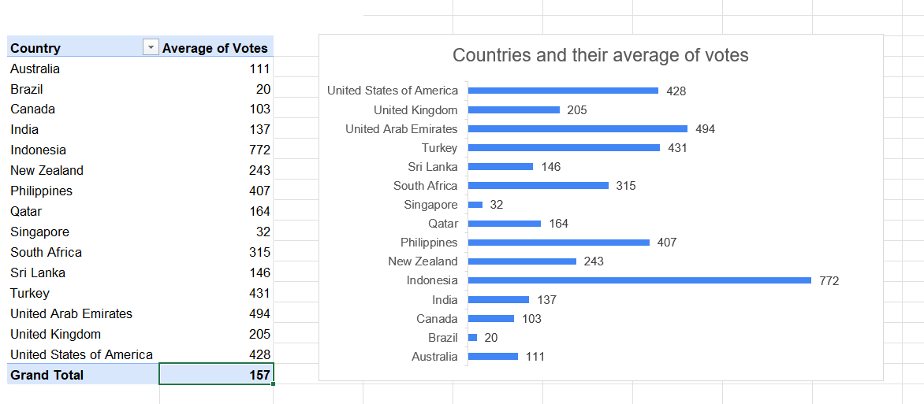

Markets with higher average votes indicate stronger user interaction and active customer communities, while countries with low engagement may require improved platform awareness, customer incentives, or stronger restaurant visibility to encourage participation.

Question 10: Calculate the average rating for all the restaurants that have price_range < 4 and provide online delivery. Use only the “IF” function, Logical Operators, and Aggregation functions to solve this problem. [Note: Don’t use Conditional aggregation in this question.]

Solution:

Final Answer (if any):
The average rating for all the restaurants that have price_range < 4 and provide online delivery is 3.27381151.

Approach (if any):
- Created a column Y, named “If Price_range < 4,and providing Online_Delivery (Objective Question 10)”
- If and function used, Formula used:
=IF(AND(P2<4,M2="Yes"),S2,"")
- Again, used the formula
=AVERAGE('Cleaned Data'!Y:Y)

Charts & Tables (if any):
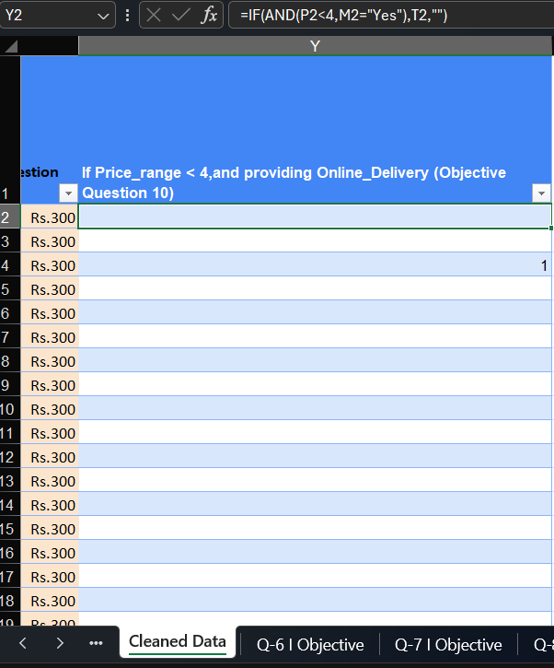

Question 11: Using Conditional formatting highlight the rows of restaurants that are located in the countries or cities that you’ve suggested to the management for opening new restaurants.

Solution:

Approach (if any):
- Solved Subjective Question 1 to identify potential International Markets using the analytical logic to identify:
- Lower restaurant count
- Higher average rating
- Average cost levels
- Solved Subjective Question 2 to identify high potential cities for restaurant expansion using the logic to identify market with:
- Low restaurant counts and high votes
- Low votes
- High cost and high competition
- Used the above condition and highlighted the rows of restaurant using Conditional formatting highlight.
Charts & Tables (if any):
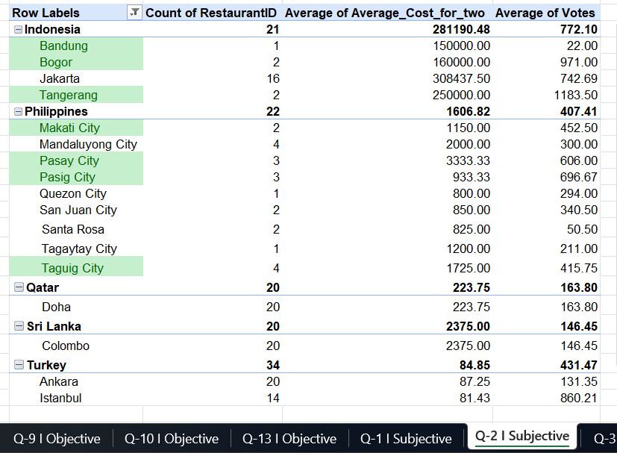

Description:
The above table provides:
- Countries with fewer restaurants, relatively high ratings, and feasible cost levels present potential opportunities for restaurant expansion.
- Cities showing strong customer engagement with limited restaurant presence represent the most attractive opportunities for new restaurant openings.

Question 12: Create a new customized price column that consists of the abbreviation/symbol of the currency along with the Average_cost_for_two value. [Use string operations to do this task]

Solution:

Approach (if any):
- Used string functions (MID, FIND) to extract currency symbol from text field
- Concatenated extracted symbol with Average Cost for Two using & operator
- Created a customized price column X

Formula used:
The formula extracts the currency symbol enclosed within parentheses using the MID and FIND functions, and then concatenates it with the average cost value using the & operator to create a formatted currency string.

Charts & Tables (if any):
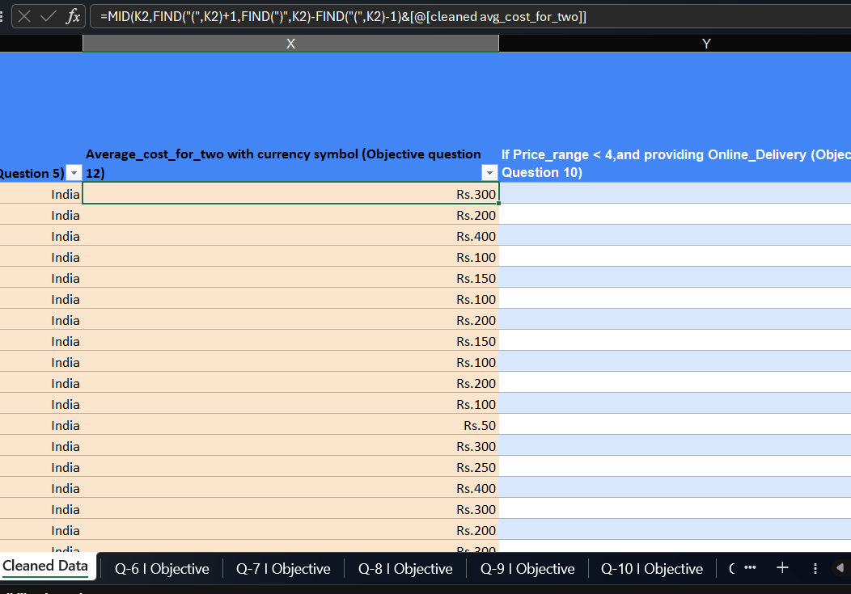

Question 13: How can you create an array formula in Excel or Google Sheets to count the number of restaurants listed that do not offer online delivery, are in the lowest price range, and have an average cost for two people less than or equal to 250 Indian Rupees?

Solution:

Final Answer (if any):
1676
Formula used: countifs(criteria_range1,criteria1,critera_range2, criteria2, criteria_range3,criteria3)

Approach (if any):
- To count the restaurants that satisfy three conditions : no online delivery, price_range is equal to 1, and average cost for two less than or equal to 250.
- Since the dataset contains multiple currencies, a new column named Converted_Avg_Cost_For_Two(INR) was created using a currency conversion lookup table to standardize all values into Indian Rupees before applying the condition.

Charts & Tables (if any):
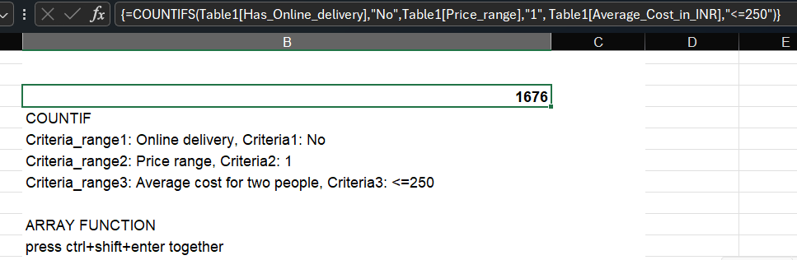

SUBJECTIVE QUESTIONS

Question 1: Suggest a few countries where the team can open newer restaurants with lesser competition. Which visualization/technique will you use here to justify the suggestions?

Solution:

Approach:
Key metrics considered:
- Number of restaurants- indicates the level of competition in each market
- Average Rating- reflects customer satisfaction and dining quality
- Average cost of two- helps understand pricing levels and market positioning

Analytical Logic:
- Lower restaurant count- indicates lower market saturation and less competition
- Higher average rating- suggests strong customer satisfaction and potential demand
- Average cost levels- help identify whether the market is premium or budget oriented

Charts & Tables:
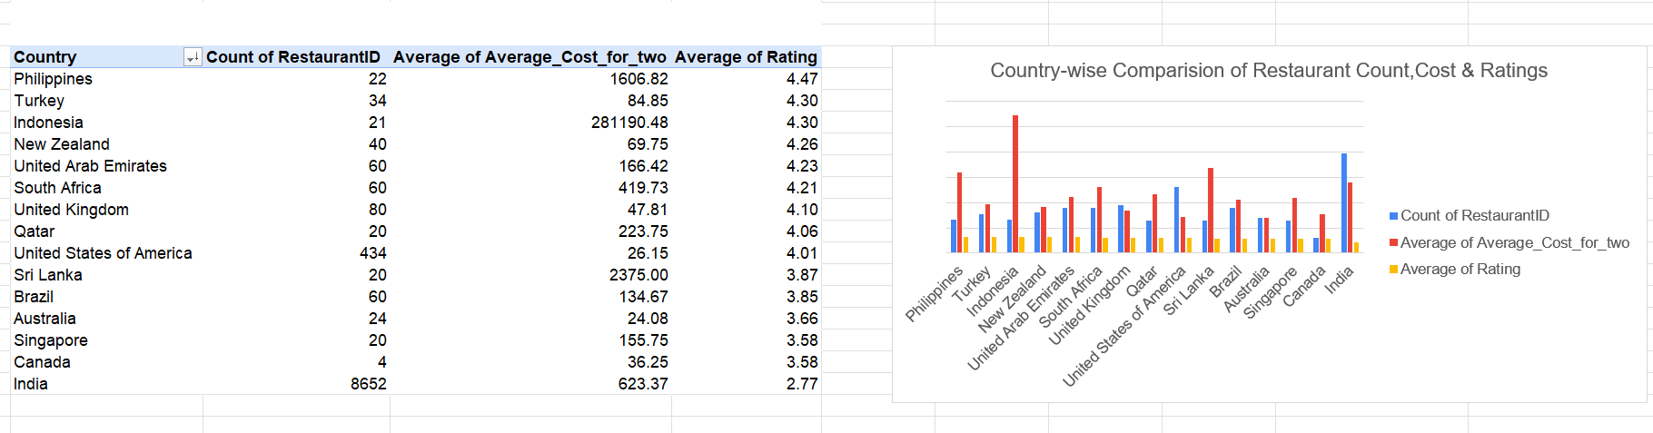
A logarithmic scale (base 10) was used to improve visualization of large cost variations while preserving relative differences.

Description:
Countries with fewer restaurants, relatively high ratings, and feasible cost levels present potential opportunities for restaurant expansion.

Insights:
- Countries such as Sri Lanka, Indonesia, Philippines, Qatar, and Turkey have very low restaurant counts (20–34) compared to other markets.
- Despite the limited number of restaurants, these countries maintain strong average ratings ranging from 3.87 to 4.47, indicating positive customer satisfaction.
- Some of these markets also show higher average cost levels, suggesting the presence of premium dining segments.

Recommendations:
Low competition with positive customer feedback suggests untapped potential for restaurant expansion. New restaurants can be opened in the following countries in order to capture early market opportunities and support future demand growth.

- Philippines – Highest customer satisfaction with relatively low competition
- Indonesia – High ratings indicating strong customer acceptance
- Sri Lanka – Emerging market with limited competition
- Qatar – Low competition with strong potential for premium positioning
- Turkey – Moderate competition with high ratings; suitable for targeted expansion

Question 2: Come up with the names of States and cities in the suggested countries suitable for opening restaurants.

Solution:

Approach:
Metrics considered:
- Count of Restaurants- Measures competition intensity within each city
- Average cost for two- Indicates pricing level and market positioning
- Average votes- Represents customer engagement and demand intensity

Analytical logic:
- Low restaurant count and high votes- indicates high demand but limited supply
- Low votes- indicates weak customer engagement
- High cost and high competition- indicates potentially saturated premium market

Charts & Tables:
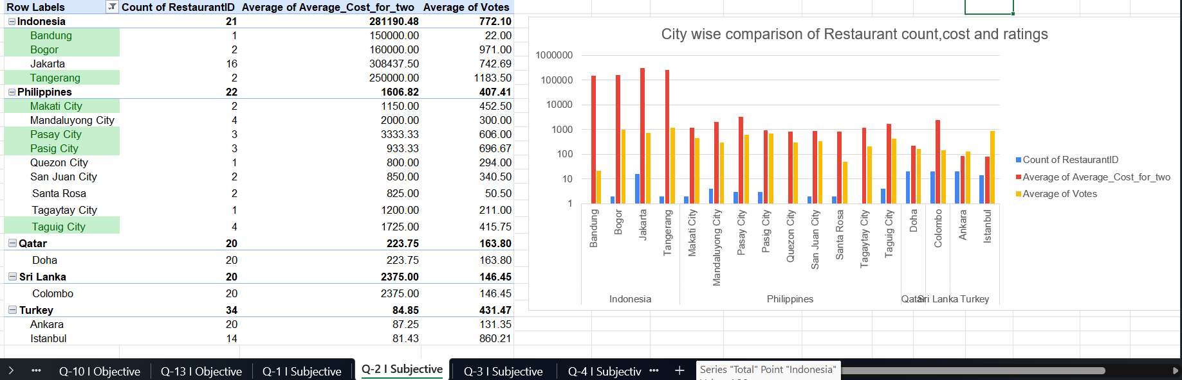
A logarithmic scale (base 10) was used to improve visualization of large cost variations while preserving relative differences.

Description:
Cities showing strong customer engagement with limited restaurant presence represent the most attractive opportunities for new restaurant openings.

Insights:
- Jakarta (Indonesia) has the highest competition and very high costs.
- Tangerang(Indonesia), Bogor (Indonesia), Pasig City(Philippines) shows high customer engagement with low competition.
- Pasay City(Philippines) shows good engagement but higher costs.
- All restaurants are concentrated in Doha(Qatar) and Colombo(Sri Lanka) with low engagement.
- Istanbul(Turkey) has very high votes with fewer restaurants compared to Ankara, while Ankara shows higher competition but much lower engagement.
Recommendations:
Restaurant partnerships in the following mentioned cities can be prioritized to capture early demand and strengthen its presence in emerging food markets.

- Bogor (Indonesia)- Low competition and strong customer engagement make it suitable for premium entry.
- Tangerang (Indonesia)- High customer engagement with minimal competition indicates strong unmet demand; premium pricing potential.
- Pasig City (Philippines)- High votes and moderate pricing suggest strong customer interest and affordable pricing scalability.
- Pasay City (Philippines)- Good engagement supports selective expansion despite higher costs.
- Taguig City (Philippines)- Balanced demand and competition; suggesting stable pricing dynamics.
- Bandung (Indonesia)- Very low demand despite minimal competition, suggesting cautious expansion.

Question 3: According to the countries you suggested, what is the current quality regarding ratings for restaurants that are open there?

Solution:

Approach:
- To identify the most suitable countries among the shortlisted options, the Average Restaurant Rating was used as a key performance indicator.
- To identify high-performing and relatively weaker markets, the average ratings are compared.

Charts & Tables:
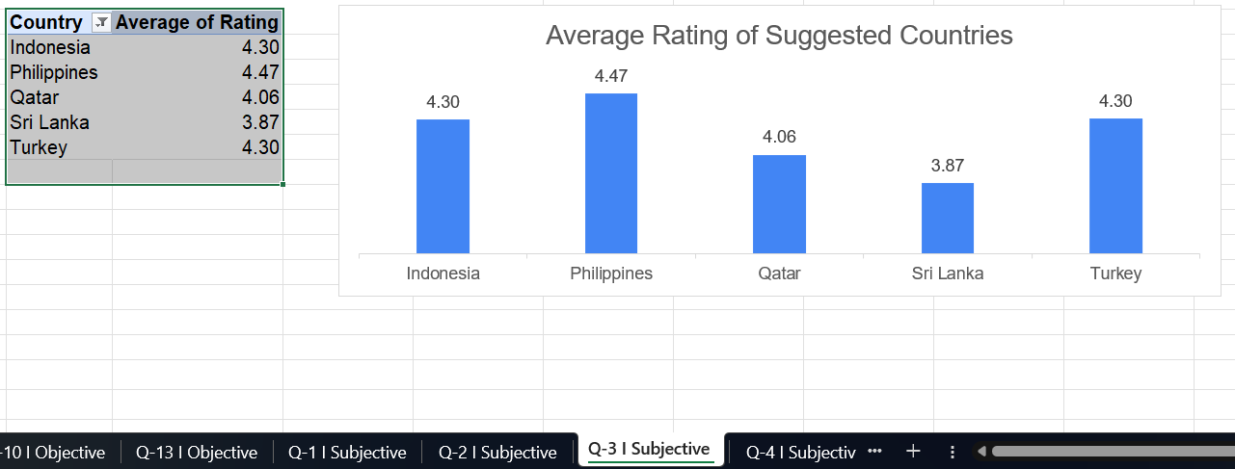

Description:
Charts and tables provide a comparative view of customer perception and overall restaurant performance in each country. Higher average ratings reflect better customer satisfaction, food quality, and service standards, making those markets more attractive for potential expansion or focus.

Insights:
- Philippines records the highest average rating among the shortlisted countries, indicating strong customer satisfaction and restaurant quality.
- Indonesia and Turkey both maintain high ratings, suggesting consistently positive dining experiences in these markets
- Qatar shows a solid rating level, reflecting stable service quality and customer perception.
- Sri Lanka records the lowest rating among the shortlisted countries though it still remains within an acceptable range for customer satisfaction.

Recommendations:
The shortlisted countries maintain average ratings close to or above 4, indicating healthy restaurant quality standards and positive customer experiences. Hence business can optimize market entry decisions, reduce operational risk, and maximize the likelihood of successful expansion through data-backed, customer-centric strategy.

Question 4: Also, what is the current expenditure on food in the suggested countries, so we can keep our financial expenditure in control?

Solution:

Approach:
- To evaluate financial feasibility across the shortlisted countries, Average Cost for Two (in INR) was used as a measure of food expenditure.
- Since all values are standardized in INR, a direct comparison across countries is conducted to assess relative cost intensity and affordability.

Charts & Tables:
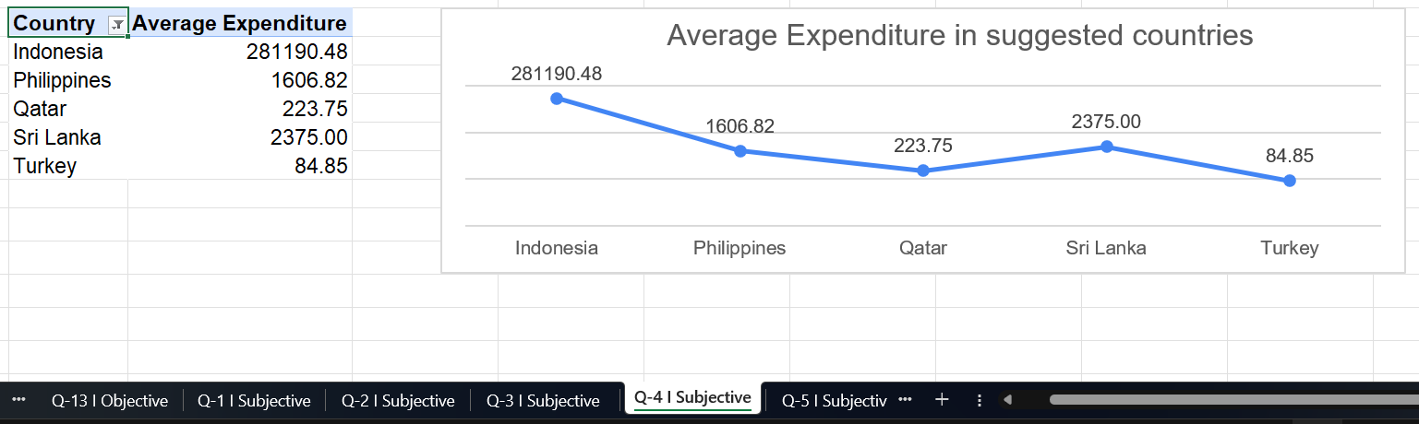
A logarithmic scale is used to improve visualization of large cost variations while preserving relative differences.

Description:
The above chart and table shows the average cost for two people at restaurants, expressed in INR, across the shortlisted countries. It provides a clear view of pricing levels and affordability in each market.

Insights:
- Food expenditure levels differ across shortlisted markets, indicating distinct pricing segments.
- Indonesia shows an extremely high average expenditure compared to other shortlisted countries.
- Sri Lanka and Philippines reflect moderate food expenditure levels
- Qatar demonstrates relatively controlled expenditure levels while still maintaining good restaurant ratings.
- Turkey shows the lowest expenditure level.
Recommendations:
The variation in expenditure levels suggests different market positioning strategies across countries. Hence ensuring that restaurant expansion decisions align with market affordability and financial sustainability.

- Premium Markets- Indonesia
- Balanced Markets- Philippines, Sri Lanka
- Affordable Markets- Qatar, Turkey

Question 5: Come up with the names of restaurants from the recommended states that are our biggest competitors and also those that are rated in the lower brackets, i.e. 1-2 or 2-3.

Solution:

Approach:
- To better understand the competitive landscape in the shortlisted expansion markets, restaurants were analyzed based on their customer ratings.
- Classified restaurants into two segments:
- .Biggest Competitors: Restaurants with ratings >= 4.5
- Lower-Rated Restaurants: Restaurants with ratings ~1.0 and 3.0
Assumptions:
- Higher ratings indicate stronger brand presence, customer loyalty, and competitive pressure.
- Lower ratings (<= 3.0) suggest:
- Poor service or quality, Operational inefficiencies, and Opportunity for new, better-positioned restaurants

Charts & Tables:
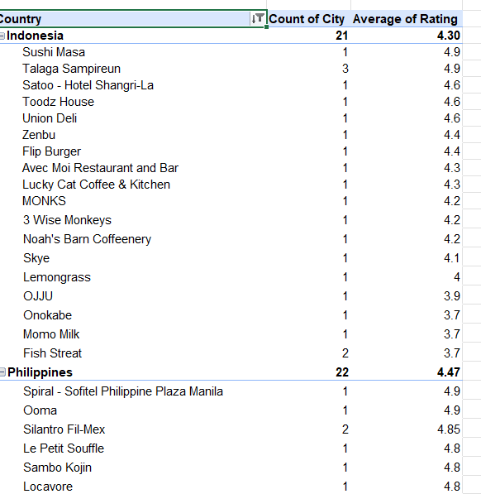
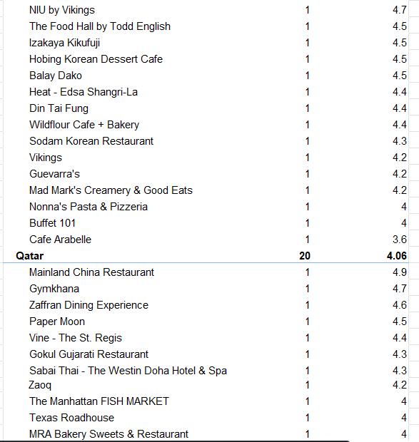
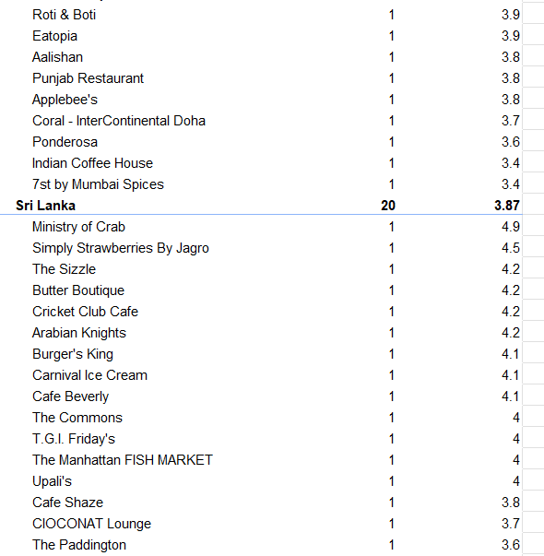
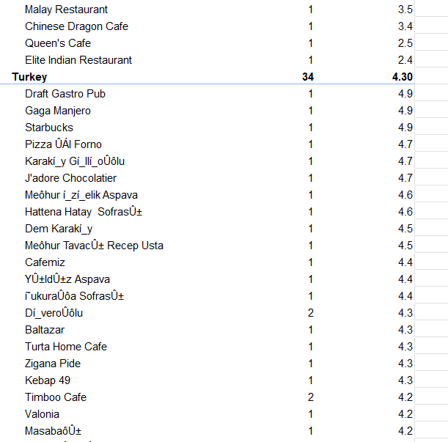
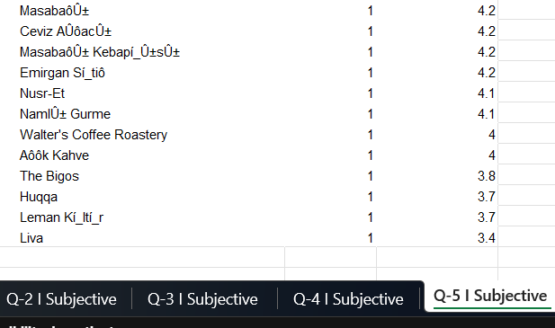
Description:
The above table helps identify both strong competitors with high customer loyalty and underperforming restaurants that indicate potential market gaps.
Insights:

Country | Strong Competitors (Rating >=4.5) | Lower-Rated Restaurants (~1.0-3.7)
Indonesia | Sushi Masa, Talaga Sampireun, Satoo- Shagri-La | Onokabe, Momo Milk, Fish Streat
Philippines | Spiral - Sofitel, Ooma, Silantro Fil-Mex | Cafe Arabelle
Qatar | Mainland China Restaurant, Gymkhana | Indian Coffee House, Ponderosa
Sri Lanka | Ministry of Crab, Simply Strawberries | Queen’s Cafe, Elite Indian Restaurant
Turkey | Draft Gastro Pub, Gaga Manjero, Starbucks | Liva, Huqqa, Leman Kultur

- Most shortlisted countries contain highly rated premium restaurants, indicating strong competition at the top tier.
- At the same time, several mid-to-low rated restaurants exist, suggesting inconsistent service quality across the market.
Recommendations:
- Competitive Benchmarking
Use top-rated restaurants (e.g., Sushi Masa, Ministry of Crab, Draft Gastro Pub) as benchmarks for quality, service, and pricing.
- Market Entry Strategy
Enter markets where high-rated competitors exist but are limited in number, ensuring room for differentiation.
- Opportunity Targeting
Replace or outperform low-rated restaurants such as: Elite Indian Restaurant (Sri Lanka), Indian Coffee House (Qatar), Liva (Turkey).
- Quality-Led Expansion
Focus on consistent food quality, hygiene, and service, especially in markets with visible rating gaps.

Question 6: Which cuisines should we focus on in the newer restaurants to get better feedback? Does the choice of cuisines affect the restaurant ratings?

Solution:

Approach:
- Cuisines with high average ratings AND high vote counts are considered strong performers.
- Comparing cuisines within and across countries helps assess whether cuisine choice impacts ratings.
- Country-level averages are used as benchmarks to identify cuisines performing above the national average.

Charts & Tables:
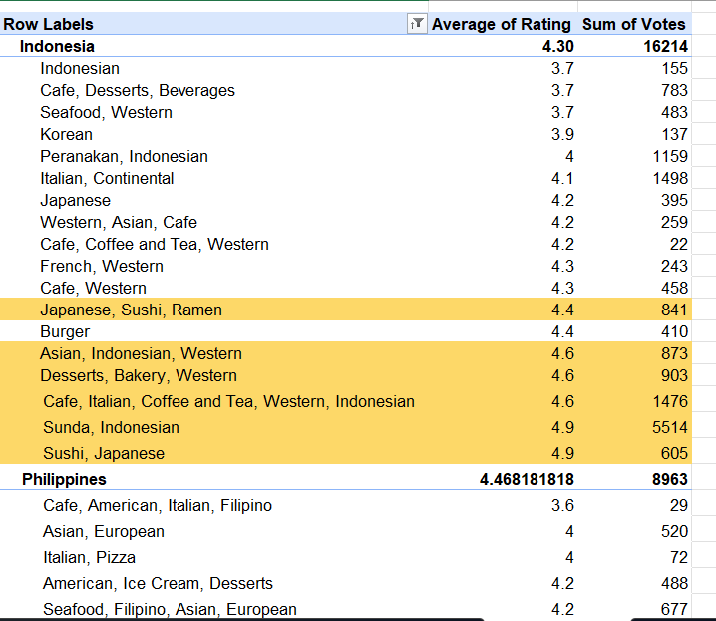
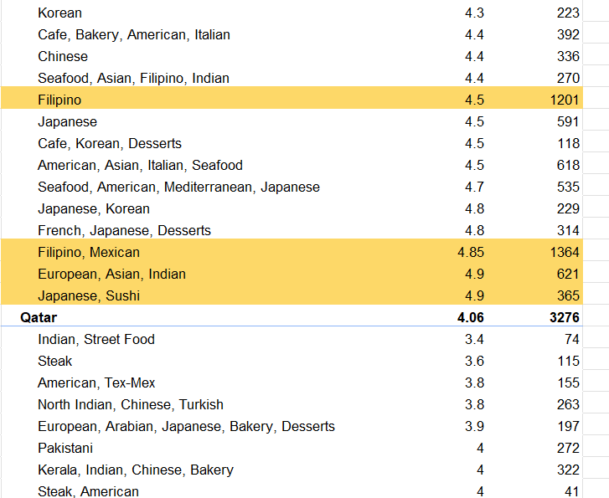
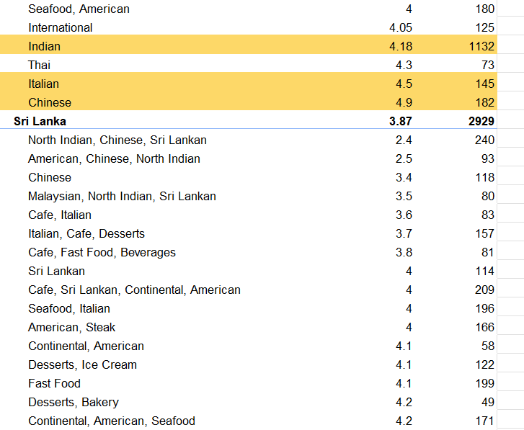
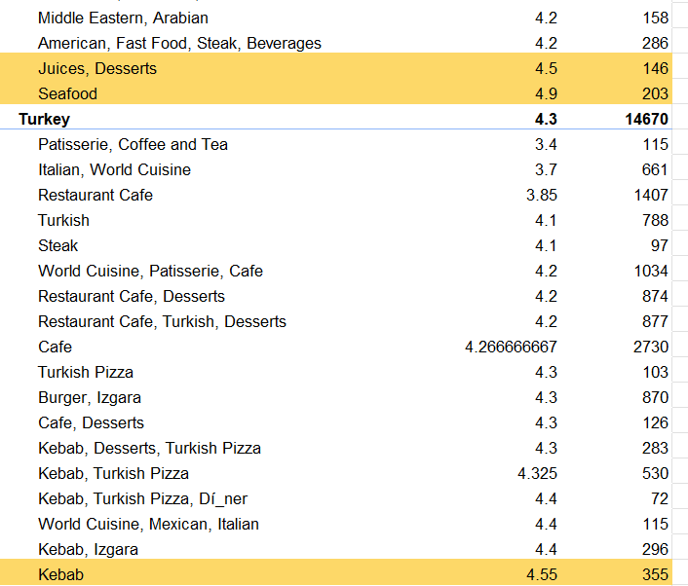
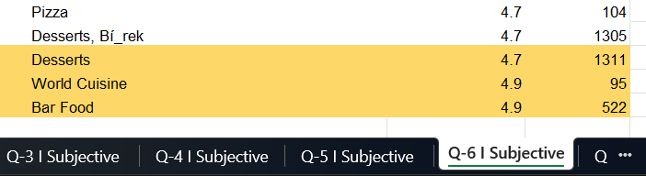

Description:
The table highlights cuisines that consistently receive high ratings and strong customer engagement, indicating higher customer preference and market potential.

Insights:

Country | High Performing Cuisines | Key Insight
Indonesia | Sunda, Indonesian, Japanese, Sushi | Strong customer preference with very high ratings and engagement
Philippines | Chinese, Italian | High ratings despite relatively lower vote volumes., emerging opportunity
Sri Lanka | Seafood, Desserts, Cafes | Seafood significantly outperforms country average; strong niche demand
Turkey | World Cuisine, Bar Food, Desserts | High ratings with strong engagement, especially in dessert category

Across multiple countries, specific cuisine categories consistently outperform the national average ratings, demonstrating that cuisine selection plays a critical role in restaurant success and customer satisfaction.
Recommendations:
- Prioritizing high performing cuisines can help new restaurants gain faster customer acceptance and stronger market positioning.
- Use country-specific cuisine strategies rather than a one-size-fits-all approach, as cuisine performance varies significantly by region.

Question 7: According to our current data, should we go for online delivery and table booking? Does that affect the customer’s ratings?

Solution:

Approach:
- Creating pivot tables to compare average ratings across service combinations
- Evaluating the individual and combined effect of service features on ratings
- Identifying whether the availability of convenience services improves customer perception

Charts & Tables:
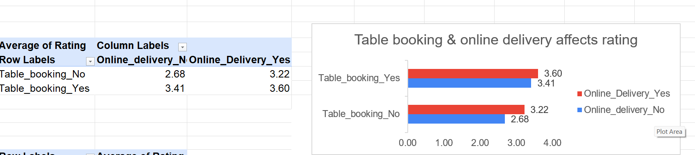
The above chart and table shows the Impact of Online Delivery and Table Booking (Combined)

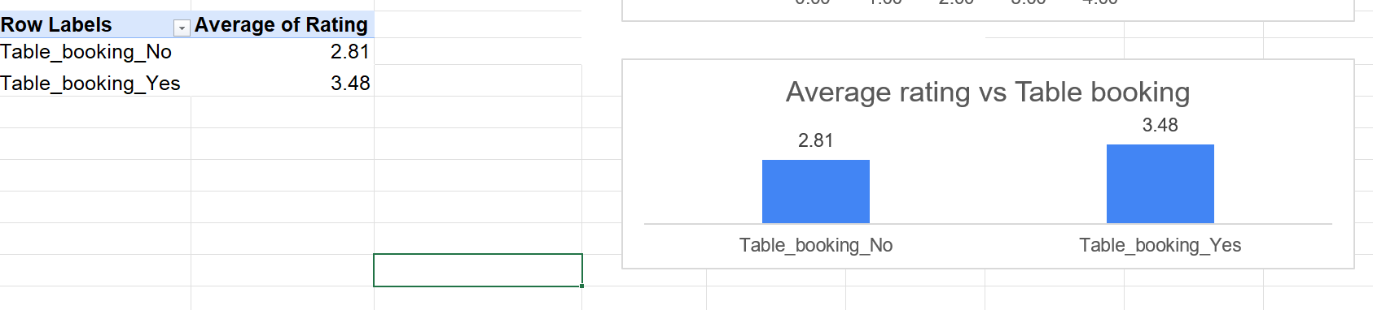
The above table and chart shows the Impact of Table Booking on Ratings

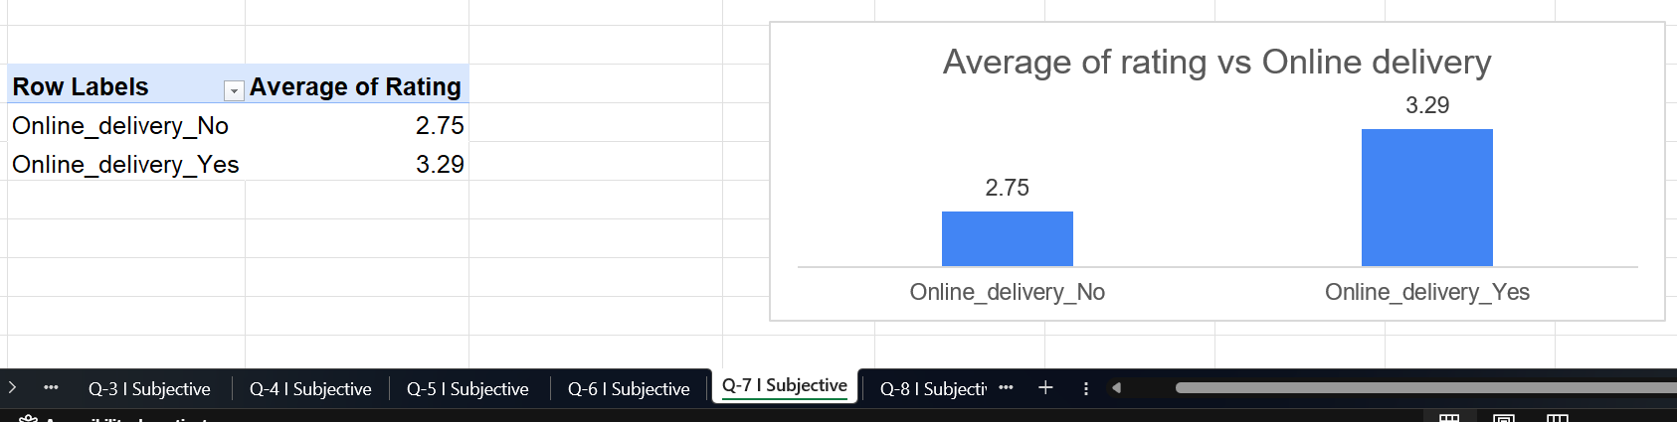
The above table and chart shows the Impact of Online Delivery on Ratings

Insights:
- Restaurants offering both services receive the highest ratings (3.60).
- Restaurants offering neither service have the lowest ratings (2.68).
- Introducing even one convenience feature significantly improves customer perception.
- Restaurants with table booking receive substantially higher ratings, suggesting that reservation convenience improves the dining experience and customer satisfaction.
- Restaurants providing online delivery receive higher average ratings, indicating that accessibility and convenience influence customer feedback positively.

Thus we can conclude, Restaurants that provide online delivery and table booking options consistently receive higher customer ratings, indicating that service convenience plays a significant role in shaping customer satisfaction and dining experience.

Recommendations:
- Based on the analysis, restaurants should prioritize implementing both online delivery and table booking wherever operationally feasible.
- If prioritization is required, table booking should be implemented first, followed closely by online delivery.
- Avoid operating without both services, as this configuration is associated with significantly lower ratings.

Question 8: Should the team keep the rate of cuisines higher? Will that affect the feedback? According to our data are the rates of cuisines and ratings, correlated?

Solution:

Approach:
- To evaluate whether higher cuisine pricing leads to better customer ratings, pricing and ratings data is analyzed.
- Formula used:
The formula used to calculate correlation is = CORREL(cost range, rating range).
Correlation result obtained = 0.304803941

Charts & Tables:
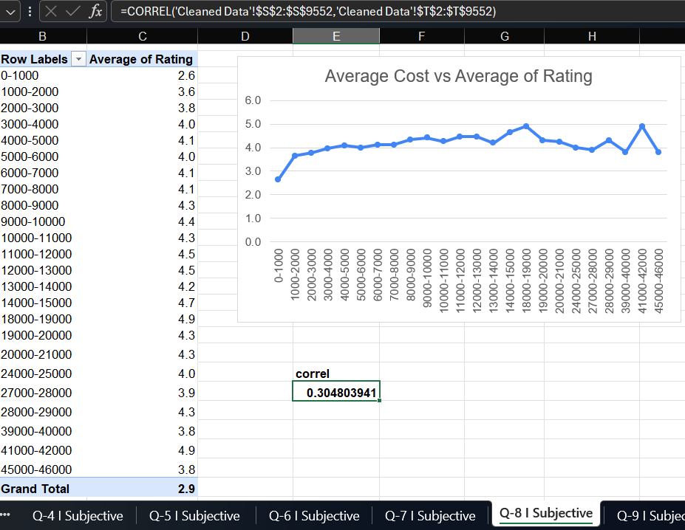
Description:
Visual representation of rating trends across price bands to identify patterns and fluctuations.

Insights:
- The correlation between cost and rating is 0.30, thus the relationship is weak.
- This indicates no meaningful linear relationship between price and rating.
- Thus increasing cuisine prices is unlikely to positively impact customer feedback.
- Data does not support price as a key determinant of customer feedback.
- Premium pricing does not guarantee higher customer satisfaction.

Recommendations:
Based on the insights:
- Do not increase cuisine prices solely to improve ratings.
- Data shows no strong positive correlation between higher prices and better feedback.
- Price hikes without clear value addition may hurt ratings.
- Focus on operational drivers of customer satisfaction such as food quality, service efficiency, delivery time, and overall customer experience.
- Conduct further analysis on other variables (e.g., cuisine type, location, online delivery availability, service features) to identify stronger predictors of ratings.
- Implement value-based pricing rather than price-led positioning.
- Monitor customer sentiment and reviews to understand qualitative drivers behind ratings.

Question 9: What is the distribution of the number of restaurants of different price ranges in all the countries?

Solution:

Approach:
- Classified all restaurants into four price ranges (1–4) based on the predefined pricing criteria.
- Created a pivot table to count the number of restaurants in each price range across all countries.
- Built a country-wise pivot table to understand how different price ranges are distributed geographically.
- Used a line chart to visualize the overall distribution trend of restaurants across price ranges.
- Analyzed the distribution to identify concentration, gaps, and expansion opportunities.

Charts & Tables:
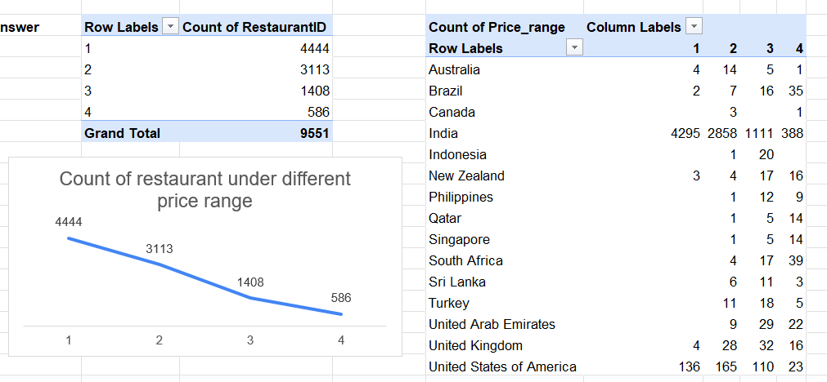
Table 1: Count of Restaurants by Price Range (Overall)
This table shows the total number of restaurants falling under each price range across all countries.
Chart 1: Count of Restaurants under Different Price Ranges
A line chart representing the decline in the number of restaurants as the price range increases from 1 to 4.
Table 2: Country-wise Distribution of Restaurants by Price Range
This table displays how restaurants in different price ranges are distributed across countries.

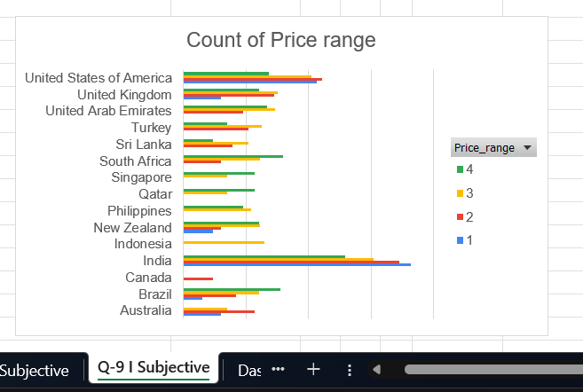
Chart 2: Count of Price Range
A bar chart representing the count of price range distributed across countries.

Insights:
Distribution of restaurants by price range:
- Price Range 1 dominates the market, representing the largest share of restaurants globally.
- Price Range 2 also shows strong presence, reinforcing the dominance of affordable dining options.
- Premium restaurants (Price Range 4) represent the smallest segment, indicating a limited high-end dining market.

Country-Level Pricing Distribution Insights:
The pricing distribution varies significantly across countries:
- India shows the largest concentration of low-priced restaurants, indicating a highly price-sensitive market.
- Brazil, South Africa, and UAE have a strong presence of higher price range restaurants, suggesting growing premium dining markets.
- United Kingdom and New Zealand demonstrate a balanced distribution across mid-range and premium segments.
- United States shows a diverse pricing structure, with a notable presence across all price ranges.

Recommendations:
Restaurants planning expansion should:
- Focus primarily on mid-range pricing segments, which balance customer affordability and profitability.
- Explore premium restaurant opportunities in markets showing higher price distribution, such as UAE, Brazil, and South Africa.
- Adapt pricing strategies based on country-specific dining preferences and economic conditions.
- In markets like India and Indonesia, prioritize affordability.
- In developed markets, maintain a balanced portfolio including premium offerings.

Question 10: Explain your approach in brief for suggesting countries/cities in order to open new restaurants, if the objective and subjective questions would have not been given to assist you. [you have to give bullet pointers in order to answer this question]

Solution:

Approach:
Firstly, clean and prepare the dataset to ensure accurate analysis.Then below mentioned is the approach for suggesting countries/cities in order to open new restaurants:
- Analyze the distribution of restaurants across countries and cities to identify markets with low presence but potential for expansion.
- Evaluate average customer ratings and vote counts to understand customer acceptance and demand in different regions.
- Study historical trends in restaurant openings to identify growing, stable, or saturated markets over time.
- Compare service availability factors such as online delivery and table booking to assess their impact on customer ratings and expectations.
- Assess price range distribution across countries to understand affordability levels and target appropriate customer segments.
- Identify regions with high ratings and engagement but fewer restaurants as strong candidates for new restaurant openings.
- Perform city-level analysis within high-potential countries to pinpoint specific locations with favorable demand and limited competition.
- Validate insights by analyzing data across multiple dimensions (time, price range, services, and customer feedback) to reduce bias in recommendations.

Charts & Tables:
Visual Representation of the Market Selection Framework
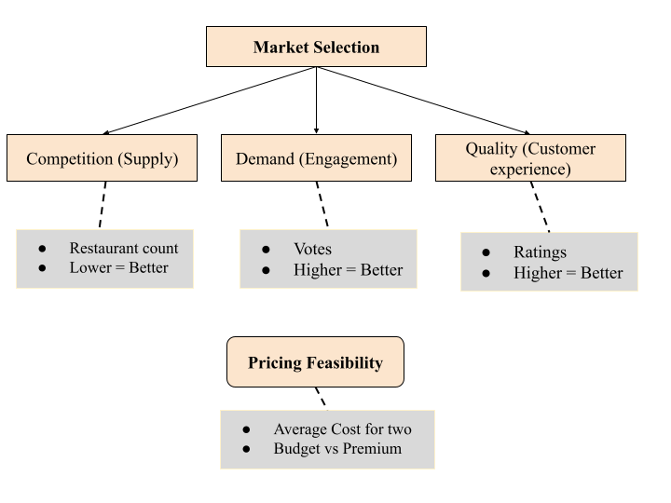
City - Level Filtering
High votes + Low Restaurants
Identify underserved cities
Final Validation Layer
Top Cuisine Performance
Online Delivery Impact
Table Booking Impact
Price Range Distribution
Final Decision
High Demand + Low Competition + Good Ratings = Ideal for Expansion
The objective would be to find the markets where demand is high, competition is low, and customers are satisfied.
Recommendations:
- Market Expansion Strategy
- Target low competition international markets
- Prioritize high demand cities
- Reduce entry risk through market selection
- Customer Experience and offering strategy
- Enable online delivery and table booking
- Focus on high performing cuisines
- Align offerings with market preferences
- Pricing and competitive strategy
- Position in mid-range pricing

