**Trinh Son – Project work 2017**

**Link to application:** <http://www.students.oamk.fi/~t6trso00/Database/>

**1.Introduction**

This application allows users to write note for each day and check their precious notes.

How to use it:

Step 1: User need to create an account and log in with it.

Step 2: Click on the day user want to make note and click the “Make Note” button.

Step 3: Click “Submit” button. The note will be stored in the database

Step 4: To view previous note, click on the desired date and click the “Check old notes” button

Step 5: Log out after finish.

Note: User can not see the notes made by other users.

**2.Database**

a. Requirement analysis

N1: We can add username to users.

N2: We can add email to users.

N3: We can add password to users.

N4: We can add username to notes.

N5: We can add time to notes.

N6: We can add note to notes.

b. Referential Integrity

In notes table, username is the Forein Key to users table

We are not allowed to delete user if they have note in notes table.

If we update the username in users table, we will cascade the updates to notes table.

b. ER diagram

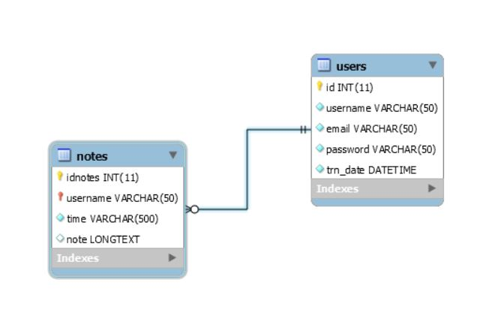

c. SQL code

CREATE TABLE IF NOT EXISTS `users` (

`id` INT(11) NOT NULL,

`username` VARCHAR(50) NOT NULL,

`email` VARCHAR(50) NOT NULL,

`password` VARCHAR(50) NOT NULL,

`trn_date` DATETIME NOT NULL,

PRIMARY KEY (`id`),

UNIQUE INDEX `id_UNIQUE` (`id` ASC),

UNIQUE INDEX `username_UNIQUE` (`username` ASC),

UNIQUE INDEX `email_UNIQUE` (`email` ASC))

ENGINE = InnoDB

CREATE TABLE IF NOT EXISTS `notes` (

`idnotes` INT(11) NOT NULL,

`username` VARCHAR(50) NOT NULL,

`time` VARCHAR(500) NOT NULL,

`note` LONGTEXT NULL,

PRIMARY KEY (`idnotes`, `username`),

INDEX `username_idx` (`username` ASC),

CONSTRAINT `username`

FOREIGN KEY (`username`)

REFERENCES `users` (`username`)

ON DELETE RESTRICT

ON UPDATE CASCADE)

ENGINE = InnoDB