Nipuna Samarasinghe (Student ID - 22084280)

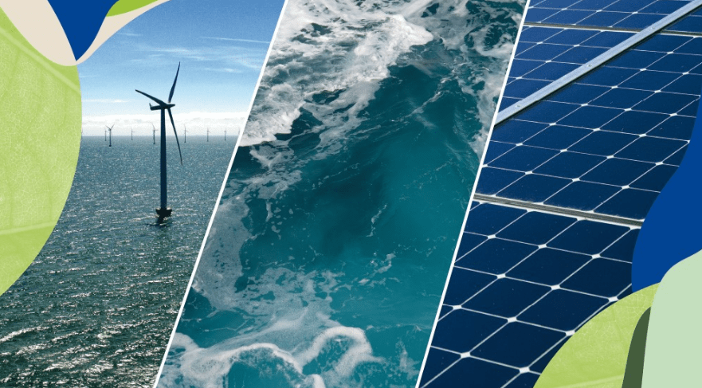
Adoption of Renewable Energy
ISYS6013 Assignment Report
Contents
ISYS6013 Assignment Report – Adoption of Renewable Energy 0
Executive Summary 3
Introduction 3
Section 1 – Proportion of Renewable Energy in Australia: 4
Section 2 – Balance of Renewable Sources: 5
Section 3 – Country Comparison: 6
Section 4 – Australia’s Future Trajectory in Renewable Energy Generation 7
Conclusion: 8
Appendices: 9
Appendix A: Data Sources 9
Appendix B: ELT and Data Preparation Process 9
Appendix C: Power BI Dashboard Design and Features 10
References 10

Table of Figures
Figure 1 - Proportion of Renewable Energy in Australia 4
Figure 2 - Balance of Renewable Sources 5
Figure 3 - Comparison of Renewable Electricity Generation 6
Figure 4 - Forecasting Australia's Energy Generation 7

Executive Summary
This project investigates the transition of Australia’s renewable electricity generation from 2005 to 2022 while assessing its future direction up to 2030. This report reflects a data-driven dashboard developed in Power BI for a business intelligence consultancy project and delivers strategic insights. The analysis is based on four key areas: the proportion of renewable energy in Australia’s electricity generation compared to non-renewable, the changing composition of renewable sources, a comparison of renewable energy with three neighbouring countries, and a forecast for Australia’s renewable share by the year 2030.

This analysis is completed using a combination of government-published data from Australian Energy Statistics and a global dataset called Our World in Data. The project involved data extraction, transformation, and visualisation to answer each of the questions asked by the client. The Power BI dashboard includes dynamic charts and interactive slicers to support exploration of trends and patterns in renewable energy. Key findings include that Australia’s renewable electricity share has increased from 9% in 2005 to 36% in 2022, which is largely driven by solar and wind. Forecast modelling suggests this trend could continue towards 55-65% by the year 2030, while the national target is 82%. New Zealand leads the renewable energy game with over 80% renewable generation, while Papua New Guinea trails behind.

The report concludes that while Australia has made significant progress, further investment as well as supportive policies are needed to reach national targets. The interactive dashboard enables stakeholders to explore data flexibility and make informed decisions based on the visual evidence of the renewable energy generation in the four countries.

Introduction
This report has been prepared with a Dashboard created using Power BI as part of a business intelligence project on renewable energy trends in Australia and surrounding countries. The key concerns are understanding how renewable electricity generation has changed over time, how Australia compares with nearby nations, and how likely it is that Australia will meet its future targets in renewable energy generation.

The project was structured around four core questions, which are addressed using interactive visualisations in Power BI.
The questions are as below,
1. What proportion of energy in your country is generated from renewable sources, and how has that changed since 2005?
2. How has the makeup of renewable sources changed since 2005 (how has the balance of the various renewable energy sources changed)?
3. How does your country compare with three closely neighbouring countries in terms of the generation of renewable energy?
4. What is your forecast for the use of renewable energy in your country for the year 2030?

Each question was approached using publicly available datasets. The Australian data was extracted from the Australian Energy Statistics, while comparative country data was sourced from Our World in Data on GitHub. These were cleaned and transformed in Power BI to enable dynamic filtering and interactive analysis. The report includes data visualisations that support strategic decision-making and communicate insights clearly to non-technical stakeholders with easy understanding.

The structure of this report reflects the structure of the questions mentioned above. Section number 1 focuses on presenting the findings for Australia’s renewable electricity share over time. Section 2 reflects on the changing composition of renewable sources, while Section 3 compares Australia’s performance with selected neighbouring countries. Finally, Section 4 provides a forecast based on the historical data using the analytical features of Power BI. Each section includes charts, methods, and insights catering to relevant decision-making needs. The report concludes with key findings, limitations, as well as recommendations.

Section 1 – Proportion of Renewable Energy in Australia:
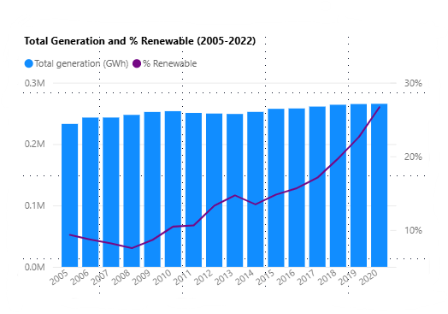
Figure 1 - Proportion of Renewable Energy in Australia
The analysis of Australia’s electricity generation from 2005 to 2020 unveils a clear upward trend in the contribution of renewable sources to the national energy grid. As Figure 1 explains, the generation of electricity as a total has remained relatively stable. Yet, the proportion of energy derived from renewable sources has steadily increased over the period shown. In the year 2005, renewable sources accounted for just under 9% of total generation. By the year 2020, this figure had increased to over 26%, indicating a national shift towards much cleaner and renewable energy production.

These electricity generation data were collected from the Australia Energy Statistics, which lists annual generation of energy by the type of fuel in gigawatt-hour (GWh). The dataset was loaded into Power BI and transformed using Power Query. Only records from 2005 onwards were kept, and total rows were excluded. A new column was added to include each of the types of fuel as either Renewable or Non-Renewable.
A third measure was used to compute the annual percentage of renewable electricity as below,
% Renewable = (Renewable Generation/ Total Generation) * 100.

Several factors are contributing towards this rise, including increased investment in wind and solar infrastructure, federal and state-level policy incentives, and a broader societal shift towards environmental sustainability ("Renewables | energy.gov.au," 2025). Particularly, this growth has occurred even though the total generation levels have stayed consistent. This will mean that the renewables are displacing fossil fuel sources rather than simply supplementing rising demand.

The findings align with Australia’s national commitment to reach 82% renewable electricity generation by the year 2030. The current path of the trend indicates strong progress, while continued policy and infrastructure support will be fundamental to meet future targets in renewable energy.

Section 2 – Balance of Renewable Sources:
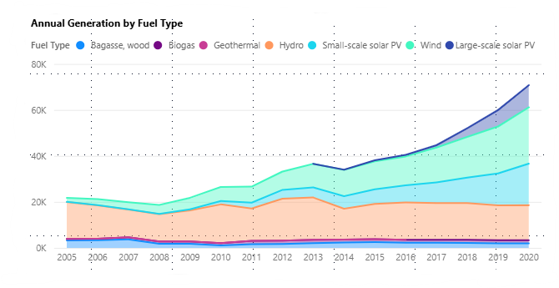
Figure 2 - Balance of Renewable Sources
This section investigates how the composition of Australia’s renewable electricity generation has changed over the years. Understanding the change in fuel type is critical to identifying which technologies are leading the improvements and where future investments may become more effective.
The same data as section one is used for this analysis, which was sourced from Australian Energy Statistics, filtered to include only renewable fuel types such as hydro, wind, large-scale solar PV, small-scale solar PV, biogas, bagasse (wood), and geothermal. Using Power BI, a stacked area chart was created to visualise the total generation in GWh per fuel type from the year 2005 to 2020. Furthermore, the fuel types can be found in the legend and the Year on the x-axis.

As key findings, in the year 2005, Australia’s renewable energy generation was governed by hydroelectricity, while contributing the majority of renewable energy. Over the following years, wind and later solar PV technologies have experienced a rapid gain in growth. From the year 2010 onwards, wind generation steadily increased, while by the year of 2014, large-scale solar PV began contributing more substantially. The upward growth of large and small-scale solar trends accelerated post-2016.

By the year of 2020, wind and solar energy together made up the majority of renewable electricity generation in Australia, exceeding hydro-powered energy. Rise of solar energy contemplates reduced technology costs as well as government incentives for rooftop installations, and investment in solar farms. At the same time, contributions from bioenergy and geothermal remained comparatively minor and constant.

The analysis confirms that the hydro-dominated system in 2005 has transitioned to an energy system that is increasingly reliant on wind and solar. This diversification of the renewable mix supports energy resilience and reflects evolving policies and market conditions.

Section 3 – Country Comparison:
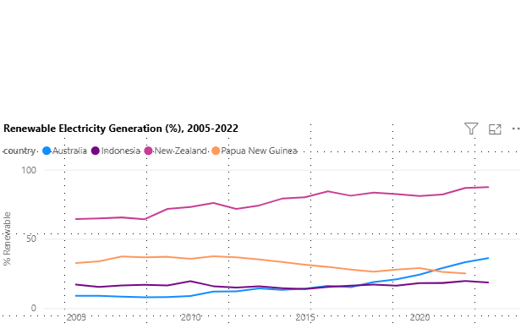
Figure 3 - Comparison of Renewable Electricity Generation

This third section compares Australia’s renewable energy generation performance in relation to three neighbouring countries, which are New Zealand, Indonesia, and Papua New Guinea. This regional comparison of data helps put into perspective Australia’s progress and highlights differences in renewable energy adoption across the Asia-Pacific region.

Data for section 3 is sourced from Our World in Data (OWID) global dataset found on GitHub. The dataset includes annual electricity generation and renewable generation in terawatt-hours, which was separated by country. Calculated measures are taken to establish the percentage of electricity generated from renewable energy sources for each of the countries from the year 2005 to 2022. The visualisations, a multi-line chart created using Power BI, show each country's renewable share as a trend over the years.

Among key findings, the below can be highlighted,
New Zealand systematically achieved the highest renewable share in the region, starting at 64% in the year 2005 and improving to 87% by the year 2022, largely due to its reliance on hydro and geothermal energy ("Our energy mix," 2025). However, Australia started at 9% in 2005, yet experienced steady growth, reaching 36% in 2022 while reflecting a strong investment in solar and wind infrastructure.
Indonesia revealed a slower pace in progress, increasing from 15% to 20% during the given time period, demonstrating a continuous dependency on fossil fuels. Furthermore, Papua New Guinea started with a renewable share of 33% in the year 2005, yet it peaked at 37% and declined to 19% by 2022, suggesting it could be due to stagnation in renewable infrastructure or increased fossil fuel use.

This section of the analysis demonstrates that while Australia has made significant gains in renewable energy generation, it has remained behind New Zealand, which sets the benchmark for renewable integration in the region. No less importantly, Australia has outpaced Indonesia and Papua New Guinea in terms of recent growth, suggesting effective energy policy and technological adaptation.

Section 4 – Australia’s Future Trajectory in Renewable Energy Generation
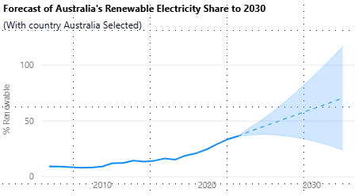
Figure 4 - Forecasting Australia's Energy Generation
The final objective of this analysis is to project the potential share of Australia’s renewable energy generation till the year 2030. Forecasting this value enables assessing whether current trends are sufficient to meet national energy targets and to evaluate the need for further interventions.

Similar to section three, for this analysis, the historical renewable energy generation share from the years 2005 – 2022 was used, extracted from the Our World in Data (OWID) global dataset found on GitHub. Using the measure “% Renewable” previously created in early steps, a line chart was constructed using Power BI to demonstrate the trend in Australia’s renewable share over time. The inbuilt function of Power BI, the forecasting tool, was applied to this chart to extend the trend to 2030.

During the forecasting, a 10-year projection period, a 95% confidence interval, and allowed Power BI to auto-select the seasonality based on the pattern of the data. The confidence interval was visualised as a shaded cone to represent the uncertainty in future projections.

As for key findings, the forecast predicts that Australia’s renewable electricity share could increase from 36% in the year 2022 to between 55% and 65% by 2030, assuming the historical trend continues. This reflects a promising course yet still falls short of the federal government’s target share of 82% renewable energy generation by the year 2030.

The broadening confidence interval indicates growing uncertainty in longer-term projections, highlighting the importance of sustained policy support, substructure investment, and market stability. If the growth continues at the current pace, future acceleration will be necessary to bridge the gap between the forecasted outcome and policy goals.
This forecast can be used by energy planners to evaluate current progress and prioritise actionable areas to achieve Australia’s renewable energy ambitions.

Conclusion:
This project set forth to assess Australia’s progress in renewable energy generation and provide insights for strategic decision making using interactive data visualisation with Power BI. The comprehensive aim was to answer four specific questions relating to historical performance, source of energy composition, regional comparison and finally, a future prediction.

The analysis was carried out using data extracted from the Australian Energy Statistics database and the Our World in Data energy dataset on GitHub, which were later imported into Power BI for transformation, analysis, followed by visualisation. Custom measures, conditional classifications, and time-based filtrations were applied to prepare the data before the visualisations. Key visualisations include line charts, stacked area charts, and forecast models, all of which are supported by interactive slicers to enable flexibility in exploring insights.

The findings from the analysis exposed that Australia has made significant progress, increasing the country's renewable electricity share from 9% in 2005 to 36% in 2022. A transparent shift in the renewable energy mix was observed. Furthermore, wind and solar energy are playing a dominant role, replacing hydro as the leading source of growth. In comparison with the regions, New Zealand appeared as the leader with over 80% renewable generation, while Indonesia and Papua New Guinea lagged behind. Suggestions from the forecast model mean that Australia could reach 55%-65 % renewables by the year 2030, yet this seems to fall behind the national target of 82%, highlighting a gap that must be addressed through continued investment and supportive policies.

Future work could expand the analysis to include emission intensity, energy storage capacity, and the economic impact of the renewable transition. However, this report furnished stakeholders with a substantial evidence base to track progress, compare performance, and plan efficiently for Australia’s clean energy future.

Appendices:

Appendix A: Data Sources
- Australian Energy Statistics
  - Source: Department of Climate Change, Energy, the Environment and Water (Australia)
  - URL: https://www.energy.gov.au/publications/australian-energy-statistics-table-o-electricity-generation-fuel-type-2020-21-and-2021?utm_source=chatgpt.com
  - Description: Annual electricity generation by fuel type (GWh) from 2005 to 2022.
- Our World in Data
  - Source: Our World in Data (OWID)
  - URL: https://github.com/owid/energy-data
  - Description: Global electricity generation data, including total and renewables (TWh), by country and year.

Appendix B: ELT and Data Preparation Process
- Extract:
  - Excel and CSV files were downloaded from official data warehouses.
  - Files were imported into Power BI using “Get DATA > Excel/CSV”.
- Transform (Power Query):
  - AUS FY Dataset:
    - Removed header rows and footnotes.
    - Unpivot the year columns to create a long-format table.
    - Created a conditional column (Fuel group) to classify fuel types as Renewable or Non-renewable.
    - Removed total and subtotal rows.
    - Added a calculated column for % Renewable.
  - OWID Dataset:
    - Filtered to include only the four target countries: Australia, New Zealand, Indonesia, and Papua New Guinea.
    - Kept only relevant columns: Country, year, electricity_generation, renewables_generation.
    - Removed null values and filtered for years >= 2005.
    - Added a calculated column for % Renewable using:
= (renewables_electricity/ electricity_generation)*100
- Load:
  - The cleaned dataset was loaded into Power BI for visualisation.
  - Relationships were managed within a single table for simplicity.

Appendix C: Power BI Dashboard Design and Features
- Visual Types Used:
  - Line chart for time series trends
  - Clustered column and line combo for total vs %renewable
  - The stacked are chart for renewable composition
  - Forecast visual using the built-in analytical tool in Power BI
- Interactivity:
  - Slivers:
    - Country selection
    - Fuel type selection
  - Drilled through disabled for simplicity, and cross-report filtration is enabled.
  - All visual dynamically responds to the slicer changes.
- Calculated measure creation:
  - Total generation by year
  - Renewable generation by year
  - % Renewable for both Australia and regional datasets.

References

Australian Energy Statistics, Table O Electricity generation by fuel type 2020-21 and 2021. (2025). Department of Climate Change, Energy, the Environment and Water (Australia). https://www.energy.gov.au/publications/australian-energy-statistics-table-o-electricity-generation-fuel-type-2020-21-and-2021?utm_source=chatgpt.com

Our energy mix. (2025). Energy Resources Aotearoa. https://www.energyresources.org.nz/oil-and-gas-new-zealand/our-energy-mix/#:~:text=In%20New%20Zealand%20we%20are,includes%20geothermal%2C%20hydro%20and%20wind.&text=Natural%20gas%20is%20piped%20throughout%20the%20North%20Island%20to%20homes%20and%20businesses

Owid/energy-data: Data on energy by our world in data. (2024). GitHub. https://github.com/owid/energy-data

Renewables | energy.gov.au. (2025). Australian Government. https://www.energy.gov.au/energy-data/australian-energy-statistics/renewables

