Assessment 2
STAT5009
2024-05-02

Q1. Write your interpretation (one sentence) regarding the quality of the regression model based on the above residual plots.
Both plots of representation models appear to be good and the residuals are scattered randomly around the horizontal zero line suggesting that the errors are independent and normally distributed while both can be used as a key assumption for a liner regression model.

Q2.

a) load the airquality data and store in your R-session as data.frame called’air’. Show the dimensions of ‘air’
air <- data.frame(airquality)
dim(air)
## [1] 153 6

b) Remove all missing values from this data and store the data as ‘air.no’. Show the code
str(air)
## 'data.frame': 153 obs. of 6 variables:
## $ Ozone : int 41 36 12 18 NA 28 23 19 8 NA ...
## $ Solar.R: int 190 118 149 313 NA NA 299 99 19 194 ...
## $ Wind : num 7.4 8 12.6 11.5 14.3 14.9 8.6 13.8 20.1 8.6 ...
## $ Temp : int 67 72 74 62 56 66 65 59 61 69 ...
## $ Month : int 5 5 5 5 5 5 5 5 5 5 ...
## $ Day : int 1 2 3 4 5 6 7 8 9 10 ...
head(air)
## Ozone Solar.R Wind Temp Month Day
## 1 41 190 7.4 67 5 1
## 2 36 118 8.0 72 5 2
## 3 12 149 12.6 74 5 3
## 4 18 313 11.5 62 5 4
## 5 NA NA 14.3 56 5 5
## 6 28 NA 14.9 66 5 6
summary(air)
## Ozone Solar.R Wind Temp
## Min. : 1.00 Min. : 7.0 Min. : 1.700 Min. :56.00
## 1st Qu.: 18.00 1st Qu.:115.8 1st Qu.: 7.400 1st Qu.:72.00
## Median : 31.50 Median :205.0 Median : 9.700 Median :79.00
## Mean : 42.13 Mean :185.9 Mean : 9.958 Mean :77.88
## 3rd Qu.: 63.25 3rd Qu.:258.8 3rd Qu.:11.500 3rd Qu.:85.00
## Max. :168.00 Max. :334.0 Max. :20.700 Max. :97.00
## NA's :37 NA's :7
## Month Day
## Min. :5.000 Min. : 1.0
## 1st Qu.:6.000 1st Qu.: 8.0
## Median :7.000 Median :16.0
## Mean :6.993 Mean :15.8
## 3rd Qu.:8.000 3rd Qu.:23.0
## Max. :9.000 Max. :31.0
##
air.no <- na.omit(air)
summary(air.no)
## Ozone Solar.R Wind Temp
## Min. : 1.0 Min. : 7.0 Min. : 2.30 Min. :57.00
## 1st Qu.: 18.0 1st Qu.:113.5 1st Qu.: 7.40 1st Qu.:71.00
## Median : 31.0 Median :207.0 Median : 9.70 Median :79.00
## Mean : 42.1 Mean :184.8 Mean : 9.94 Mean :77.79
## 3rd Qu.: 62.0 3rd Qu.:255.5 3rd Qu.:11.50 3rd Qu.:84.50
## Max. :168.0 Max. :334.0 Max. :20.70 Max. :97.00
## Month Day
## Min. :5.000 Min. : 1.00
## 1st Qu.:6.000 1st Qu.: 9.00
## Median :7.000 Median :16.00
## Mean :7.216 Mean :15.95
## 3rd Qu.:9.000 3rd Qu.:22.50
## Max. :9.000 Max. :31.00

Q3.
Compare two approaches - backward regression and the leave-one-out cross validation (LOOCV) - to recommend the best model to predict Ozone concentration using other predictors.
library(leaps)
## Warning: package 'leaps' was built under R version 4.3.3
air.bw <- regsubsets(data = air.no,
Ozone ~.,
method = "backward"
)
air.s <- summary(air.bw)
names(air.s)
## [1] "which" "rsq" "rss" "adjr2" "cp" "bic" "outmat" "obj"
plot(air.s$adjr2,
xlab = "No. of variables",
ylab = "Adjusted R-sq",
pch = 16,
cex.lab = 1.5
)
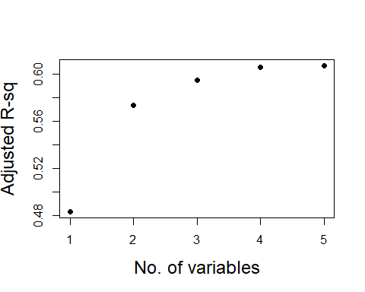
The plot created indicates that the R-sq keeps rising as we add more variables and the rate of growth slows beyond the fourth variable that already explains 60% of the variation. It is possible to select all 5 variables in a model. Yet the impact on the 4th and 5th variables are considerably lower, it is best to omit the last variable.
air.feat <- coef(air.bw,4)
names(air.feat)
## [1] "(Intercept)" "Solar.R" "Wind" "Temp" "Month"
airbw.mod <- lm(Ozone ~ Solar.R + Wind + Temp + Month,
data = air.no
)
summary(airbw.mod)
##
## Call:
## lm(formula = Ozone ~ Solar.R + Wind + Temp + Month, data = air.no)
##
## Residuals:
## Min 1Q Median 3Q Max
## -35.870 -13.968 -2.671 9.553 97.918
##
## Coefficients:
## Estimate Std. Error t value Pr(>|t|)
## (Intercept) -58.05384 22.97114 -2.527 0.0130 *
## Solar.R 0.04960 0.02346 2.114 0.0368 *
## Wind -3.31651 0.64579 -5.136 1.29e-06 ***
## Temp 1.87087 0.27363 6.837 5.34e-10 ***
## Month -2.99163 1.51592 -1.973 0.0510 .
## ---
## Signif. codes: 0 '***' 0.001 '**' 0.01 '*' 0.05 '.' 0.1 ' ' 1
##
## Residual standard error: 20.9 on 106 degrees of freedom
## Multiple R-squared: 0.6199, Adjusted R-squared: 0.6055
## F-statistic: 43.21 on 4 and 106 DF, p-value: < 2.2e-16
From the summary it is clear that the month is not significant as the P value is more than 0.05(actual value - 0.051). Hence creating a new linear model without the month named airbw.mod2.
airbw.mod2 <- lm(Ozone ~ Solar.R + Wind + Temp,
data = air.no
)
summary(airbw.mod2)
##
## Call:
## lm(formula = Ozone ~ Solar.R + Wind + Temp, data = air.no)
##
## Residuals:
## Min 1Q Median 3Q Max
## -40.485 -14.219 -3.551 10.097 95.619
##
## Coefficients:
## Estimate Std. Error t value Pr(>|t|)
## (Intercept) -64.34208 23.05472 -2.791 0.00623 **
## Solar.R 0.05982 0.02319 2.580 0.01124 *
## Wind -3.33359 0.65441 -5.094 1.52e-06 ***
## Temp 1.65209 0.25353 6.516 2.42e-09 ***
## ---
## Signif. codes: 0 '***' 0.001 '**' 0.01 '*' 0.05 '.' 0.1 ' ' 1
##
## Residual standard error: 21.18 on 107 degrees of freedom
## Multiple R-squared: 0.6059, Adjusted R-squared: 0.5948
## F-statistic: 54.83 on 3 and 107 DF, p-value: < 2.2e-16
multi-collinearity check for the linear model “airbw.mod2”
library(car)
## Warning: package 'car' was built under R version 4.3.3
## Loading required package: carData
## Warning: package 'carData' was built under R version 4.3.3
vif(airbw.mod2)
## Solar.R Wind Temp
## 1.095253 1.329070 1.431367
The variation inflation factor is less that 5 and closer to 1 being a smaller mult-colinearity. Hence it is possible to use all the variances.
residual analysis - plot of residuals versus fitted values
fit <- fitted.values(airbw.mod2)
res <- residuals(airbw.mod2)
plot(airbw.mod2)
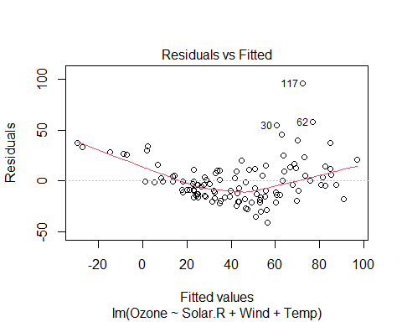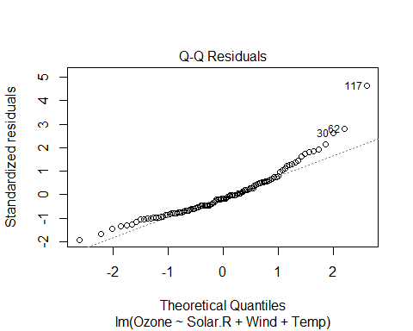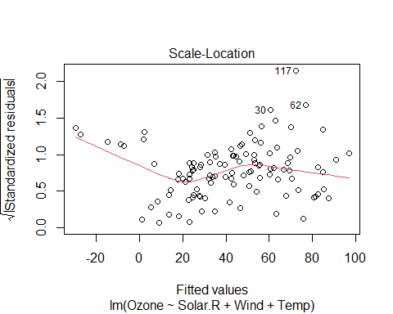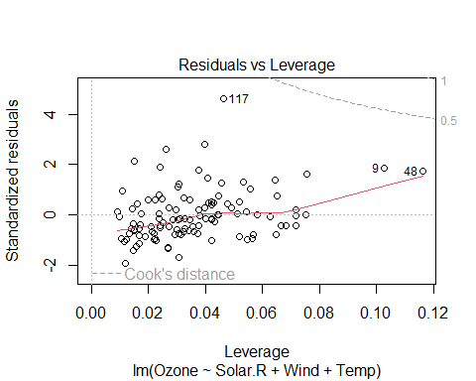
From the Residuals versus Fitted values plot shown above it is clear that the model is not linear. It is possible to observe that this is in a funnel shape meaning, linear regression model does not follow a constant variance.
Model equation and interpretation of chosen model
summary(airbw.mod2)
##
## Call:
## lm(formula = Ozone ~ Solar.R + Wind + Temp, data = air.no)
##
## Residuals:
## Min 1Q Median 3Q Max
## -40.485 -14.219 -3.551 10.097 95.619
##
## Coefficients:
## Estimate Std. Error t value Pr(>|t|)
## (Intercept) -64.34208 23.05472 -2.791 0.00623 **
## Solar.R 0.05982 0.02319 2.580 0.01124 *
## Wind -3.33359 0.65441 -5.094 1.52e-06 ***
## Temp 1.65209 0.25353 6.516 2.42e-09 ***
## ---
## Signif. codes: 0 '***' 0.001 '**' 0.01 '*' 0.05 '.' 0.1 ' ' 1
##
## Residual standard error: 21.18 on 107 degrees of freedom
## Multiple R-squared: 0.6059, Adjusted R-squared: 0.5948
## F-statistic: 54.83 on 3 and 107 DF, p-value: < 2.2e-16
Using the summary above, can select any one feature coefficient to write interpretation of its relationship with Ozone.
Ozone = -64.34 + 0.06* Solar.R + (-3.33)* Wind + 1.65* Temp
Selecting Solar.R coefficient, Ozone will increase by 0.06 units with increase of 1 unit of Solar.R
Confidence interval of chosen model,
confint(airbw.mod2)
## 2.5 % 97.5 %
## (Intercept) -110.04538108 -18.6387768
## Solar.R 0.01385613 0.1057851
## Wind -4.63087706 -2.0363055
## Temp 1.14949967 2.1546862
according to the information above, 95% of the confidence will lay between 0.014 and 0.106
Cross-validation based selection: R-implementation code
Using first three variables only since the results from previous activities shows that the significance of the variable 4, 5, is unaccountable.
library(boot)
##
## Attaching package: 'boot'
## The following object is masked from 'package:car':
##
## logit
err_j <- c()
for(j in 1:3)
{
air.j <- air[,1:(j+1)]
airmod_j <- glm(Ozone ~., data = air.no)
cv.j <- cv.glm(airmod_j, data = air.no)
err_j[j] <- cv.j$delta[1]
}
str(cv.j)
## List of 4
## $ call : language cv.glm(data = air.no, glmfit = airmod_j)
## $ K : num 111
## $ delta: num [1:2] 463 463
## $ seed : int [1:626] 10403 321 1961221515 1263740265 -1957607624 487344614 -1804309119 -2084781805 549314242 -1193256588 ...
plot(1:3, err_j)
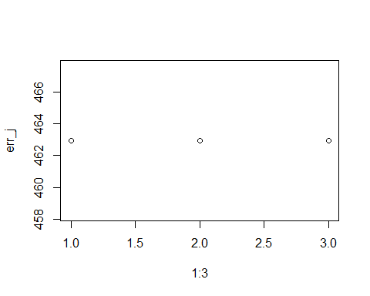
mse.air <- mean(err_j)
mse.air
## [1] 462.9437
computed Mean Squared Error for the cross validation according to above is 462.9437
res.val.reg <- airbw.mod2$residuals
sq.err <- res.val.reg^2
mse.reg <- mean(sq.err)
mse.reg
## [1] 432.4576
Computed Mean Squared Error for the backward regression according to above is 432.4576
Hence the MSE is less in backward regression.

Q4.
Using the IRIS data (available with baseR) a botanist wants to assess if a given iris flower is of the virginica species -based on its morphological features, Sepal Length, Sepal Width, Petal Length, and Petal Width. S/he hired a statistician who did some modelling (below).
ir <- iris
str(ir)
## 'data.frame': 150 obs. of 5 variables:
## $ Sepal.Length: num 5.1 4.9 4.7 4.6 5 5.4 4.6 5 4.4 4.9 ...
## $ Sepal.Width : num 3.5 3 3.2 3.1 3.6 3.9 3.4 3.4 2.9 3.1 ...
## $ Petal.Length: num 1.4 1.4 1.3 1.5 1.4 1.7 1.4 1.5 1.4 1.5 ...
## $ Petal.Width : num 0.2 0.2 0.2 0.2 0.2 0.4 0.3 0.2 0.2 0.1 ...
## $ Species : Factor w/ 3 levels "setosa","versicolor",..: 1 1 1 1 1 1 1 1 1 1 ...

A. Construct a categorical variable ‘vir’ that takes values ‘1’ if a flower is Virginica, ‘0’ otherwise.
vir <- ifelse(ir$Species == "virginica", 1, 0)

B. Assuming that this data is a true representation of the natural world what is the probability that a randomly selected flower is from the species virginica. Show your code and result.
table(ir$Species)
##
## setosa versicolor virginica
## 50 50 50
tab.ir <- table(ir$Species)/nrow(ir)
tab.ir
##
## setosa versicolor virginica
## 0.3333333 0.3333333 0.3333333
The probability of a randomly selected flower to be from the specie virginica is 33%. The amount of virginica flowers divided by the amount of total flowers in general will give the same answer.

Q4.1- Which of the above would be your recommended model? Write out the full expression of this model. For your recommended model choose any (one) feature and write the interpretation of the corresponding model coefficient in relation to virginica flower.
The model 1 uses all the variables while having a statistically significant Petal.Length and a Residual deviance of 11.899 and an AIC (Akaike Information Criterion) of 21.899. The model 2 uses data while omitting the Sepal.Length, and Petal.Length and petal.Width both are statistically significant. The Residual deviance is 13.266 and the AIC is 21.266. It is possible to conclude that the model 2 is recommended as the Residual deviance stays less in the model two meaning less deviation, while having a higher AIC value.

Q4.2– Use your recommended model to predict the odds of the following IRIS flower being Virginica. Hint: You would need to manually calculate the odds, using the R-model estimates.
log.odds = (-50.527) + (-8.376)* Sepal.Width + 7.875* Petal.Length + 21.43* Petal.Width
log.odds = (-50.527) – (8.3762.77) + (7.8754.26) + (1.33*21.43)
log.odds = (-50.527) + 33.5475 - 23.20152 + 28.5019
log.odds= -11.67912 odds = exp(-11.67912)
odds = 8.468815e-06

