Project Report: Puppy Simulation

  - Name: Nipuna Hansika Samarasinghe
  - Student Number: 22084280
  - Date: 05/05/2024
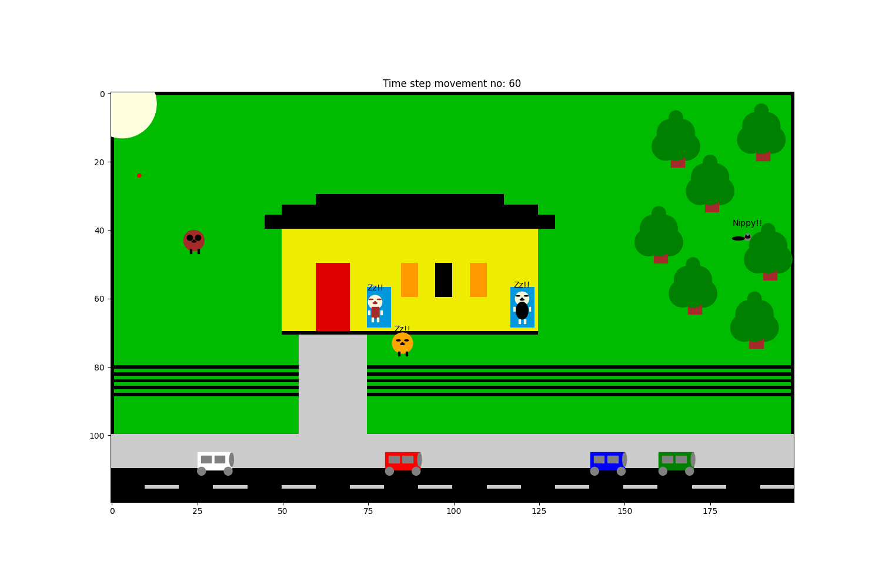

Overview
This program of a simulation of puppies’ behaviour in a family of two who are the father and the son (Guy). The Father being challenged with activities his behaviours are usually slow. Guy works during daytime loves and being loved by Snoopy while Rover is an innocent puppy who thinks everyone wants to play with him and connects more with the father.
This simulation carries three parts of their daily life which are, the morning, evening, and the night. Each mentioned scenarios are included with separate activities and simulations.
User Guide
This program was written using Visual Studio Code in python language yet, it can be run using Terminal or similar applications as well. It is required to keep all the supporting files (creatures.py and maincode.py) in the same folder as the files are lined together and run only the main file which is named as Maincode.py. It is recommended to use the global version of python which will be required to be selected after installation of python into the Visual Studio Code application.
The Main code (maincode.py) can be run using either the play button in the top right corner or by typing “python3 Maincode.py” in the terminal. Once the program is running, the user will be greeted with a question asking which event they wish to see out of the three scenarios. The required inputs are “M” for Morning, “E” for Evening, and “N” for Night. Once the user has viewed one scenario, it is possible to replay another scenario by using the same method as the first time.
Furthermore, installation of matplotlib and numpy will be required.
Traceability Matrix
Feature | Code Reference | Test Reference | Status | Date Completed
1.0 Creatures
1.1 MSnoopy | Class MSnoopy in creatures.py | testMPuppy.py | p | 27/4/24
1.1.1 Runs behind the news van | Class MSnoopy in creatures.py | Tested with the testmorning.py | p | 27/4/24
1.1.2 Walks back home with the newspaper | Class MSnoopy in creatures.py | Tested with the testmorning.py | p | 27/4/24
1.2 ESnoopy | Class ESnoopy in creatures.py | testEPuppy.py | p | 28/4/24
1.2.1 Runs for the ball | Class ESnoopy in creatures.py | Tested with the testevening.py | p | 28/4/24
1.2.2 Comes with the ball | Class ESnoopy in creatures.py | Tested with the testevening.py | p | 28/4/24
1.2.3 Runs for the Guy | Class ESnoopy in creatures.py | Tested with the testevening.py | p | 28/4/24
1.3 NSnoopy | Class NSnoopy in creatures.py | testNPuppy.py | p | 4/5/24
1.3.1 Walks to the frontyard | Class NSnoopy in creatures.py | Tested with the testnight.py | p | 4/5/24
1.3.2 Sleeps | Class NSnoopy in creatures.py | Tested with the testnight.py | p | 4/5/24
1.4 MRover | Class MRover in creatures.py | testEPuppy.py | p | 27/4/24
1.4.1 chases the ball | Class MRover in creatures.py | Tested with the testmorning.py | p | 27/4/24
1.4.2 Comes back with the ball | Class MRover in creatures.py | Tested with the testmorning.py | p | 27/4/24
1.5 ERover | Class ERover in creatures.py | testEPuppy.py | p | 28/4/24
1.5.1 Chases the squirrel | Class ERover in creatures.py | Tested with the testevening.py | p | 28/4/24
1.6 NRover | Class NRover in creatures.py | testEPuppy.py | p | 4/5/24
1.6.1 Walks around the backyard | Class NRover in creatures.py | Tested with the testnight.py | p | 4/5/24
1.7 Car | Class Car in creatures.py | testCar.py | p | 27/4/24
1.7.1 Drives to the house | Class Car in creatures.py | Tested with the testevening.py | p | 27/4/24
1.8 Newscar | Class Newscar in creatures.py | testNewscar.py | p | 27/4/24
1.8.1 Drives on the road | Class Newscar in creatures.py | Tested with the testmorning.py | p | 27/4/24
1.9 Newspaper | Class Newspaper in creatures.py | Tested with the testmorning.py | p | 27/4/24
1.9.1 Goes to the house in the dog’s mouth | Class Newspaper in creatures.py | Tested with the testmorning.py | p | 27/4/24
1.10 MSquirrel | Class MSquirrel in creatures.py | testMSquirrel.py | p | 27/4/24
1.10.1 Walks around in the woods | Class MSquirrel in creatures.py | Tested with the testmorning.py | p | 27/4/24
1.11 ESquirrel | Class ESquirrel in creatures.py | testESquirrel.py | p | 28/4/24
1.11.1 Getting chased by Rover | Class ESquirrel in creatures.py | Tested with the testevening.py | p | 28/4/24
1.12 NSquirrel | Class NSquirrel in creatures.py | testNSquirrel.py | p | 4/5/24
1.12.1 Walks around in the woods | Class NSquirrel in creatures.py | Tested with the testnight.py | p | 4/5/24
1.13 MHomeman | Class MHomeman in creatures.py | testMHomeman.py | p | 27/4/24
1.13.1 Runs behind Snoopy | Class MHomeman in creatures.py | Tested with the testmorning.py | p | 27/4/24
1.13.2 Walks Snoopy back with the newspaper | Class MHomeman in creatures.py | Tested with the testmorning.py | p | 27/4/24
1.14 EHomeman | Class EHomeman in creatures.py | testEHomeman.py | p | 28/4/24
1.14.1 Walks home from the car | Class EHomeman in creatures.py | Tested with the testevening.py | p | 28/4/24
1.15 NHomeman | Class NHomeman in creatures.py | testNHomeman.py | p | 4/5/24
1.15.1 Checks on father and walks to bed | Class NHomeman in creatures.py | Tested with the testnight.py | p | 4/5/24
1.16 MOtherman | Class MOtherman in creatures.py | testMOtherman.py | p | 27/4/24
1.16.1 Follows Rover to make him bring the ball back | Class MOtherman in creatures.py | Tested with the testmorning.py | p | 27/4/24
1.16.2 Runs behind Rover to get the ball back | Class MOtherman in creatures.py | Tested with the testmorning.py | p | 27/4/24
1.17 EOtherman | Class EOtherman in creatures.py | testEOtherman.py | p | 28/4/24
1.17.1 Chases Rover to stop him from chasing the squirrel | Class EOtherman in creatures.py | Tested with the testevening.py | p | 28/4/24
1.18 NOtherman | Class NOtherman in creatures.py | testNOtherman.py | p | 4/5/24
1.19 Toy | Class Toy in creatures.py | testToy.py | p | 27/4/24
1.19.1 Ball being thrown | Class Toy in creatures.py | Tested with testmorning.py, testevening.py | p | 27/4/24
1.19.2 Ball returning in dog’s mouth | Class Toy in creatures.py | Tested with testmorning.py, testevening.py | p | 27/4/24
1.20 SunMoon | Class SunMoon in creatures.py | Tested with testmorning.py, testevening.py, testnight.py | p | 4/5/24
1.21 Tree | Class Tree in creatures.py | testTree.py | p | 27/4/24
1.22 Pond | Class Pond in creatures.py | testPond.py | p | 5/5/24
2.0 Maincode | Maincode.py | testMaincode.py | P | 4/5/24
2.1 Asses.png | Outcome image of Maincode | N/A | p | 4/5/24
2.2 testmorning | Trying morning codes for maincode.py | testmorning.py | p | 28/4/24
2.2.1 morning.png | Outcome image of testmorning.py | N/A | p | 4/5/24
2.3 testevening | Trying evening codes for maincode.py | testevening.py | p | 28/4/24
2.3.1 Evening.png | Outcome image of testevening.py | N/A | p | 4/5/24
2.4 testnight | Trying night codes for maincode.py | testnight.py | p | 4/5/24
2.4.1 Night.png | Outcome image of testnight.py | N/A | p | 4/5/24

Discussion
In all three scenarios the dogs are in close contact with humans and some scenarios animals are interreacting with each other. Rover (one of the dogs) is more interactive with the father while Snoopy (the other dog) is more interactive with the Guy. Both dogs love playing; yet Rover loves to play with mates than with the toys. Snoopy gets triggered when he sees strangers.
The supporting codes in “creatures” as classes are MSnoopy, MRover, MSquirrel, MHomeman, MOtherman, Newscar, Toy and Tree helps with the Maincode.py to run the program.
The “creatures.py” is the modified version of the given code in the starting codes in the assignment. Similarly, the “Maincode.py” is the modified version of the “task3.py” from the “PracTest4.py” (COMP5005, 2024) (Self, 2024).
Colorcodes are taken from the website matplotlib.org (“Reference for Matplotlib Artists — Matplotlib 3.8.0 Documentation,” n.d.).
The measurements and the positions to draw the program is done manually by rearranging the cordinations multiple times.
Many of the codes are learnt from the practicles and the practical walkthrough videos (COMP5005, 2024).

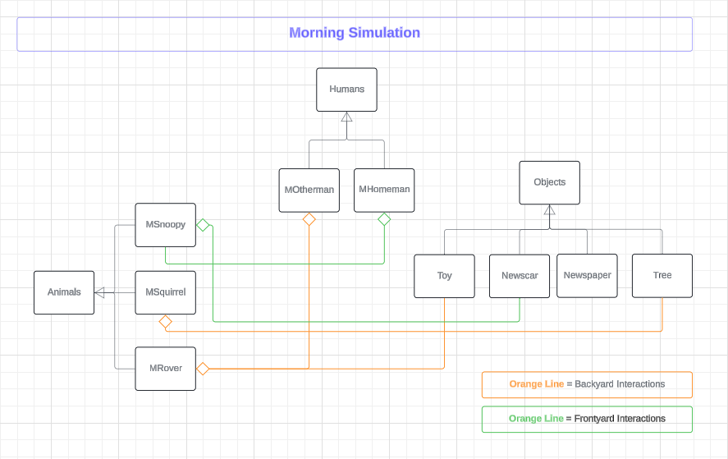

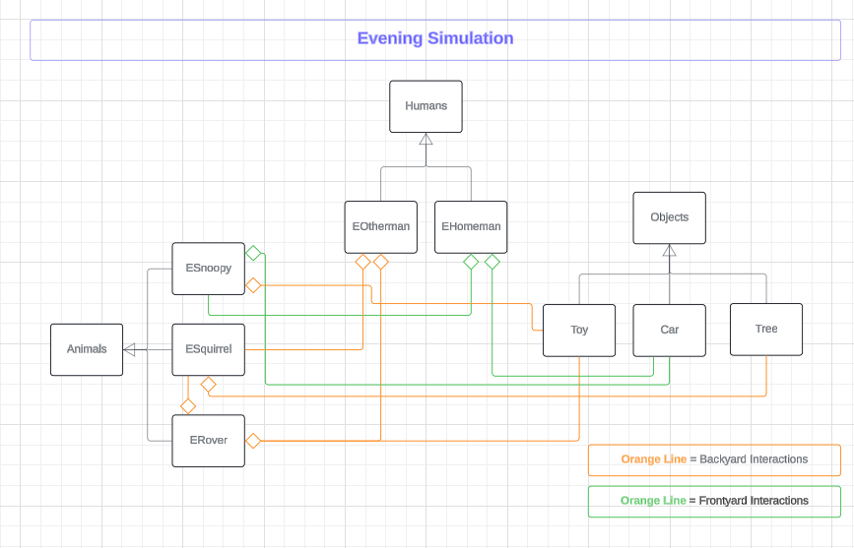

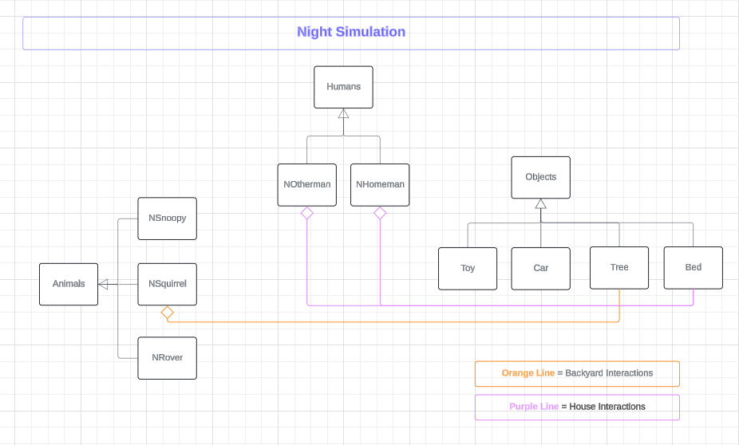

Showcase:

Scenario 1:
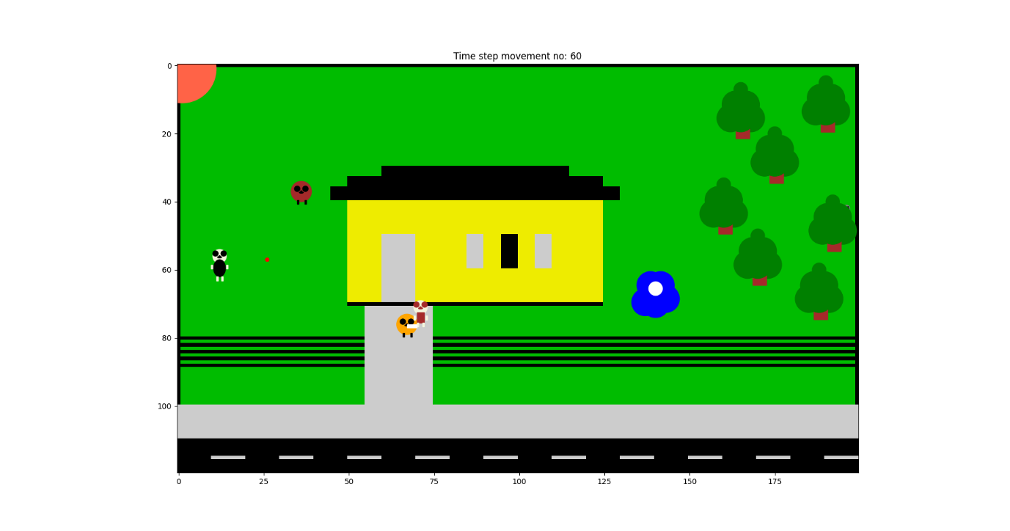
The scenario one is the event of a ‘Morning’ with the morning sun where the usual newspaper delivery is happening and the Guy is outside to go to work and the father is in the backyard playing with the dog using a ball. Rover in the backyard and plays with the father and catches the ball when its being thrown but decides not to return the ball to father instead trying to make father to come to him.
In the front yard, the other dog, Snoopy is walking and sees the news paper van which is waiting to deliver the papers and chases it. The driver of the van starts to drive without dropping the paper however manages to throw it in front of the doorway and continues to drive. Snoopy stops the chase after seeing the paper and takes it to his mouth thinking it’s a toy . Guy sees Snoopy running behind the news paper van and runs behind the dog to catch and he was able to catch him as soon as Snoopy gets the news papers and both walks back home.
This scenario can be run using the ‘Maincode.py’ and selecting “M” as the input and this will require the file “creatures.py” to support. Furthermore, the selection of right python program (Global) to run is recommended.

Scenario 2:
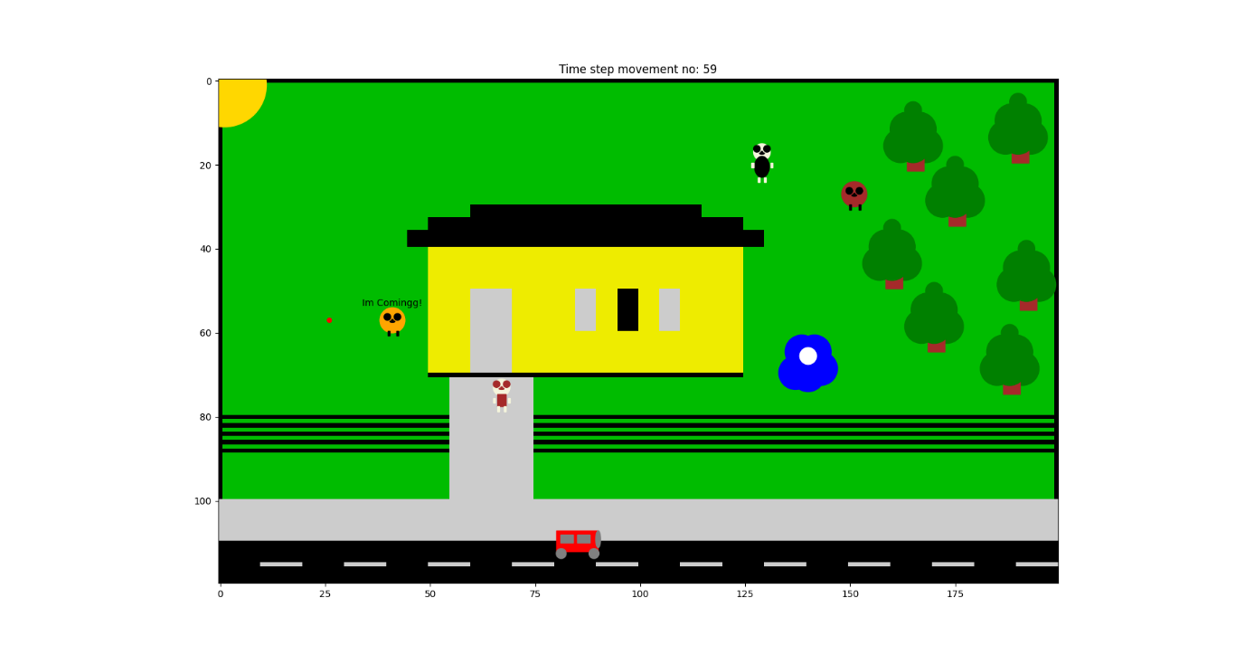
This scenario two is the ‘Evening’ scenario where the sun is more yellower. The father being old and retired he tries to play with Rover and Snoopy in the backyard. Rover being rover, he tries to grab the ball before Snoopy yet sees the running squirrel and starts running behind it to start play with the squirrel. Father tries to stop a desaster by running behind Rover to stop him. The squirrel not understanding that Rover just wanna play, it goes towards the trees and hides in one of the trees where Rover can’t find him. Meantime Snoopy chooses to play with the ball and runs and grabs the ball.
In the frontyard, Guy comes home in his car gets down to walk to the house. Snoopy can hear the guys approach and starts running towards Guy dropping the ball behind.
This scenario can be run using the Maincode.py and selecting “E” as the input and this will require the file “creatures.py” to support. Furthermore, the selection of right python program (Global) to run is recommended.

Scenario 3:
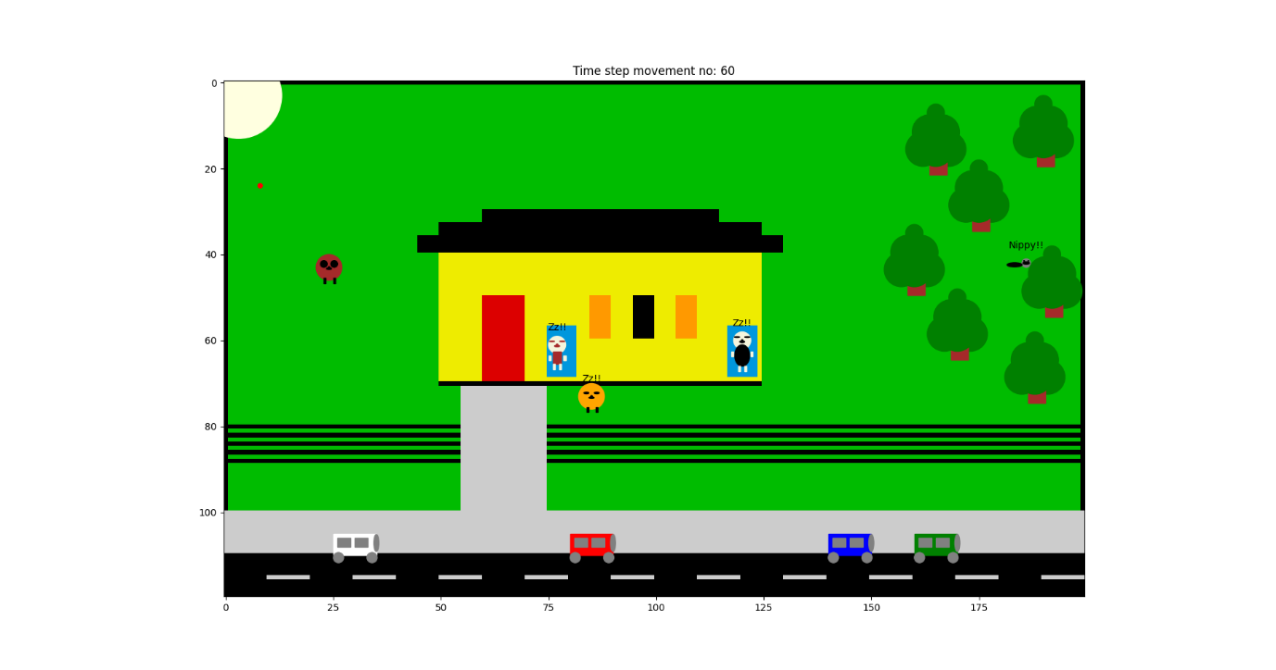
In the scenario three, it shows a ‘Night’ time where the moon is up. After being tired all day father is already sleeping and the Guy is there in fathers’ room to check on him and walks back to his room to sleep while being so tired and sleepy. As soon as he gets to the bed he falls in sleep. Snoopy being the frontyard dog, he walks towards the front and falls a sleep infront of the house. The squirrel is still in the woods after being chased in the evening and just wonders around. Rover walks around in the backyard and thinks he should stay awake to protect the house but eventually finds it boring but still walks around the house. There are multiple cars parked in the side of the road because people are home at night including Guy’s car.
This scenario can be run using the Maincode.py and selecting “N” as the input and this will require the file “creatures.py” to support. Furthermore, the selection of right python program (Global) to run is recommended.

Conclusion
Puppy simulation created using python program was an opportunity with unlimited learning chances and experimental methods. The outcome of the three scenarios and the interactions between the humans and the animals as well as the interactions between other objects demonstrates a ‘Day’ simulation. Usage of codes and other python tools can open a world with unlimited possibilities.

Future Work
Usage of pygame will open the opportunity to convert the two-dimensional simulation into a three-dimensional simulation with more realistic characters and objects. The scenarios can be further improved by adding more objects and tasks while making the length of the simulation higher. The interaction between other animals as well as day to day behaviour can be simulated with further improvements.

References
COMP5005a. “Fundamentals of Programming: Practical 4, Walkthrough.” Accessed May 20th, 2024 via Blackboard
COMP5005a. “Fundamentals of Programming: Practical 5, Walkthrough.” Accessed May 24th, 2024 via Blackboard
COMP5005a. “Fundamentals of Programming: Practical 6, Walkthrough.” Accessed May 25th, 2024 via Blackboard
“Reference for Matplotlib Artists — Matplotlib 3.8.0 Documentation.” n.d. Matplotlib.org. https://matplotlib.org/stable/gallery/shapes_and_collections/artist_reference.html#sphx-glr-gallery-shapes-and-collections-artist-reference-py.
Self, COMP5005a. “Fundamentals of Programming: Practest04, task3.” Accessed May 25th, 2024 via Blackboard

