Nipuna Darshana
KD_HDCSE_CMU_77_46

Mobile Application Development
(CSE 5011)

Assignment Cover Sheet

Qualification |  | Module Number and Title
HD in Computing and Software Engineering/ |  | CSE5011
Student Name & No. |  | Assessor
KD/HDCSE/CMU/77/46  Dabare Liyanage Nipuna Darshana |  | Mr.
Hand out date |  | Submission Date
14/10/2025 |  | 04/01/2026
Assessment type  WRIT1-Coursework | Duration/Length of  Assessment Type  3 weeks (3000 Words) | Weighting of Assessment  100%

Learner declaration
I, KD/HDCSE/CMU/77/46 Dabare Liyanage Nipuna Darshana, certify that the work submitted for this assignment is my own and research sources are fully acknowledged.
Marks Awarded
First assessor
IV marks
Agreed grade
Signature of the assessor |  | Date

Feedback Form

International College of Business & Technology

Module: MAD CSE5011
Student: KD/HDCSE/CMU/77/46 Dabare Liyanage Nipuna Darshana
Assessor:
Assignment: Mobile Application Development
Strong features of your work:

Areas for improvement:

Marks Awarded:

Table of Contents
Task A 8
Introduction. 8
Mobile Operating Systems. 8
Android Operating System. 8
Advantages of Android: 9
Disadvantages of Android: 9
Appropriateness for TechCare Services: 9
iOS Operating System 9
Advantages of iOS: 10
Disadvantages of iOS: 10
Appropriateness for TechCare Services: 10
Android vs iOS – Critical Comparison 10
Feature 11
Android 11
iOS 11
Market Share 11
Very High 11
Moderate 11
Development Cost 11
Low 11
High 11
Customization 11
High 11
Limited 11
Security 11
Moderate 11
Very High 11
Device Range 11
Wide 11
Limited 11
Suitability for TechCare 11
Very Suitable 11
Moderately Suitable 11
Mobile Development Tools 12
Android Studio 12
Xcode (iOS Development Tool) 13
Mobile Development Technologies 14
Security Considerations 16
Conclusion 16
Task B 17
Use Case Diagram 17
Class Diagram 18
ER Diagram 19
19
Database Desing 20
Task C 21
Interface Design Analysis 22
Color Scheme Analysis 22
How to Color Match for my App 23
Additional Design Tips 24
Tools to Help with Design 24
Task D 25
Login Flow and Notifications in Your App 25
Why This Approach is Effective 29
Consistency 29
Task E 30
Task F 31
Overview 31
Conclusion 33
References 34

Task A
Critically Compare Mobile Operating Systems, Development Tools, and Technologies for the Tech Care Services Mobile Application.

Introduction.
Mobile applications have turned out to be a vital component of service-oriented companies. In the case of Tech Care Services, a mobile application is needed to enable the customer to browse the repair services, post repair requests, monitor the status of their services, and get notifications. The selection of the right mobile operating system, development tools, and technologies is quite important to make sure that performance, security, scalability, and user satisfaction are guaranteed.
This part describes and critically compares the key mobile operating systems and development tools that can be used to create the Tech Care Services mobile application, with special emphasis being placed on native mobile development since cross-platform frameworks are also prohibited.

Mobile Operating Systems.
A mobile operating system (OS) is a software that controls hardware on a mobile device and gives it a platform to provide applications to execute. Android and iOS are the two most powerful mobile operating systems.

Android Operating System.
Android is an open-source mobile operating system that is Google developed. It is popular with various manufacturers of devices like Samsung, Xiaomi, Oppo, and Huawei.

Advantages of Android:
  - High market share: Android has the largest market share in the world and particularly in developing nations such as Sri Lanka.
  - Diversity of devices: Operates on smartphones, tablets, smart TVs, and others.
  - Customization: Allows UI customization and background services.
  - Open-source: The developers are more at liberty to control the system-level features.
  - Economical development: No required annual developer fee (Google Play one-time fee).

Disadvantages of Android:
  - Fragmentation of devices: Numerous screen sizes, hardware differences, and versions of OS.
  - Security risks: Android is more susceptible to malware-based attacks because it is open.
  - Complexity of testing: It involves a lot of testing in various devices.

Appropriateness for TechCare Services:
- Android is a great choice because
- Android users probably make up the majority of TechCare's clientele.
- Push notifications and background services are supported.
- Simple Google Firebase integration for notifications and updates in real time.

iOS Operating System
iOS is Apple’s proprietary mobile operating system used exclusively on iPhones and iPads.

Advantages of iOS:
- Excellent stability and performance
- Robust security and stringent app review guidelines
- UI/UX uniformity across devices
- Quicker OS updates for all compatible devices

Disadvantages of iOS:
- Closed ecosystem
- High development cost (Apple Developer Program fee)
- Limited customization
- Smaller market share in some regions

Appropriateness for TechCare Services:
  - Although iOS is appropriate for high-end clients, it might not be the best choice for TechCare Services' main platform because of:
  - Increased expenses for development and implementation
  - Sri Lanka has a smaller user base than Android

Android vs iOS – Critical Comparison

Feature | Android | iOS
Market Share | Very High | Moderate
Development Cost | Low | High
Customization | High | Limited
Security | Moderate | Very High
Device Range | Wide | Limited
Suitability for TechCare | Very Suitable | Moderately Suitable

Conclusion
Android is the more practical and economical operating system for TechCare Services, particularly since the assignment calls for development using Android Studio and native technologies.

Mobile Development Tools

Android Studio
Android Studio is the official Integrated Development Environment (IDE) for Android app development.
Attributes:
  - Built-in code editor
  - Emulator for testing
  - UI designer (XML layouts)
  - Debugging and performance profiling tools
  - Gradle-based build system
Advantages:
  - Official Google support
  - Smartphone-based integration with Firebase.
  - Strong community support
  - Android development optimized.
Disadvantages:
- High system resource usage
- Steep learning curve for beginners
Relevance to TechCare Services:
- Android Studio is ideal for Developing booking systems
- Real-time service updates management.
- Installation of notifications and authentication.

Xcode (iOS Development Tool)
Xcode is Apple’s official IDE for iOS development.

Advantages:
- Excellent debugging tools
- Swift programming language
- Optimized performance

Disadvantages:
- Works only on macOS
- Requires Apple devices
- Not relevant for Android-based assignments

Mobile Development Technologies
Programming Languages
- Java
- Object-Oriented Programming (OOP).
- Popular with Android development.
- Stable and well-documented
- Kotlin
    - Google officially recognized modern language.
    - Less boilerplate code
    - Better null safety

Comparison:
Java | Kotlin
Mature | Modern
More Code | Less Code
Stable | Safer

User Interface Technologies
  - XML Layouts for UI design
  - Material Design principles for consistent UI
  - Responsive layouts for different screen sizes

These are essential for:
  - Service browsing screens
  - Booking forms
  - Status tracking dashboards

Backend and Cloud Technologies
Backend services are still necessary even though the app is native.

Firebase:
- Authentication (email/phone login)
- Realtime Database / Firestore
- Cloud Messaging (notifications)
- Storage (photo uploads)

Advantages:
- Easy integration with Android
- Real-time updates
- No server maintenance required

Notifications and Background Services
- Firebase Cloud Messaging (FCM) for notifications
- Android background services for tracking service status

These technologies support:
  - Booking confirmations
  - Repair status updates
  - Completion alerts

Security Considerations
- Secure login using Firebase Authentication
- Data encryption
- Role-based access (customer vs technician)
- Secure API communication
- Android provides permission-based security, which helps protect user data.

Conclusion
In conclusion, Android is the best mobile operating system for the TechCare Services app because of its large user base, adaptability, and affordability. When paired with Java and Firebase, Android Studio offers a robust native development environment that satisfies all functional requirements of the application, such as booking management, real-time updates, notifications, and customer support features.
Android is more sensible in this situation, especially considering the need to use native development exclusively, even though iOS offers superior security and performance. Thus, the best option for creating the TechCare Services mobile application is to use Android native technologies.

Task B

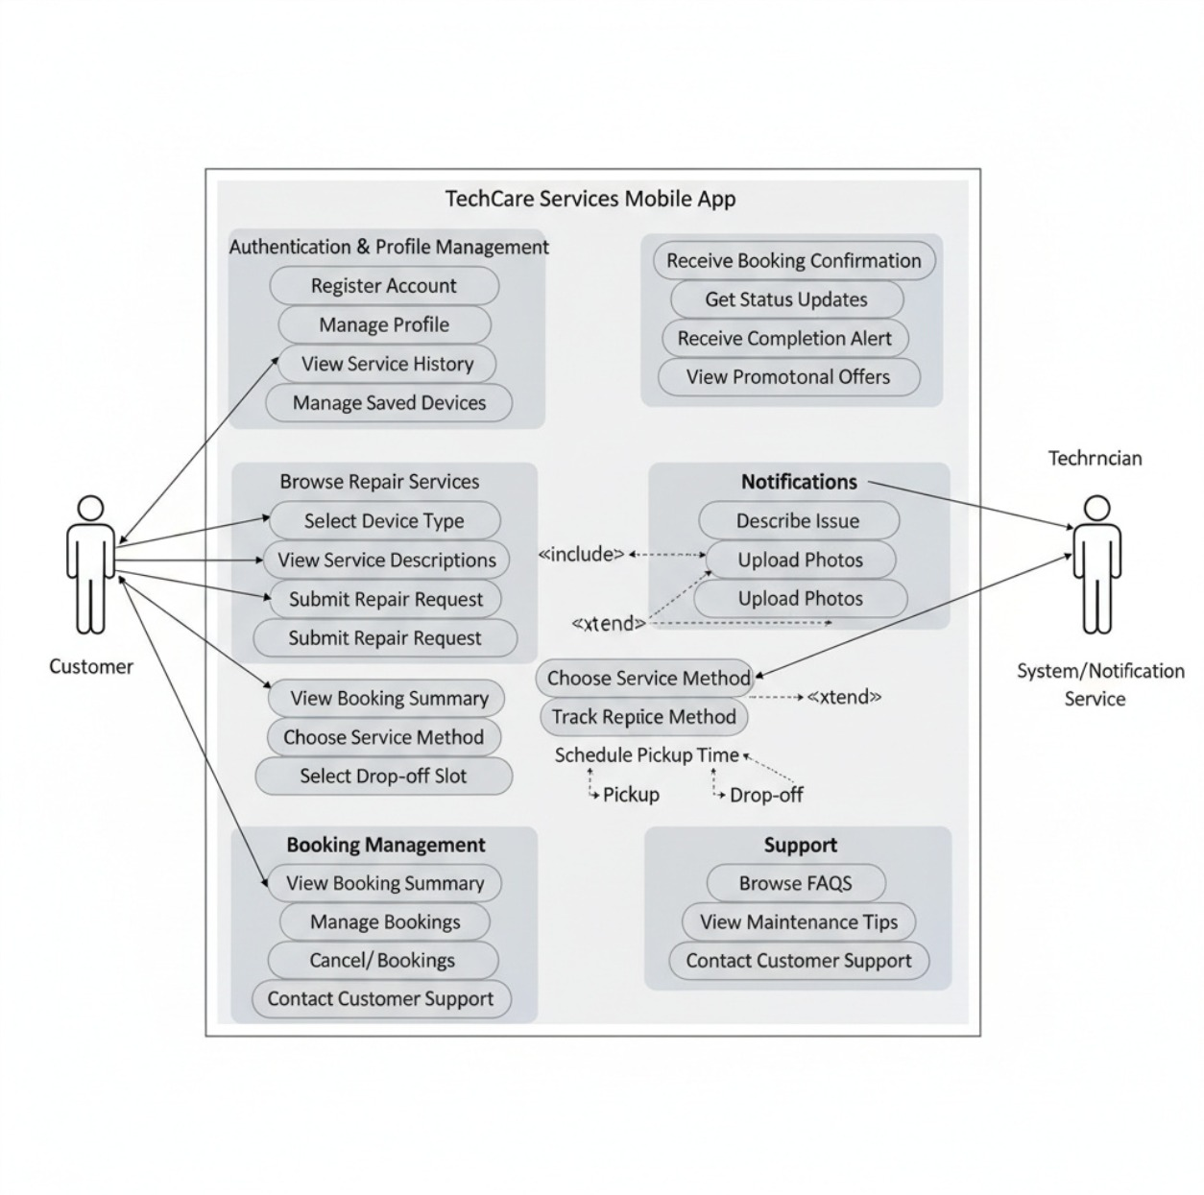
Use Case Diagram

Class Diagram
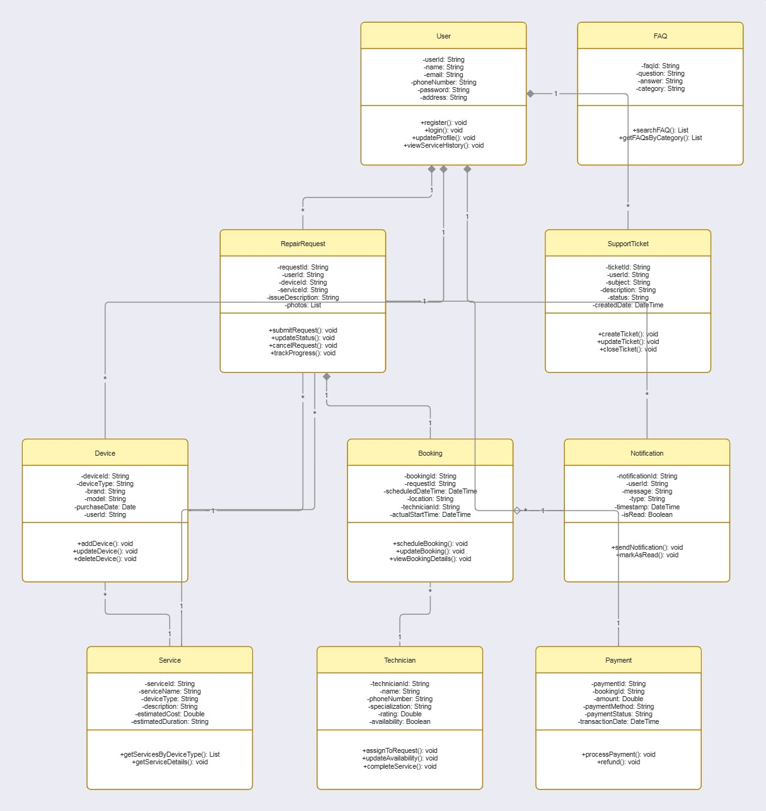

ER Diagram
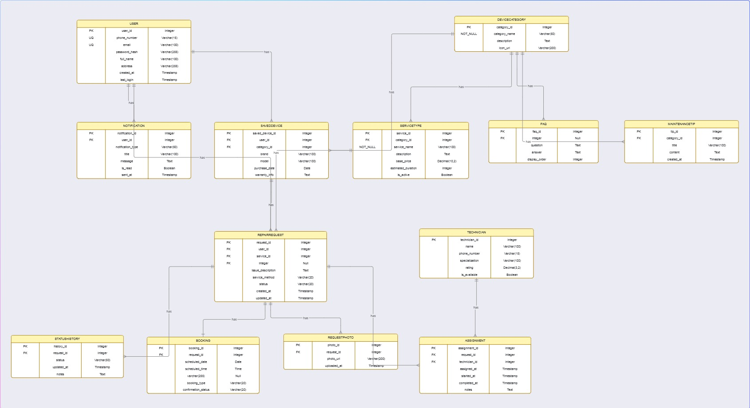

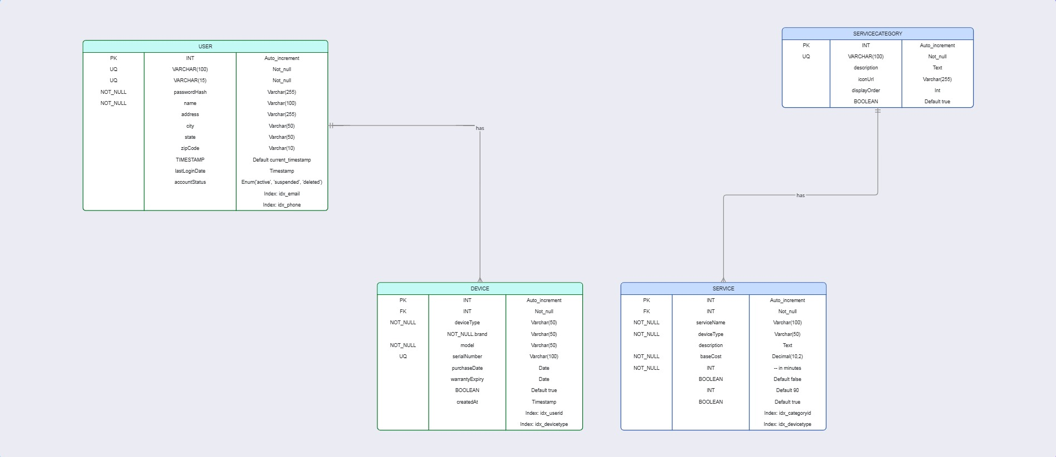
Database Desing

Task C
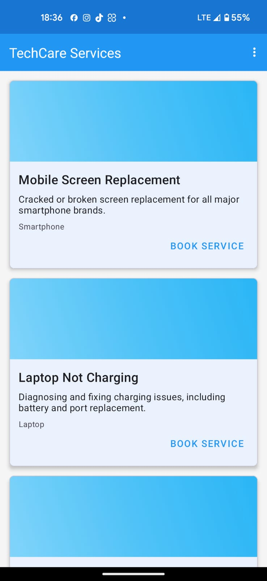

Interface Design Analysis
Layout and Structure
- Card-Based Design: Every service is displayed as a card with a "Book Service" button, an image, a title, and a description. Users can browse and choose services more easily as a result.
- Consistent Spacing: Both readability and visual appeal are enhanced by the consistent spacing between elements.
- Minimalist Approach: By concentrating on important details and actions, the design avoids clutter.

Typography
  - Bold Headings: Service titles (like "Mobile Screen Replacement") are easy to scan because they are bold and noticeable.
  - Readable Descriptions: The descriptions use a readable font size and are succinct.

Navigation
- Top Navigation Bar: The top of the screen displays the app name ("TechCare Services"), along with a three-line menu icon for more navigation options.
- Status Bar: As is typical for mobile apps, the status bar at the top displays the time, battery life, and network status.

Color Scheme Analysis
Current Color Palette
  - Primary Color: The header and action buttons ("Book Service") are blue (#4285F4 or comparable).
  - Background: For contrast, the cards have a light background, either white or off-white.
  - Accent Colors: For consistency and a unified appearance, the color blue is used repeatedly.

Color Psychology
blue: represents professionalism, dependability, and trust—all of which are perfect for a service-based app.
White: ensures readability and content focus by offering a clear, neutral background

How to Color Match for my App
Step 1: Define Your Brand Colors
Primary Color: Use the blue shade (#4285F4 or similar) as your primary brand color for headers, buttons, and accents.
Secondary Colors: Select complementary hues for text, backgrounds, and other UI components. For instance:
        - Light gray (#F5F5F5) for card backgrounds.
        - Dark gray (#333333) for text to ensure readability.
        - A lighter blue (#E3F2FD) for highlights or secondary buttons.

Step 2: Use a Color Palette Tool
A harmonious color scheme can be produced with the aid of programs like Adobe Color, Colors, or Material Design Color Tool.
After entering your primary shade of blue, the tool will recommend complementary hues.

Step 3: Apply Colors Consistently
  - Headers and Buttons: Any actionable elements, such as buttons and headers, should use the primary blue.
  - Backgrounds: To keep backgrounds readable, use light hues like white or light gray.
  - Text: For contrast and legibility, use dark gray or black.

Step 4: Test for Accessibility
Make sure your color selections adhere to accessibility guidelines, such as text-to-background contrast ratios.
Make sure all users can access your colors by using tools such as WEB AIM Contrast Checker.

Additional Design Tips
- Icons: For services, use straightforward, identifiable icons (e.g., a smartphone icon for mobile repairs).
- Images: To accurately depict the device being fixed, use high-quality photos for every service.
- Feedback: Give user actions visual feedback by changing the color of buttons when they are pressed, for example.

Tools to Help with Design
  - Figma or Adobe XD: Design wireframes and prototypes to visualize your design of apps.
  - Canva: Apply ready color schemes and layouts.
  - Material Design Guidelines: Adhere to mobile application design principles.

Task D

Login Flow and Notifications in Your App
A. Failed Login Attempt
- Scenario: User enters an incorrect email or password.
- Notification: At the bottom of the screen, a brief, unobtrusive toast notification reads, "Authentication failed."
- Design Elements: The notification doesn't interfere with the user's flow and is subtle.
It indicates failure with a small icon (such as an error or warning icon) on a light background.
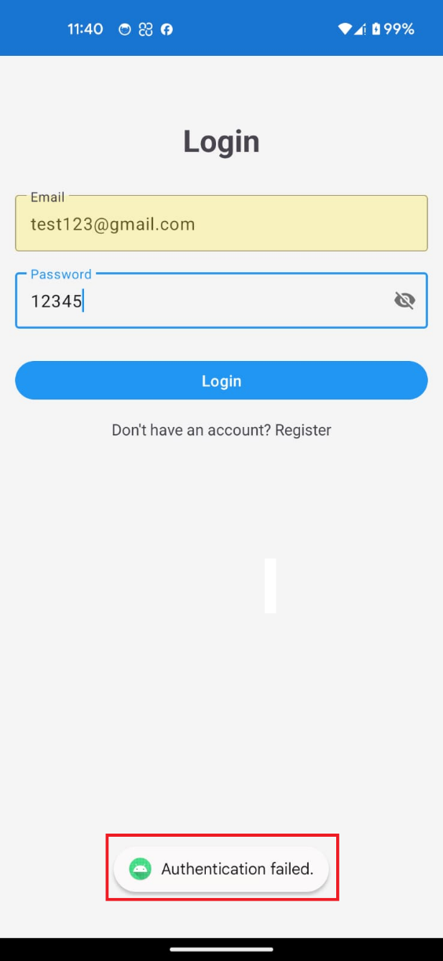
The user is informed about the problem without being overwhelmed by the text's clarity and conciseness.

Enters an incorrect email or password.
Notification: "Authentication failed."

B. Successful Login Attempt
- Scenario: User enters the correct email and password.
- Notification: A toast notification that looks like this says, "Login successful."
- Design Elements: The notification indicates success with a green icon, such as a checkmark.
The message, which verifies that the user has successfully logged in, is encouraging and comforting.
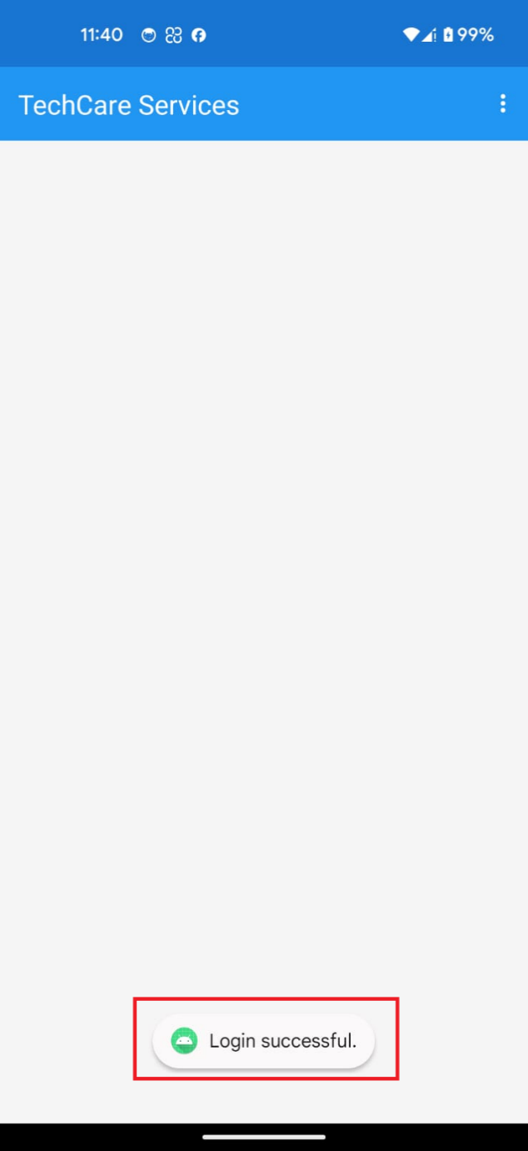
Enters the correct email and password.
Notification: "Login successful."
C. Form Validation and Error Handling
- Purpose: The Book a Service screen provides the option of placing a request in order to repair the vehicle. Nevertheless, this is checked by the application so that the user has to fill in all the necessary fields and send the form.
- Error Message: In case a user is attempting to fill the form without filling all the necessary fields (e.g., by choosing a service method), an error message appears at the bottom of the app: Please select a service method. This makes sure that the user is aware of what he or she has missed and he/she has an opportunity to correct.

Required Fields
  - Type of the device: here, users will be required to choose the kind of device (e.g., Laptop).
  - Service Type: The user has to choose the particular service (e.g., Laptop Not Charging).
  - Issue Description: The users have to outline the problem (e.g., battery).
  - Service Method: there is an option of Home Pickup and drop-off (this is where the mistake is made when not chosen).

Why This Matters.
  - User Guidance: The error message will assist the user to know what they should do to continue with it, as it will lessen stress and misunderstandings.
  - Data Accuracy: In making sure that all fields are filled out it ensures that the service request is complete and accurate which would be crucial in efficient service delivery.

How It Works
  - When the user hits the button "Submit Booking" the app will verify whether all the fields that are mandatory have been entered.
  - In case one of the fields is not filled (e.g. service method), the app will show the error message and will not allow submission.
  - After completing all the fields, the user can place the booking with the help of the app.

User Experience Benefits
- Clear Communication: The error message appears in a non-obtrusive manner, which allows the user to correct their error very fast.
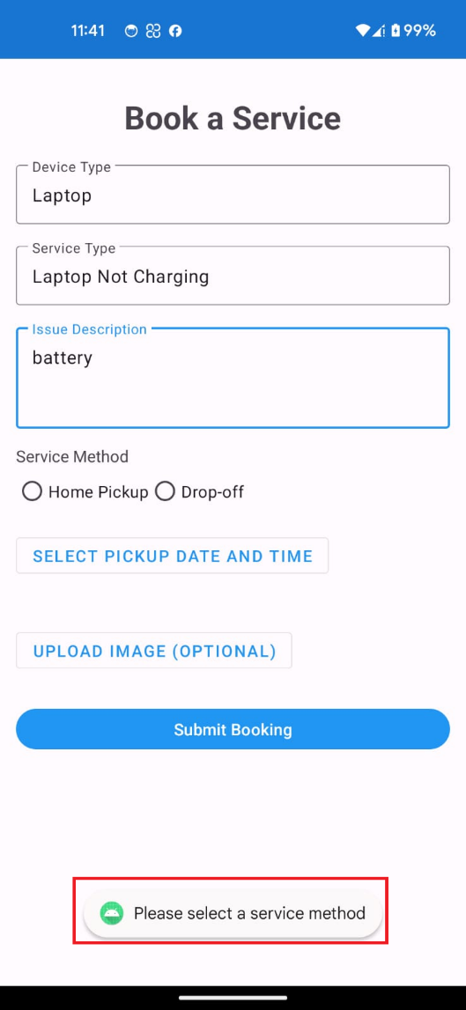
- Efficiency: It is a validation procedure that only full and valid requests are posted allowing the time savings of both users and service providers

Why This Approach is Effective
User Experience (UX) Benefits
- Immediate Feedback: Users are less confused and frustrated because they receive immediate feedback on their actions.
- Non-Intrusive: After a few seconds, the notifications at the bottom of the screen vanish, enabling users to carry on using the app.
- Visual Clarity: Icons, such as a checkmark for success and a warning for failure, are used to help users quickly understand the status of their action.

Consistency
The notifications' layout and style are the same for both success and failure messages. The app feels unified and polished as a result.

Task E



Task F

Overview
Users of the Tech Care Services Mobile App can request, monitor, and oversee home appliance and electronic device repair services. With features like service browsing, booking management, and real-time updates, the app is made to be simple to use.

Getting Started
Installation
- Download the app from the Google Play Store or Apple App Store.
- Open the app and follow the on-screen instructions.

Registration and Login
- Register using your phone number or email.
- Verify your account via OTP or email confirmation.
- Log in using your credentials.

Using the App
Browsing Services
- Navigate to the "Services" tab.
- Select a device type (e.g., smartphone, laptop, refrigerator).
- Browse available repair services (e.g., "Mobile Screen Replacement," "Laptop Not Charging").

Submitting a Repair Request
- Select a service and tap "Request Repair."
- Describe the issue and upload photos (optional).
- Choose a service method (home pickup or service center drop-off).
- Select a preferred time slot for pickup/drop-off.
- Confirm the booking.

Managing Bookings
- View all active and past bookings in the "My Bookings" section.
- Track the status of each repair (e.g., "Received," "Under Repair," "Ready for Pickup").
- Cancel or reschedule bookings if needed.
Notifications
Receive real-time updates via push notifications for:
- Booking confirmations
- Repair status changes
- Completion alerts
- Promotional offers
Support and Tips
- Access FAQs and maintenance tips in the "Support" section.
- Contact customer support via chat, email, or phone.

Conclusion
This user guidebook offers a detailed description of the Tech Care Services Mobile App, such as user guide and instructions, technical specifications, and testing protocols. Test it to make sure that it develops, tests, and acquires users smoothly.

**I have added a video to the rar file in my final app**

References
Developers., A., n.d. (2024). Android Developer Documentation. Google.. [Online]
Available at: https://developer.android.com
Documentation., F., n.d. (2024). Firebase for Android. Google.. [Online]
Available at: https://firebase.google.com/docs/android
Inc., A., n.d. (2024). iOS Human Interface Guidelines.. [Online]
Available at: https://developer.apple.com/design/human-interface-guidelines
Pressman, R. S. &. M. B. R. (., n.d. Software Engineering: A Practitioner’s Approach (9th ed.). McGraw-Hill Education.. [Online].
Sommerville, n.d. I. (2016). Software Engineering (10th ed.). Pearson Education Limited.. [Online].

