Sri Lanka Institute of Information Technology

# ISO 9001:2015 Implementation Guide

**Individual Assignment 02**

**IE3102-Enterprise Standards for Information Security**

Submitted by:

|  |  |
| --- | --- |
| Student Registration Number | Student Name |
| IT20021870 | Dilshan K. N |

Date of submission

2nd November 2022

Table of Contents

**ISO 9001:2015 Implementation Guide 1**

**Introduction 3**

**Requirements 5**

**Implementation 7**

**ISO 9001 Clauses – PLAN** 8

**Followings are the Management Responsibilities** 9

**Followings are the Resource Management Responsibilities** 10

**ISO 9001 Clauses – DO** 11

**ISO 9001 Clauses – CHECK** 12

**ISO 9001 Clauses – ACT** 12

**Effective Tips for Implementation 14**

**Conclusion 15**

# Introduction

The International Organization for Standardization (ISO), a global organization made up of the national standards organizations of more than 160 nations, initially released ISO 9001 in 1987. In September 2015, the most recent edition of ISO 9001 was made public.

The international standard known as ISO 9001 is used to provide the specifications for a quality management system (QMS). The standard is used by businesses to show that they can consistently deliver goods and services that adhere to legal and consumer standards. It is the most widely used standard in the ISO 9000 series and the only one to which enterprises may receive certification.

Utilizing the ISO 9001 standard benefits businesses of all shapes and sizes by:

* Arrange procedures
* Increase process effectiveness
* Continually improve

All businesses that employ ISO 9001 are urged to upgrade as soon as feasible to ISO 9001:2015. This covers any organizations engaged in training or certifying others, in addition to those that are accredited to ISO 9001:2008.

Based on the plan-do-check-act methodology, ISO 9001 offers a process-oriented approach to describing and analyzing the organizational structure, roles, and processes necessary to implement successful quality management. Information is provided in certain parts of the standard on a variety of subjects, including:

* Requirements for a QMS, such as recorded data, planning, and figuring out how processes interact
* Obligations of management
* Management of resources, such as human resources and the working environment inside a company
* Realization of a product, from conception to delivery
* Internal audits, corrective and preventative action, and measurement, analysis, and improvement of the QMS

To ensure that ISO 9001 continues to adapt to the shifting settings in which businesses operate, changes were made in the 2015 edition of the standard. Among the significant modifications in ISO 9001:2015 are:

* New phrase being introduced
* Reorganizing a portion of the data
* A focus on risk-based thinking to improve how the process approach is used
* Increased service applicability
* 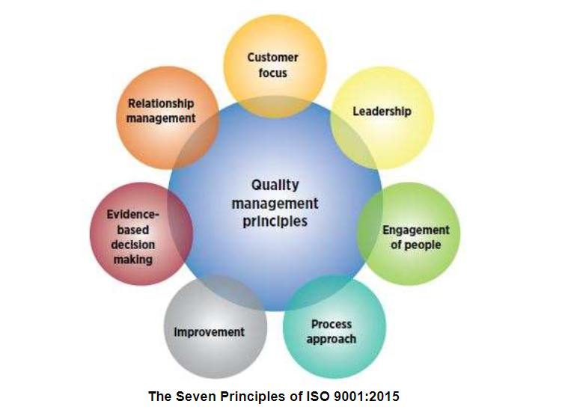Increased need for leadership

Figure 1

# Requirements

A business or organization must submit documentation that detail its internal processes, procedures, and standards in order to receive ISO certification. A company's ability to continuously deliver high-quality goods and services is determined by these records, often known as the quality management system.

The ISO has laid down all of the criteria for ISO 9001 in 10 clauses. While non-required criteria may be presented for documentation needs, obligatory requirements must be followed. The following documents must be presented in order to receive ISO 9001:2015 certification.

**ISO 9001 Mandatory Requirements — Documents and Records**

1. Monitoring and measuring equipment calibration records
2. Records of training, skills, experience and qualifications
3. Product/service requirements review records
4. Record about design and development outputs review
5. Record about design and development inputs
6. Records of design and development controls
7. Records of design and development outputs
8. Design and development changes records
9. Characteristics of product to be produced and service to be provided
10. Records about customer property
11. Production/service provision change control records
12. Record of conformity of product/service with acceptance criteria
13. Record of nonconforming outputs
14. Monitoring measurement results
15. Internal audit program
16. Results of internal audits
17. Results of the management review
18. Results of corrective actions

**Non-Mandatory Requirements — But Often Included**

1. Procedure for determining context of the organization and interested parties
2. Procedure for addressing risks and opportunities
3. Procedure for competence, training and awareness
4. Procedure of equipment maintenance and measuring equipment
5. Procedure for document and record control
6. Sales procedure
7. Procedure for design and development
8. Procedure for production and service provision
9. Warehousing procedure
10. Procedure for management of nonconformities and corrective actions
11. Procedure for monitoring customer satisfaction
12. Procedure for internal audit
13. Procedure for management review

Having this certification, however, enables other businesses and individuals know that everything your firm does and produces met a worldwide level of quality. Keep in mind that each company is unique and is operated differently.

The ISO certificate is advantageous for both your business and your customers.

# Implementation

Implementing the standard takes careful planning, whether you are doing it to advance your company's operations or in response to a tender requirement. When developing an ISO 9001 quality management system, there are certain crucial concerns for both large and small businesses (SME's). You should consider your company's management style and your strategic objectives since ISO 9001 is a potent instrument for business improvement.

In order to successfully implement ISO 9001, you must ensure that your entire organization is on board. Engagement of individuals is also crucial. Making ensuring that individuals are properly trained to apply ISO 9001 may also be necessary. With the exclusive collection of tools and services, experts can assist in reducing the difficulty of implementing ISO 9001.

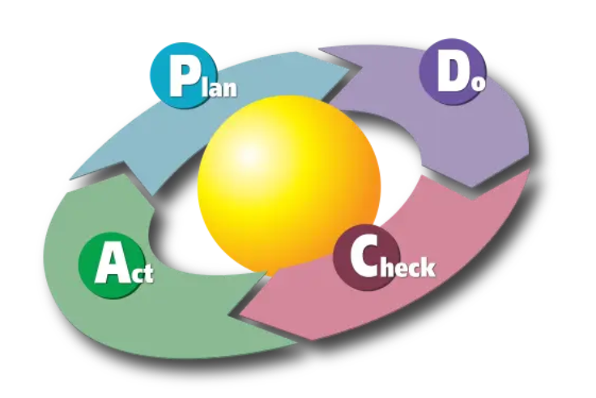**Implement using Plan-Do-Check-Act principles**

Figure 2

## **ISO 9001 Clauses – PLAN**

The creation and execution of your quality management system require the support of top-level management. Additionally, this aspect of ISO 9001 offers you a potent planning tool.

Inhere examine the processes now in place at your business, decide on broad goals, choose intermediate benchmarks for evaluation, and create strategies to reach those goals.

1 Scope

2 Normative references

3 Terms and Definitions

4 Context of the organization

4.1 Understanding the organization and its context

4.2 Understanding the needs and expectations of interested parties

4.3 Determining the scope of the quality management system

4.4 Quality management system and its processes

5 Leadership

5.1 Leadership and commitment

5.1.1 Leadership And Commitment For The Quality Management System

5.1.2 Customer Focus

5.2 Policy

5.2.1 Establishing the quality policy

5.2.2 Communicating the quality policy

5.3 Organizational roles, responsibilities and authorities

6 Planning

6.1 Actions to address risks and opportunities

How to address risk in ISO 9001

6.2 Quality objectives and planning to achieve them

6.3 Planning of changes

To successfully archive the implementation of above requirements organizational top management support is essentials.

### **Followings are the Management Responsibilities**

* **Customer focus**

Learn about the requirements and expectations of the client, both now and in the future. Talking to certain important consumers or conducting surveys to get feedback can do this.

* **Objectives**

To assist you in achieving the objectives of the quality policy, establish quantifiable organizational objectives.

* **Review the System**

At regular intervals, evaluate your system's performance and make any required improvements. Make sure all necessary resources are offered.

* **Quality Policy**

Create a quality policy that is appropriate to your company using the knowledge you've learned from your customers.

* **Plan the System**

Establish efficient procedures and assign duties to attain your goals.

### **Followings are the Resource Management Responsibilities**

The standard's resource management section ensures that you evaluate and provide the resources required to establish and enhance the system. Three categories of resources are considered: people, infrastructure, and work environment.

## **People**

* Establish the talents and skills the company needs.
* Next, take a look at your current workforce to spot any areas where skills are lacking.
* Fill in such gaps with coaching and training, or promote self-learning.
* Next, assess how well your actions have contributed to the development of the essential expertise for your line of work.
* With the help of this approach, you can always tell whether the training you offer is genuinely beneficial to the company and produces results.

### **Infrastructure**

This relates to the settings and tools you require for efficient performance. Start by figuring out what is required, giving it to them, and making sure you keep an eye on it.

* **Work Environment**

Here, you examine the working environment to make sure it's suitable for satisfying the demands of the client. Once more, you must make sure that this is evaluated frequently.

## **ISO 9001 Clauses – DO**

In this step normally organization implement their organizational plans.

7 Support

7.1 Resources

7.1.1 General

7.1.2 People

7.1.3 Infrastructure

7.1.4 Environment for the operation of processes

7.1.5 Monitoring and measuring resources

7.1.6 Organizational knowledge

7.2 Competence

7.3 Awareness

7.4 Communication

7.5 Documented information

7.5.1 General

7.5.2 Creating and updating documented information

7.5.3 Control of documented information

8 Operation

8.1 Operational planning and control

8.2 Requirements for products and services

8.3 Design and development of products and services

8.4 Control of externally provided processes, products and services

8.5 Product and service provision

8.6 Release of products and services

8.7 Control of nonconforming outputs

You now have the required support, guidance, and commitment from management. adequate tools for the job. After that, ISO 9001 provides you with a list of guidelines for overseeing your job. Planning should be done first, then map out the route from the customer's point of inquiry from beginning to end, including shipping (and beyond if necessary).

Typically, this involves defining the processes for:

• Sales

• Design and development

• Purchasing

• Production / operational / service activities

• Delivery

## **ISO 9001 Clauses – CHECK**

Measure and track your outcomes versus your intended goals.

9 Performance evaluation

9.1 Monitoring, measurement, analysis and evaluation

9.1.2 Customer Satisfaction

9.2 Internal Audit

9.3 Management Review

## **ISO 9001 Clauses – ACT**

Correct and enhance your strategies for achieving your desired goals.

10 Improvement

10.1 General

10.2 Nonconformity in ISO 9001

10.2 What is Non-conformance

10.2 Corrective Action

10.3 Continual Improvement

Don't stop once you've delivered to your consumers! Continue by asking them whether they are content. Measure the system's performance using additional metrics, analyze the results, and pinpoint the areas that need to be improved. Once more, the standard gives you a list of specifications for accomplishing this using tried-and-true methods.

**Customer Satisfaction**

Actually, this requires keeping track of consumer perception. It does not imply that you must send your consumers surveys. Perception monitoring may be done in a variety of ways. You can employ strategies appropriate to your industry.

**Monitoring and measurement of products and Processes**

The system is driven by individual processes; thus, it is crucial that they are functioning successfully and efficiently. To make sure that your products are satisfying the needs of your customers, you should measure and monitor your products.

**Analysis of data**

Data about the efficiency of your systems will be generated by successfully using the standard. Make improvements using the data.

**Internal audit**

Review your system frequently to ensure that everything is operating as intended.

**Control of non-conforming products**

In the event that something goes wrong, protocols should be in place to guarantee that the issue is managed and resolved effectively.

**Continual improvement**

One of the primary goals of the requirement is to ensure that your business improves. Using the analysts' findings will enable you to locate those. The situation can be improved.

# Effective tips for implementation

1. If there is no top management commitment, The system must be successfully introduced. Make sure top management is engaged. involved, give resources the OK, and concur the essential business procedures.
2. Review the current systems, policies, procedures, and processes that you have in place. After that, contrast those with what ISO 9001 requires. How much you already accomplish could astound you. The standard will let you preserve the aspects that are beneficial to you while improving the things that aren't.
3. Make sure your business has effective internal communication channels and procedures. The workforce must be involved and kept up to date on events.
4. Think about how departments interact with one another. It's critical that employees in your company collaborate with one another for the benefit of both the company and its clients.
5. Be mindful of the effect implementing these technologies will have on your suppliers and customers. Speak with them to learn more about how they see your service and where they believe it may be improved.
6. Clearly draw up an action plan with deadlines that is effectively communicated. Ensure that everyone is aware of them and their part in accomplishing them.
7. Your organization's structure and complexity will determine the type and level of documentation you produce. There are just six procedures that are required by ISO 9001. It's up to you what you have in addition to this.
8. Make achieving ISO 9001 an enjoyable and engaging experience. These will inspire you more.
9. Your personnel should receive training to do system audits. The growth and knowledge of a person may be aided through auditing, which can also offer insightful input on potential issues and areas for progress.
10. Finally, consider whether something is really important if you feel like you are only doing it to meet standards rather than for the benefit of your organization. In nine out of ten cases, it won't be necessary.

# 

# 

# Conclusion

Any firm, no matter how big or little, and regardless of the nature of its goods or services, may utilize ISO 9001 to improve its operations. Here, we go over the fundamentals and how to start using ISO 9001 so you can profit. A management system is essentially the method an organization controls its operations, personnel, and other resources to ensure that its goods and services satisfy the needs of its clients and achieve its goals. For instance, your goal can be to follow legal requirements or offer high-quality items for your consumers. The system should support a culture of continuous development and be adaptable to your company's needs. A set of guidelines for running a quality management system are provided by ISO 9001, which also serves as an example of best practices in quality management throughout the world. It is based on eight management principles that direct and explain all of its decisions. [1] [2] [3]

# References

|  |  |
| --- | --- |
| [1] | "Implementing ISO 9001 Quality Management," bsigroup.com, [Online]. Available: https://www.bsigroup.com/en-GB/iso-9001-quality-management/Implementing-ISO-9001/. [Accessed 25 October 2022]. |
| [2] | R. Keen, "What are the ISO 9001 Requirements?," www.iso-9001-checklist.co.uk, 3 March 2022. [Online]. Available: https://www.iso-9001-checklist.co.uk/iso-9001-requirements.htm#ISO-9001-Clauses. [Accessed 25 October 2022]. |
| [3] | J. B. P. J. Behnam Neyestani, "ISO 9001 Standard and Organization's Performance:A Literature Review," researchgate.net, 2017. [Online]. Available: https://www.researchgate.net/publication/313698473_ISO_9001_Standard_and_Organization's_Performance_A_Literature_Review. [Accessed 2022 October 2022]. |
| [4] | "WHAT IS ISO 9001:2015 – QUALITY MANAGEMENT SYSTEMS?," asq.org, [Online]. Available: https://asq.org/quality-resources/iso-9001. [Accessed 25 October 2022]. |