- You need to install Android studio in your machine. Check following tools mentioned in the screenshot have been downloaded and installed.
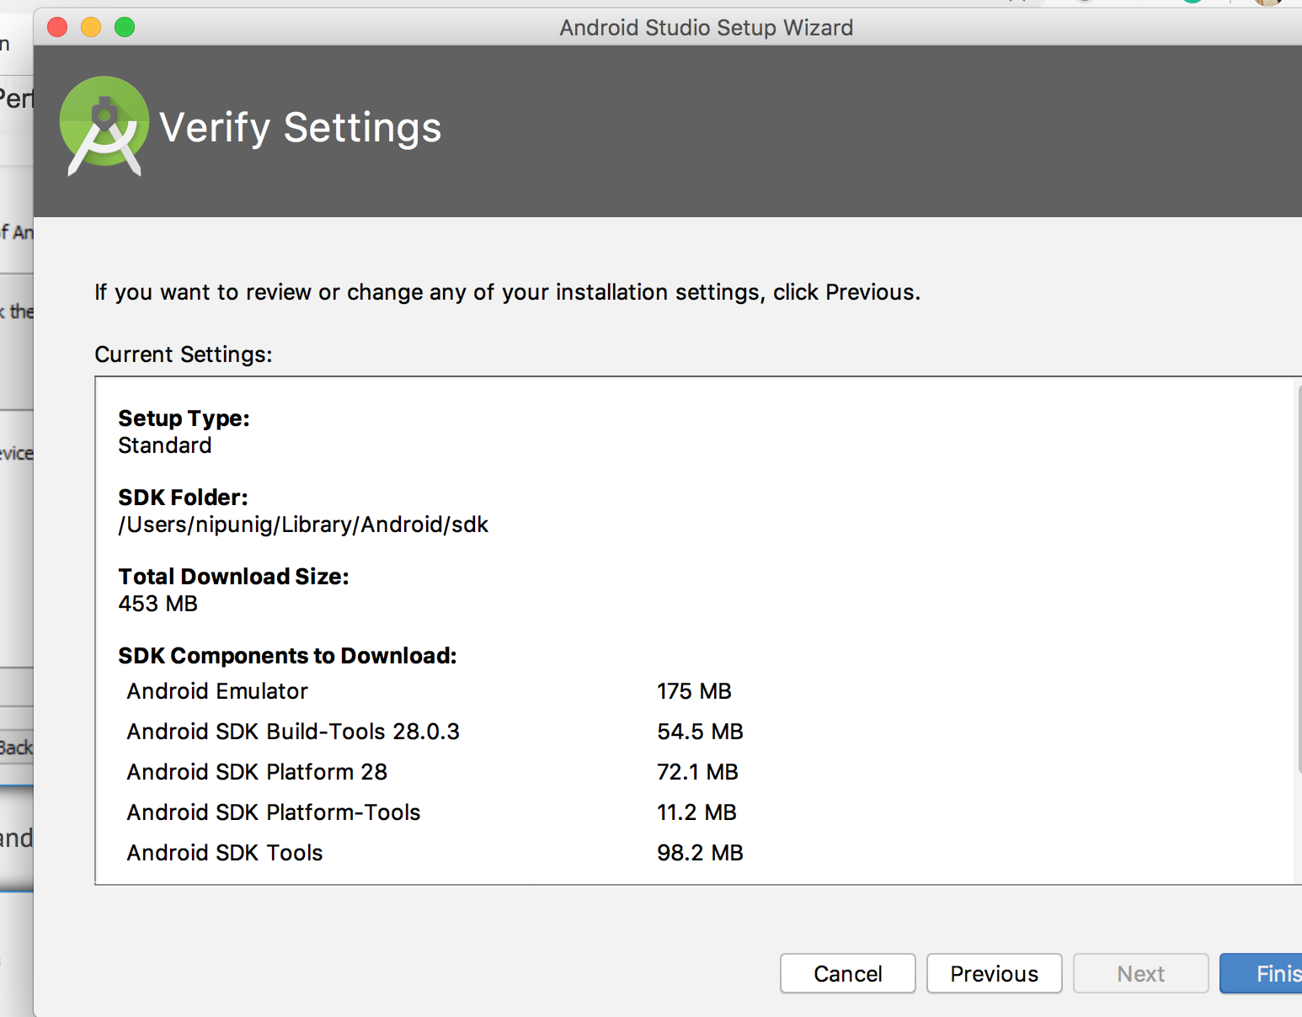

- Check your ANDROID_HOME variable and its path should be Android SDK’s path. Also, check your JAVA_HOME variable. JAVA_HOME should equal to JAVA SDK’s path.
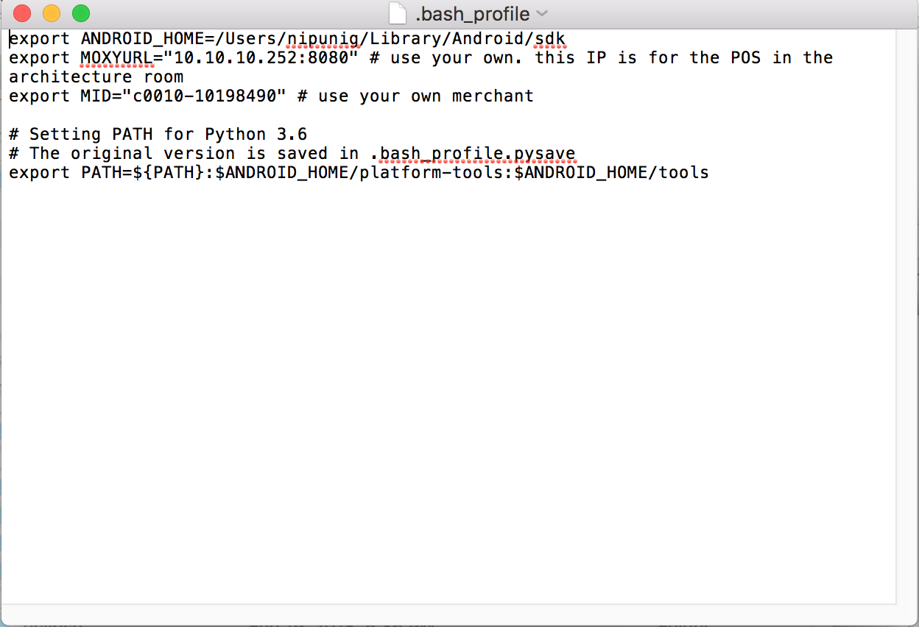

- Install your apk in your android phone and connect the device to the machine and check the device is displayed using abd devices command. It should display the device id.

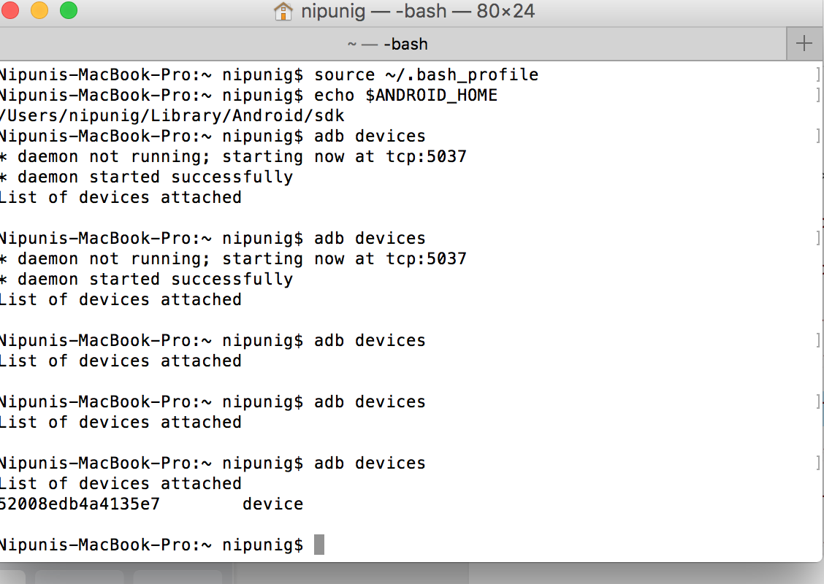
4.Install Appium software. Add the apk tour working directory. Add desired capabilities as mentioned in the screenshot and start session.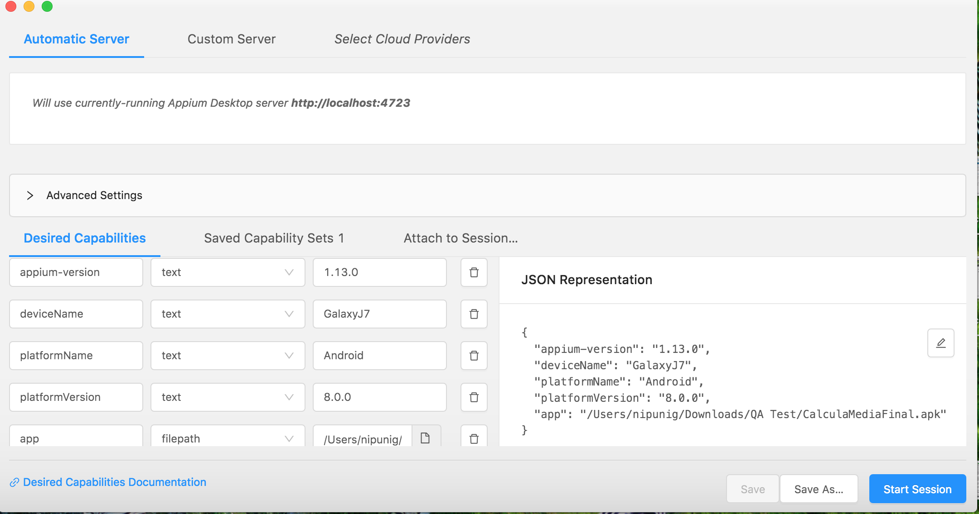

you will the server is running message when you start the session.

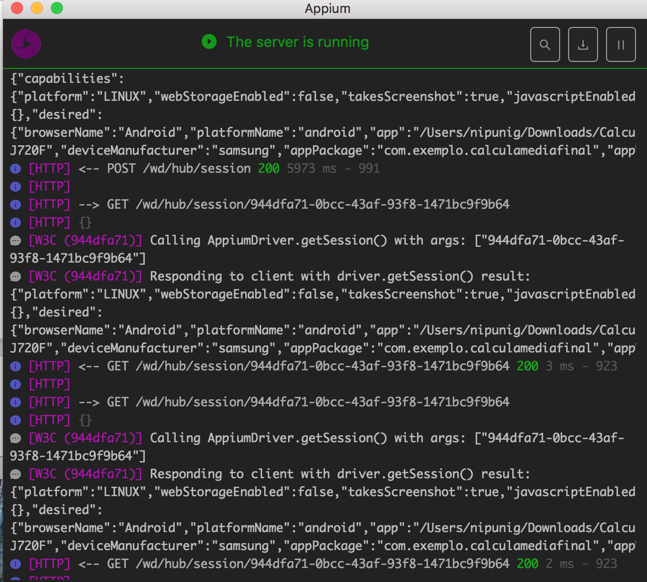
5. Give the same url that you have used to start appium in your java code and run the code as mentioned below. You will see the app is tested through the mobile phone.

