CSL 783 Assignment 2 Using Image Pyramids

**Submission date: September 15, 2014**

Very often we need to work with images of different resolution of the same image. For example, while searching for something in an image, we are not sure at what size the object will be present in the image. In that case, we will need to create a set of images with different resolution and search for object in all the images. These set of images with different resolution are called Image Pyramids (because when they are kept in a stack with biggest image at bottom and smallest image at top look like a pyramid).

The resolution of an image can be reduced by sub sampling in both x and y directions. Usually this is done by a factor of 2. While the original image is at level zero, this one is called level 1 image. Repeating the process, one can get the image at various levels. Put together, the levels constitute an image pyramid. The image at any level is smoothed before sub sampling is carried out. Image pyramids (Gaussian and Laplacian pyramids) have long been used for compression of images.

\begin{figure}
\centerline{\epsfig{figure=ImagePyramid.eps,width=0.9\columnwidth}}
\end{figure}

In this assignment you have to implement the image pyramids for image compression and image stitching.

1. Image stitching:

One application of Pyramids is Image Blending. For example, in image stitching, you will need to stack two images together, but it may not look good due to discontinuities between images. In that case, image blending with Pyramids gives you seamless blending. One classical example of this is the blending of two fruits, Orange and Apple shown on next page.

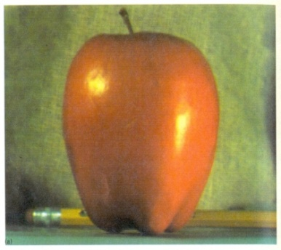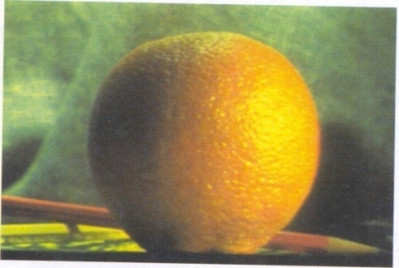

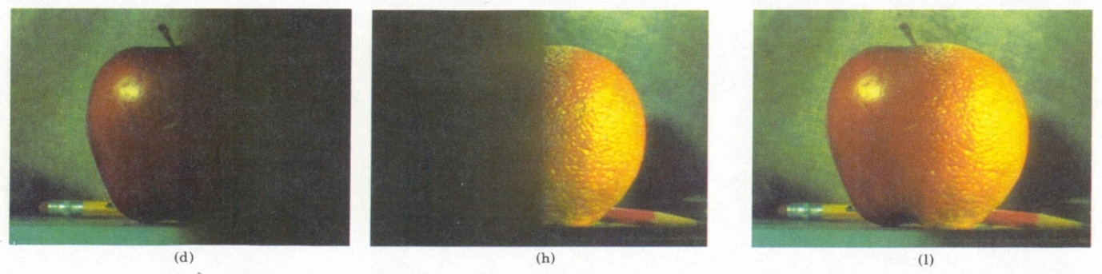

You have to use your MATLAB implementation of image pyramids for stitching two images. The program should ask for two input images and then blend from the sides. If the images are colored, you can convert them in YUV space and do the stitching in Y component.

1. Image compression: You have to show that by using image pyramids, you are being able to store a multi-resolution version of an image more efficiently.

The link below will provide you with an insight on how image pyramids are being used for image stitching and compression.

<https://alliance.seas.upenn.edu/~cis581/wiki/Lectures/Pyramid.pdf>

Submit the MATLAB code along with proper documentation by 15.09.2014. The code must contain title of the assignment, your name, entry number and date of submission at the top of the assignment. It must include a statement indicating that the assignment has been done solely by you and is not copied from another source. Submissions done after the due date would receive zero credit.