RWANDA POLYTECHNIC | NGOMA COLLEGE

Student Performance Prediction System
Using Machine Learning: Project Report
Item | Detail
Module | Python and Fundamentals of AI (ITLPA701)
Assessment | CAT2 Practical Assessment, Academic Year 2026-2027
Department / Trade | ICT / IT, RTQF Level VI, Year 3, Semester 1
Module Trainer | Eng. UWAMAHORO Leopord
Student name | ______________________________
Reg. number | ______________________________
Date | October 2026

Table of Contents

1. Executive Summary
Teachers often learn that a student is struggling only after final grades are published, when it is too late to help. This project builds a machine learning system that predicts whether a secondary-school student will PASS or FAIL their final mathematics assessment, using information available before the final exam: prior grades, study habits, attendance, and family and social background.
The system was built in Python using scikit-learn on the real UCI Student Performance dataset (395 students, 33 attributes). Three algorithms were compared with cross-validation; Gradient Boosting was selected, tuned with GridSearchCV, and evaluated on a held-out test set. It is deployed as a four-page Streamlit web application.

Accuracy | Precision | Recall | F1-score
89.9% | 95.9% | 88.7% | 92.2%
Held-out test set: 79 students. ROC-AUC = 94.3%. Only 2 of 26 failing students were missed.
Key finding: prior grades carry most of the predictive power (G2 alone is about 82% of feature importance). Without G1/G2, accuracy falls from 89.9% to 67.1%. Predicting early is possible, but far less reliable.
The system is a decision-support tool. It must never be the sole basis for any decision about a student.

2. Problem Statement and Objectives

2.1 Problem statement
Given academic, demographic, social and behavioural attributes of a student, can a model reliably predict whether that student will pass or fail the final assessment early enough for teachers to intervene?

2.2 Objectives
- Acquire a real, reliably sourced student-performance dataset.
- Clean and preprocess the data with a leakage-safe pipeline.
- Explore the data (EDA) to justify feature and model choices.
- Engineer meaningful, interpretable features without target leakage.
- Compare candidate algorithms with cross-validation and tune the best.
- Evaluate with appropriate metrics and interpret the results.
- Save the model and pipeline so the application is reproducible.
- Deliver a professional Streamlit interface and discuss responsible use.

3. Dataset
Attribute | Detail
Name | Student Performance Data Set (Mathematics course)
Source | UCI Machine Learning Repository
URL | https://archive.ics.uci.edu/dataset/320/student+performance
Citation | Cortez, P. and Silva, A. (2008). Using Data Mining to Predict Secondary School Student Performance. Proceedings of FUBUTEC 2008, Porto, Portugal.
Size | 395 rows x 33 columns
Data quality | 0 missing values, 0 duplicate rows (verified in code)
Target | G3 (final grade, 0-20) converted to PASS/FAIL: PASS if G3 >= 10
Class balance | 265 PASS (67%) / 130 FAIL (33%)
Numeric variables | age, Medu, Fedu, traveltime, studytime, failures, famrel, freetime, goout, Dalc, Walc, health, absences, G1, G2
Categorical variables | school, sex, address, famsize, Pstatus, Mjob, Fjob, reason, guardian, schoolsup, famsup, paid, activities, nursery, higher, internet, romantic

Data acquisition note: the CSV used is a verified public mirror of the official UCI release. Row count, column count and the absence of missing values match the UCI documentation.

4. Methodology

4.1 Data preprocessing
Step | Purpose
Loading and inspection | Confirm shape, data types, missing values and duplicates before trusting the data.
Duplicate removal | Prevents double-counting students, which would bias training and evaluation.
Invalid-value handling | Grades are clipped to the documented 0-20 range.
Missing-value imputation | SimpleImputer (median for numeric, most frequent for categorical), fitted on training data only.
Encoding | OneHotEncoder(handle_unknown="ignore") converts categories to numbers safely.
Scaling | StandardScaler puts numeric features on one scale.
Train/test split | 80/20, stratified on the target, random_state=42 (316 train / 79 test).

All imputation, scaling and encoding live inside a scikit-learn ColumnTransformer within a Pipeline. This prevents data leakage (test data never influences fitting) and guarantees that training and live prediction use identical logic.

4.2 Exploratory data analysis
The target is moderately imbalanced (67/33), so F1-score is reported alongside accuracy. A cluster of students with a final grade of 0 is visible, typically students who did not sit the final assessment.
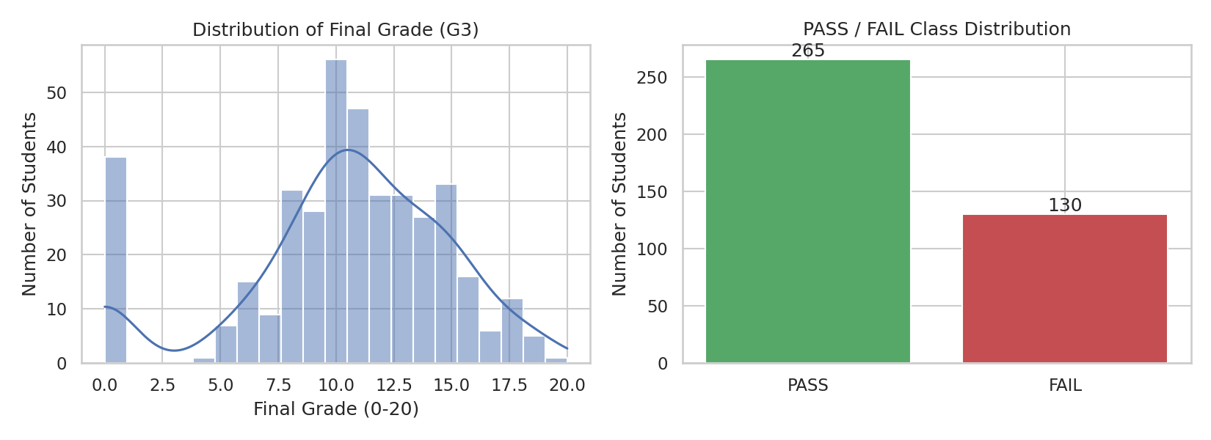
Figure 1: Distribution of final grade (G3) and PASS/FAIL class balance
The correlation heatmap confirms that G1 and G2 are the strongest numeric correlates of the final grade, while most other numeric features are only weakly related to each other.
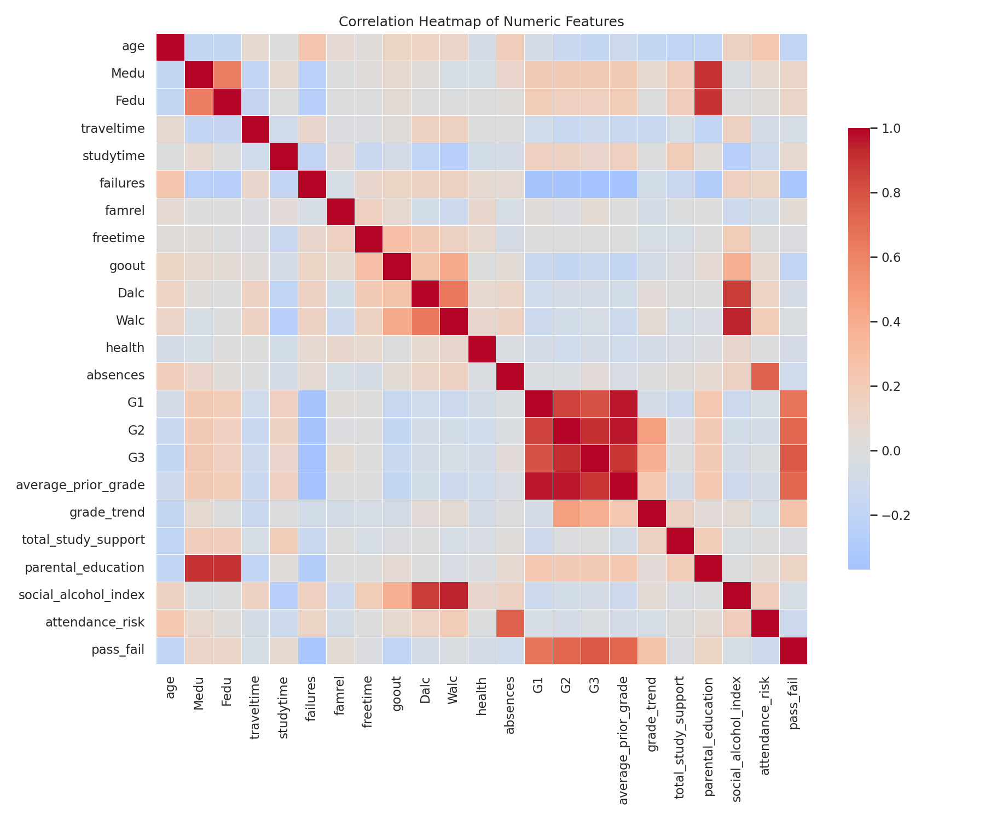
Figure 2: Correlation heatmap of numeric features
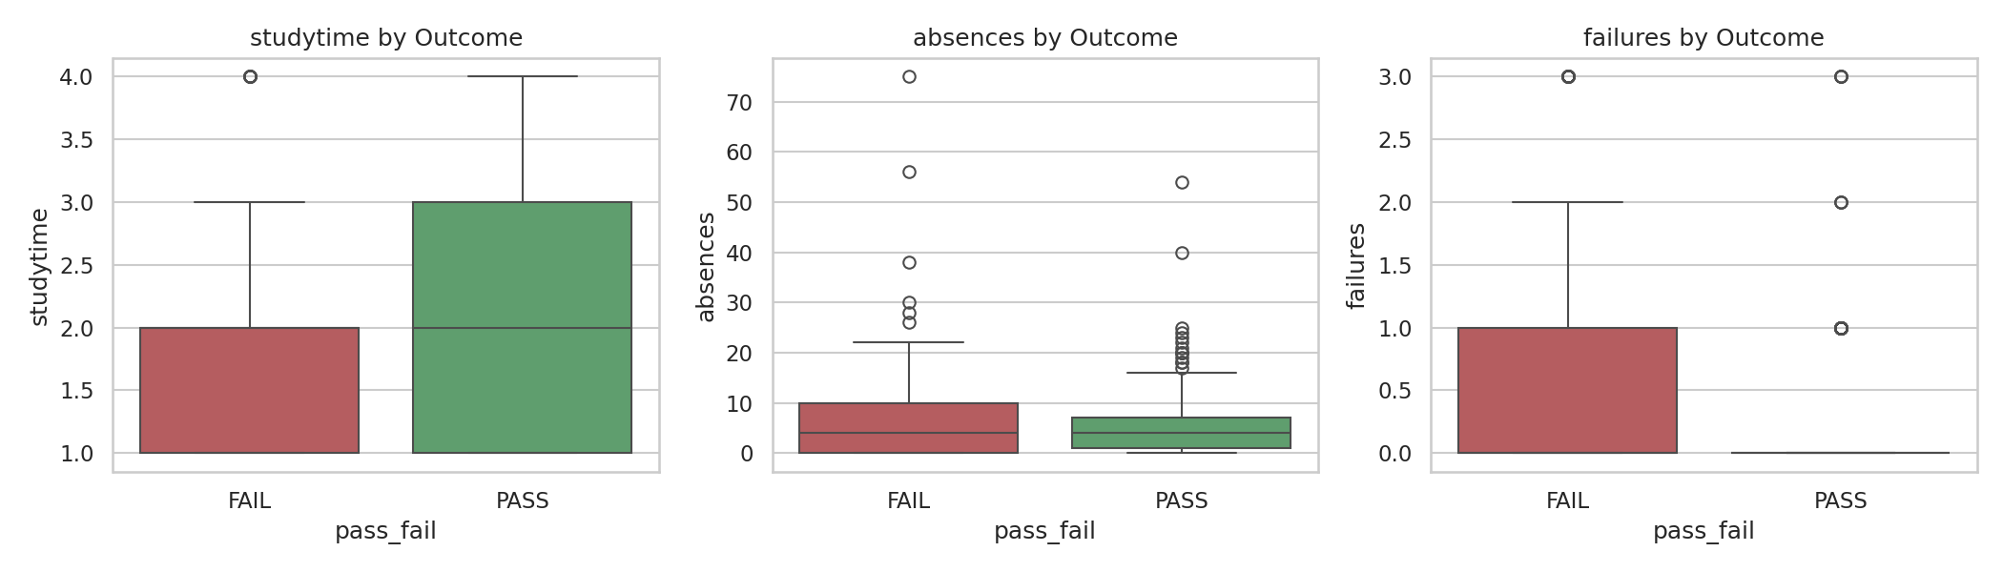
Figure 3: Study time, absences and past failures by outcome

4.3 Feature engineering
Six features were derived. None uses G3, so none leaks the target.
Feature | How it is created | Why it is useful
average_prior_grade | (G1 + G2) / 2 | Single, less noisy summary of prior performance.
grade_trend | G2 - G1 | Shows whether a student is improving or declining.
total_study_support | Count of "yes" in schoolsup, famsup, paid (0-3) | Combines several weak support signals into one.
parental_education | (Medu + Fedu) / 2 | Merges two correlated indicators of home environment.
social_alcohol_index | Dalc + Walc (2-10) | Reduces noise from two correlated columns.
attendance_risk | 1 if absences > 10, else 0 | Robust flag for a skewed variable.

Note on G1 and G2. These are earlier-period grades that a school genuinely holds before the final result, so they are legitimate features rather than leakage. Their strong influence is examined openly in Section 5.4.

4.4 Model selection
Three algorithms were compared using 5-fold stratified cross-validation on the training set only:
Model | CV Accuracy | CV F1 | CV Precision | CV Recall
Gradient Boosting | 92.7% | 94.6% | 94.4% | 94.8%
Random Forest | 92.7% | 94.5% | 96.2% | 92.9%
Logistic Regression | 91.8% | 93.9% | 93.9% | 93.9%

Decision: Gradient Boosting had the highest cross-validated F1. It builds shallow trees sequentially, each correcting the previous errors, and typically performs strongly on small tabular datasets while capturing non-linear relationships. The margin over Random Forest is small, so the choice is supported by evidence but not decisive.

4.5 Hyperparameter tuning
GridSearchCV (5-fold, scoring = F1) searched n_estimators, max_depth and learning_rate.
Parameter | Best value | Meaning
n_estimators | 100 | Number of boosting trees.
max_depth | 2 | Very shallow trees: limits overfitting on a small dataset.
learning_rate | 0.1 | How much each tree corrects the previous ones.

Best cross-validated F1 was 0.958. The search itself preferred shallow trees, consistent with the small dataset size.

5. Results and Interpretation

5.1 Test-set performance
The final model was evaluated once on 79 unseen students. Tuning is compared to the untuned baseline to check that the improvement is real.
Metric | Untuned baseline | Tuned final model | Change
Accuracy | 88.6% | 89.9% | +1.3 pts
Precision | 94.0% | 95.9% | +1.9 pts
Recall | 88.7% | 88.7% | no change
F1-score | 91.3% | 92.2% | +0.9 pts
ROC-AUC | 93.8% | 94.3% | +0.5 pts

Tuning produced a modest, measured improvement. With only 79 test students, differences of this size should be treated as small rather than conclusive.

5.2 Confusion matrix
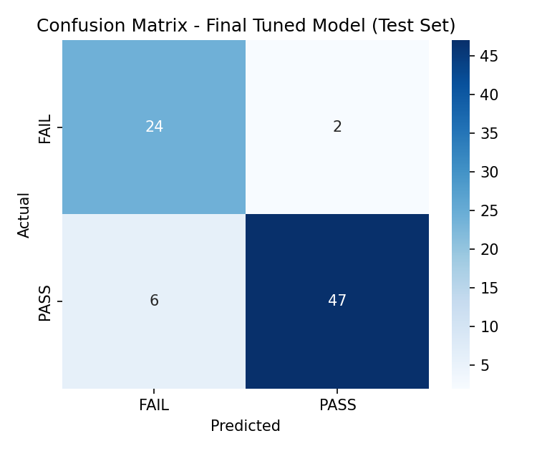
Figure 4: Confusion matrix of the final model on the test set
 | Predicted FAIL | Predicted PASS
Actual FAIL | 24 (correct) | 2 (missed at-risk student)
Actual PASS | 6 (flagged unnecessarily) | 47 (correct)

5.3 What the metrics mean here
- Accuracy (89.9%): about 9 in 10 students are classified correctly.
- Precision (95.9%): when the model says PASS, it is right about 96% of the time.
- Recall (88.7%): the model finds about 89% of students who actually pass.
- Most important error: a false PASS (2 cases) means an at-risk student is not flagged for support. The 6 false FAILs are a lower-cost error: extra attention offered where it was not strictly needed.
Caution: the report focuses on the PASS class. Because the aim is to find at-risk students, recall for the FAIL class (24 of 26 = 92.3%) is the most relevant figure for the intended use.

5.4 Feature importance and the early-warning trade-off
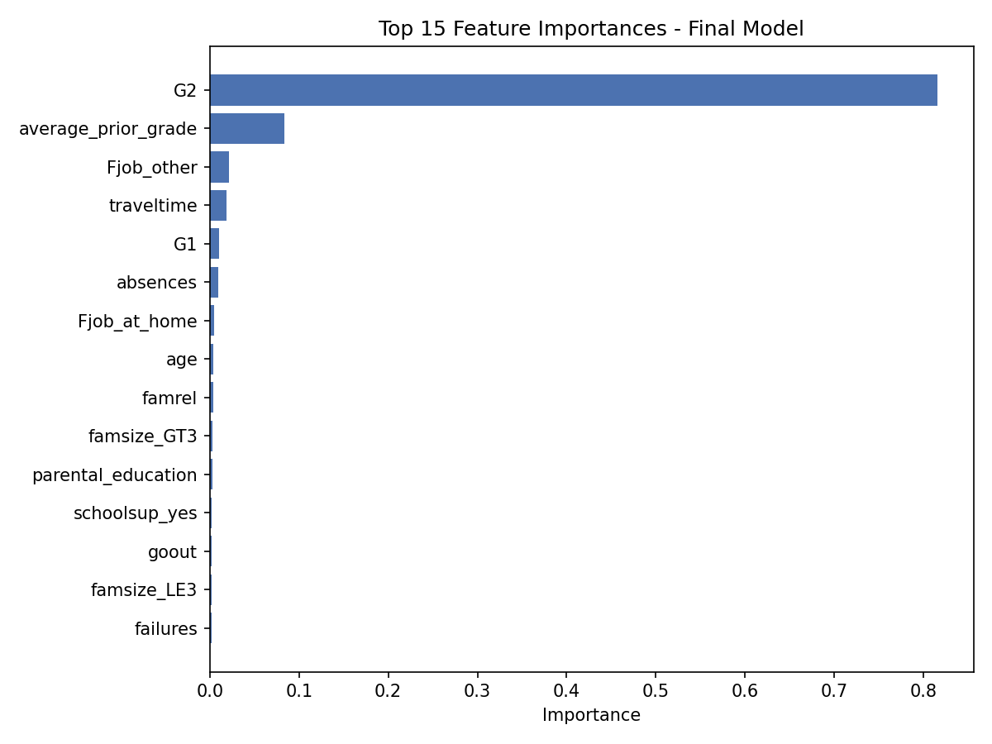
Figure 5: Top 15 feature importances of the final model
G2 accounts for about 82% of total importance, and average_prior_grade adds a further 8%. The model is therefore mostly reading the latest grade. To quantify this, the same model family was retrained without G1, G2 and their derived features:
Metric | With G1/G2 | Without G1/G2 | Difference
Accuracy | 89.9% | 67.1% | -22.8 pts
F1-score | 92.2% | 78.7% | -13.5 pts
ROC-AUC | 94.3% | 64.8% | -29.5 pts

Predicting before any grade exists is possible but substantially weaker. Schools should not expect the headline accuracy from demographic and behavioural data alone.

6. System Architecture and Application

6.1 Training pipeline
Dataset > Data cleaning > EDA > Feature engineering > Train/test split > Preprocessing > Model training and tuning > Evaluation > Model selection > Model saving > Streamlit deployment

6.2 Prediction pipeline
User input > Streamlit form > Input validation > Feature engineering > Preprocessing pipeline > Gradient Boosting model > Prediction, probability and explanation
One saved scikit-learn Pipeline (preprocessing plus model) is used for both training and prediction, so there is no train/serve mismatch.

6.3 Streamlit application
Page | Content
Home | Project description, purpose, how the system works, disclaimer.
Predict Performance | Form with sliders, select boxes and radio buttons; returns PASS/FAIL, confidence, P(pass) and a plain-language interpretation with a warning.
Model Dashboard | Dataset sizes, selected model and parameters, test metrics, confusion matrix, baseline vs tuned, early-warning comparison, feature importance, limitations.
Responsible Use | Risk and mitigation for bias, privacy, security, errors, over-reliance and fairness.

6.4 Saved artefacts
File | Purpose
models/model.pkl | Fitted Pipeline (preprocessing + tuned classifier), saved with joblib.
models/model_metadata.json | Parameters, metrics, feature lists, confusion matrix.
models/category_values.json | Valid category values used to populate the interface.

7. Testing
Tests 1-10 were executed against the trained pipeline through predict.py.
# | Test case | Input | Actual result
1 | Valid typical input | G1=12, G2=13, 4 absences | PASS, 99.6%
2 | Boundary: absences | absences = 100 | PASS, 98.0% (no error)
3 | Boundary: minimum grades | G1 = G2 = 0 | FAIL, 97.9%
4 | Boundary: maximum grades | G1 = G2 = 20 | PASS, 99.6%
5 | Failures and low grades | failures=3, G1=5, G2=4 | FAIL, 98.1%
6 | Missing field | G2 omitted | Clear ValueError naming G2
7 | Unseen category | Mjob = "astronaut" | Handled gracefully, no crash
8 | Empty value | age = "" | Clear ValueError naming age
9 | Model loading | Load model.pkl | Loads as Pipeline
10 | Metric reproducibility | Run evaluate_model.py | Matches reported metrics

Defect found and fixed: test 6 initially crashed with an unhandled KeyError inside feature engineering. Required fields are now validated before feature engineering runs.
Interface testing: app.py compiles, and all four pages were executed end-to-end against a mock of the Streamlit API, including a full prediction. The live browser interface could not be launched in the development sandbox (no internet to install Streamlit), so run "streamlit run app.py" and click through every page once before the demonstration.

8. Limitations and Responsible AI

8.1 Technical limitations
- Small, dated dataset (395 students, two Portuguese schools, collected around 2008). Results may not generalise to other regions, curricula or years.
- Heavy dependence on interim grades; accuracy drops to 67.1% without them.
- Moderate class imbalance (67/33) and a small test set (79), so metrics carry meaningful uncertainty.
- Predictions are correlations, not causes. A prediction does not explain why a student may fail.

8.2 Responsible AI risks and mitigations
Risk | Description | Mitigation
Bias | Data reflects two schools at one time; family-background features can encode historical inequality. | Present results as probabilities; retrain on local, current data; do not act on demographic features alone.
Privacy | Records include sensitive data (family, alcohol use, health). | Data processed in memory only; follow school data-protection policy and law; collect only what is needed.
Data security | Model and inputs could be exposed if deployed carelessly. | Restrict access to authorised staff; add authentication before real use.
Incorrect predictions | About 1 in 10 test predictions is wrong. | Always show confidence; state that output is an estimate; verify with teacher judgement.
Over-reliance | Staff may treat the output as authoritative. | Prominent disclaimers; position as one input among several.
Fairness | Accuracy may differ across sex, address type or school. | Audit metrics per subgroup before deployment; recalibrate if gaps are found.

This system must not decide a student's grading, placement, discipline or future opportunities. It is a decision-support tool that complements professional educational judgement.

9. CAT2 Assessment Alignment
Assessment criterion | Marks | Evidence
Environment configured; functionalities specified | 3 | requirements.txt; Sections 2 and 6
Data acquired from the given source | 3 | UCI dataset, Section 3
Data pre-processed | 3 | Section 4.1; data_preprocessing.py; ColumnTransformer
Data features engineered | 3 | Section 4.3; feature_engineering.py
Model features engineered | 3 | Full feature set and importance, Section 5.4
Approach and model selected and justified | 1.5 | Section 4.4
Model parameters selected and explained | 1.5 | Section 4.5
Application implemented and tested | 6 | Sections 6 and 7
Appropriate evaluation metrics | 1 | Accuracy, precision, recall, F1, ROC-AUC, confusion matrix
Evaluation implemented and interpreted | 2 | Sections 5.1-5.4; evaluate_model.py
Parameters adjusted from evaluation | 1 | Baseline vs tuned, Section 5.1
Model and configuration saved | 1 | Section 6.4; joblib artefacts
Demonstrated through web interface | 1 | Streamlit app, Section 6.3
Responsible use discussed | Required | Section 8
Marks show the weighting on the official rubric; they indicate where evidence is located, not an awarded score.

10. Conclusion and Recommendations
The project delivers a complete, reproducible machine learning workflow: real data, leakage-safe preprocessing, documented feature engineering, evidence-based model selection, tuning, honest evaluation and a working web interface. The tuned Gradient Boosting model reached 89.9% accuracy and 92.2% F1 on unseen students, and the analysis shows clearly that most of this strength comes from prior grades.

Recommendations
- Retrain on current, local data before any real deployment.
- Audit performance across demographic subgroups.
- Use the early-warning variant if prediction is needed before any grade exists, accepting lower accuracy.
- Always combine model output with teacher judgement.

Future improvements
- Larger, more recent, multi-school data.
- Alternative models (XGBoost, LightGBM) and SHAP explanations.
- Authentication and audit logging for the application.
- A regression version predicting the numeric grade.

References
Cortez, P. and Silva, A. (2008). Using Data Mining to Predict Secondary School Student Performance. In A. Brito and J. Teixeira (Eds.), Proceedings of 5th FUBUTEC 2008, pp. 5-12, Porto, Portugal: EUROSIS.
UCI Machine Learning Repository: Student Performance. https://archive.ics.uci.edu/dataset/320/student+performance
Pedregosa, F. et al. (2011). Scikit-learn: Machine Learning in Python. Journal of Machine Learning Research, 12, 2825-2830.

Appendix A: How to Run the Project
From the project folder:
pip install -r requirements.txt
cd src && python eda.py && python train_model.py && cd ..
streamlit run app.py
Fixed random_state=42 means re-running training reproduces the numbers in this report.

