**Title**

“Data Analysis and Interpretation on

Police Department Data”

**Created by**

Niraj Vikram Raut

Vishwakarma Institute of Technology, Pune

[niraj.raut19@vit.edu](mailto:niraj.raut19@vit.edu)

**Introduction**

Dataset consists of crime committed in the year 2016 in the respective city. We need to find the insights to improve the overall safety of the city. To solve that purpose we have done detailed analysis on the given dataset with the help of Python and PowerBI. Firstly we find the features that add values to improve the safety of city by reducing the crime rate. With the help of data visualization techniques we can plot relation between the features. From which we can draw some conclusions.

**Q1. Which category has the maximum incident recorded?**

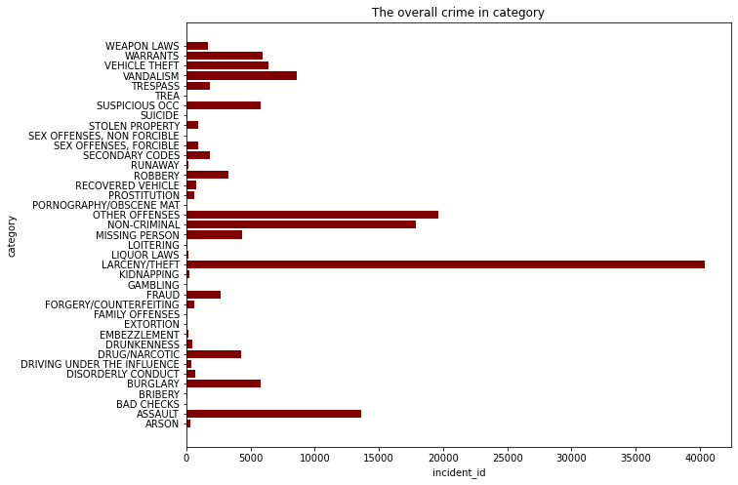

**Method** - For plotting maximum incidents in specific category, bar plot is used.

**Analysis** - From the visualization, the most crimes have been committed under the following incident categories: larceny/theft, noncriminal, other offences, assault, and vandalism.

**Conclusion** - The Department needs to concentrate more on these categories in order to lower the crime rate.

**Q2. Department district wise category count?**

**Analysis**:

Pie charts are used in a department district to display the top 10 crimes committed.

Following figure provides a summary by the department district and their top 10 crime categories.

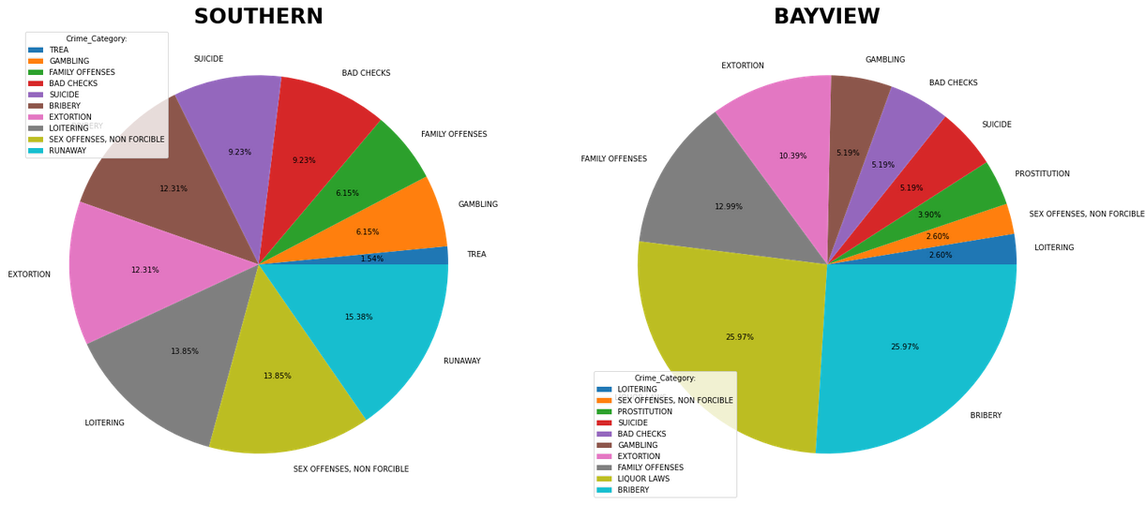

Southern:

The most common crimes in the Southern are loitering, runaways, and non-forcible sex offences.

The department must implement initiatives and run campaigns to raise awareness of these crimes in order to stop them.

Bayview –

Bayview has a high crime rate for family offences, liquor laws, and bribery.

Violation of liquor law that is tied to a health concern is also included, along with other significant insights about these crimes. People would suffer more as a result of such violations of the law, so the department must take harsh action against those types of individual.

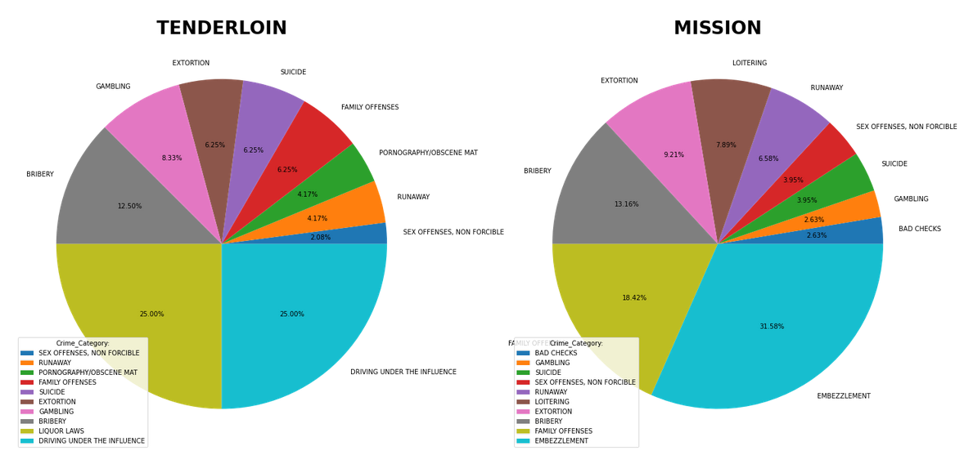

Tenderloin –

Liquor laws, driving under the influences and bribery are the top 3 crime categories in Tenderloin.

Driving under the influences leads to numerous road injuries and accidents. A concern for public health should also be provided. Innocent parties suffer more in such type of cases. Additionally, the department needs to be aware of bribery and respond quickly to stop that crime.

Mission –

Mission has maximum incident recorded of Embezzlement, family offences and bribery category.

Takes money or property that has been committed to their care, it is called embezzlement. Furthermore, bribery needs to be completely stopped. Family Offenses must also be handled carefully.

There is a need to digitally investigate transactions related to this Embezzlement. If any suspicious activity arises, the department should act quickly to stop it.

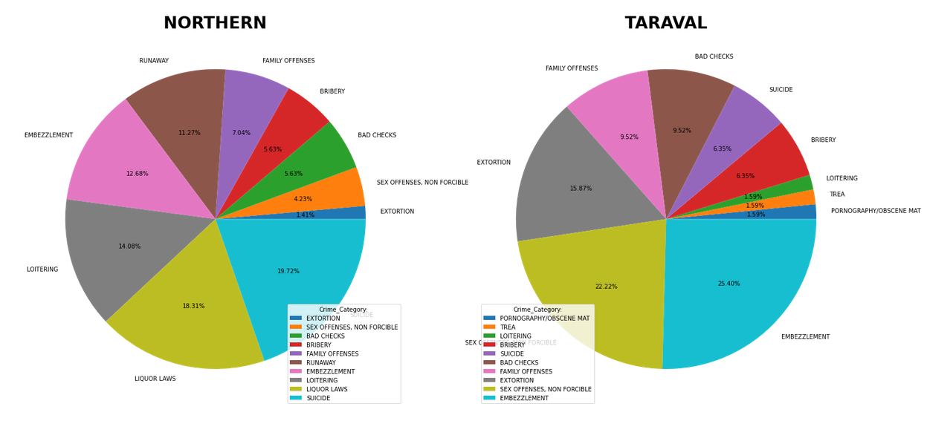

Northern –

Liquor laws, Suicide, loitering are the top 3 categories in the Northern region.

Violation of liquor law that is tied to a health concern is also included, along with other significant insights about these crimes.

People would suffer more as a result of such violations of the law, so the department must take harsh action against those types of individuals.

Taraval –

Embezzlement, sex offences non forcible and extortion this category have maximum number of crime recorded.

Sex offences non forcible this a serious crime department need to take strict action against it and In extortion. There is a need to digitally investigate transactions related to this Embezzlement. If any suspicious activity arises, the department should act quickly to stop it.

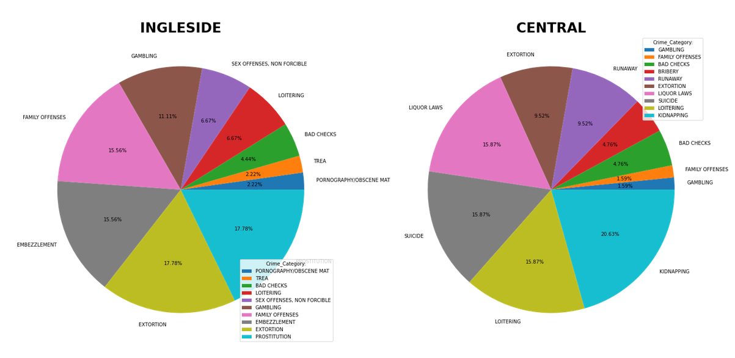

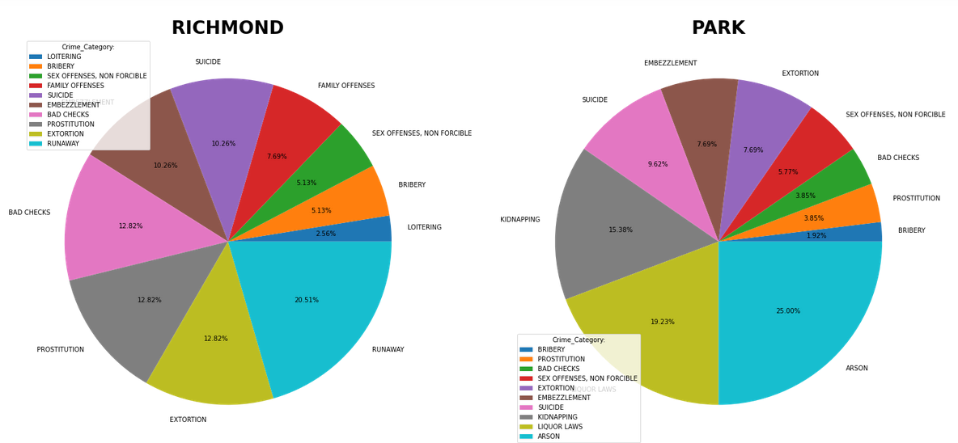

**Conclusion:**

According to the above representation, the majority of the district is affected by crimes like extortion, loitering, bribery, and violations of alcohol restrictions.

Departments need to create awareness campaigns for crimes like suicide and take severe action against offenders who violate extortion and drinking laws.

**Q3. In which month maximum crime occurred?**

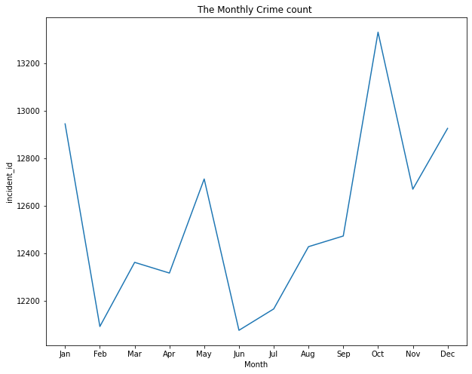

**Analysis**:

Line plot is used to find the monthly crime count.

We studied at the crime trend over the course of the entire year and discovered that it grows significantly from June to October and from December to April, there is the least amount of crime.

We assume 4 quarters 1st quarter is between January to March, 2nd quarter is between April to June,

3rd quarter in between July to September, 4th quarter in between October to December.

Third quarter results from quarterly analysis increasing crime rate progressively.

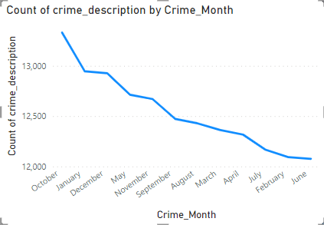

From above Visualization, Top 4 month in which crime rate is maximum those months are October, January, December, November respectively.

**Q4. At which time maximum incidents occurred?**

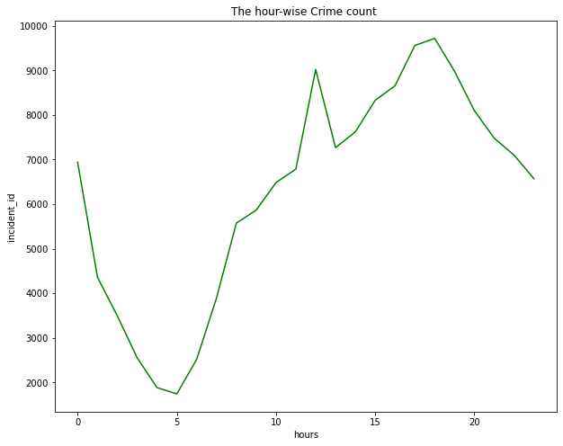

**Analysis**:

Line plot is used to find hourly crime count.

According to the plot presented above, the most crimes occur between the hours of 10:00 and 20:00.

The department must be more active or conduct any necessary patrols during these hours. People need to be made aware of this deadline by the department.

**Q5. What is the resolution rate of specific crime category?**

**Analysis**:

Pie charts are used to display the resolution based on category.

The data is divided into 38 categories and 10 resolutions.

We display in each category the resolutions that department has applied, along with the results that are typically related to the case, such as arrested, None, Unfounded, Cited, etc.

**Visualization of Top 5 Crime Category**

**Larceny/theft**:

Pie conversation planning is the approach we're taking in this case.

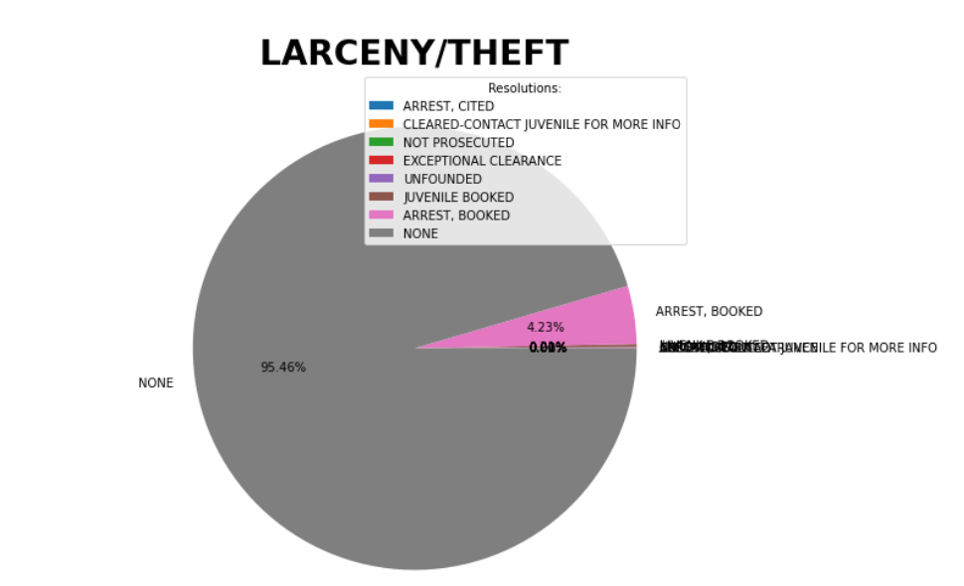

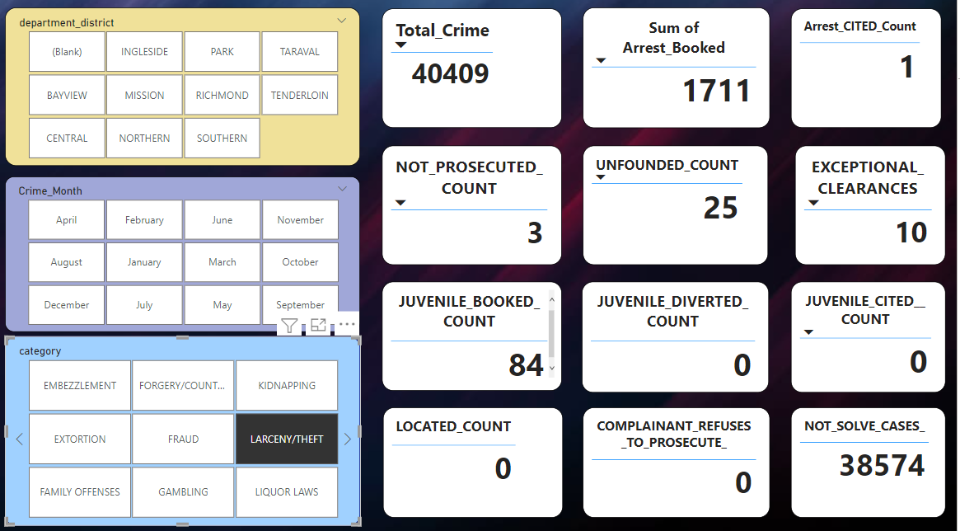

**Larceny/Theft Analysis**

It is a crime involving unlawful taking or theft of personal property of another person. The method we are using here is by plotting pie chat. Total number of crime in this type of category are 40,409 which is such a huge number.

Many unsolved cases been discovered here.Few cases result in arrests and booked.

Since there are the most incidences of this type of crime and the majority of cases are still open. Mostly 38,574 cases are still pending and the department must take appropriate action against it. The largest difficulty facing the department is the large number of pending cases.

**Other offences:**

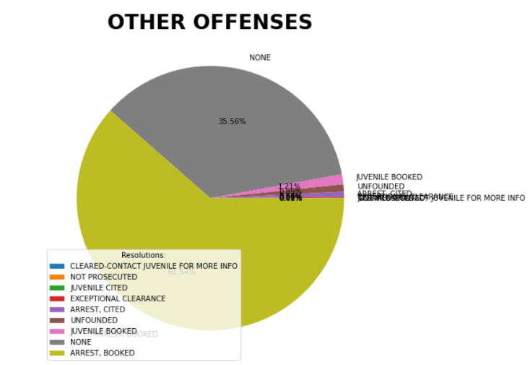

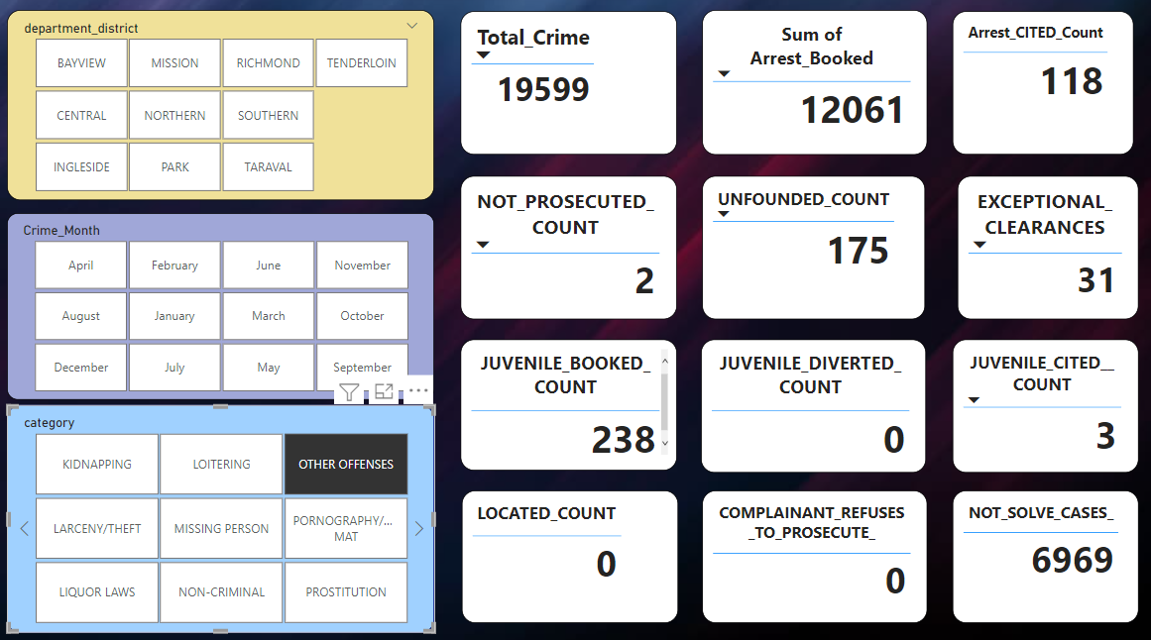

**Other Offence Analysis**

Most cases in this category are resolved, and there are fewer ones that have remained unsolved. More than 60% of cases are resolved, while only 35% remain unresolved. There have been 19,599 crimes of this type overall. Because there were more criminals arrested and booked, overall percent is up to 61%, the department had a much higher success rate with other offences.

However, more than 200 juveniles were discovered, which indicates that the department needs to monitor the behavior of juveniles, most of them are in the less than 18 years.

**Non-criminal:**

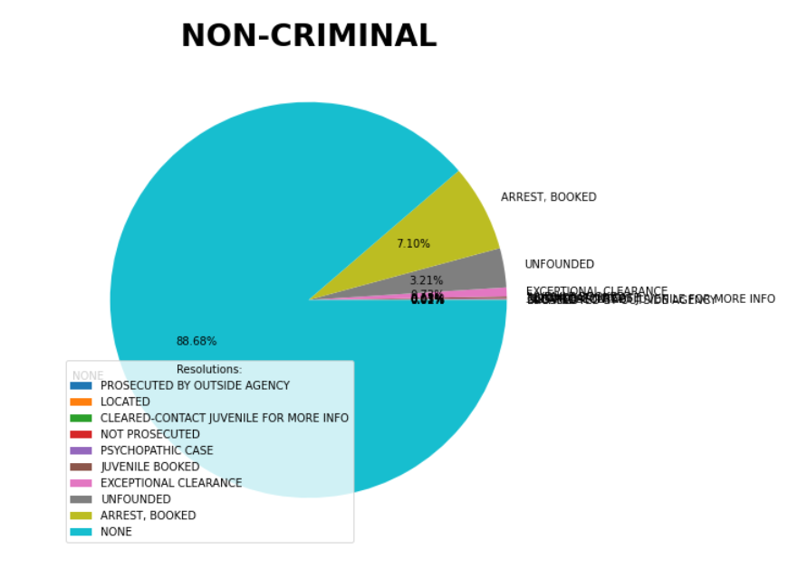

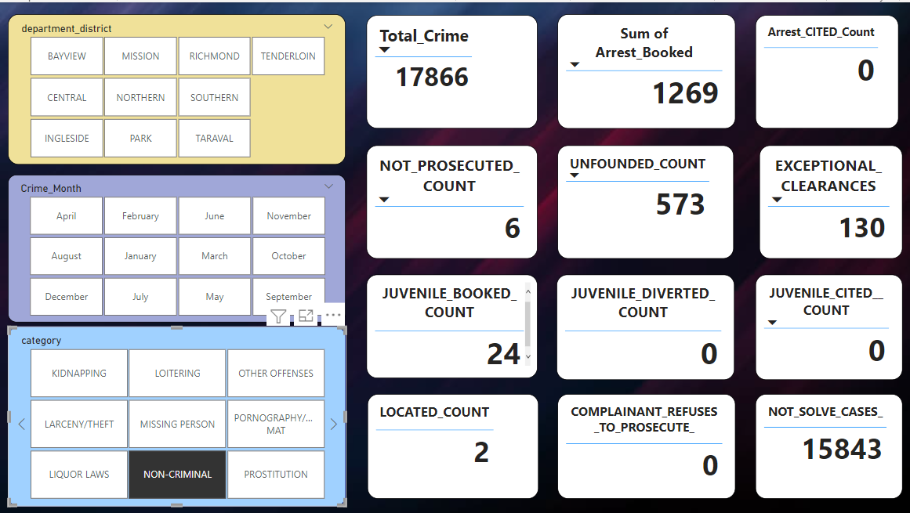

**Non-Criminal Analysis**

Total number of crime in this type of category are 17,866 which is such a huge number.

Many unsolved cases been discovered here. Very few cases result in arrests and booked.

Since there are the most incidences of this type of crime and the majority of cases are still open, the department must take appropriate action against it.The largest difficulty facing the department is the large number of pending cases. Number of unfounded cases in non-criminal is greater than 500.

**Assault:**

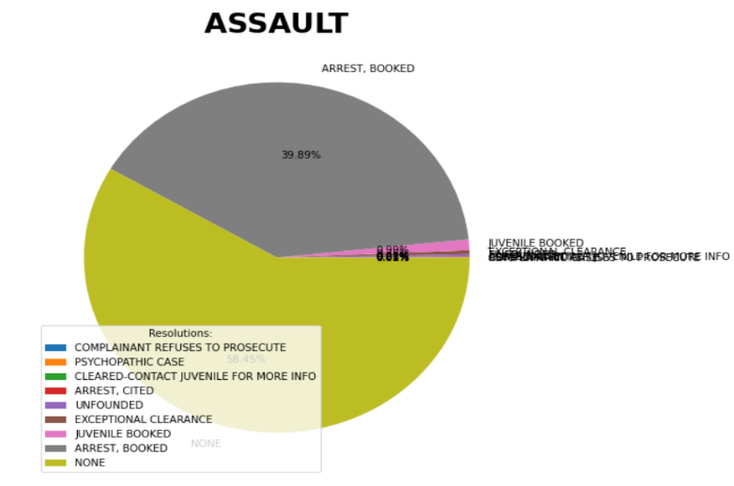

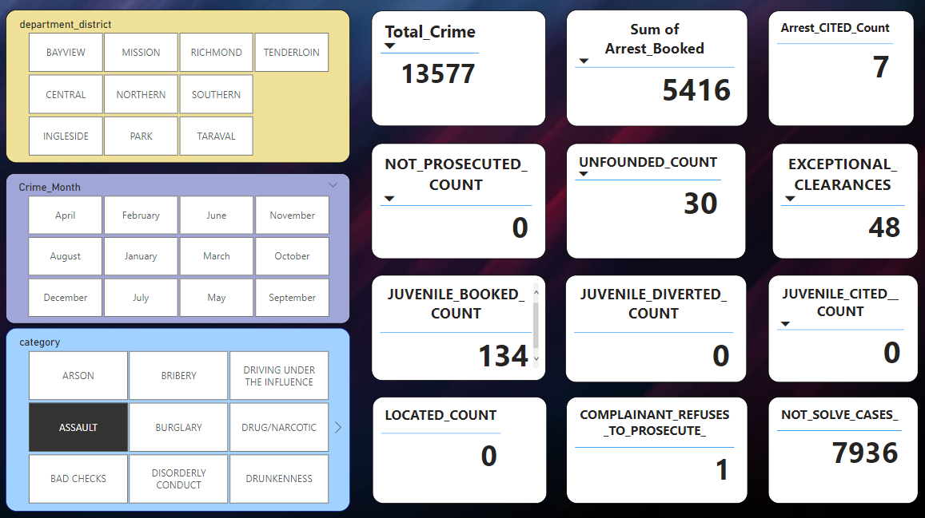

**Assault Analysis**

Assault is the act of committing physical harm or unwanted physical contact upon a person which harmful and danger kind of crime. Total number of crime in this type of category are 13,877 which is such a huge number. Many unsolved cases been discovered here.Most of cases result in arrests and booked. Since there are the most incidences of this type of crime and the majority of cases are still open, the department must take appropriate action against it.The largest difficulty facing the department is the large number of pending cases up to 58%.

**Vandalism:**

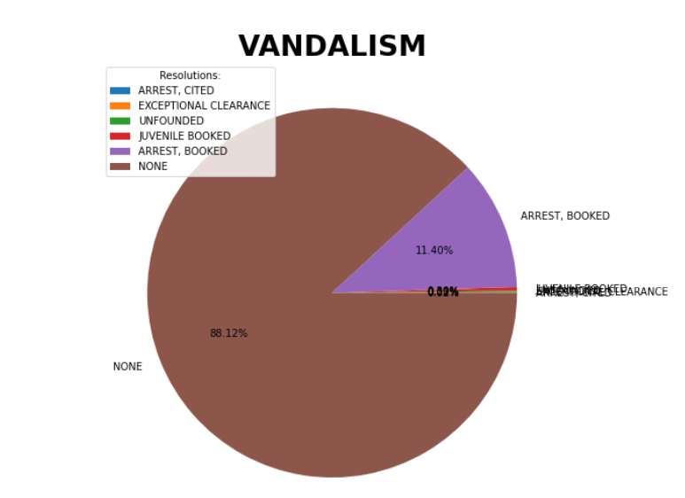

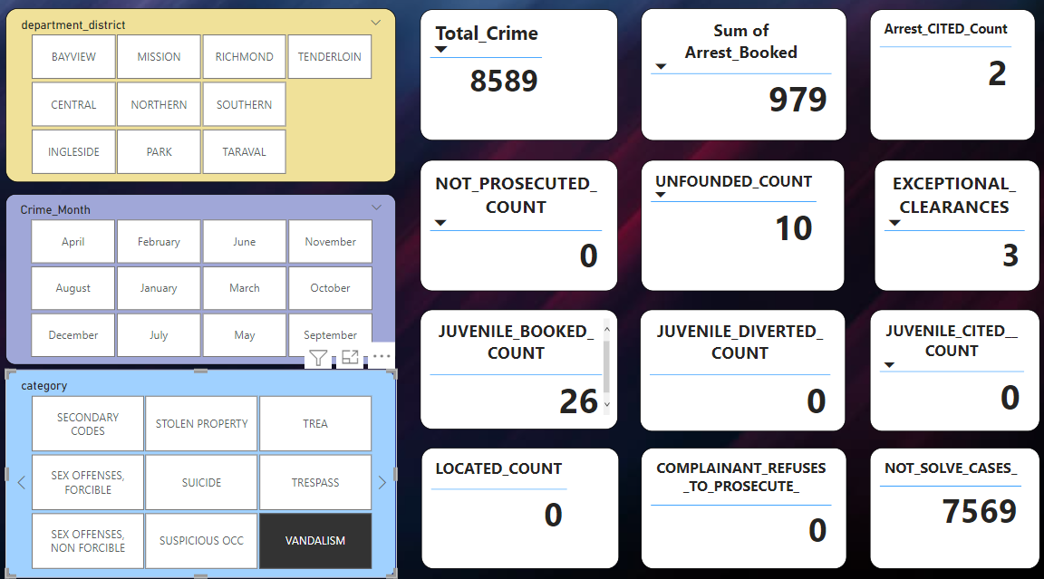

**Vandalism Analysis**

Vandalism is an act of deliberately destroying or damaging private or public property.

Which is harmful and danger kind of crime. Total number of crime in this type of category are 8,589 which is such a huge number. Many unsolved cases been discovered here.Very few of cases result in arrests and booked. Since there are the most incidences of this type of crime and the majority of cases are still open, the department must take appropriate action against it.The largest difficulty facing the department is the large number of pending cases up to 88%.

**Data Visualization using PowerBI**:

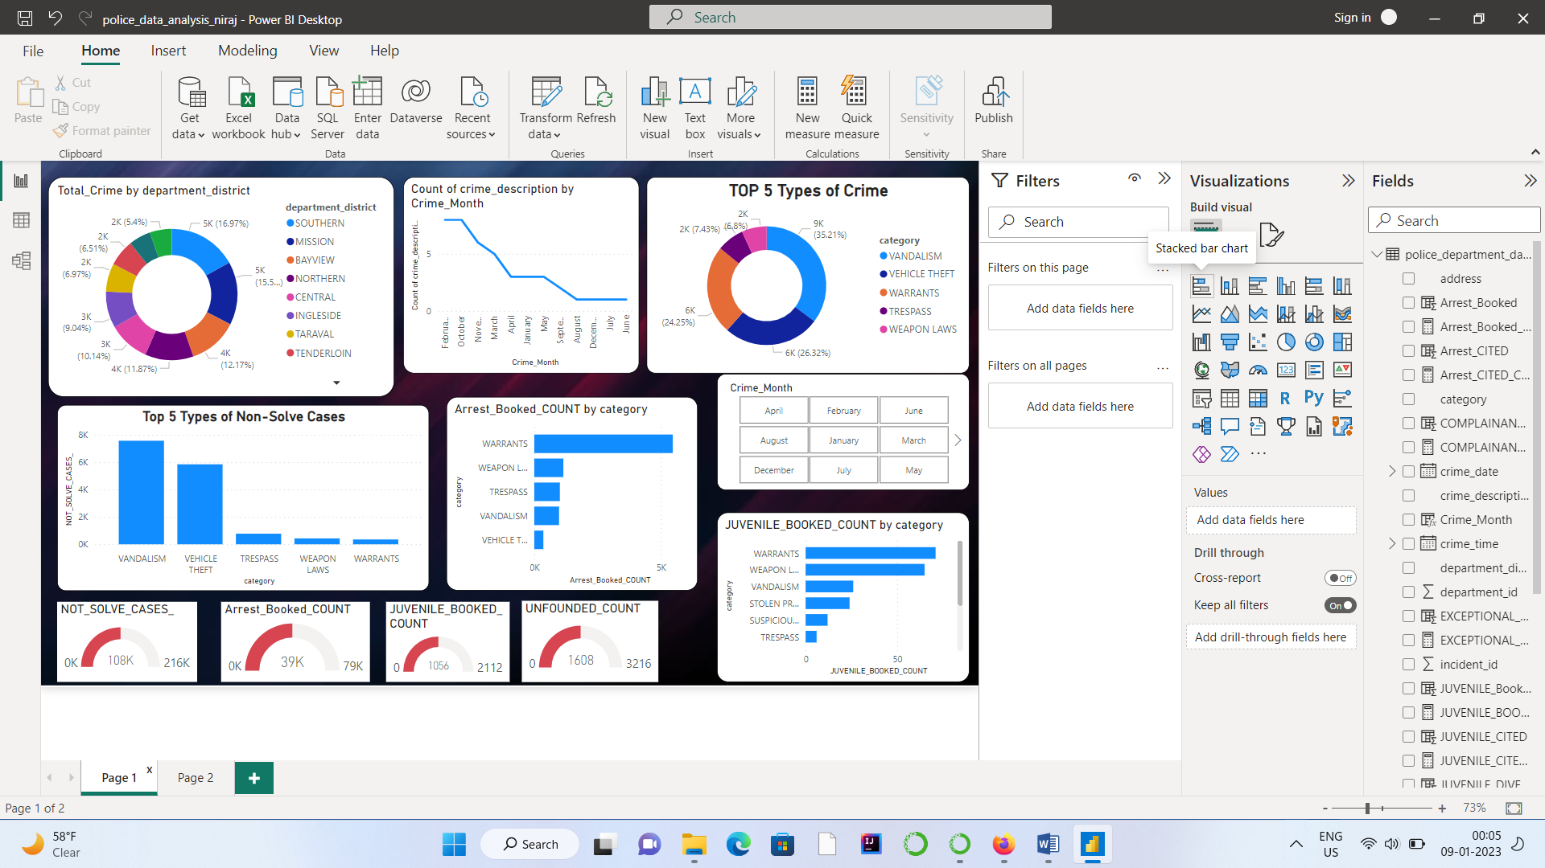

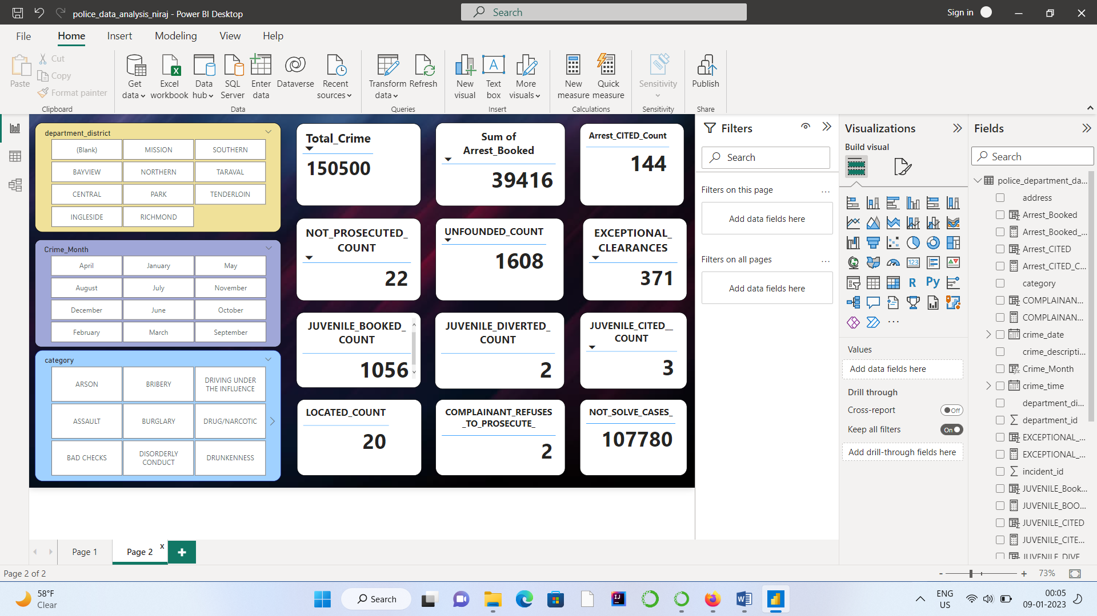

**Results:**

* The top crime category with the highest crime rate is revealed by the overall crime in category graph.
* Most of the criminal cases are unresolved and in larceny/theft, non-criminal in such type of categories most of criminal cases are unresolved.
* Third-quarter findings from a quarterly analysis show a gradually rising crime rate.
* The most crimes occur between the hours of 10:00:00 and 20:00:00.
* The highest rates of crime are seen in the southern, mission, Bayview, northern, and central department areas.
* The top five unsolved cases include vandalism, vehicle theft, trespassing, weapon law, and warrants.
* Warrants and weapon law are the most common categories under which juveniles are Arrested and booked.

**Conclusion:**

* In order to reduce crime, the police department needs to focus more on following crime categories like larceny/theft, noncriminal, other offences, assault, and vandalism.
* People would suffer more due to violations of the law, so the department must take harsh action against those types of individual. Like Violation of liquor law that is tied to a health concern.
* The majority of the district is affected by crimes like extortion, loitering, bribery, and violations of alcohol restrictions.

Departments need to create awareness campaigns for crimes like suicide and take severe action against offenders who violate extortion and drinking laws.

* Between the hours of 10:00 and 20:00, the majority of crimes take place.

During certain hours, the department must be more active or make any necessary patrols.

This timetable has to be made known to the public.

* The department had a much higher success rate with other-offences category.
* The largest difficulty facing the department is the large number of pending cases.
* Juveniles commit several major offences, such as breaking the law regarding weapons and vandalism. This must be resolved immediately.