I used node version 8

Steps to run:

1. start mongodb.

2. go to app directory

3. npm install

4. npm start

5. click on register

6. login with userid and password

7. You will directly redirect to Scrap tool

8. You can enter or select url

9. You will get Output data below.

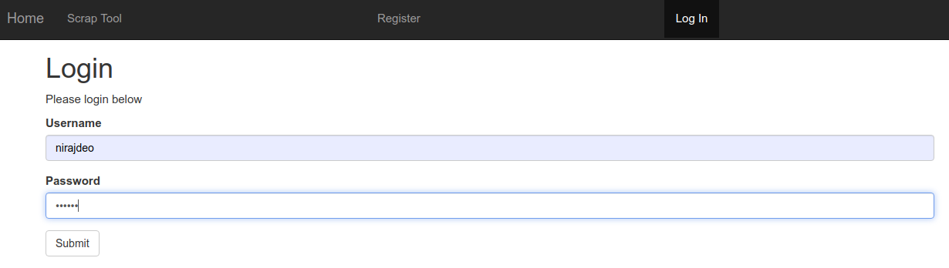

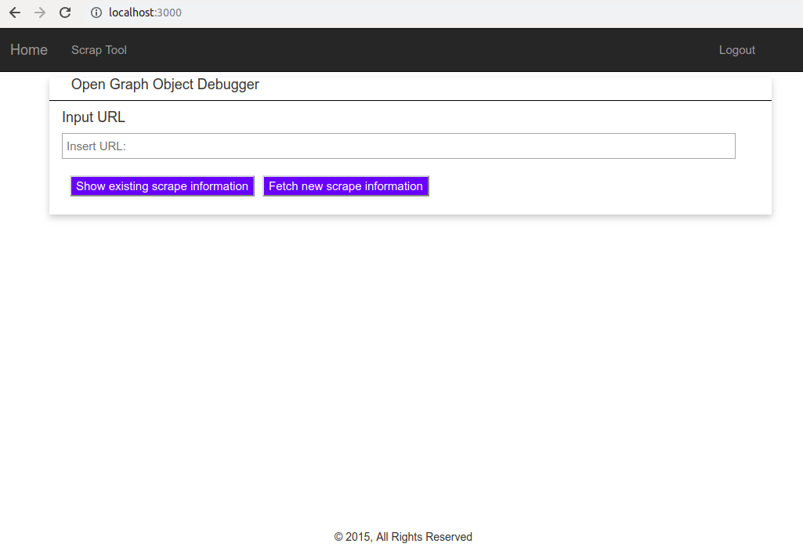

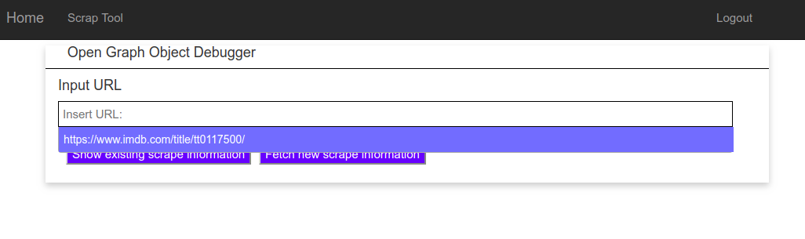

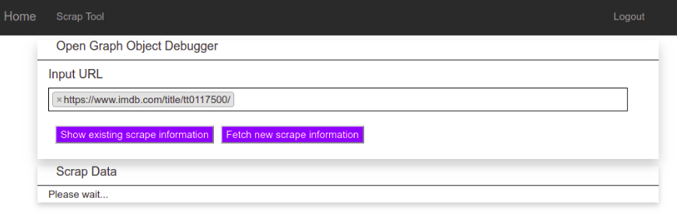

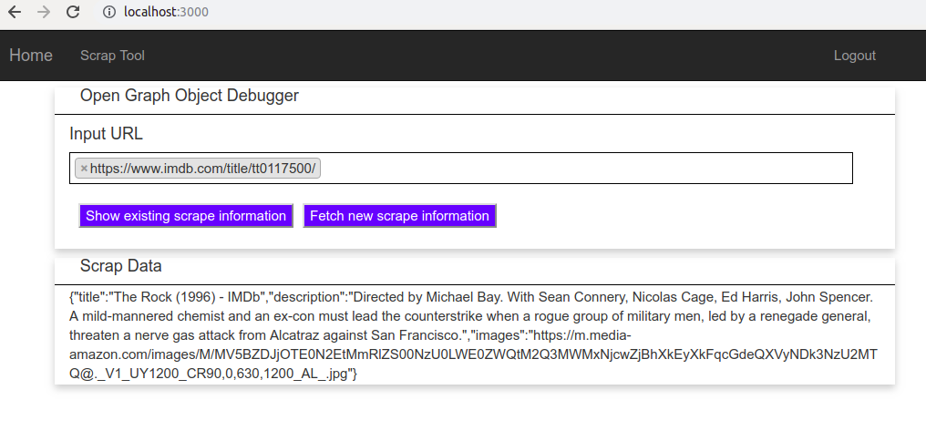

For login I used mongodb database:

