Go through the questions below and answer the questions:

1. Write a program to add 8 to the number 2345 and then divide it by 3. Now, the modulus of the quotient is taken with 5 and then multiply the resultant value by 5. Display the final result.

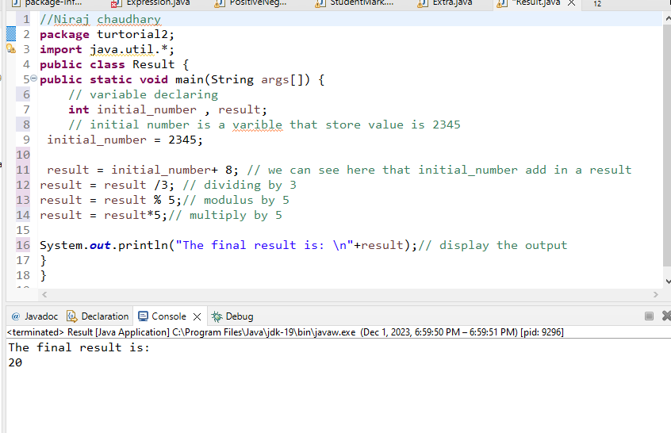

1. Given A=50, and B=40. Write a program to increase the value of A by 1 and decrease the value of B by 1.

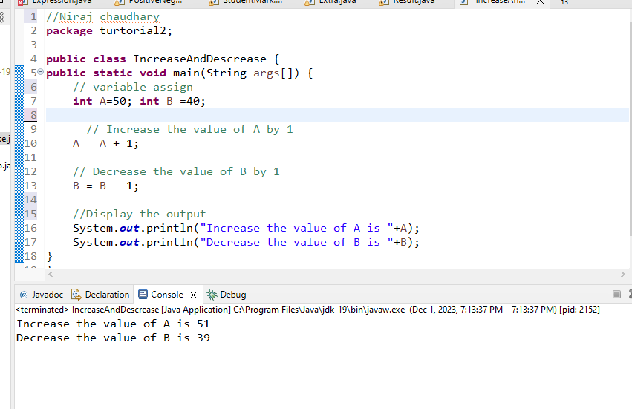

1. Examine the following code. What is the value of a and b after it completes?

int a= 40; int b = 25;

a /= 2; b %= 2;

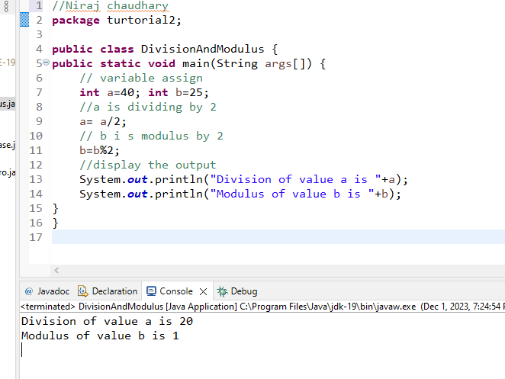

1. Given:

expr1 = (5>3), expr2 = (8>5) -> use it for Logical AND.

expr1 = (5>3), expr2 = (2>5) -> use it for Logical OR.

expr1 = (!(5==10)) -> use it for Logical NOT.

Write a program for computing above data using all the comparison operators given in the slides.

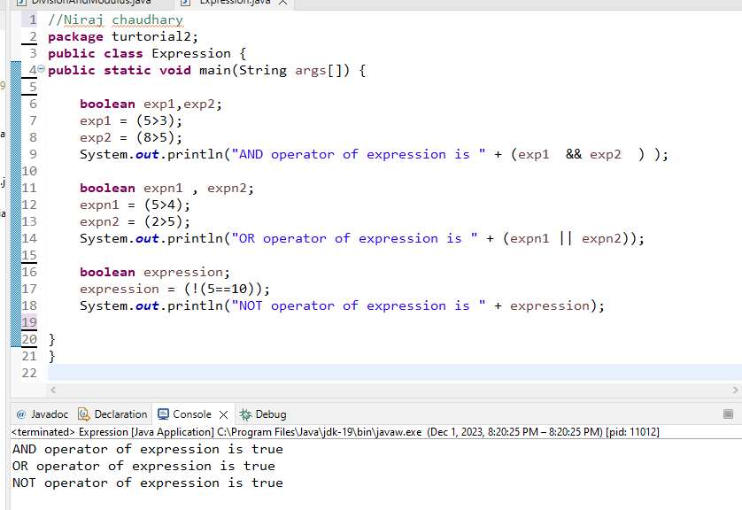

1. String methods

* compareTo() - Compare ‘s1 and s2’ , ‘s1 and s3’ ,‘s1 and s4’ , ‘s1 and s5’ ,s1 and s6

String s1="hello";

String s2="hello";

String s3="harry";

String s4="nepal";

String s5="flag";

String s6="";

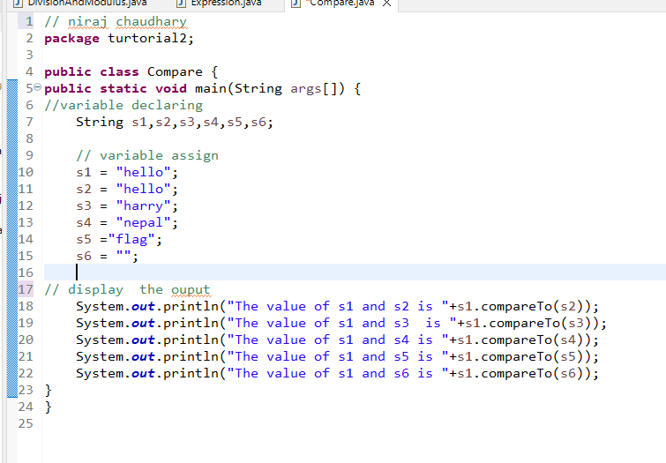

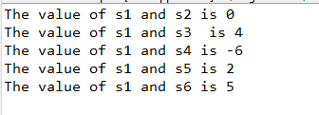

* concat() - perform concat() on following string

String s1 = "Herald College";

String s2 = ("is located in Naxal Kathmandu");

concat string s1 and s2,print and observe the result.

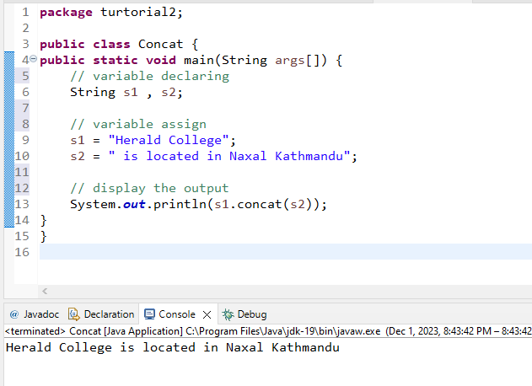

* equals() - perform equals() on ‘s1 and s2’, ‘s1 and s3’ , ‘s1 and s4’

String s1="hello";

String s2="hello";

String s3="harry";

String s4="nepal";

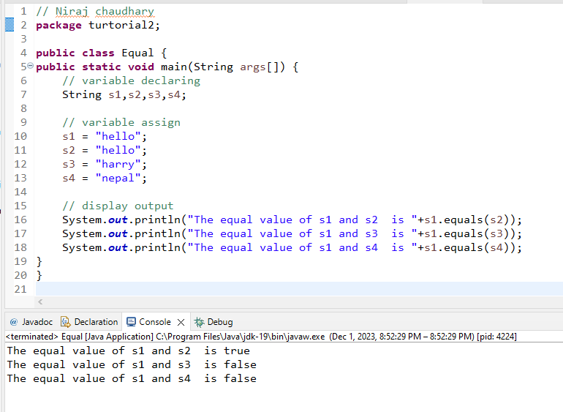

* length() - Calculate the length of

String s1 = "Herald College";

String s2 = "It is located in Naxal Kathmandu";

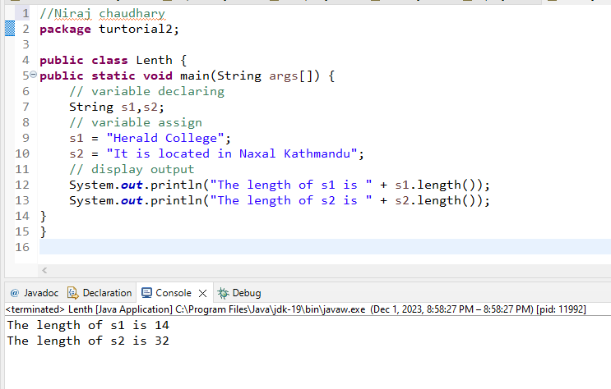

* charAt() - Find the character at 2, i.e. ‘charAt(2)’ for string below

String name="java";

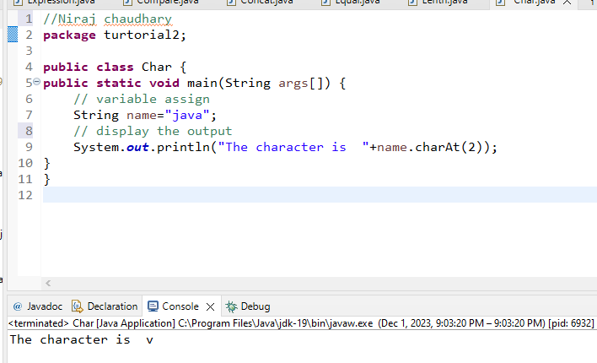

* substring() -Find the result using substring(),’substring(0,4) for string below

String name="Bachelors";

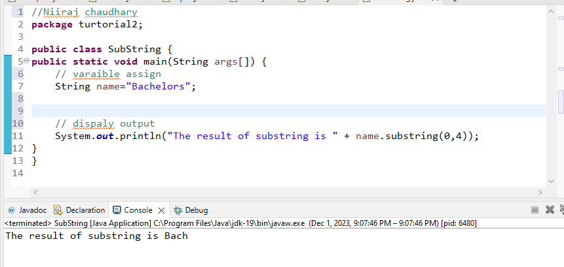

1. Write a program to check the age, using user input and print you are eligible to vote if it is greater than or equals to 18.

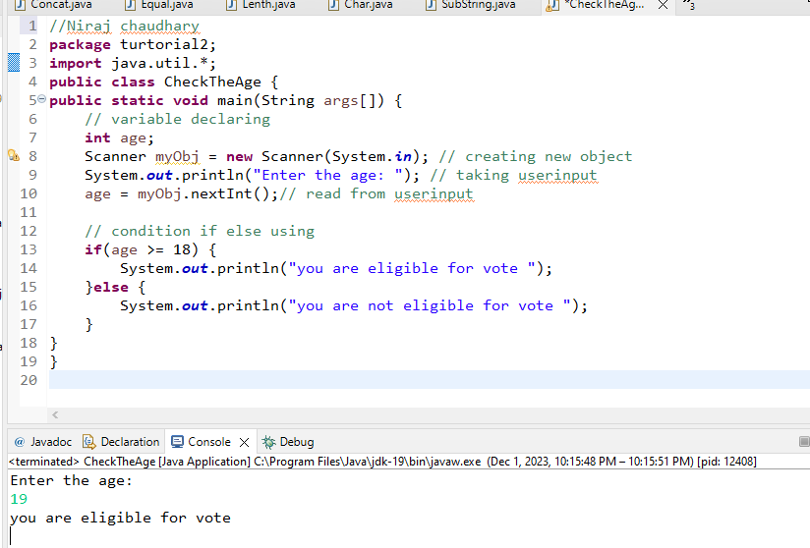

1. Write a program to find the greatest among two numbers taking user input.

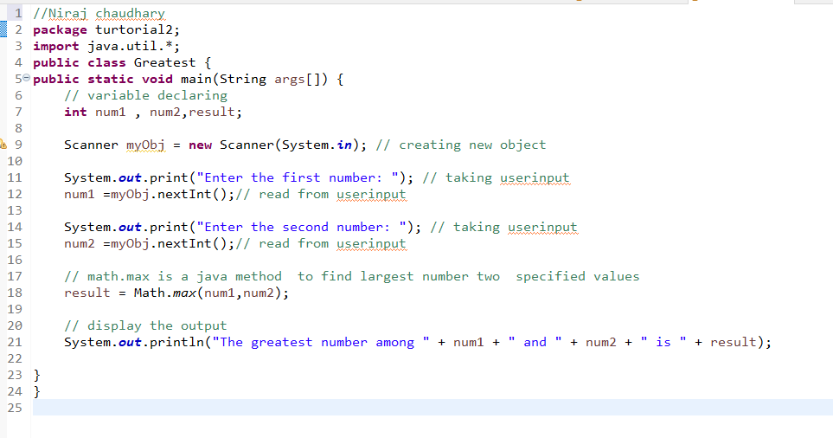 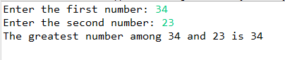

1. Find the grade of the student using following data.Using if-else-if ladder.

Using user input

Condition1: (Marks<50) -> print(fail)

Condition2: (Marks>=50 && Marks<60) -> print(“C grade”)

Condition3: (Marks>=60 && Marks<70) ->print(“B grade”)

Condition4: print(“A grade”)

