Go through the questions below and answer the questions:

1. What are the basic data types in Java used to store whole numbers and decimal numbers?

* The basic data types in java to store whole number is integer and decimal number is floating point number (float).

1. How do you declare an integer variable in Java, and what is the range of values it can hold?

* We can declare an integer variable in java like :-

int num1 = 18. If we create a variable, we must specify their type and assign a value.

18 is the range of values it cam hold.

1. Explain the difference between int and double data types in Java.

|  |  |
| --- | --- |
| Int | Double |
| 1. They can stores whole number or integer number. | 1. They can stores fractional or decimal number. |
| 2. Their size is 4 bytes. | 2. Their size is 8 bytes. |
| 3. Eg: 1,34,123 , -23, -145 etc. | 3. Eg: 12.34d , 30.23d , etc. |

1. Write a Java code snippet to declare and initialize an integer variable with the value 5.

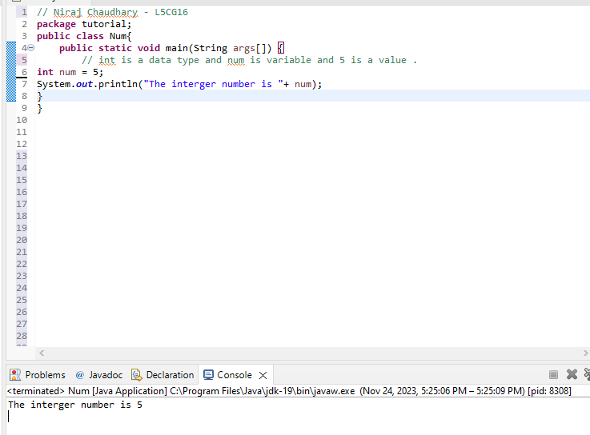

1. How can you perform addition, subtraction, multiplication, and division in Java using arithmetic operators?

* We can perform addition, subtraction, multiplication, and division in Java using arithmetic operators. They are :-

1. Addition operation– They used to add the two number and their symbol is ( + ).

Syntax = num1 + num2

Eg : num1 = 10, num2 = 15

Sum = num1 + num2 = 25

2. Subtraction operator– They used to subtract the two number and their symbol is ( - ).

Syntax = num1 – num2

Eg : num1 = 10, num2 = 5

Sum = num1 - num2 = 5

3. Multiplication operator- They used to multiple the two number and their symbol is ( * ).

Syntax = num1 * num2

Eg : num1 = 10, num2 = 5

Sum = num1 * num2 = 50

4. Division operator – They used to divided the two number and their symbol

is ( / ).

Syntax = num1 / num2

Eg : num1 = 10, num2 = 5

Sum = num1 / num2 = 2

1. What is the result of the expression 7 / 2 in Java, and how can you get the correct result if you want to include the remainder?

* The result of the expression is 3.5 .

We can get the correct result if we want to include the remainder is 1. If the integer left over after dividing one integer by another. The quotient produced by the division of two numbers.

1. How do you declare a variable to store a single character in Java, and what is its data type?

* We can declare a variable to store a single character in java is

char mycharacter = ‘A’ .

Data types refer to a type of value a variable has and what type of mathematical , relational or logical operation can be applied.

1. What is the difference between the float and double data types in terms of precision and storage space?

|  |  |
| --- | --- |
| Float | Double |
| 1. They are a single-precision floating point number. | 1. They are a double- precision floating-point number. |
| 2. They have been 32 bits in total with about 7 decimal digits of precision. | 2. They have been 64 bits in total with about 15 decimal digital of precision. |
| 3. They also requires 4 bytes of storage space. | 3. They also require 8 bytes of storage space. |

1. Write a Java code snippet to calculate the area of a rectangle with a length of 10 units and a width of 5 units.

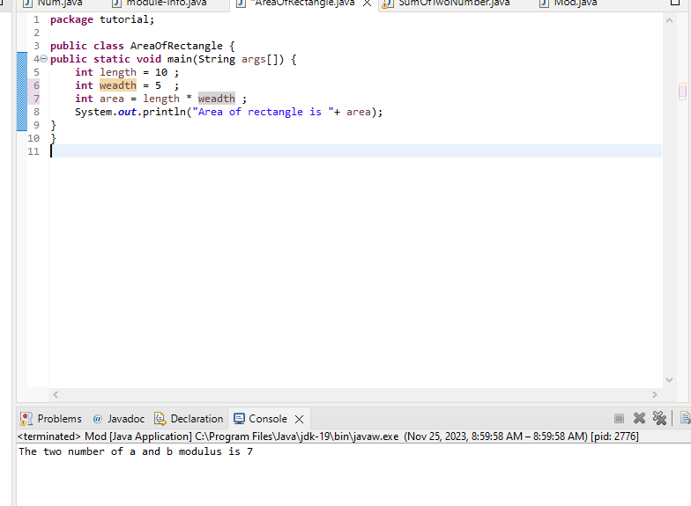

1. Explain the purpose of the modulus operator (%) in Java and provide an example.

* The modulus or remainder operator return the remainder of the two number after division. If we are provided with two number say A and B then A is the dividend and B is the divisor. A mod B is there a remainder of the division of A and B . Modulus operator is an arithmetical operator which is denoted by ( % ).
* Synatx : A % B where A is the dividend and B is divisor.
* Example 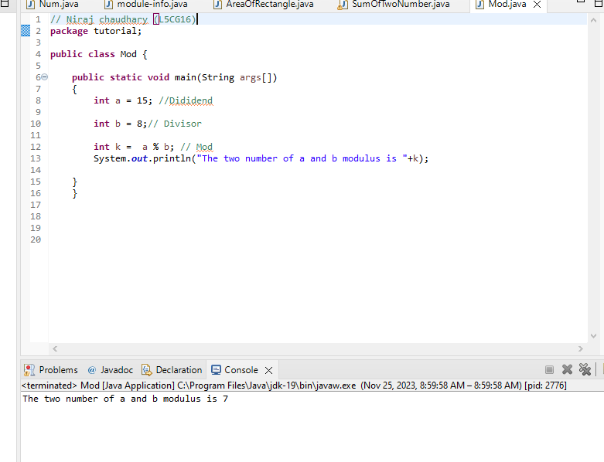

1. What is the significance of variable naming conventions in Java, and what are some best practices?

* The significance of variable naming conventions in Java. They are:-
* Lower Camel case = first letter of the variable be lowercase and subsequent word start wither uppercase letter.

Eg: int studentId = 2332917;

String studentName = “Niraj Chaudhary”

* Upper camel case = first letter of each concatenated word is capitalized.

Example:- public class AreaOfRectangle

Public class AreaOfCirle

* Screaming snake case = All the letter are uppercase and word are separated by unnderscores.

Example= ‘MAX_VALUE’ and ‘DEFAULT_COLOR’

1. Write a Java program to calculate the sum of two numbers the user enters and display the result.

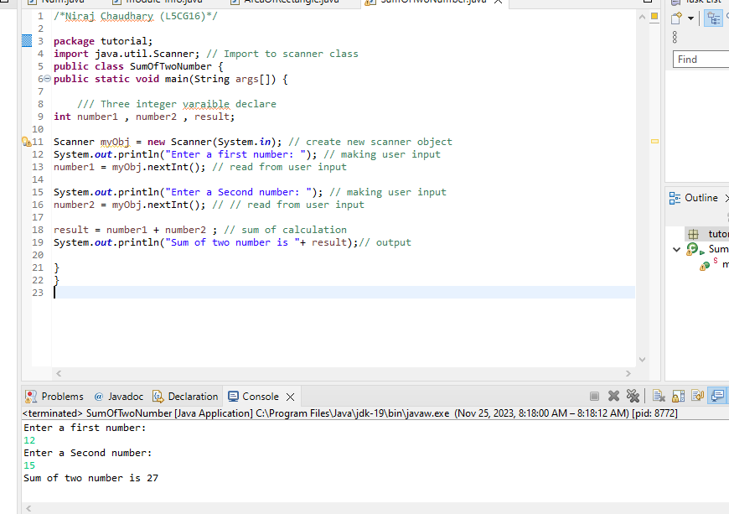

1. How do you determine the data type of a variable in Java?

* To check the type of any variable data type we can use the type()function. IT will return the type of the mentioned variable data type.