1. **Write a program to get the following output.**

**Hey there,**

**I am “*some data*”! (assign a variable and print the variable data** .

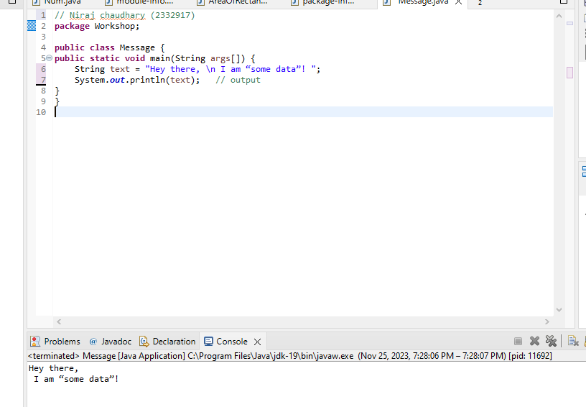

1. Write a program to print the difference and product of numbers 45 and 32.

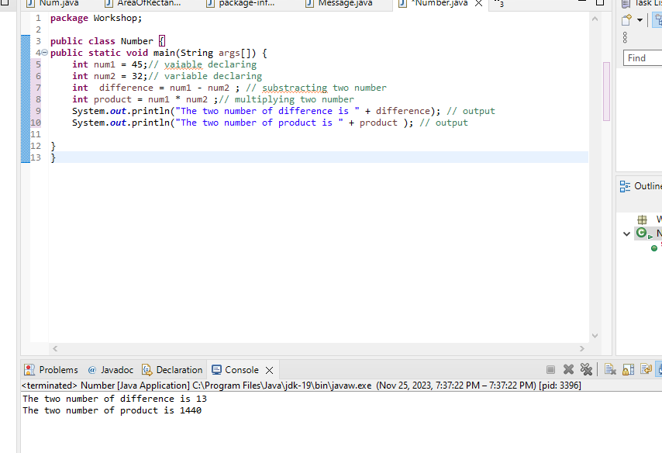

1. **Write a Java program to print an int, a double, and a char on the screen.**

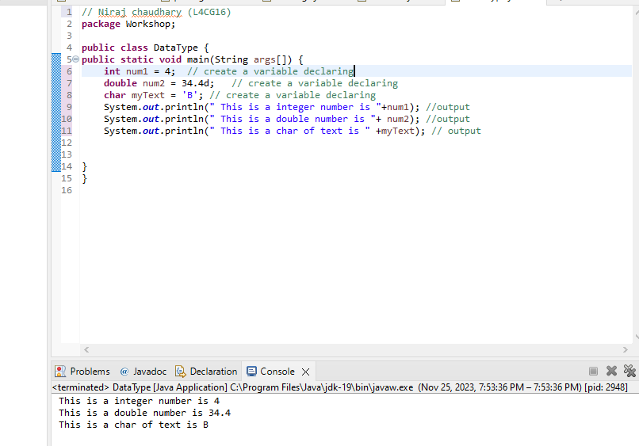

1. **Write a program to calculate the area of a triangle.**

**Area = ½*base* height or** 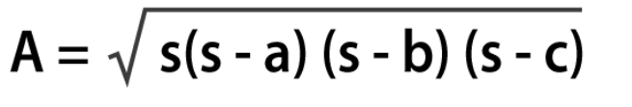

**Where s is the semi-perimeter of the triangle s = (a+b+c)/2**

**Method no 1**

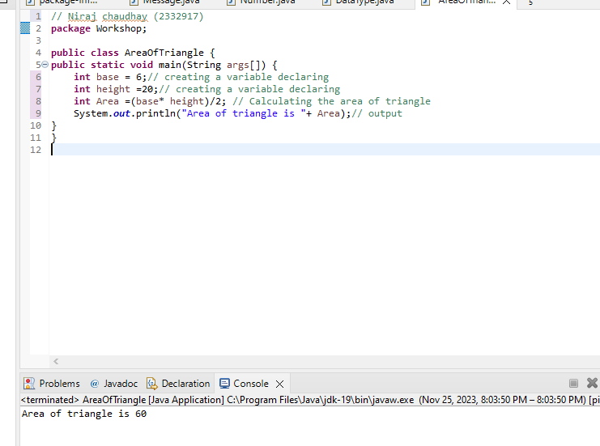

**Method no 2**

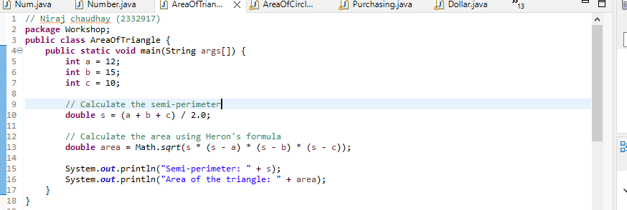



1. Write a Java program to calculate the area of a square. Prompt the user to enter the length of one side and then display the result. Ensure that the program handles user input as a double data type.

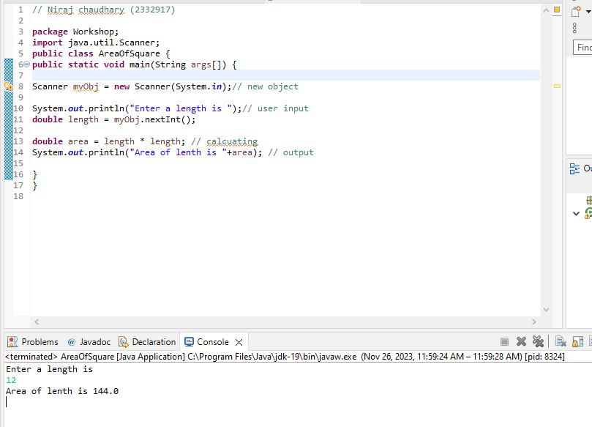

1. Create a Java program that converts a temperature in Celsius to Fahrenheit. Prompt the user to enter the temperature in Celsius, perform the conversion using the formula (F = C * 9/5 + 32), and display the result as a double.

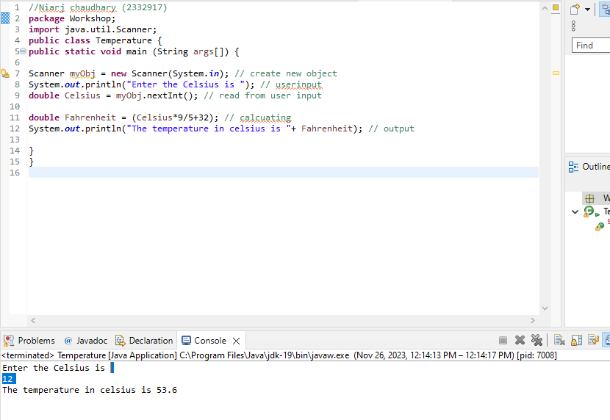

1. **Develop a Java program that calculates the volume of a cylinder. Prompt the user to enter the radius and height of the cylinder and then display the result. Ensure that the program uses appropriate data types for calculation and output.**

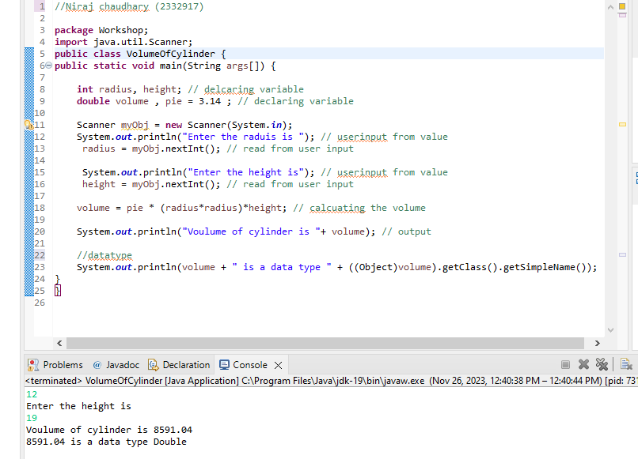

1. **Write a Java program that calculates the simple interest on a loan. Prompt the user to enter the principal amount, the rate of interest, and the time period. Calculate and display the interest amount as a double.**

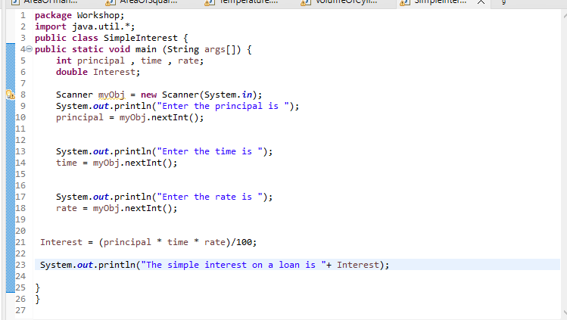 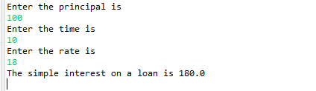

1. **Create a Java program that takes two integer inputs from the user, performs all basic arithmetic operations (addition, subtraction, multiplication, and division) on these numbers, and displays the results.**

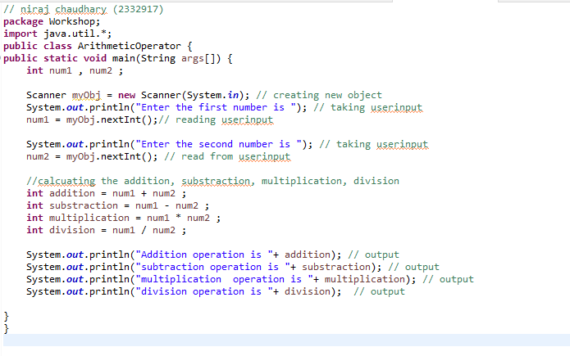 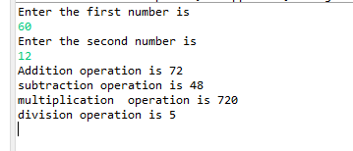

1. Write a Java program that calculates the perimeter of a rectangle. Prompt the user to enter the length and width of the rectangle, and then display the result. Use appropriate data types for calculation and output.

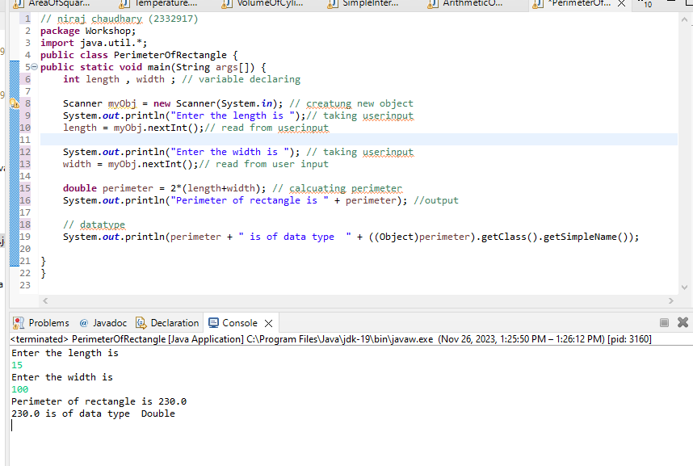

1. **Develop a Java program that converts miles to kilometers. Prompt the user to enter the distance in miles and display the equivalent distance in kilometers as a double.**

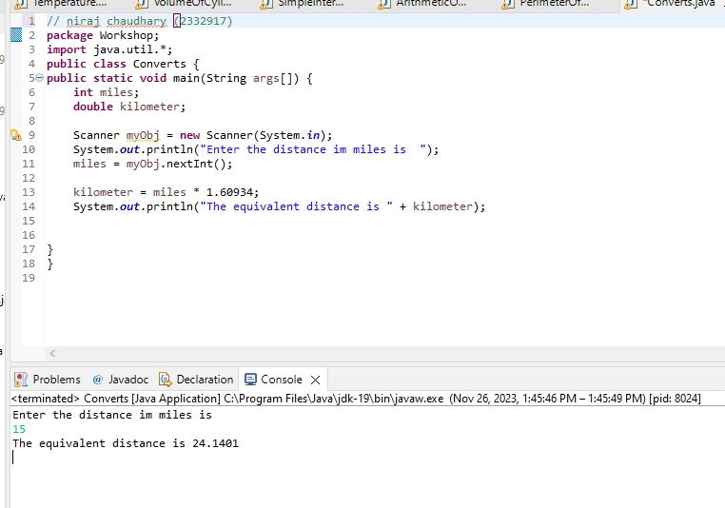

1. Create a Java program that computes the area of a circle. Prompt the user to enter the radius and display the result as a double. Use the formula (Area = π * r * r) for the calculation.

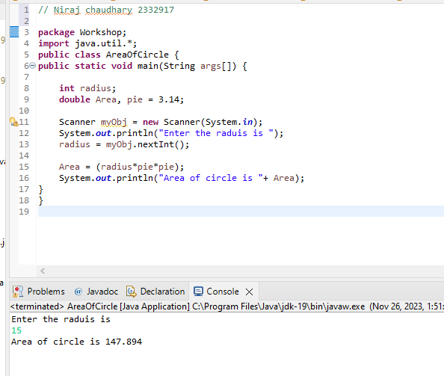

1. **Develop a Java program that calculates the total cost of purchasing a given quantity of items at a certain price per item. Prompt the user to enter the quantity and price, and display the total cost as a double.**

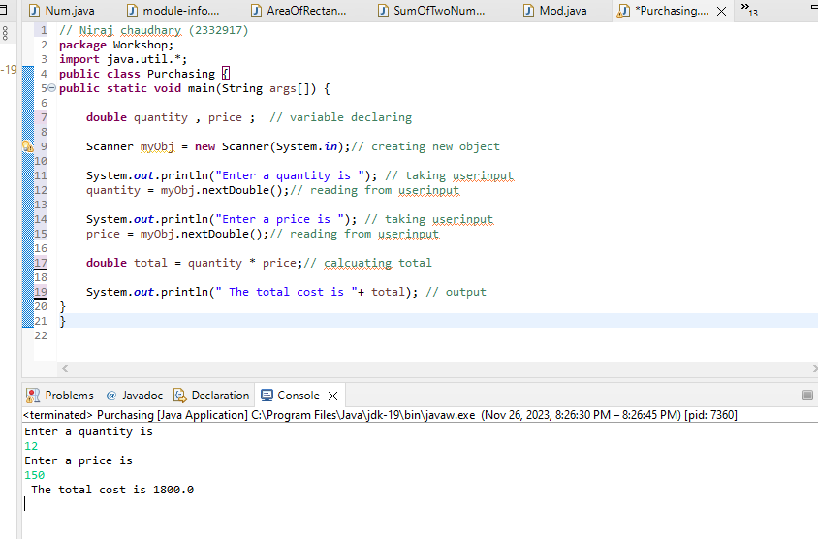

1. Write a Java program that converts a given amount of money in U.S. dollars to another currency (e.g., rupees). Prompt the user to enter the amount and the exchange rate, and display the converted amount as a double.

