1. What are the three types of loops in Java, and how do they differ?
2. For loop:- It is  use when we need to repeatedly execute a block of statements.
3. While loop:- The while loop loops through a block of code as long as a specified condition is true:
4. Do loop:- The loop will always be executed at least once, even if the condition is false, because the code block is executed before the condition is tested.
5. Explain the syntax and usage of a "for" loop in Java.

**Synatx**

for (initialization expr; test expr; update exp)

{

// body of the loop

// statements we want to execute

}

**Explanation:**

1. Control falls into the for loop. Initialization is done
2. The flow jumps to Condition
3. Condition is tested.
4. If the Condition yields true, the flow goes into the Body
5. If the Condition yields false, the flow goes outside the loop
6. The statements inside the body of the loop get executed.
7. The flow goes to the Updation
8. Updation takes place and the flow goes to Step c again
9. The for loop has ended and the flow has gone outside.

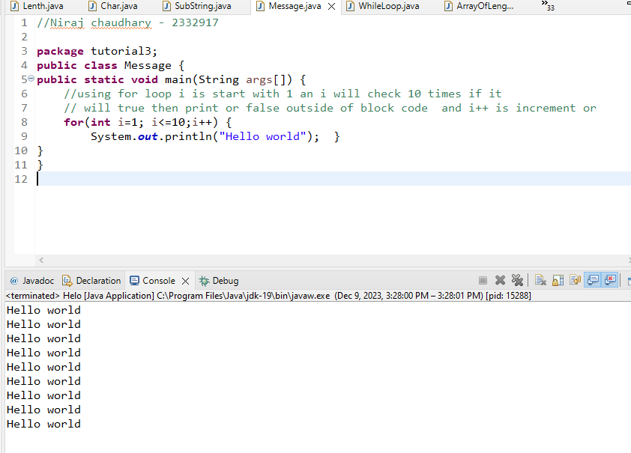

1. How does a "while" loop work in Java? Provide an example.
2. Control falls into the while loop.
3. The flow jumps to Condition
4. Condition is tested.
5. If Condition yields true, the flow goes into the Body.
6. If Condition yields false, the flow goes outside the loop
7. The statements inside the body of the loop get executed.
8. Updation takes place.
9. Control flows back to Step 2.
10. The while loop has ended and the flow has gone outside.

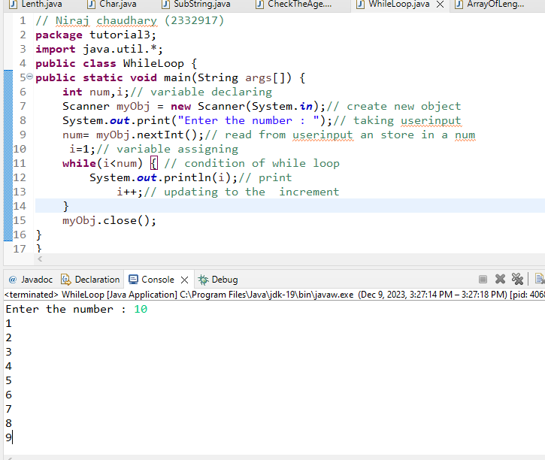

1. Describe the purpose and syntax of a "do-while" loop in Java.
2. Control falls into the do-while loop.
3. The statements inside the body of the loop get executed.
4. Updation takes place.
5. The flow jumps to Condition
6. Condition is tested.
7. If Condition yields true, go to Step f.
8. If Condition yields false, the flow goes outside the loop
9. The flow goes back to Step b.

**Syntax**

do

{

// Loop Body

Update\_expression

}

// Condition check

while (test\_expression);

1. What is an infinite loop, and how can it be prevented in Java?

* Infinite loops in Java occur when the terminating condition of the loop is not met. Usually, an infinite loop in Java is a programming error, but sometimes infinite loop in Java is also used intentionally, for example in a wait condition.

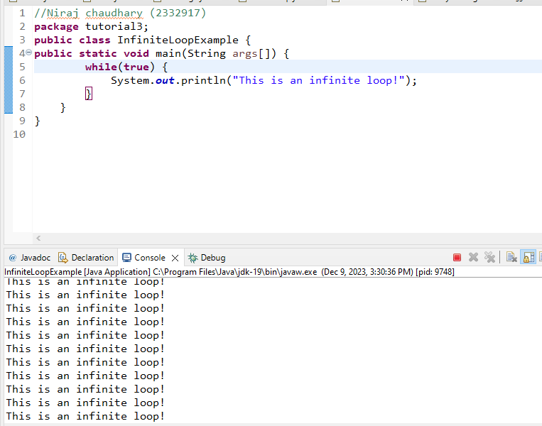

1. Explain the role of the break and continue statements in Java loops.

**Break Statement :-** Break Statement is a loop control statement that is used to terminate the loop. As soon as the break statement is encountered from within a loop, the loop iterations stop there, and control returns from the loop immediately to the first statement after the loop. 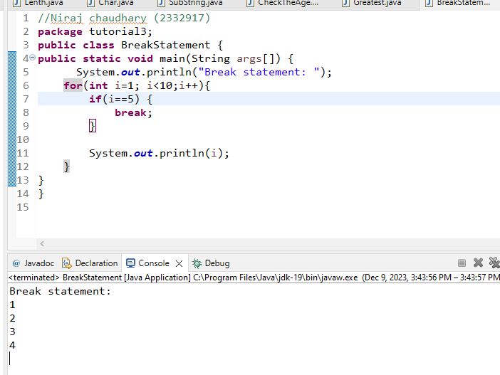

**Continue Statement:**- Suppose a person wants code to execute for the values as per the code is designed to be executed but forcefully the same user wants to skip out the execution for which code should have been executed as designed above but will not as per the demand of the user. In simpler words, it is a decision-making problem as per the demand of the user.

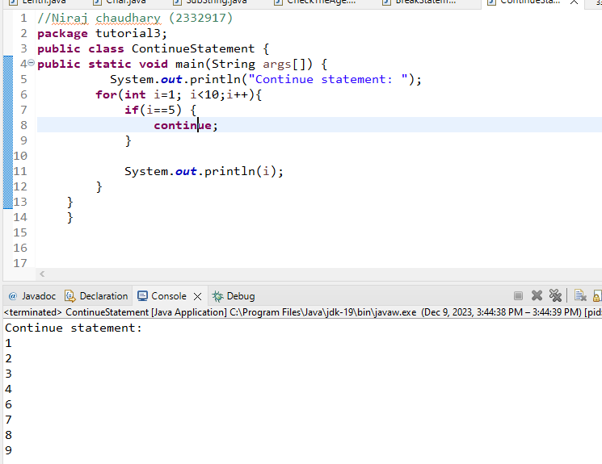

**Arrays:**

1. How do you declare a one-dimensional array in Java, and what is its syntax?

* We can declare a one-dimensional array in java is type var-name[ ];
* Its syntax is type var-name[ ].

1. Explain how to initialize an array during declaration and later in Java.

* int[] myarray = {1, 2, 3, 4, 5};

1. Declaration: int[] myarray: This line declares an array named myarray that can hold integers. The [] indicates that it's an array, and int specifies that it will hold integers.
2. Initialization: {1, 2, 3, 4, 5}: This part initializes the array with the specified values.The array myarray now contains five elements: 1, 2, 3, 4, and 5.
3. Discuss the concept of a multi-dimensional array in Java. Provide an example.

* A multidimensional array is an array of arrays. It is useful when you want to store data as a tabular form, like a table with rows and columns.To create a two-dimensional array, add each array within its own set of curly braces.

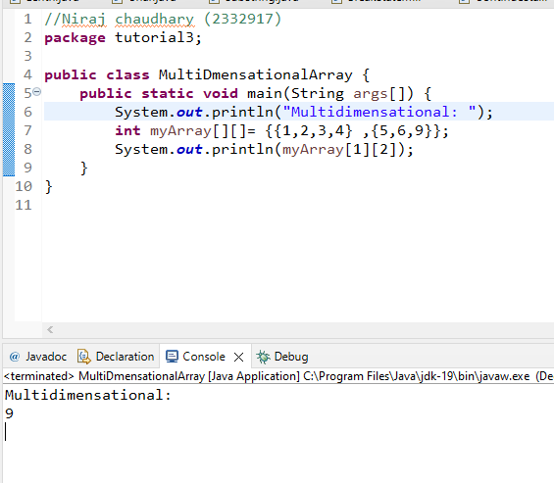

1. What is the default initialization value for elements in an integer array in Java?

* The is the default initialization value is 0 for elements in an integer array in Java.

1. How do you find the length of an array in Java?

* We can find the length of an array in java is (var-name.length).

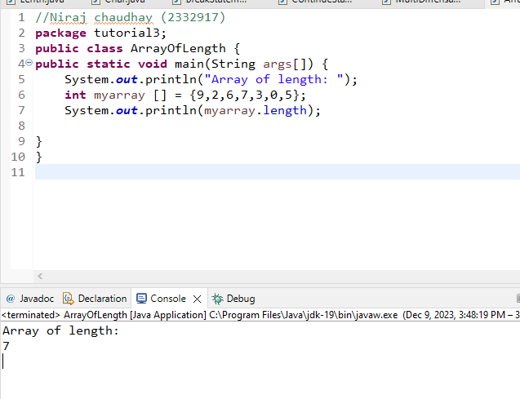

1. Discuss the importance of the index in arrays and why it starts from zero in Java.

* Array indices are essential in programming as they provide a way to uniquely identify and access elements within an array. They serve as reference points for efficient data manipulation, enabling tasks such as searching, sorting, and iteration, making indices a fundamental aspect of effective array usage in programming.
* Array indices are essential in programming as they provide a way to uniquely identify and access elements within an array. They serve as reference points for efficient data manipulation, enabling tasks such as searching, sorting, and iteration, making indices a fundamental aspect of effective array usage in programming.

1. How can you copy elements from one array to another in Java?
2. Using variable assignment. This method has side effects as changes to the element of an array reflects on both the places. To prevent this side effect following are the better ways to copy the array elements.
3. Create a new array of the same length and copy each element.
4. Use the clone method of the array. Clone methods create a new array of the same size.
5. Use [System.arraycopy() method](https://www.tutorialspoint.com/java/lang/system_arraycopy.htm" \t "_blank).  The arraycopy() can be used to copy a subset of an array.

**Enhanced For Loop:**

1. What is the enhanced for loop (for-each loop) in Java, and when is it preferable?

* In Java, the for-each loop is used to iterate through elements of [arrays](https://www.programiz.com/java-programming/arrays) and collections (like [ArrayList](https://www.programiz.com/java-programming/arraylist)). It is also known as the enhanced for loop.
* The Java for-each loop or enhanced for loop is introduced since J2SE 5.0. It provides an alternative approach to traverse the array or collection in Java.

1. Provide the syntax for using the enhanced for loop to iterate through an array in Java.

for(dataType item : array) {

...

}

* array - an array or a collection
* item - each item of array/collection is assigned to this variable
* dataType - the data type of the array/collection

1. Can the enhanced for loop be used for other collections besides arrays in Java? If yes, give an example.

* Yes, the enhanced for loop (also known as the "for-each" loop) can be used for other collections besides arrays in Java. It can iterate over any object that implements the Iterable interface. Examples of iterable collections include lists, sets, and maps.

1. Explain the limitations of the enhanced for loop in Java.

* The drawback of the enhanced for loop is that it cannot traverse the elements in reverse order. Here, you do not have the option to skip any element because it does not work on an index basis. Moreover, you cannot traverse the odd or even elements only.

* How does the enhanced for loop handle concurrent modification in Java?  
  The enhanced for loop in Java does not handle concurrent modification well. If you try to modify the collection (like adding or removing elements) while using the enhanced for loop, it may lead to unpredictable behavior or throw a ConcurrentModificationException. It's like trying to change a recipe while someone is cooking – it might mess up the process. To avoid this issue, it's recommended to use an iterator and the remove method from the Iterator interface if modifications are necessary during iteration.