# CURRICULUM VITAE

**NIRAJ YADAV** 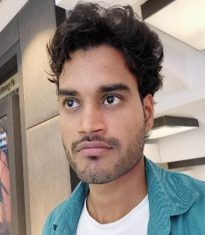

*New Delhi*

*Pin Code – 110062*

*Mobile No.* ***9795382496***

## Career Objective:

To be an asset for the organization by learning and contributing best for the organizational growth and for update my skills from time to time.

* + **Job Profile:**
    - Providing classes and training to students regarding following:
      * Basic Computers
      * Web Designing (HTML, CSS, JavaScript, J Query, Media Query, Dot Net, ASP .Net, SQL Server)

## Faculty in Lal Bahadur Shastri Training Institute (LBSTI)

01/2022 - 03/2022

* 1. **Key Skills:** Learning Languages, Attending training scheduled by LBSTI.

## Job Profile:

* + 1. Book Keeping.
    2. Cash handling.
    3. Salary distribution.
    4. Preparing fee receipts of students.
    5. Doing tasks of Front Office Coordinator and Back Office Coordinator.
    6. Prepared an action plan for improving business goals and objectives.

* 1. **Job Profile:**
     1. Providing classes and training to students regarding following:
        1. HTML
        2. CSS
        3. JavaScript
        4. J Query
        5. Bootstrap
        6. Media Query

**Key Skills as on MIS:** - MS-Office, Functions, Advance knowledge of Excel.

## Knowledge:

* + Create pivot tables and modify spreadsheets to achieve analytical goals.
  + Know about the Monthly, Weekly & Daily Report Creating in MS-Excel.
  + Extensive usage of MS Excel (Aggregate function, VLOOKUP, Pivot table).
  + Web Designing (Html, CSS, Java Script, J Query, Media Query, ASP.Net, SQL Ser

and Dot Net)

## Strength:

Organization, capability of work hard in a focused manner. Interested always to learn, new things with a positive attitude.

**TECHNICAL SKILLS:**

## Web Tools:

* HTML
* CSS
* BOOTSTRAP
* JAVASCRIPT
* JQUERY
* BASIC KNOWLEDGE OF REACT.JS
* AND NODE.JS

**Educational Qualification:**

* + Graduated (B.A) from DR. RAM MANOHAR LOHIA UNIVERSITY FAIZABAD (AYODHYA).
  + 12th Class passed from UP Board in 2015, Uttar Pradesh.
  + 10th Class passed from UP Board in 2013,Uttar Pradesh.

**Personal Details:**

Father's Name SHIV KUMAR

Date of Birth 05/11/1997

Marital Status Unmarried Language known Hindi, English Gender Male

Nationality Indian

Hobbies Reading, Writing, Surfing new things on internet.

**DECLARATION**

**The above statements are true to the best of my knowledge and belief.**

**REFRENCES**

**Will be available on request.**

**Date: (NIRAJ)**