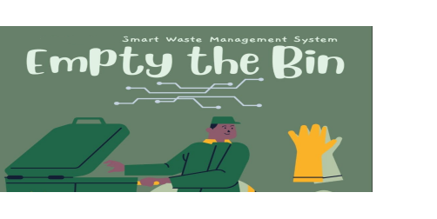

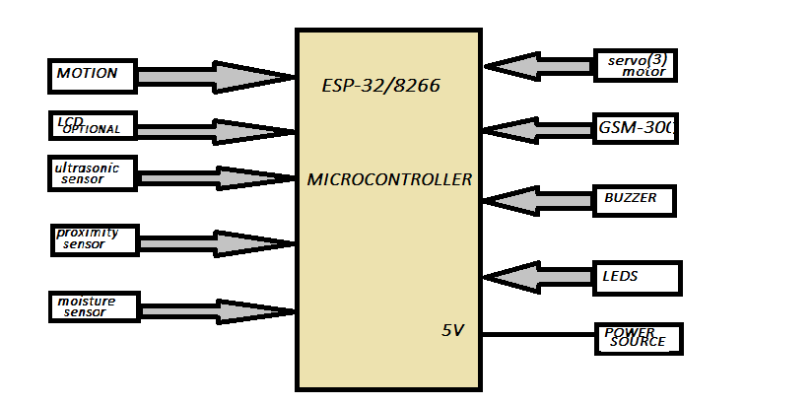**SMART I-WASTE MANGEMENT SYSTEM**

**INTRODUCTION:**

Now a days,in the rapidly urbanizing world, waste management has become a significant challenge for municipalities and governing bodies.The large quantity of waste in landfill became the obstacle throughout the world.Recycling is important to develop a sustainable environment as it can reduce the quantity of waste goes to landfill and enable recyclable materials to extract their value .But now days traditional waste disposal methods often lead to inefficient sorting, excessive land filling, and environmental pollution. Addressing these issues requires innovative and sustainable solutions.

**Solution:**

Our project introduces a Smart Waste Management System designed to automate and optimize the segregation of waste into three categories: dry, wet, and metal. This system leverages advanced technologies such as sensors and more to identify and sort waste efficiently at the source. By doing so, it not only enhances recycling rates but also reduces the burden on landfills and minimizes environmental impact.

*Objective*:

1**.**To create or make a user friendly smart waste management system that will simplify the recycling process for the public or make it more streamline.

1. To develop an a model that will direct the waste(dry,wet,metal…) to the proper bins.

*BLOCK DIAGRAM:*

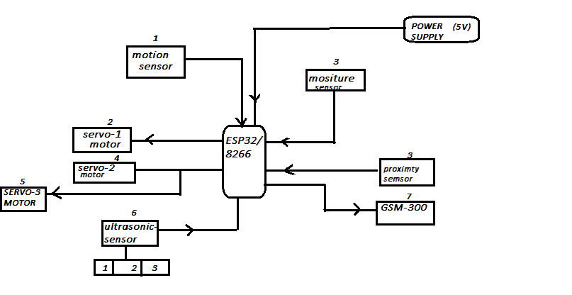

**Components that will be using:**

1. proximity sensor
2. Moisture sensor
3. Ultrasonic sensor(3)
4. Motion sensor
5. GSM-300
6. Sound Buzzer/LEDs
7. Servo motor
8. Micro-controller Esp-32or 8266
9. Power supply 5 volt
10. Outer body structure

Methodology:

**Hardware Components:**

Micro-controller: An ESP32/8266 micro controller will be used to manage sensor data , control the servo motors and to communicate with GSM-300 module.

Sensors:

Moisture Sensor: To detect wet waste.

Proximity Sensor: To identify the presence of metal-objects.

Motion Sensor: To detect the motion of user as they enter the system lid will get open.

Ultrasonic Sensor: To monitor the fill **level of the waste bins**.

Actuators:

Servo Motors: Three servo motors will be used **to direct the waste into the appropriate bins** based on sensor readings**.**

**Communication Module:**

**GSM Module**: To **send notifications to users when the waste bins are full.**

System Design:

**Sensor Integration:** The moisture sensor will identify wet waste, the Inductive proximity sensors will detect the presence of metal waste item, and after that the system will trigger the to start the segregation process. The ultrasonic sensor will monitor the fill levels of the bins.

Micro-controller Programming: The ESP32/8266 micro controller will be programmed to process sensor data and control the servo motors accordingly. The micro controller will execute decision-making algorithms to determine the type of waste and activate the appropriate servo motor to direct the waste into the correct bin.

**Notification System**: The micro controller will communicate with the GSM module to send an a SMS notification to a predefined number when any of the bins reach a specified fill level.

**Algorithm Implementation:** Develop algorithms to process sensor data and classify waste types.

Servo Motor Control: Implement control mechanisms for precise movement of servo motors to ensure accurate segregation.

Notification Logic: Implement logic to trigger GSM notifications when the bin fill levels exceed a threshold.

# Conclusion

With growing urbanization and increasing population, effective waste disposal is a major concern. Manual waste segregation is very lavish, time consuming and inefficient.

This project will be a initiative to provide a practical and innovative solution for waste management.The smart bin will not only streamline waste segregation but also contribute to environmental sustainability by promoting recycling and proper waste disposal practices.

SOURCE:

1.https://greensutra.in

MENTOR SIGNATURE: